Board of Peace May Attempt to Replace the UN
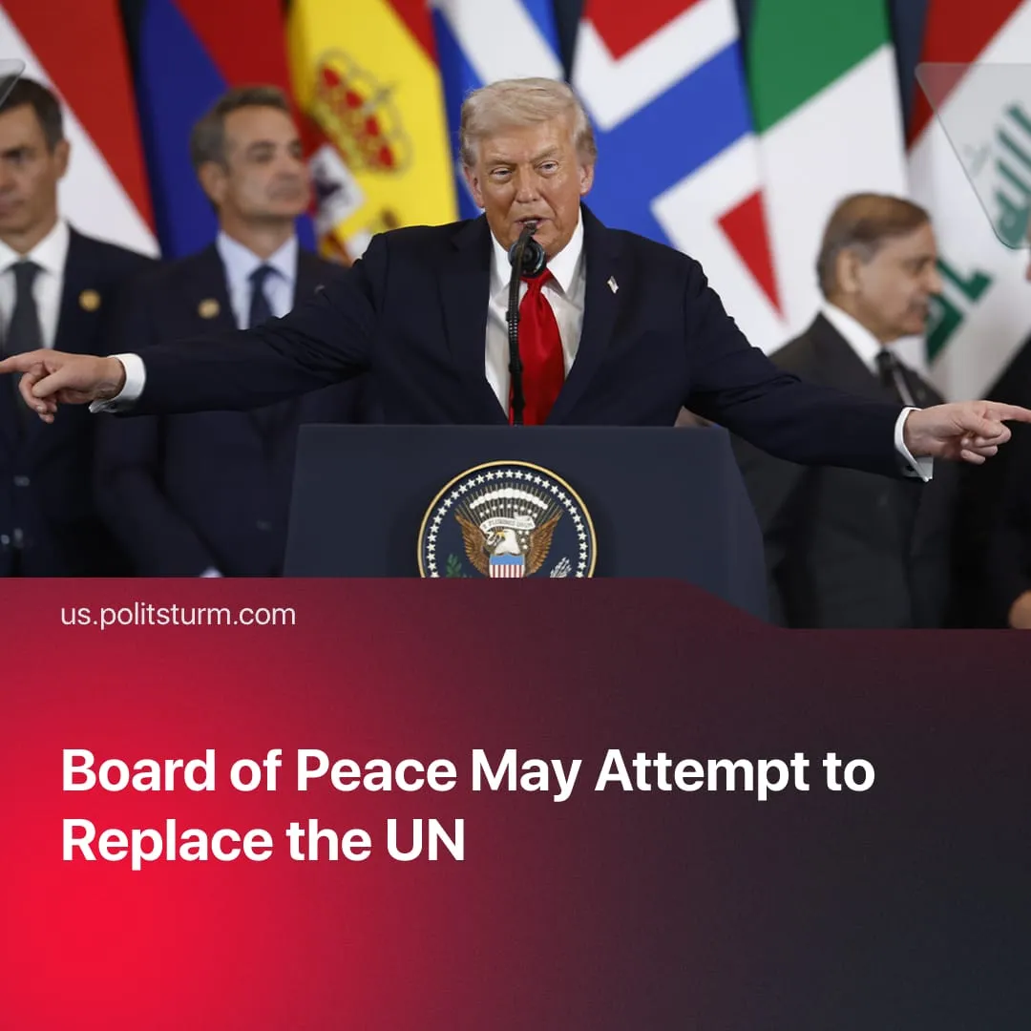

Original article
2026-02-12
2 min read

Trump’s “Board of Peace” may attempt to replace the financially struggling United Nations.
Details. During the Davos conference, Trump established the Board of Peace, an international organisation originally intended to administer the ceasefire in Gaza and oversee its reconstruction.
► The Board of Peace has evolved to include not only individual political figures, but also states as members of the organisation. Any country wishing to become a permanent member of the organisation must pay $1 billion into a fund to “reconstruct Gaza”. Otherwise, each country serves a three-year term that can be renewed at Donald Trump's discretion.
► Trump appointed himself as the organisation's chairman. He has the right to veto key decisions and implement resolutions on behalf of the Board without prior consultation. He did not impose a term limit on himself and will be chairman for life or until he picks a successor. Trump has stated that the organisation's goal is to establish peace in Gaza and beyond. Noticeably, the charter is deliberately broad and never mentions Gaza.
► Several invited countries, such as France and the UK, refused to participate in the Board of Peace. The main criticism was that the structure could be an attempt to replace or bypass the UN, particularly the Security Council. Further concerns were raised regarding corruption risks and the 'money for influence' model, as well as Belarus' participation and the invitation extended to Russia.
Context. After nearly two years of conflict, Trump's plan to end the Gaza conflict was approved in November 2025 by the UN Security Council. The plan included the creation of an international transitional body to resolve the conflict and oversee reconstruction, gradual withdrawal of Israeli troops, Hamas disarmament, and international management of the post-conflict situation.
► The resolution mandates that the Board of Peace and the International Stabilisation Forces operate until 2027, which effectively legalises US influence in the region. Pro-US governments and partners have been given a key role in Gaza's reconstruction and security, ensuring their interests are maintained.
► The UN’s financial and political power has significantly weakened. Secretary-General António Guterres has warned that global problems cannot be solved by “one power calling the shots” and has called for a multipolar world.
► The organisation is facing substantial debt and could run out of funds by July 2026 due to unpaid membership fees, particularly from the US.
► In the past, the UN was used to preserve the interests of US capital, but the Trump administration has since withdrawn from several international and UN-affiliated organisations, claiming that they “do not serve the national interest” any longer, with Trump personally criticising the UN and questioning its purpose. The UN’s charges against Netanyahu and condemnation of the US operation in Venezuela, for example, are obstacles to the US.

Original article

