Billionaires Increased Their Wealth by Two-Trillion Dollars in 2024
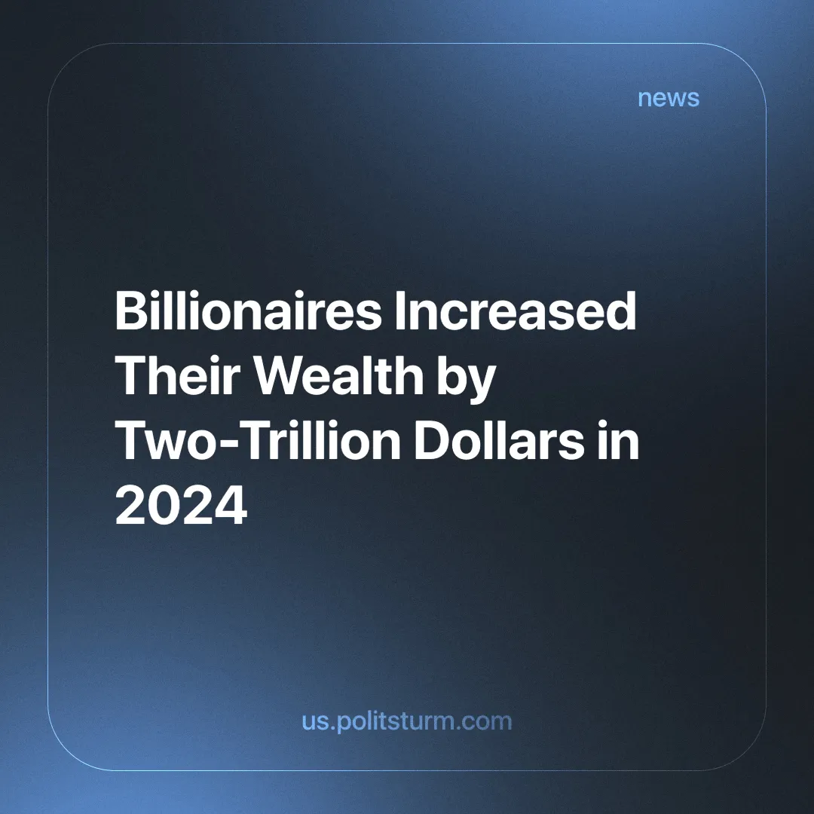

Original article
2025-02-05
4 min read

A study by Oxfam, a charitable NGO, found that the net wealth of billionaires is growing by $5.7 billion a day, reaching a total of $2 trillion in 2024 [1]. This is three times faster than in 2023 [2].
There are now 204 new billionaires globally, bringing the total to 2,769. In addition, it is now expected that there will be five trillionaires within a decade. Previous calculations predicted one [3].
The wealth of the ten richest men has increased so dramatically that if they lost 99% of their wealth, they would still be billionaires. The study comes as the world's richest people gather in Davos for the World Economic Forum, where world leaders discuss key economic and political issues.
At the same time, the number of people living below the World Bank's poverty line of $6.85 a day has barely changed since 1990, representing 44% of the world's population [4].
It is also important to note that it is difficult to get an accurate and exact picture of how many people are living in poverty. The minimum wage in the United States is currently $7.25 an hour, which would put them above the poverty line. However, it is still considered a wage insufficient for workers to make ends meet.
Every year, as a species, we produce more efficiently and on a much larger scale than ever before thanks to advances in modern industry. But all this increase ends up going to capitalists while billions struggle to get by. Comparing the billionaires’ increasing wealth to the poverty figures, the accelerating accumulation of wealth that is currently taking place becomes obvious.
The Oxfam study also claims that most wealth is taken, not earned, with 60% coming from inheritance. The report also claims that the UK has the highest proportion of “crony and monopoly capitalists”. This being classified as capitalists that increase their wealth through lobbies, campaigns, bribes, etc. In short, through “crony connections between the richest and governments.”
But can we then say that the other 40% of their wealth has been earned? The capitalist class, which owns the means of production, is able to make a profit by selling through the exploitation of a working, dispossessed class.
It is the worker who adds value to raw materials or other commodities by working on them. A small fraction of this new value created by his labour is returned to him through his wages, while the capitalist pockets the rest. In this way, the wealth of the capitalist is always taken from the value produced by the worker, nothing is earned.
We are currently living in the era of monopoly capitalism, also known as imperialism. Monopolies are present in every aspect of our lives. We have the illusion that multiple companies compete against each other when we buy our products, but most of the “competing brands” end up being owned by the same company.
The almost unimaginable amount of capital held by monopolists means that any company that refuses to be bought out can be strangled out of every sector of the economy. We explained what monopolies are and why they are a permanent feature of modern capitalism in a previous article.
What is called “crony capitalism” is also a very natural and expected phenomenon of capitalism. Since society and its means of production are geared towards making profits, and given the enormous influence that monopolies have, it is not surprising that capitalists would use their wealth to lobby governments in favour of their profit-making.
The Oxfam report claims that extreme poverty could be ended three times faster if inequality were reduced, and goes on to call for bold solutions to 'radically reduce inequality and hardwire fairness into our economies'.
However well-intentioned, this is where the report falls short. It can call for bold solutions, but it fails to understand the root causes of inequality and wealth accumulation. It calls for a fairer capitalism in which wealth is more equally distributed. But fairness is a subjective term and therefore a loose term. But what does “fair” even mean? Don’t the wealthy and powerful already claim that today’s economy is fair because it rewards hard work and innovation? And under capitalism, isn’t this the only kind of “fairness” that actually makes sense — where wealth is distributed according to who owns and controls production, not according to need?
Economic systems don’t run on moral ideals; laws and policies follow the structure of the economy, not the other way around. So long as capitalism exists, any attempt to “hardwire fairness” into it will just mean tweaking the system while leaving the real problem — the private ownership of wealth and production — untouched. That’s why even well-meaning reforms always end up reinforcing the same inequality they claim to fight.
Extreme poverty is a feature of capitalism. It is a system that puts profit and capital accumulation above all else. For the capitalist to be able to buy labour power through wages, it is necessary for the vast majority of people to be dispossessed and compelled to sell their ability to labour in order to survive. Without this class of people, the capitalist cannot exist.
Only when the working class takes ownership of the means of production and repurposes them to meet the needs of society, thus depriving the capitalists of their only means of accumulating wealth and perpetuating themselves as a class, can social inequality really be ended once and for all.
The only real solution is to replace capitalism with socialism. And the only ones capable of doing this are the working masses of the whole world. If you would help Politsturm in its long task of building foundations for communist parties to work towards socialism, consider joining.
Sources:
[1] Oxfam — Takers not Makers —20/01/2025
[2] The Guardian — Wealth of world’s billionaires grew by $2tn in 2024, report finds — 20/01/2025
[3] The Guardian — World’s five richest men double their money as poorest get poorer — 15/01/2024
[4] The World Bank Group — Poverty, Prosperity, and Planet Report — 2024

Original article

