Billionaire’s Project Gets $100 Million Funding from Taxpayers
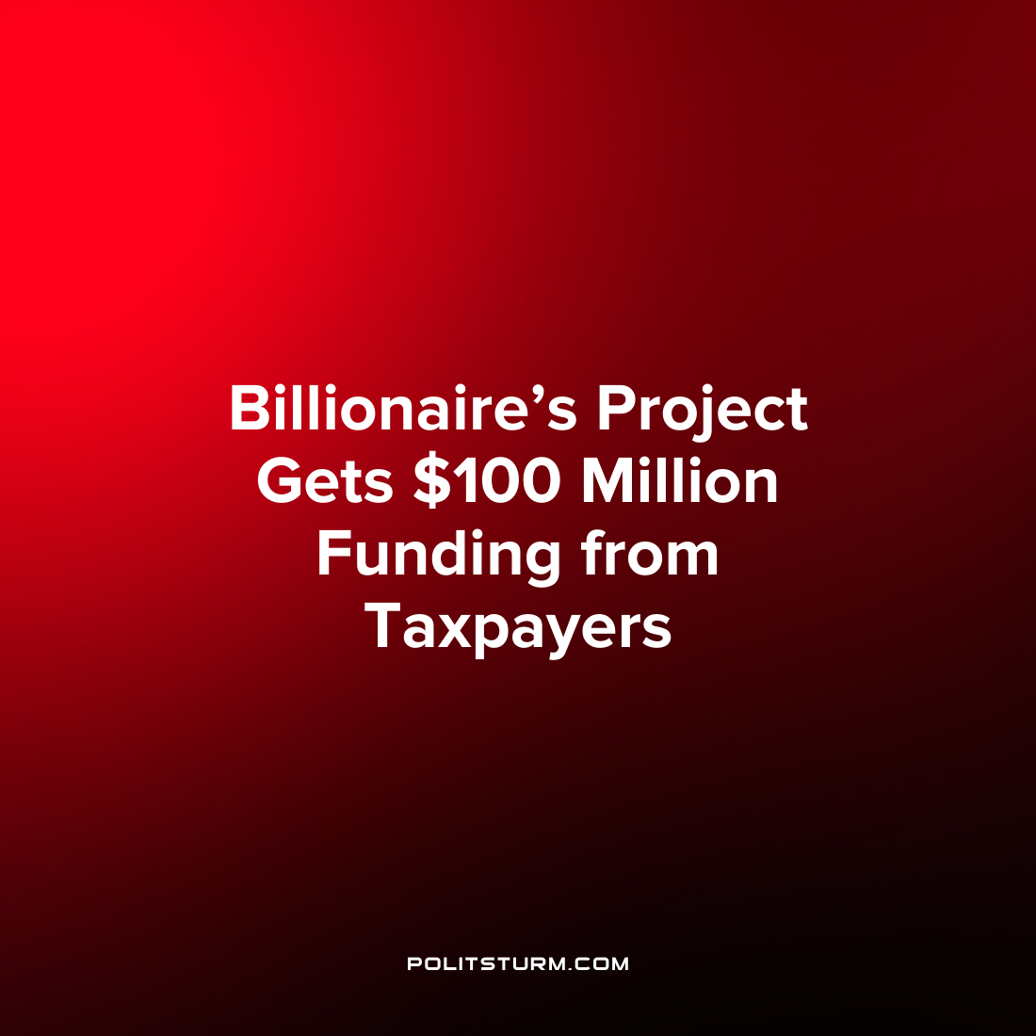

Original article
2022-07-14
1 min read

The state of Michigan’s 2023 budget approved $100 million for the pet project of billionaire Stephen Ross but does not offer any tax relief for state residents. Ross has a reported net worth of $8.2 billion and lobbied state representatives to have the funds appropriated for his project.
The seed funding for the Detroit Center for Innovation reportedly came from a $100 million donation from Stephen Ross. The project states that it is a “world-class research, education and entrepreneurship center in the heart of the city”. The project is set to be constructed by Related Companies, of which Stephen Ross is the founder and chairman.
The president of the Center for Economic Accountability Joe Mozena remarked that “the auto industry in Michigan will never pass up an opportunity to try to offload its costs onto the state’s taxpayers”.
As we can see the oligarchs will have no problems offloading costs which they will ultimately benefit from onto the masses under the guise of spurring innovation and entrepreneurship. Not only will Ross be able to claim philanthropic gifting, his company will benefit from the construction of the facilities which transfers public taxpayer funds into the coffers of the private profit maximizing entity.
Under the dictatorship of the capitalist class society’s resources are used by the capitalist class for their private benefit. The politicians who ultimately serve the capitalist class are perfectly content using public funds to the benefit of the oligarchs. This is yet another example of the hollow shell of capitalist “democracy” in which you can simply elect which representatives serve the interests of the billionaire oligarchs while the living conditions of the masses continue to deteriorate.
Source: 1 2 3

Original article

