Billionaires Gain $434 Billion Wealth During Pandemic
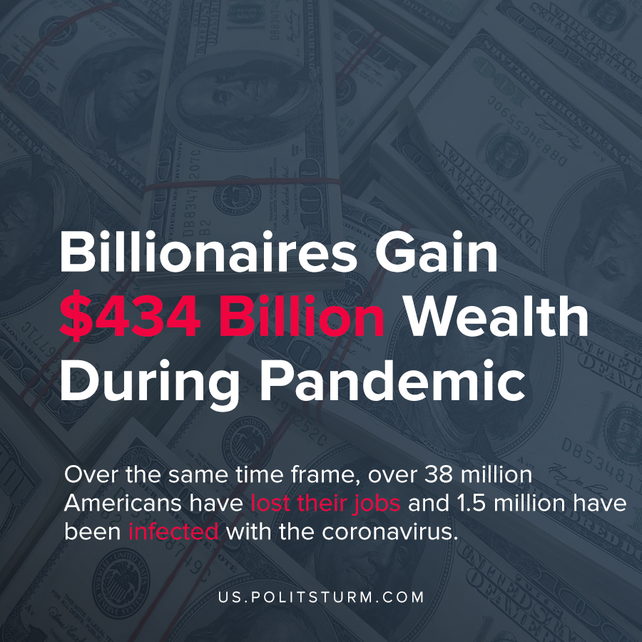

Original article
2020-05-25
1 min read

American billionaires are accumulating wealth at an extraordinary rate despite the coronavirus, according to a study by “Americans For Tax Wellness”. Jeff Bezos increased his wealth by $34.6 billion, which represents a 30.6% increase in wealth over a 2 month period.
Five American billionaires (Jeff Bezos, Bill Gates, Mark Zuckerberg, Warren Buffett, Larry Ellison) increased their wealth by $75 billion. These five capitalists captured 21% of the total wealth appropriated by all 600-plus billionaires over the past two months.
Over the same time frame, over 38 million Americans have lost their jobs and 1.5 million have been infected with the coronavirus. Over 90,000 Americans have died from the coronavirus.
While the wealthiest Americans are enriching themselves throughout the crisis, millions of other Americans suffer from joblessness and poverty. The capitalist economic system is founded upon the appropriation of unpaid labor from the global working class. The processes of capitalist production concentrate this stolen wealth in the hands of a small group of oligarchs, the capitalists. Despite the claims of the capitalist-owned media we are not “all in this together”, as the interests of the parasitic capitalists and the workers are at loggerheads as is clearly demonstrated by this study.
https://americansfortaxfairness.org/wp-content/uploads/2020-5-21-Billionaires-Press-Release-at-Two-month-Covid-Pandemic-FINAL.pdf

Original article

