Over a Billion Food Portions Wasted Worldwide Every Day
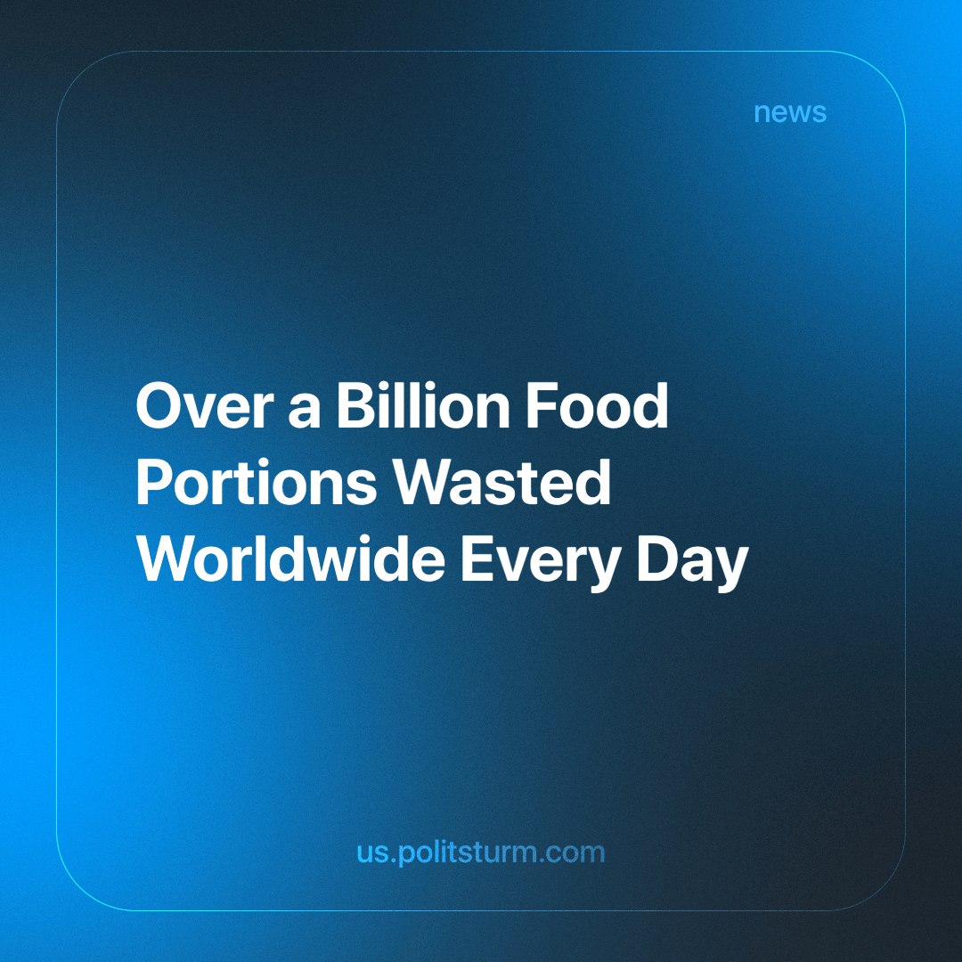

Original article
2024-05-08
3 min read

UN experts presented distressing facts in their environmental report. In 2022, 783 million people (almost 10% of the global population) suffered from hunger, and one in three people worldwide faced food insecurity.
Additionally in 2022, over a billion tons of food waste were sent to landfills. Each year, the world produces enough food to completely eradicate hunger, feeding everyone. However, one-fifth of this vast amount of production is wasted, either disposed of, unused, or spoiled before reaching consumers. The result is millions of hungry people and mountains of garbage, causing enormous harm to our planet.
The recommendations of the report's authors and associated individuals deserve special attention. Let's consider a representative example: Harriet Lamb, CEO of the climate change combating non-governmental organization WRAP, whose members are among the authors of this report. She stated that this problem needs to be addressed by improving coordination among philanthropists, businesspeople, and governments worldwide. Their involvement in programs aimed at addressing the massive impact of food waste on food security must increase.
All of this sounds good, but here's the catch - year after year, decade after decade, reports like this one are published, voiced, and highlighted, screaming about hunger, poverty, and colossal social inequality in the world. However, it all remains solely on paper, and various figures from the worlds of science and politics only dutifully suggest the "need" for the wealthy to share more with the poor, express their concern about this problem, and so on.
But the crux of the matter is that this issue has never been and will never be solved by charity, no matter how large the funds fighting poverty are and how generous their members are. The wealthy minority hides behind charity like a fig leaf, hoping to whitewash themselves in the eyes of society and conceal the true cause of poverty, hunger, and social inequality. And that cause is capitalism.
Capitalism has driven humanity into such a dire situation that the wealth of 1% of people exceeds the combined wealth of the other 99% of the Earth's inhabitants. It is this super-rich minority, owning all the means of production on our planet, that dictates and disposes of all the goods produced with their assistance as their private property. Yet all this production, without exception, is created by the overwhelming majority of the population - wage laborers forced to live from paycheck to paycheck, counting every penny.
A capitalist exists in this system of social relations only as long as their capital grows. By selling goods produced by the very same workers, they aim for one thing only - maximizing profit while minimizing losses. Naturally, if a capitalist cannot sell their products for whatever reason (if consumers lack money, for example, because their classmate, just like them, decided to increase their profits by cutting workers' wages, or inflation has eaten up all the population's income), the capitalist will not give away food for free.
Instead, they will discard it, let it rot in warehouses, and crush it with bulldozers, just to avoid giving it away for free, as this would reduce demand for goods, collapse prices, and hit potential profits, which is unacceptable for any capitalist. But every few years, such an "Atlas" will inevitably donate some round sum to another charitable fund and continue to profit from the suffering of millions.
Unemployment, poverty, hunger, social stratification - all of these are the products of capitalism. Therefore, trying to defeat the disease by only combating its symptoms is a tactic doomed to failure from the start. Only by destroying the root that gives rise to all these problems, by destroying capitalism worldwide, can we rid ourselves of all its ugly offspring.
Lenin, more than a hundred years ago, said:
"Capitalist barbarism is stronger than civilisation. On all sides, at every step one comes across problems which man is quite capable of solving immediately, but capitalism is in the way. It has amassed enormous wealth—and has made men the slaves of this wealth. It has solved the most complicated technical problems—and has blocked the application of technical improvements because of the poverty and ignorance of millions of the population, because of the stupid avarice of a handful of millionaires. Civilisation, freedom and wealth under capitalism call to mind the rich glutton who is rotting alive but will not let what is young live on. But the young is growing and will emerge supreme in spite of all." – V. Lenin, Civilised Barbarism.
As we can see, this statement is still relevant today.
Sources: OSN - "UN: one-fifth of food worldwide is discarded" dated March 27, 2024.
The Guardian - "Millions go hungry as a billion meals binned every day, says UN report" dated March 27, 2024.

Original article

