Bill Gates Largest Owner of U.S. Farmland
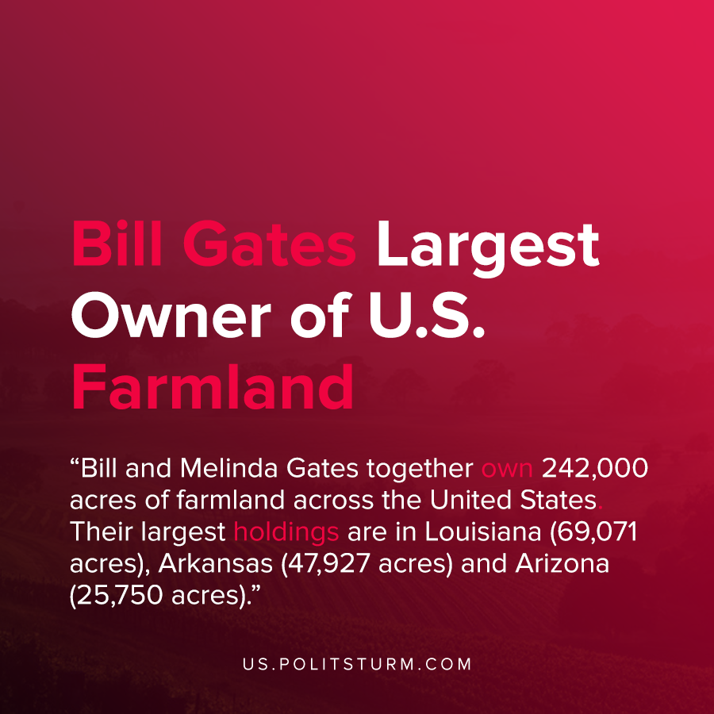

Original article
2021-01-20
1 min read

According to an investigation done by The Land Report, the largest owners of farmland in the United States are Bill and Melinda Gates. Former bond-fund manager Michael Larson acquires real-estate through an entity called Cascade Investment LLC to diversify their portfolios.
Bill and Melinda Gates together own 242,000 acres of farmland across the United States. Their largest holdings are in Louisiana (69,071 acres), Arkansas (47,927 acres) and Arizona (25,750 acres).
However, the Gates land holdings are not confined simply to farmland. They also own 25,750 acres of transitional real estate and 1,234 acres of recreational real estate.
The billionaires are able to diversify their portfolios and spread their capital across all sectors of the economy, including farmland. As such, it is not surprising that a founder of the technology monopoly Microsoft would employ his capital in other ventures than simply owning Microsoft stock.
In this way the oligarchs are able to protect their wealth through diversification and exploit workers all over the world and in any profession. For as long as the private ownership of the means of production is private, the oligarchs will use their capital to accumulate increasing quantities of land and material wealth. The only way to resolve the contradictions of capitalism is the abolition of capital without compensation to the exploiting capitalist class.
Source: 1

Original article

