The Results of the Biden Administration
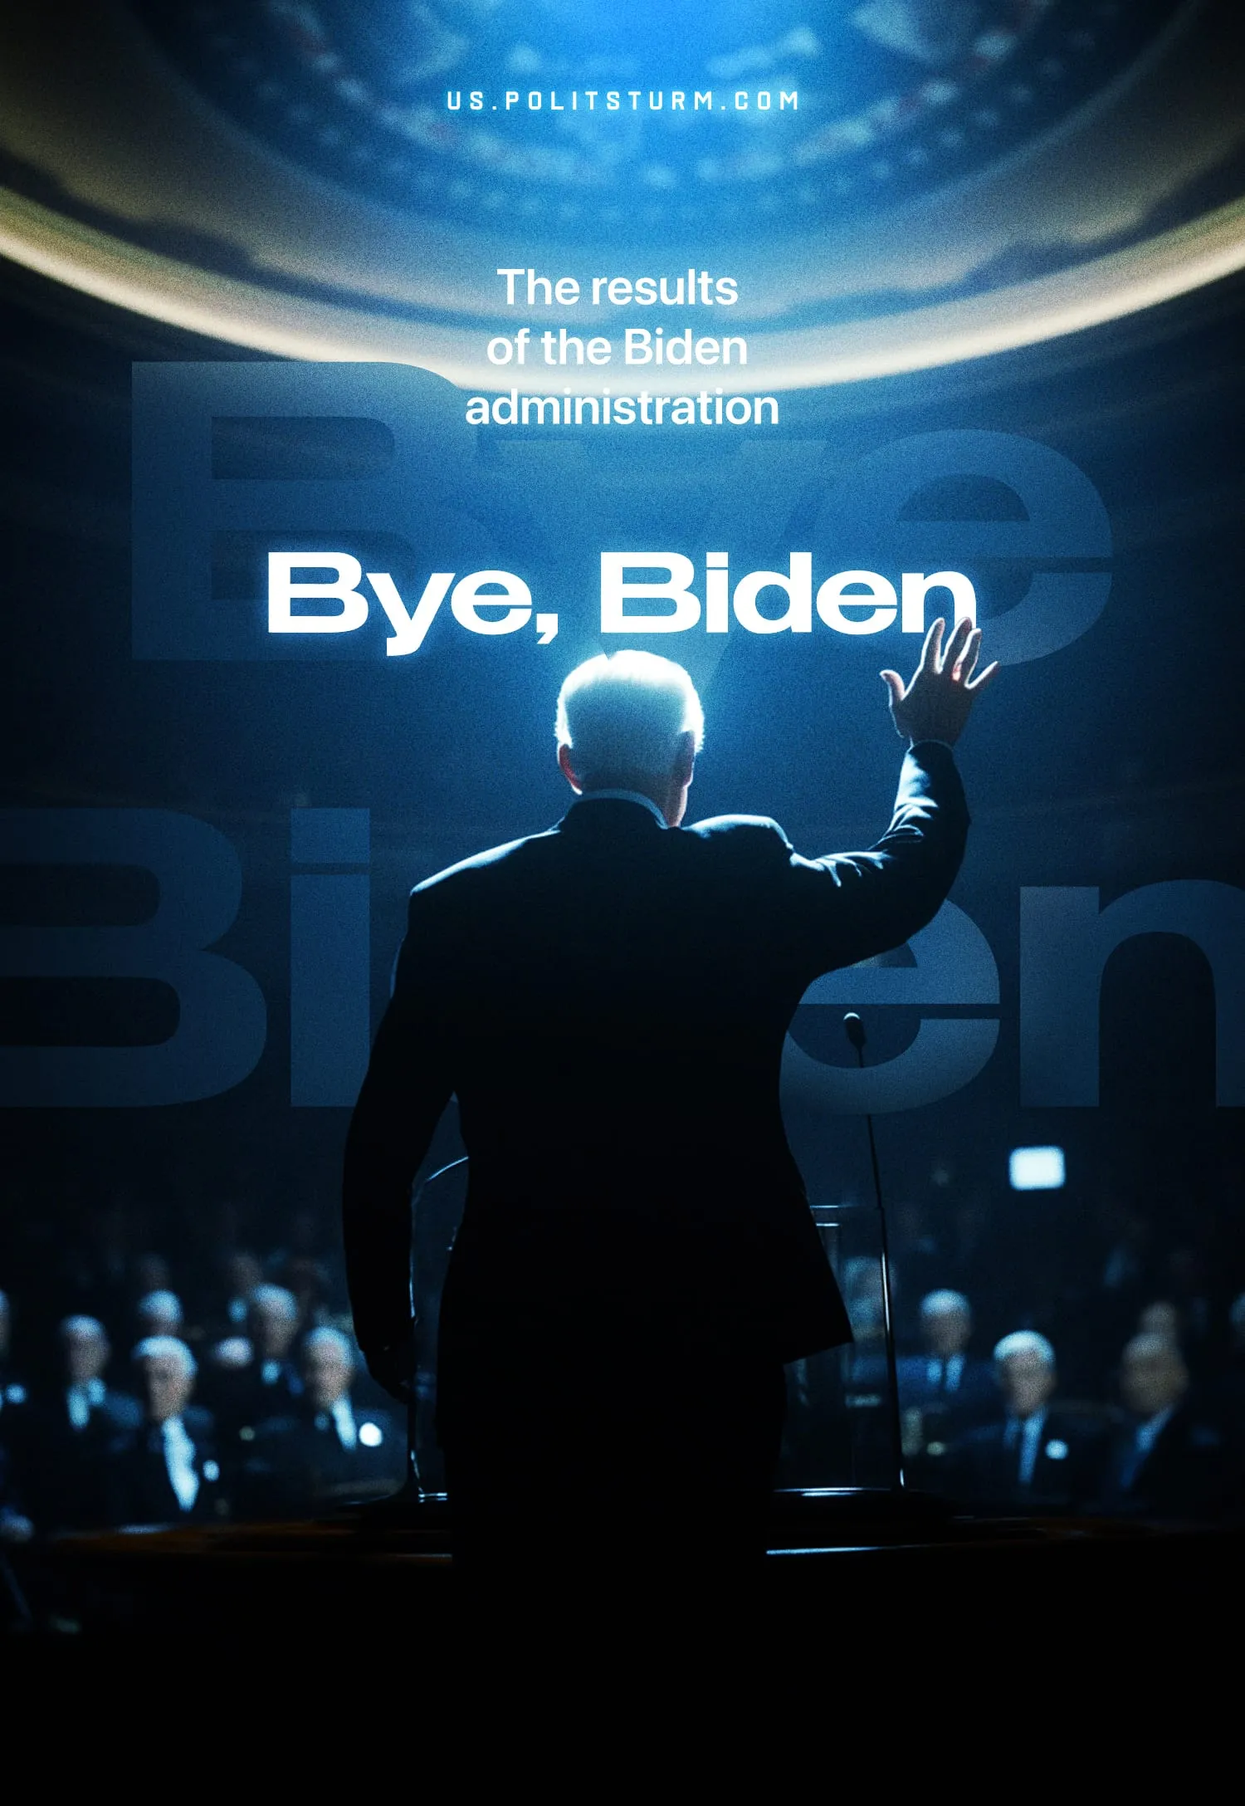

Original article
2025-01-26
12 min read

On 16 January, the now ex-president Joe Biden gave a farewell speech to the American people [1]. In this speech, Biden talks about the idea of the United States, a nation supposedly built for freedom, equality, ambition, democracy and many other great ideals.
The ex-president mentions some of the challenges facing the US today, such as competition from China and the climate crisis. Biden also explains how his administration was able to negotiate a ceasefire between Hamas and Israel.
The most striking moment of his speech, however, is when Joe Biden warns the American people about the “dangerous concentration of power in the hands of a very few, ultra-wealthy people”. He goes on to say that “today, an oligarchy is taking shape in America, of extreme wealth, power and influence”, that literally threatens the US’s “entire democracy.”
Donald Trump's return as President of the United States is marked by a more outwardly aggressive foreign posture, as demonstrated by his threats to annex Greenland [2]; or by far-right tendencies, such as when multi-billionaire Elon Musk, which has endorsed Trump, given his campaign generous donations and after having been appointed as head of the Department of Government Efficiency, performed a Nazi salute during Trump’s inauguration speech [3].
Many opponents of Trump support the Democratic Party as the only alternative to save “American democracy”, but is this true? Are the dangers posed by Trump's second term a mere coincidence? Can the problems facing the United States and the world as a whole be blamed on a single individual? Can we say that under Biden there was no “powerful oligarchy threatening democracy”?
Starting with Biden's first claim that his administration was responsible for the current ceasefire in Gaza. While this is not strictly untrue, it is worth remembering that the US has vetoed all previous ceasefire proposals [4]. This delay, which has led to the deaths of at least 46,600 Palestinian civilians [5], is caused because the administration would only settle for peace, once it had secured favourable terms. This capitalist peace, which doesn’t solve the fundamental contradictions of the region, will undoubtedly be temporary as the causes of the conflict remain.
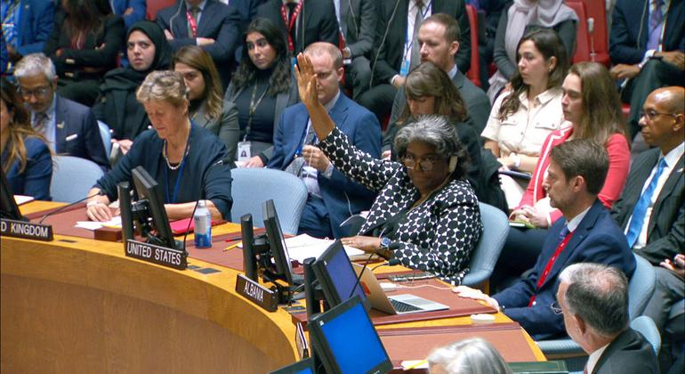
US vetoes the Brazilian-led draft resolution on the Israel-Gaza crisis.
One of the points of his speech is to remind the American people of some of the achievements of his administration, such as the modernisation of infrastructure, such as new “roads and bridges”. But, for example, America's rail infrastructure, one of the cleanest and most efficient modes of transport, remains underdeveloped, outdated and dangerous.
We need to remember the horrific derailment in East Palestine in 2023, which caused toxic chemicals to spill into the town, threatening the lives of its residents [6]. Just the year before, Joe Biden had made it illegal for rail workers to strike after campaigning as the most pro-union presidential candidate in American history [7].
The former president also boasts of the 17 million jobs created during his term in office. But working conditions leave much to be desired, with the minimum wage remaining at just $7.25 an hour amid high inflation and despite calls to raise the federal minimum wage to $15 an hour.
Despite having one of the lowest end-of-term unemployment rates, when compared to other presidents, this still means that there are 6.8 million unemployed people in the US [8]. Capitalism cannot guarantee everyone a job, despite an abundance of work to do. A “low” figure still means millions without a stable livelihood and pressure on the labour market - and many employed Americans even experience in-work poverty.
Joe Biden also states that his administration saw the climate crisis for the threat that it is, and was exemplary in working towards a transition to green energy. But his administration approved some of the largest oil drilling projects in decades [9] and crude oil production continued to break records [10].
But what of the former president's great concern that he felt compelled to warn the country about? The dangerous concentration of power in the hands of a few ultra-wealthy individuals, with dangerous consequences if their abuse of power goes unchecked.
In this day and age, it is hard to argue with Joe on this point. Large monopolies are present in every country and dominate almost every aspect of our lives. The billionaires who own them are getting richer every day as wealth accumulates in the hands of a shrinking circle of people, while crises affect several nations and loom over others, and many working-class people struggle to make a living.
But the problem is that Joe Biden is presenting this as something that his administration has been actively fighting and trying to solve, or that has just cropped up now. Firstly, Biden himself abused the power of the presidency to pardon his own son at the end of his term [11].
But more importantly, did Biden do anything to curb the concentration of power in the hands of a few ultra-wealthy individuals? If so, this would seem to contradict the fact that Biden received donations from at least 40 billionaires during his campaign [12]. But if we look at Biden's entire tenure, we see that despite his anti-ultra-rich rhetoric, the 100 richest Americans increased their collective net worth by 63% [13].
Biden's promise to raise taxes on the ultra-rich if re-elected only leads those who support this policy to ask “why wasn't this done during his first term?” The state is not a body that exists above and outside society, it is part of it and will represent the current class relations that govern it. The office of president, whether occupied by a Republican or a Democrat, will serve to represent the ruling class in the US - the capitalist class.
The two parties simply represent different flavours of capitalism. One is more openly aggressive and right-wing, while the other is more moderate and reformist. In a previous article, we took a closer look at the two-party system in the United States and what the elections really represent.
Biden's class character is evident in his speech when he refers back to Franklin Roosevelt’s administration, more than a century ago. He emphasises how in tackling the big trusts, the people of America did not punish the rich, only made to pay their fair share in taxes and to play by the rules. In this way, he is telling the workers of America to not punish billionaires today, only to limit themselves to a tax reform – i.e. for the workers to play by the capitalists’ rules.
The capitalist notion of what constitutes a “fair share” is also vague. A billionaire would say they already pay their fair share. These are calls that appeal to “common sense”, of which many who have only ever experienced capitalism and buy into its inner logic, would naturally agree to. However, it does not mean anything concrete and implies that the exploiter and exploited can sit down and agree on a “fair” degree of exploitation.
Biden is echoing the line of a section of the capitalist class which defends higher taxes as the solution to capitalist contradictions [14]. This position is just as hostile to the workers as more extreme tendencies because it fools the working class into thinking that the system that exploits them is fixable and can be reformed into something better. It is merely another tool in the repertoire of the ruling class.
The impossibility of stopping the concentration of power, which we have previously written about, is shown by the fact that the “robber barons” of over a century ago never really went away. Their oligarchies are now more powerful and influential than ever. No amount of reform or taxation can change this. Monopolies grew out of free competition; even if we could somehow return to that old capitalism, capital accumulation would lead right back to monopolies.
While Trump represents a dangerous shift in global politics, the turn to the far right is not just in America, but around the world. It is wrong to say that it has come out of nowhere. To be surprised by this is to fail to understand the foundations of capitalism.
Under capitalism, the means of production are the private property of the capitalist class. The labour-power of the worker is bought in order to produce commodities to be sold at a profit, which is then reinvested in the purchase of more means of production in a cycle designed to accrue increasing amounts of wealth to the owning class.
Under capitalism, the means of production are directed towards the private interests of the capitalist class, who accumulate vast amounts of wealth through the exploitation of the working class. This means that production doesn't serve the needs of society. The needs of society are only taken into account insofar as the capitalist class needs a mass of proletarians to exploit in order to produce capital. If the working class dies out, the capitalist class cannot exist.
The independent interest of the working class lies in socialism, where the means of production are directed towards satisfying the needs of the working class - of society. In order to maintain class rule, the capitalist class resorts to giving the working class crumbs of its huge super-profits.
This means that, in some cases and for a limited period, the working class has access to higher wages, labour rights and a welfare state. For a limited time, the working class believes that capitalism can be fixed and abandons revolutionary struggle.
But by the very nature of capitalist competition, different capitalists (both from the same and different nations), in a fierce struggle not to be left behind, will intensify the exploitation of labour and try to make even greater profits. Even in the era of monopoly capitalism, this cut-throat competition does not end - it only intensifies.
The drive for profit forces this powerful oligarchy and the states that represent it (such as Biden's presidency) to cut back on the social institutions that make capitalism bearable for a section of the proletariat. This gives a platform to far-right figures who use bombastic anti-establishment rhetoric to divert the anger of the working class away from the roots of its misery - capitalist relations of production. In this sense, Biden is as complicit as Trump in the concentration of power and the rise of the far right.
Only by replacing the individual appropriation of capitalism can the massive productive potential of modern industry be fully utilised to meet the needs of society. The only way to defeat the far right, to defeat fascism, is through the workers' struggle for socialism.
Workers turn to the far right because they are looking for an alternative to capitalism, but the left is mainly dominated by reformists or left-liberals who have shown, through administrations such as Biden’s, that their position does not work.
This is because there are no genuine communist parties to educate and lead the working class. We aim to work towards their creation. If you want to contribute to our work and help in the long process of building the foundation for revolutionary communist parties, consider joining our organisation.
Sources:
[1] ABC News — FULL SPEECH: President Joe Biden's farewell address to the nation — 16/01/2025
[2] BBC — Trump ramps up threats to gain control of Greenland and Panama Canal — 7/01/2025
[3] The Guardian — ‘The gesture speaks for itself’: Germans respond to Musk’s apparent Nazi salute — 21/01/2025
[4] The NY Times — A Look at the Three Previous U.N. Cease-Fire Resolutions the U.S. Vetoed — 22/03/2024
[5] Routers — Gaza death toll: how many Palestinians has Israel's offensive killed? — 15/01/2025
[6] The Guardian — ‘It feels like an apocalyptic movie’: life in East Palestine six months after toxic train crash — 04/08/2023
[7] Time — Why ‘Union Joe’ Chose to Make it Illegal for Rail Workers to Strike — 02/12/2022
[8] Trading Economics — United States Unemployment Rate — 10/01/2025
[9] The Guardian — Biden’s approval of Willow project shows inconsistency of US’s first ‘climate president’ — 14/03/2023
[10] EIA — United States produces more crude oil than any country, ever — 11/03/2024
[11] BBC — Biden gives son Hunter 'unconditional' pardon — 02/12/2024
[12] Forbes — Biden Beats Trump In Another Demographic—Billionaires — 25/02/2021
[13] Financial Post — American billionaires decried by Biden gained US$1.5 trillion during his term — 16/01/2025
[14] CNBC — Mega-rich renew call on global leaders at Davos to ‘tax our extreme wealth’ — 17/01/2024

Original article

