Biden Becomes the First US President to Support a Strike
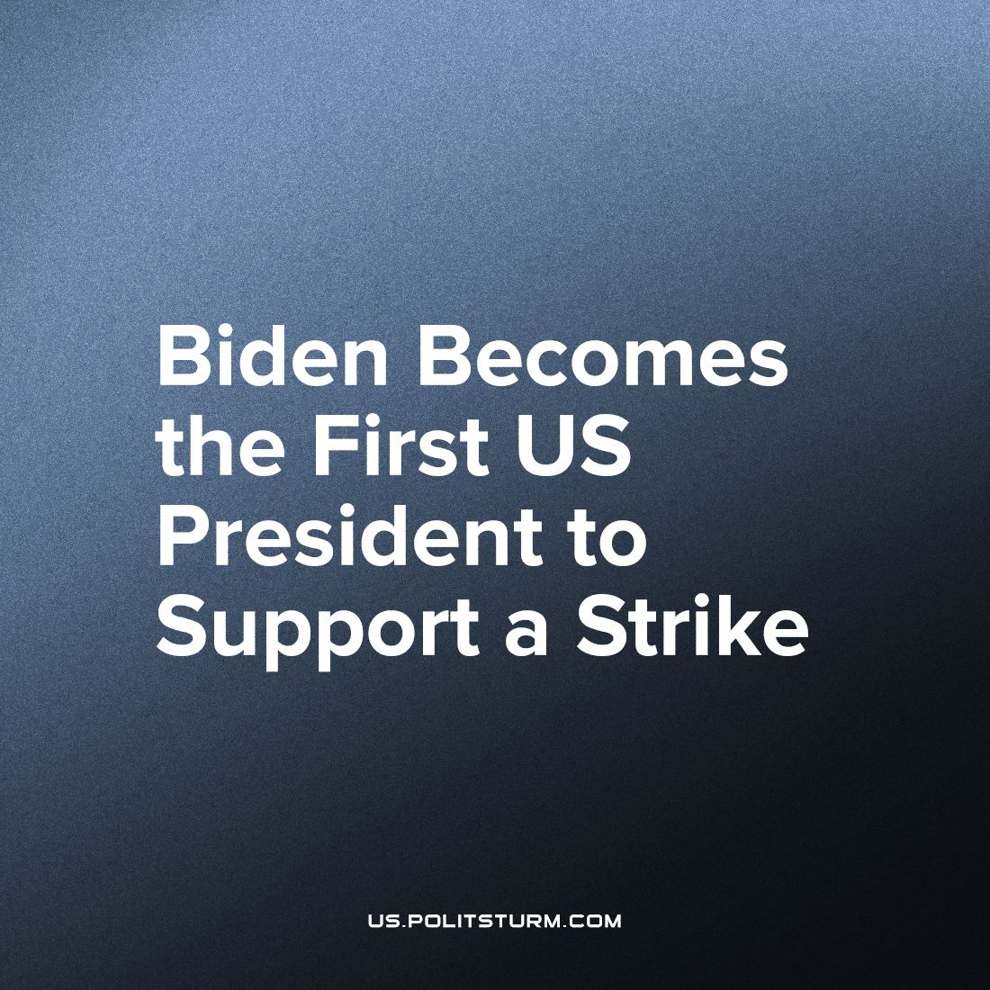

Original article
2023-10-02
3 min read

US President Joe Biden has backed striking car workers in Michigan during a visit to their picket line – the first case for the US president. Joining a strike is historic and unusual in this case, as never has a president joined a strike.
The White House announced Biden's visit to the UAW workers last week, soon after Trump announced he would skip the 27 September Republican presidential debate in California to visit Detroit, the heart of US vehicle manufacturing.
In his “Truth Social” post, Trump vowed that car workers are "toast" if they do not endorse him and if he does not win the election. This furthermore contradicts Trump's agenda, as Trump appointed a court that struck down decades of pro-union laws.
The current and former presidents are trying to appeal to the masses by the increase in popularity of unions, to try to appear in support of them. The actual reason why Biden joined the strike is that unions in America have had a massive jump in popularity. 71% of Americans now support Labor unions – a record number since 1965. An additional 40% of union workers say that union membership is extremely important. This jump in popularity was after the massive strikes that happened around America for the first time in decades, such as the Starbucks strikes of a 3,500 workers, UPS delivery strikes of 340,000 workers, and the most recent Hollywood actor and writer strikes, accumulating more than 170,000 workers.
The workers who participated in the strike were robbed of their labor and had to deal with the harsh exploitation of capitalism. The unions provide a way to alleviate the pressure and allow workers to enjoy more of the value that they created. Although the formations of these unions can only improve a worker's conditions under capitalism, but they cannot end capitalism. The unions would only go as far as to get trade-union consciousness.
The puppets of the capitalists – the US presidents – try to stand next to the workers, who are the people doing the actual work of liberating the working class. This posturing by the president and former president is all a ploy for popularity in the next election, since both candidates are not together with the working class, but also have a history of doing the complete opposite.
The current president, Joe Biden, has repeatedly been against the working class. A few months ago he shut down a rail strike with a bill, that makes it illegal for rail workers to strike.
Trump, on the other hand, had somehow an even more direct anti-union stance when he posted on “Truth Social” that the UAW workers should not be with the union and not pay union fees during this strike. This action does not take into account his history of fighting against unions and workers in his own “Trump-Equitable Fifth Avenue Company”. He did not pay workers until he settled the lawsuit for more than a million dollars.
These are not the most horrendous cases of the US government and its presidents being anti-union and anti-worker. In 1970, for example, the Postal Services had a strike against their starvation wages. In reaction, Nixon ordered the Army to take over the jobs of the workers and to stop the strike.
The most horrendous case of the US government breaking the backs of unions is the Battle of Blair Mountain, in which the US government deployed the US Military in order to stop a strike of 10,000 coal miners. The battle lasted only a short while, as the US government bombed their own citizens and workers, clashing in a bloody battle with over a million bullets fired. Eventually, after 5 days, the outnumbered workers surrendered to the government.
The only way of the liberation of the working class is Socialism. Led by a vanguard party to stop the capitalists and their puppets, the presidents, from suppressing the working class, the people of America will be able to build a bright future without wage slavery.
Sources:
https://www.bbc.com/news/world-us-canada-66926060
https://time.com/6238361/joe-biden-rail-strike-illegal/
https://edition.cnn.com/2023/09/27/business/trump-labor-record/index.html
https://aflcio.org/about/history/labor-history-events/great-postal-strike
https://www.bls.gov/wsp/data/tables/
https://www.nytimes.com/2017/11/27/nyregion/trump-tower-illegal-immigrant-workers-union-settlement.html
https://edition.cnn.com/2023/07/17/business/hollywood-actors-sag-aftra-strike-by-the-numbers/index.html
https://www.kqed.org/news/11929057/amazon-workers-strike-at-third-largest-air-hub-in-us-file-labor-complaint
https://edition.cnn.com/2023/07/14/economy/ups-strike-economic-impact/index.html
https://us.politsturm.com/the-battle-of-blair-mountain-100th-anniversary-of-the-biggest-labor-uprising-in-the-us
https://www.youtube.com/watch?v=uYRsi8CJbJE

Original article

