Biden Signs Executive Order Avoiding Railroad Worker Strike
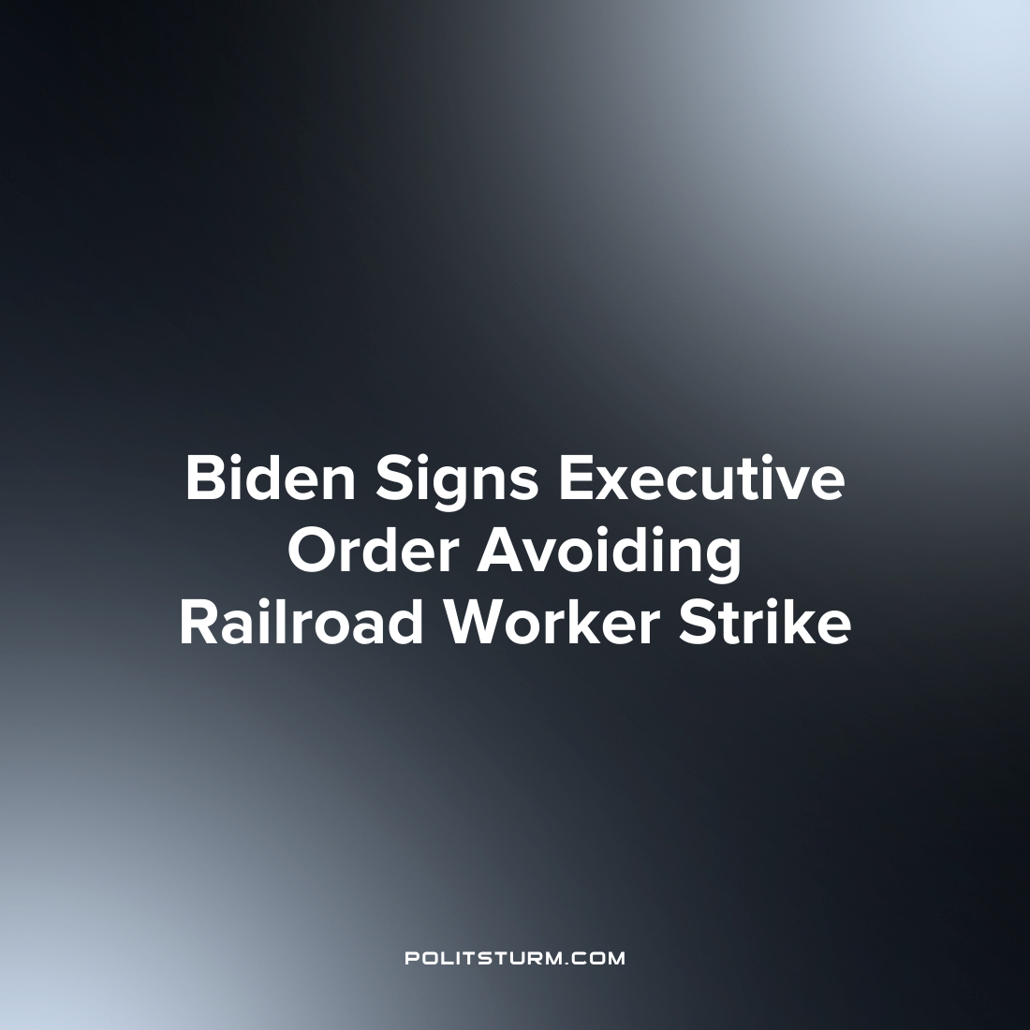

Original article
2022-07-15
2 min read

President Joe Biden signed an executive order that established an Emergency Board to investigate the labor disputes between rail companies and the sector’s labor unions. The order comes as contract negotiations between the two have not yielded any results and the threat of a freight rail work stoppage looms.
The executive order delays the possibility that any work stoppage could occur for 60 days after the order takes effect.
The President and CEO of the National Association of Manufacturers Jay Timmons wrote a letter to the President with respect to the implications of a potential work stoppage.

“With continued supply chain challenges contributing to inflation, any rail network slowdowns—or, even worse, a shutdown—must be avoided. We encourage both sides to resolve their differences directly, but if that does not occur, we respectfully ask that you do all in your power to keep freight rail moving—for manufacturers and for the American people.”
While the representative of the capitalists suggested that a work stoppage would potentially exacerbate the disruptions to the supply chain and inflation, labor union leaders expressed their disagreements with the existing labor conditions.

“The time has come for the nation’s railroads to be held accountable for their actions, and reconcile the long-term effects of their greed. The seven Class I railroads have raked in $146 billion in profits since 2015 while cutting 45,000 jobs in the same period”, said President of the Transportation Trades Department Greg Regan.
The disputes between rail freight workers and companies have been ongoing and to this point negotiations have been fruitless. As such workers have voted to authorize a strike and Biden intervened with the executive order to prevent a work stoppage for at least 60 days. While Biden would hope to mediate the disputes with independent arbitration, the struggle between the workers and capitalists is fundamentally irreconcilable. The capitalists act to maximize their profits which entails the minimization of expenditures which include labor costs. The workers who are seeking to improve their working conditions will constantly come into conflict with the capitalists. Only Marxist-Leninist theory can truly reveal the dynamics of the class struggle and its implications for the working class.
Sources: 1 2 3 4

Original article

