Biden Claims Putin Wants to Restore the USSR
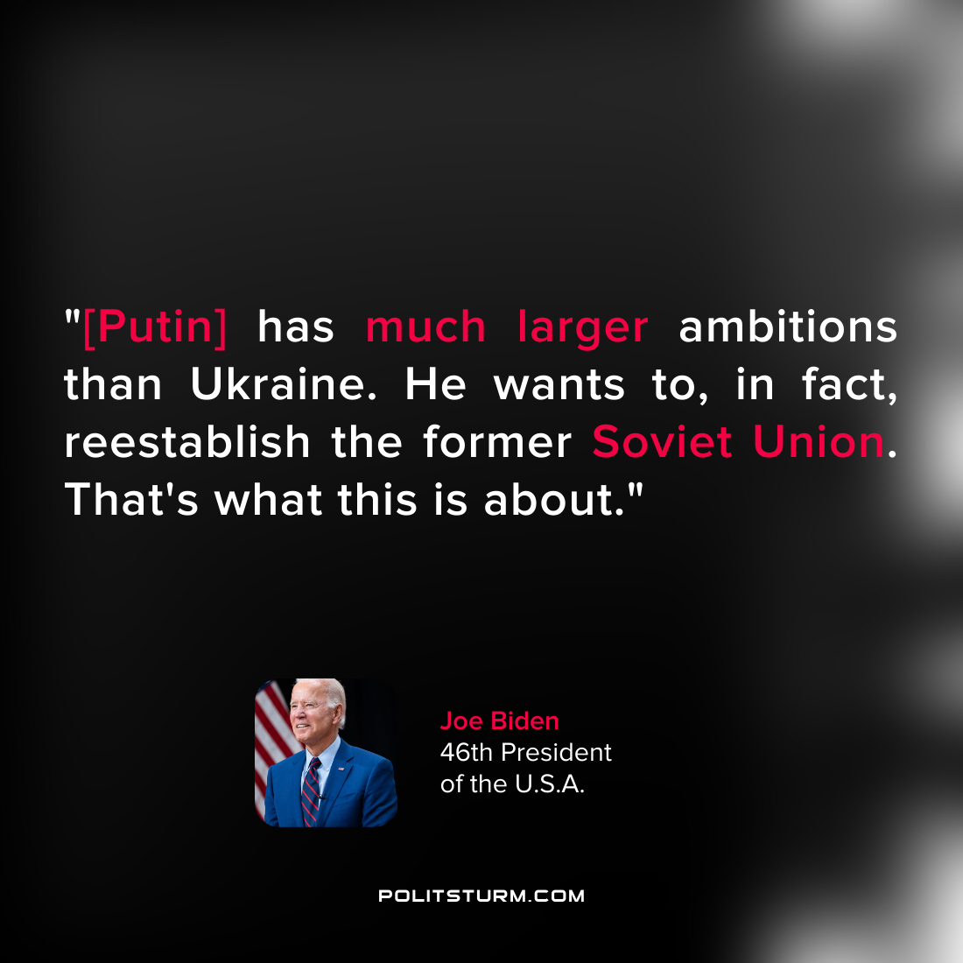

Original article
2022-02-25

Original article

