Biden Administration Limits Semiconductor Exports to China
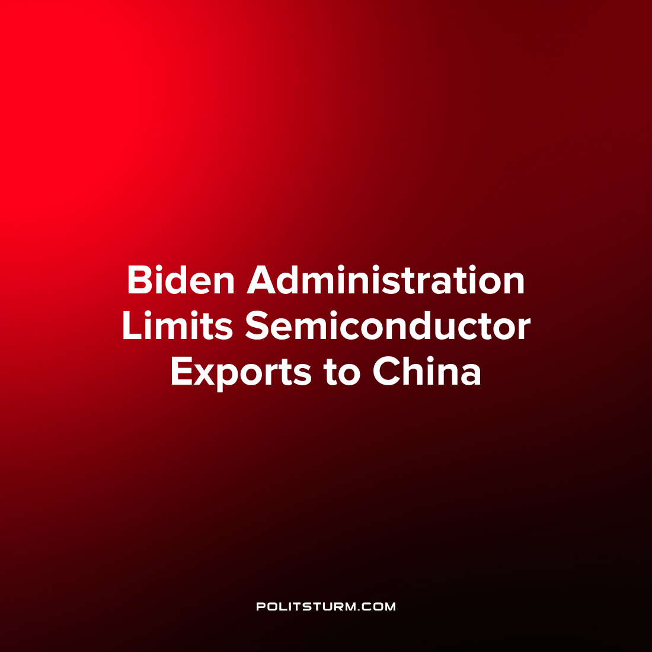

Original article
2022-10-11
1 min read

The U.S Department of Commerce announced sweeping new export controls on integrated circuits and semiconductors. In addition, the Bureau of Industry and Security is expanding the controls on transactions related to the manufacture of supercomputers and semiconductors. The increased scope of the rule would subject 28 entities in China to licensing requirements.
When providing background for the implementation of these new changes, the agency stated that they were considering the impact that integrated circuits, semiconductor manufacturing equipment and supercomputers would have on the modernization of China’s military. As China has stated its intent to become a world leader in Artificial Intelligence by 2030, the agency “seeks to protect U.S. national security and foreign policy interests by restricting the PRC’s access to advanced computing for its military modernization, including nuclear weapons development, facilitation of advanced intelligence collection and analysis, and for surveillance”.
In a previous related statement on the role of U.S. export controls for computer chips, China’s Foreign Ministry Spokesperson Wang Wenbin stated that the U.S. was “stretching the concept of national security and abusing state power” in order to “hobble and suppress the development of emerging markets and developing countries”.
The Biden administration’s imposition of semiconductor exports is another effort to limit the economic and military development of China as a competitor. As domestic manufacturing has left the U.S. in search of higher profit rates and a large supply of exploitable labor in China, over time the manufacturing base and technological development of China has risen to such a degree where it is considered a national security concern. As such, the U.S. aims to protect the national interests of its domestic capitalists against its developing capitalist rival who seeks to do the same.
Source: 1 2

Original article

