Biden: A Year in Review
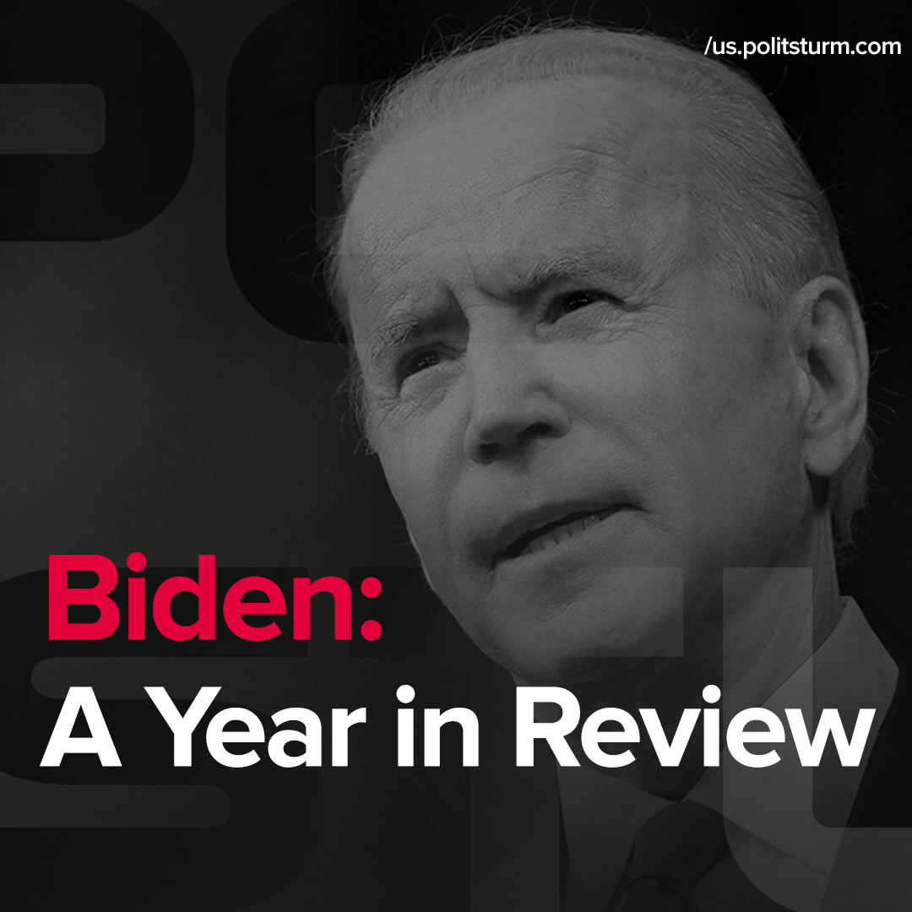

Original article
2022-01-20
1 min read

Error loading image

Error loading image

Error loading image

Error loading image

Original article

