Bezos To Be First Trillionaire by 2026
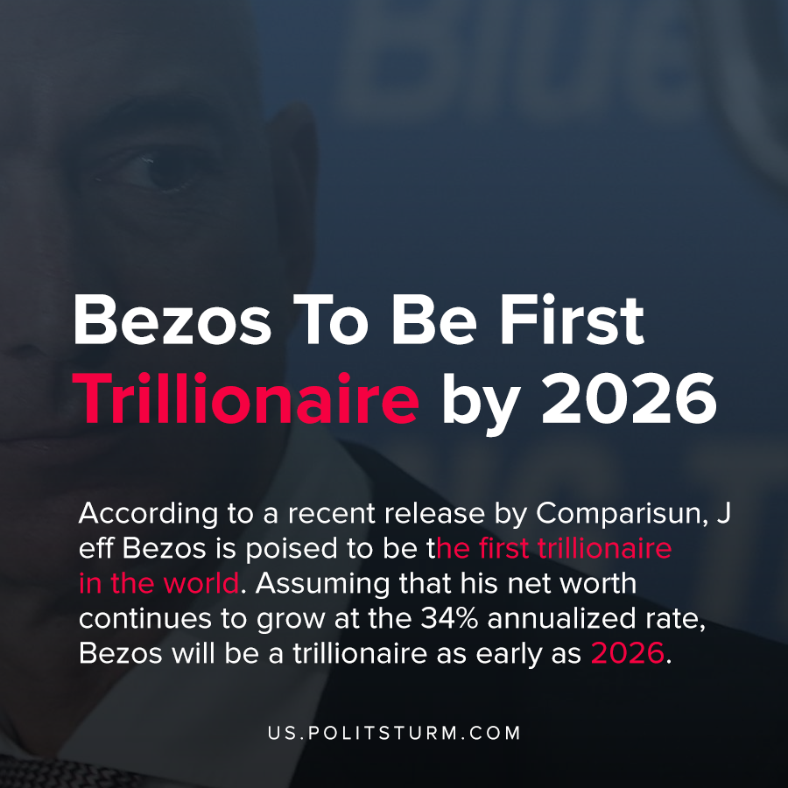

Original article
2020-05-19
1 min read

According to a recent release by Comparisun, Jeff Bezos is poised to be the first trillionaire in the world. Assuming that his net worth continues to grow at the 34% annualized rate, Bezos will be a trillionaire as early as 2026.
The other billionaires that are expected to reach trillionaire status after Bezos include Xu Jiayin, Jack Ma, Ma Huateng, and Mukesh Ambani. Facebook founder Mark Zuckerberg was also mentioned, as he would obtain trillionaire status at age 51 if his wealth keeps growing at the same rate.
The capitalist economic system allows individuals who own the means of production to amass wealth by their exploitation of the world’s workers. Over time, profits are reinvested and the private owners of the means of production amass unfathomable fortunes.
Rather than organize production in a planned and rational manner, production is left to the capitalists and the anarchy of the market. Under such conditions society is constrained to serve the needs of the capitalists who privately accumulate hordes of wealth. A socialist, planned economy would be able to end the parasitic accumulation of the capitalists altogether, to utilize resources for the greater needs of the working class.
https://www.comparisun.com/resources/the-trillion-dollar-club/

Original article

