Beirut Explosion: A Sentence to Capitalism
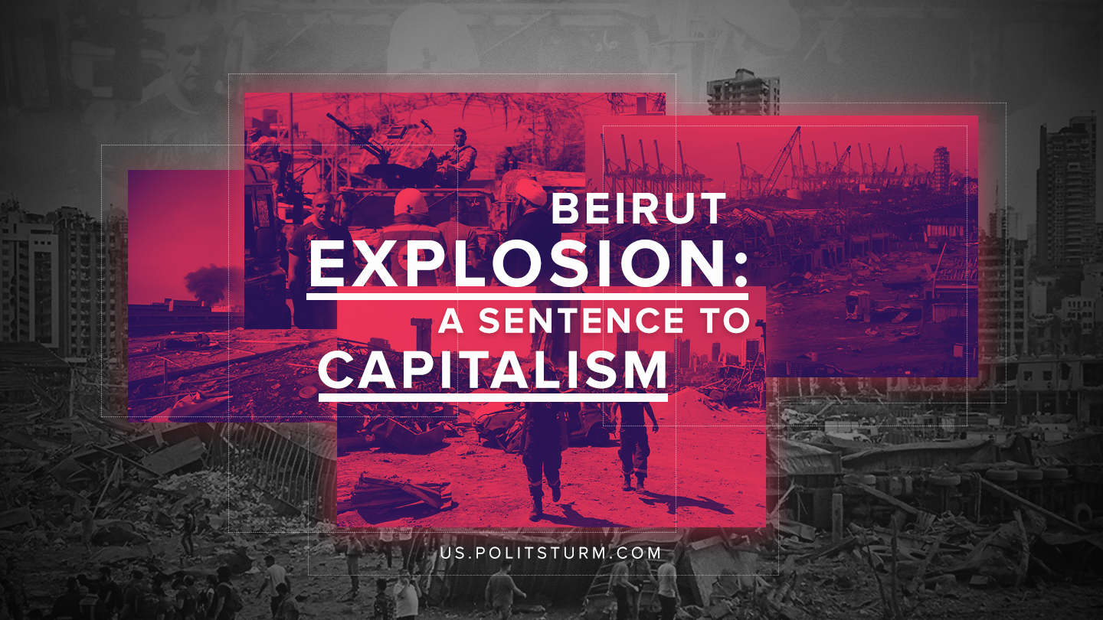

Original article
2020-08-08
4 min read

Lebanon declared three days of mourning for the victims of a huge explosion in the city’s port. According to the latest data, 135 people were killed and over 4,000 injured. More than the half of the buildings in Beirut have been destroyed or damaged. Eyewitnesses compare the incident with an earthquake or an atomic bombing. The city was declared a disaster zone, and a state of emergency was introduced for two weeks.
Hundreds of stunned and blood-splattered people roamed the streets in search of help. But Beirut hospitals, already overcrowded due to the coronavirus pandemic, could not let them in. Overwhelmed with patients, medical workers are forced to sort patients on the street, while the Red Cross works with the government to create morgues. And many people still have to be buried under the rubble that the center of this proud city has become.
Although the official cause of the explosion remains to be determined, senior officials told news agencies that the likely cause was ammonium nitrate stored in warehouse of the port, which blew up after welding operations had set the warehouse on fire.
The chemicals were stored there after it was confiscated from the Moldovan-flagged vessel “Rhosus” in 2014. The vessel belonged to the “Teto Shipping” company, owned and operated by Russian citizen Igor Grechushkin living in Cyprus. He left the ship, which was en route from Georgia to Mozambique via Beirut, after a dispute with the port authorities, leaving his sailors stranded with unpaid wages for almost a year.
The explosion will have devastating economic, social and political consequences. For Lebanon, which is no stranger to war and death, what happened on August 4 is a huge national tragedy. The murderous explosion itself seems to be just the beginning. There were granaries on the territory of the port. The port today simply doesn’t exist; instead, there is a pit filled with sea water and grain which can no longer be consumed. The granaries were also destroyed.
Error loading image
The port of Beirut was the main artery for food imports. There are other ports in Lebanon, but they are small and will not be able to handle the volume of production needed for a country of 6 million.
The blast wave severely damaged the infrastructure of the airport; it stopped working.
On Thursday, August 6, protests against Diab’s government, which came to power after massive protests against poverty, government mismanagement, corruption and political sectarianism last October, started to appear.
Even before the explosion, Lebanon was in a severe economic and financial crisis: there was an actual collapse of the national currency – the Lebanese lira, which had lost most of its value, a rapid rise in inflation and a doubling of food prices, widespread and constantly increasing poverty, aggravated by the coronavirus pandemic.
Last November, far before the pandemic, the World Bank calculated that 45% of Lebanon’s population lived below the poverty line, up from 33% before September and 22% of the population in extreme poverty. World Bank analysts predicted that the country’s impending bankruptcy would lead to further growth of poverty to 50% in 2020.
Damage to the port may cause a shortage of basic necessities such as food, fuel and medical supplies as the country imports most of the basic goods.
The explosion is a formidable indictment of the Lebanese political elite, which for years allowed the storage of huge quantities of explosive ammonium nitrate in a warehouse near the pier without proper security controls.
It is one of a series of recent disasters around the world that could have been fully foreseen and prevented, which collectively represent a searing conviction of capitalism and the world’s ruling elites, including hell at the Grenfell Tower in London in 2017, the collapse of the eight-story Rana Plaza building in Dhaka in 2013, the Deepwater Horizon oil spill in the Gulf of Mexico in 2010, and the current coronavirus pandemic.
It’s time to put an end to this intolerable situation. What is required is not this or that reform, but a radical change.

Original article

