Barclays Banks Targeted by Pro-Palestine Groups
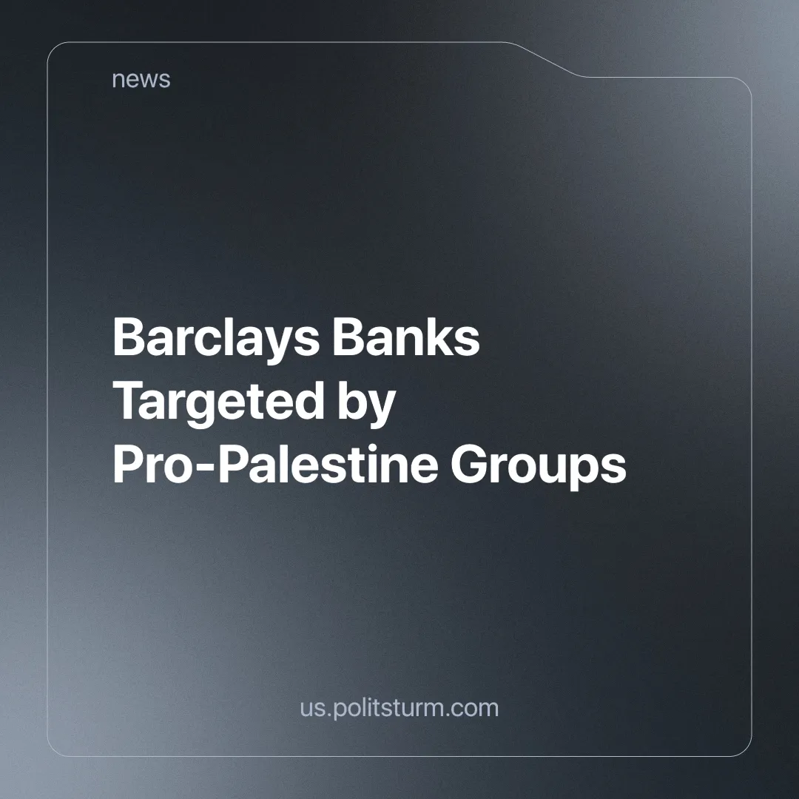

Original article
2024-06-18
2 min read

On the 10th of June, 20 branches of Barclays Bank were targeted, according to a pro-Palestinian group called "Palestine Action", with the help of an underground environmentalist group called "Shut the System". Red paint and smashed windows were a common sight at the targeted banks.
The justification for these attacks is that Barclays' investments facilitate and fund the current genocide in Gaza by investing in companies that produce the weapons used. Its shareholdings amount to over £2 billion and are spread across eight of the nine companies that produce these vital tools of conflict [1]. The bank has also stated that it is committed to investing in sustainable energy and taking the climate crisis seriously, but as is common with corporations, these promises fall short and prove to be nothing more than a PR stunt.
With an estimated 37,084 people killed in Gaza and a ceasefire agreement that both sides still haven't accepted. Actions such as those by "Palestine Action" and "Shut the System" intend to help the cause of Palestine by putting pressure on companies and governments to stop funding and supporting Israel.
However, Israel has already stated that it intends to continue the conflict well into 2024 [2]. As massive profits can be made by Israel and international capital from the reconstruction of the devastated Gaza Strip and with the accelerated immiseration of the population, it will be easier to exploit them for low wages and as a captive market, as they will be completely dependent on Israel and other capitalist countries. In addition, there are hundreds of under-the-table methods for companies to make investments outside of the public eye.
Individual acts of "heroism" that try to fight an immensely powerful and entrenched system show the impatience of a group and their lack of understanding of the real causes of the problems we face. They detach themselves from the working class and try to work without organising the masses, assuming that their individual "heroics" will rally people behind them.
The increasing number of these actions symbolises the growing popular discontent with Britain's complicity in genocide and concern about global warming. But these acts of "heroism" alone cannot by themselves influence the movement, and represent only a small section of workers and small business owners who believe their actions alone are enough to fight the system.
In reality, at best, these actions do nothing meaningful towards really changing the system, and at worst, they alienate the working masses from the movement and only further incite those who don't support it. We have discussed this in more detail in an earlier article.
The UK is currently experiencing a cost of living crisis [3] with several strikes in recent years attempting to fight poverty wages. The number of working days lost to strikes is the highest since 1989 [4]. There is a feeling of apathy around the upcoming national election, as it is believed that no party will actually improve the situation. The Labour Party, currently the opposition to the Conservative Party, will continue to defend British interests in the genocidal war in Gaza.
In this situation, working-class organisation is the only way to fight back against falling living standards and the country's complicity in the destruction of Gaza and its people. Only a truly communist party can do this to the full extent
A communist understands that it is the working masses that are capable of bringing about revolutionary change and that the communist party can succeed in winning over the workers by relentlessly explaining and exposing the failures of the capitalist system, highlighting the workers' real interests and fighting for them. The communist party can achieve this through agitation in all forms of workers' organisations, not through poorly organised individual acts of spectacle.
Sources: 1, 2, 3, 4

Original article

