The Axis of Resistance: Iranian Imperialism in the Middle East
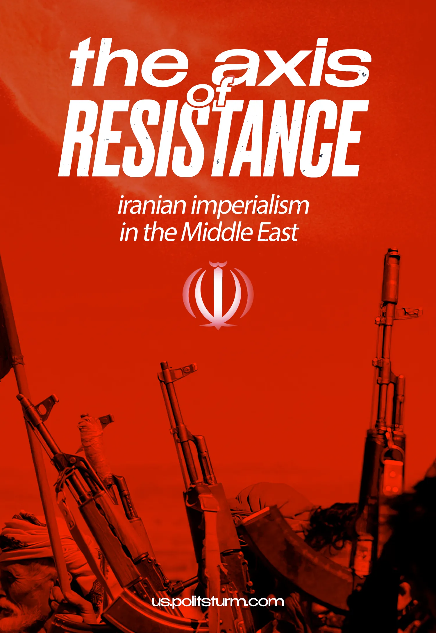

Original article
2024-09-21
16 min read

Many leftists and self-proclaimed communists have a high regard for Middle Eastern movements like Hezbollah, Hamas, and the Houthis.
Their assumption is that these organizations oppose American hegemony, fight against imperialism and have the liberation of the oppressed peoples of the Middle East as their final goal. Is this true? Who is standing behind these movements and in whose interests do they act? We will examine this in this material.

I. The Essence of the 'Axis of Resistance'
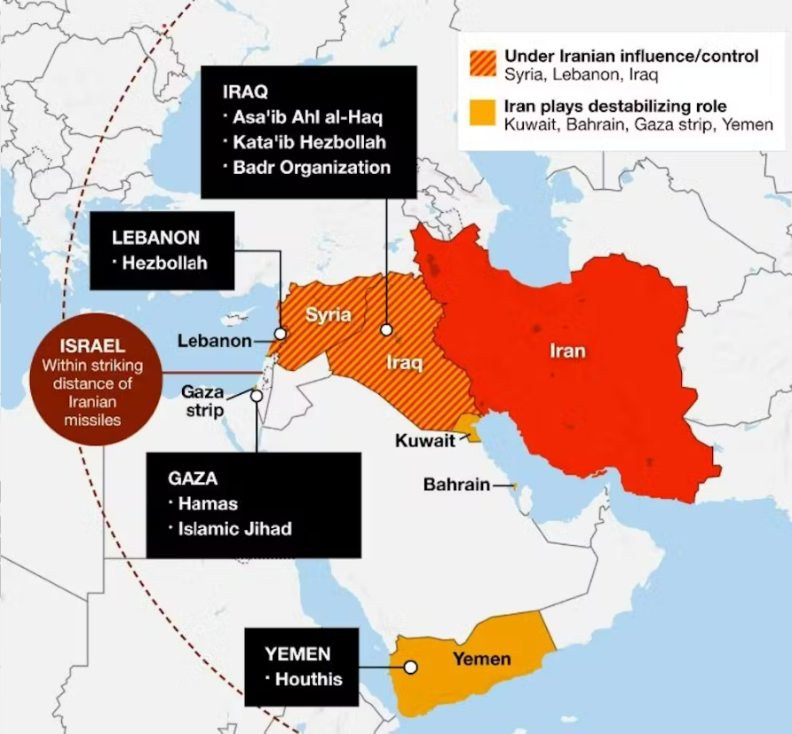
The term describes Iran and its Middle Eastern allies. It originally comes from George W. Bush's speech, where he called Iran, Iraq, and North Korea "The Axis of Evil". This speech was answered by a Libyan newspaper, Al-Zahf Al-Akhdar, which published an article "Axis of Evil or Axis of Resistance". Later, the official newspaper of the Islamic Republic of Iran adopted the term 'Axis of Resistance'.
This structure unites Iran and the movements in various Middle Eastern countries aligned with them, mostly on the basis of the ideology of Shia Islamism. Why is it so?
Historically, the religion of Islam was split between two main schisms: Sunnism and Shiism. They are the most prominent results of the past religious struggles in the Islamic world, with Sunnis composing the majority.
The main initial difference between them lies in the understanding of the institution of supreme power. Shias believe that only descendants of the prophet Muhammad – Ali and his dynasty of 12 imams – can be Caliphs (monarchs) and rule united Islamic communities. Sunnis, on the other hand, believe that Caliphs should be elected by Muslims or their representatives.
Shias in the Islamic world, except in Iran since the 16th century, have been a marginalized minority, oppressed by Sunnis. Many movements, that are now a part of the 'Axis of Resistance', were initially founded by these minorities.
In feudal society, the growth of social contradictions most often expressed itself in the form of religious struggle. For example, the Christian conflict between Catholics and Protestants reflected the struggle of various classes. Lenin reflected on the mass reactionary Catholic organizations in 20th-century Germany:
"The Catholics in Germany have succeeded in playing up the people’s prejudices and ignorance, partly owing to the fact that the Catholics in Germany are a minority of the population, which at one time was subjected to persecution by the state … The Catholic reactionaries have made skillful use of this sentiment." – Vladimir Lenin, "Organisation of the Masses by the German Catholics".
In the Iranian case, after the revolution of 1979, a section of the Iranian clergy, with Ayatollah Ruhollah Musavi Khomeini as their leader, took power in the country. They mobilized the ascending national bourgeoisie and petit-bourgeois strata of Iran and soon forged an anti-American network throughout the region. Using their populist rhetoric about a third way between capitalism and communism and the anti-American struggle, they approached these Islamist movements with support and skillfully used their anti-West 'sentiments' towards their own goals.
Ayatollah Khomeini gave an ideological superstructure to Iranian imperialism by formulating a reactionary thesis based on Shia theology called the "Absolute Guardianship of the Islamic Jurist" or Velayate-Motlaqe-Faqih (Persian: ولایت مطلقه فقیه). This principle states the necessity of a religious Shia Islamic state, where the clergy act as "regents", waiting for the last descendant of Muhammad, and exports "the Islamic revolution" by supporting Shia movements in the neighboring countries.
Supported by Iranian money and arms, Shiite militias throughout the region have submitted to the "Supreme Ayatollah" Khomeini, who promoted the interests of the Iranian monopolies through his absolute spiritual and political authority.
However, Tehran doesn't work exclusively with Shia groups. They have no problem aligning themselves with China, a secular and self-proclaimed "communist" state, or funding Hamas, a former branch of the Sunni Muslim Brotherhood.
The religious rhetoric is merely a mask for their real motivation – imperialist expansion in the region. Tehran needs cadres in the region to weaken American imperialism (and its outpost in Israel in particular) through terrorist, missile and cyber-attacks, and then to expand its own control over the resources and labor.
The essence of the 'Axis of Resistance' is to militarily support Iranian imperialism and provide Iranian reactionaries with allied armed forces in the region.

II. Allies of Iran and Their Funding

2.1 Hezbollah
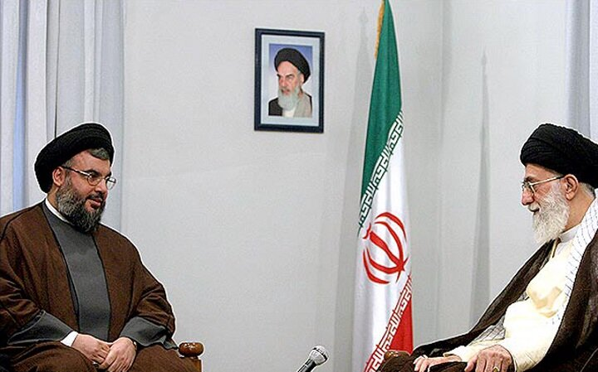
The jewel in the crown of Iran's militia network is Hezbollah – a Shia movement in Lebanon. It was inspired and organized by Iran in 1982 after Israel invaded Lebanon during the 1975-90 civil war.
The connections between Iran and the local Shia agitation that eventually led to the birth of Hezbollah, interestingly enough, predate the Ayatollah regime.
In 1957, the Lebanese Shia population asked Iran's leading Shia authority (Grand Ayatollah Borujerdi) to send a capable cleric to lead them.
The secret police of the Iranian Shah, SAVAK, sent a cleric to them. He was guaranteed a salary and budget for his cooperation in politically organizing the Lebanese Shias [1].
After the Islamic Revolution, this relationship was consolidated. It is officially acknowledged by Hezbollah that they are funded by Iran. "Yes, we received moral, and political and material support in all possible forms from the Islamic Republic of Iran since 1982", said Hezbollah leader Sayyed Hassan Nasrallah [2].
The exact amount of funds, however, is unclear, since much of it comes in the form of material goods, such as weapons. According to Western analysts in Lebanon, Hezbollah is estimated to receive around $200 million per year [3].
Iranian cargo planes deliver sophisticated weaponry, from rockets to small arms, to Hezbollah in regular flights to Damascus from Tehran. These weapons are offloaded in Syria and trucked to Hezbollah camps in the Beka'a Valley [3].
Furthermore, Iran finances and establishes training camps in the Syrian-controlled Beka'a Valley to train Hezbollah and Hamas fighters to use rockets [4].
On special occasions, they receive additional resources from Iran. For example, after the death of Palestinian leader Yasser Arafat, Hezbollah reportedly received an additional $22 million from Iranian intelligence to support Palestinian groups [5]. Therefore, one could speculate that they are now being further subsidized because of their skirmishes on the Israeli-Lebanese border.
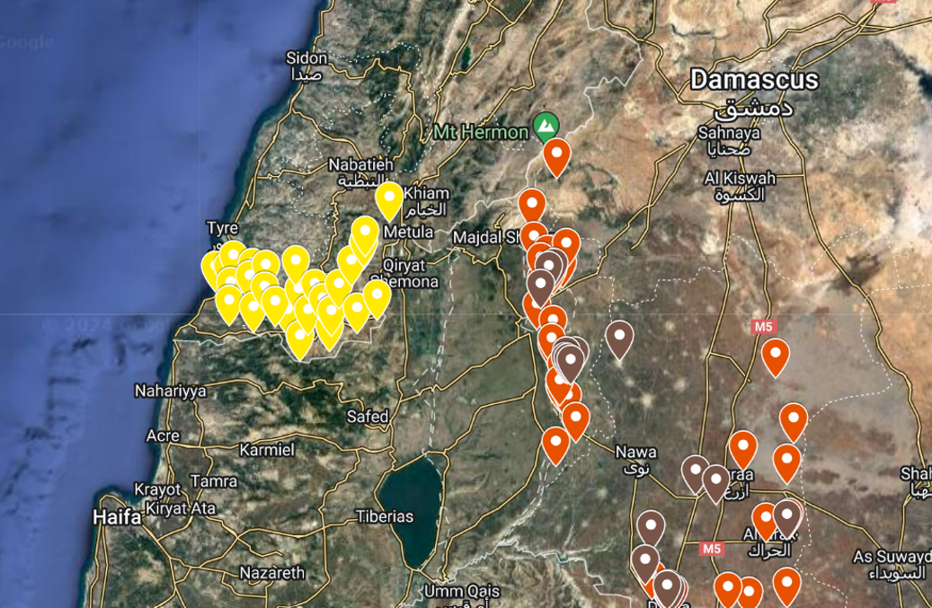
Map of Hezbollah (in yellow) and Syrian (in red) military/logistics Infrastructure bordering Israel, the aforementioned Beka'a Valley is located between Syria and Lebanon [6].
Map of Hezbollah (in yellow) and Syrian (in red) military/logistics Infrastructure bordering Israel, the aforementioned Bekaa Valley is located between Syria and Lebanon [6].
As global sanctions have tightened against Hezbollah's Iranian patrons, they in turn have begun to look for other sources of revenue. Perhaps characteristic of bourgeois gangsterism, Hezbollah is notorious for its drug trafficking activities worldwide [7] [8].

2.2 The Houthis (Ansar Allah)
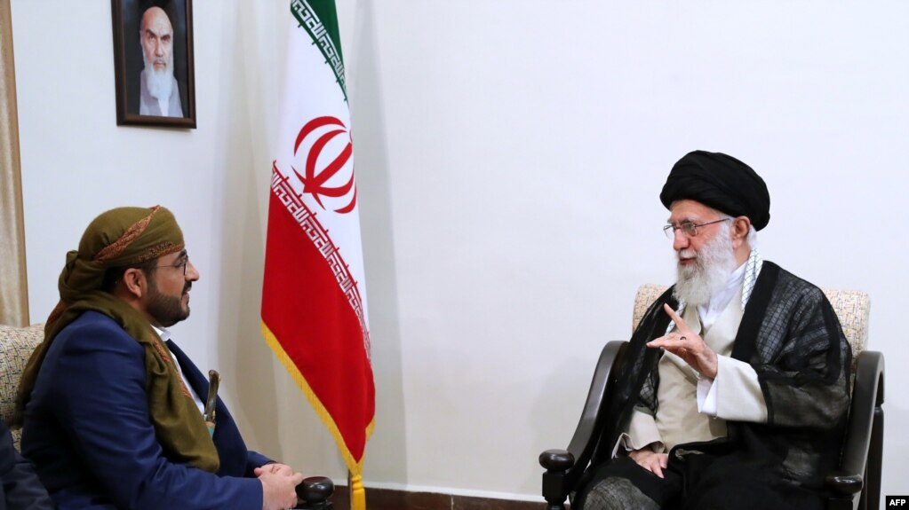
The Houthi movement, officially known as the Ansar Allah ('Supporters of Allah'), is an organization in Yemen, with its name being taken from the Houthi tribe from which the majority of its members are drawn. The movement became famous after the civil war broke out in the country in the mid-2010s with the foreign military intervention led by Saudi Arabia.
After the "Al-Aqsa Flood" operation of Hamas and following Israel's aggression in Gaza the Houthis started bombing Israeli territory with missiles and drones and attacking cargo ships in the Red Sea. In March 2024, the Yemeni Houthis announced that they would not bombard Chinese and Russian merchant ships.
Due to sanctions on its main benefactor, the Houthi movement is funded through a huge series of exchange firms in Yemen, Turkey, St Kitts and Nevis, Dubai and Lebanon.
Recently, parts of this network were discovered by the U.S. Treasury Department and immediately sanctioned. A Turkey-based company, Al Aman, served as the waypoint. The Islamic Revolutionary Guard Corps (IRGC) deposited millions of dollars with Al Aman for shipment to Yemen, where the funds were transferred to Nabco Money Exchange Remittance Co [9].
Another source of revenue for the Houthis was their appropriation of U.N. humanitarian aid for the starving Yemeni population [10].
Similar to Hezbollah, the Houthis receive arms shipments and training in addition to funds. For example, the U.S. intercepted a shipment of drone parts, missile warheads, and anti-tank missile units [11].
Also, IRGC and Hezbollah representatives advise the Houthis' military command, the Jihad Council, although the extent of their influence on Houthi decision-making is unclear [12].

2.3 Hamas and PIJ
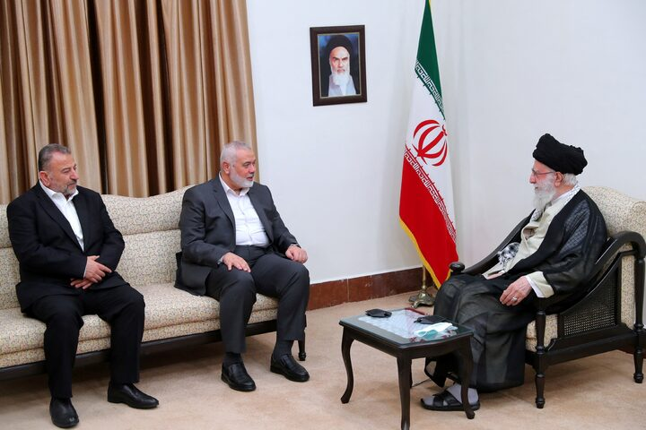
According to foreign estimates, Iran provides from $100 million to $350 million annually to Palestinian groups, including Hamas [13] [14].
Hamas, as an offshoot of the Muslim Brotherhood, initially had little connection to Iran because of Sunni-Shia sectarian differences; instead, Islamic Jihad (PIJ), the smallest Palestinian group, was the closest to Iran.
After the PLO called for peace with Israel, relations between Iran and Hamas developed. A Hamas delegation met with Ayatollah Khamenei in Tehran in the early 1990s. Iran promised military and financial aid – an estimated $30 million a year – and advanced military training for thousands of Hamas operatives at Revolutionary Guards bases in Iran and Lebanon [15].
Hamas PM, Haniyeh who was recently assassinated, visited Iran after Hamas's victory in the 2006 Palestinian elections, Iran again reportedly pledged $250 million in aid. Furthermore, the Islamic Republic allegedly supplied much of the military equipment that Hamas used against Israel in the December 2008 Gaza war [15].
With the outbreak of the 2011 Syrian civil war, Hamas sided with the anti-Assad Sunni rebels. They were consequently expelled from their political bureau in Damascus and relocated to Qatar.
Afterwards, Iran's relationship with Hamas became more volatile but not cut off. The Islamic Republic was not Hamas's only benefactor anymore, as Türkiye and Qatar became two staunch allies of Hamas. Turkish and Qatari aid to Hamas is estimated to be in the hundreds of millions of dollars [16].
In 2012, for example, the former emir of Qatar pledged to raise $400 million for the reconstruction of Gaza [17]. Also in 2018, Hamas operatives were arrested by Israel who were in direct contact with Turkish authorities and transported large sums of money – hundreds of thousands of euros – from Türkiye to the West Bank on behalf of Hamas [18].
In this way, Hamas created a mini-army with the help of regional capitalists and planned the attacks of October 7 well in advance.
We explain more about the role of Hamas as an instrument of Iranian imperialism, its role in provoking Gaza bombings and profits made by both Hamas and Iran from the deaths of Gazans, in our material on Palestine.

2.4 Syria
Tehran and the Syrian Arab "Socialist" Ba'ath Party became increasingly important to each other as the Cold War ended and the United States became the world's dominant imperialist power.
There was cooperation in the development of ballistic missiles. They worked together to arm and support Hezbollah and Hamas in order to put pressure on Israel, as well as to influence events in the Palestinian Authority. Their assistance was instrumental in enabling Hezbollah to carry out a guerrilla campaign against Israel throughout the 1990s.
After the Syrian civil war erupted in 2011, Iran stepped up its support for the Syrian regime. Tehran hoped to protect Iran's interests in Syria by sending military advisors, equipment, and billions of dollars in aid. Tehran also created the National Defense Forces – a group of nearly 80,000 Alawites (a Shia sect), and regime loyalists who support the Syrian army in battle to bolster the regime's strength.
The Iranian capital has a firm foothold in Syria. A notable example is SIAMCO (Syrian-Iranian Auto-Mobile Company) which was considered the export base of the Iranian auto industry to the Middle East [19]. Furthermore, there has been the establishment of a joint bank, the development of mechanisms to deal in local currencies, and the signing of an agreement to rehabilitate damaged factories in Syria by Iranian companies.
In addition, the establishment of two insurance companies, and the development of the free trade agreement signed in 2011 to boost bilateral trade, especially by ensuring the needs of production processes and investment projects all signify the capital export of Iran to Syria [20].

2.5 Iraqi Shiah Militias
Kataib Hezbollah, Harakat Hezbollah al Nujaba (HHN) and other Iraqi militias also have their roots in the opposition activities of the marginalized Shia minority.
After the revolution in Iran, they fled Iraq and joined the IRGC, forming the Badr Corps in 1982 – an organization created by Iranian intelligence services and Shia clerics to fight Saddam's Ba'athist regime during the Iran-Iraq War [21].
Their leaders have publicly acknowledged Iran’s support. “We do not hide the fact that the technical and logistical support comes from the Islamic Republic at all levels of training, arming and with the provision of advice through the presence of leaders and field advisers from the brothers in the Qods Force of the Revolutionary Guards,” Akram al Kaabi, the HHN leader in 2015 [22].
According to the estimate by Iraqi intelligence in 2014, Asaib Ahl al Haq (AAH), one of the many Iranian-funded militias, was receiving up to $2 million a month [22].

Conclusion
As we can see, the 'Axis of Resistance' is only a mask for an axis of obedience to Tehran. In this context, the economic ties between these movements and Iranian capitalism should not go unnoticed. While 3 million child laborers roam Iran's cities, Tehran generously funds these groups.
As they cut fuel subsidies (tripling prices overnight) [23], fanning the flames of anger among the impoverished Iranian masses, caravans of gas tankers are dispatched to Lebanon to legitimize Hezbollah [24].
However, this is not out of the goodness of the Ayatollah's heart; in fact, the Iranian regime is funding these groups not only to fend off the much stronger American capital (and its outpost, Israel) but also to firmly establish a sphere of influence in the region for the export of Iranian capital and the extraction of surplus value from West Asian peoples.
The militia movements in the Middle East are not fighting imperialism. They are an instrument for the capitalist redivision of the world between imperialist blocs. Iran is standing behind the 'Axis of Resistance' movements. In turn, behind Iran, we see Chinese capital, whose primary interests lie in weakening the bloc of the capitalists of the US and EU.
Iran and its allies in Middle Eastern countries are not friends of communists in the alleged "anti-imperialist struggle". They are reactionaries, and, therefore, a major enemy of the workers in their struggle to abolish wage slavery.
The communists in the region and abroad should not subordinate class struggle to inter-capitalist competition.
Only an international network of communist parties could liberate the people of Gaza or Lebanon, not Ayatollahs or drug traffickers. Our task is to work towards the formation of them – join us.

Sources:
[1] Interviews with SAVAK director Parviz Sabeti, not translated to English - (در دامگه حادثه -پرویز ثابتی -ص۱۱۷.)
[2] Reuters — https://www.reuters.com/article/world/hezbollah-says-gets-support-not-orders-from-iran-idUSTRE81629I/ — February 8, 2012.
[3] Washington Institute — https://www.washingtoninstitute.org/policy-analysis/hezbollah-finances-funding-party-god — Feb 13, 2005.
[4] Center for Strategic and International Studies — https://www.csis.org/analysis/case-studies-iranian-expansion-across-middle-east-el-boqaa-training-facility-lebanon — May 15, 2019.
[5] al-Watan (Kuwait) — "Iran Expands its Palestinian Control; Offers al-Khadoumi Five Million Dollars" — December 13, 2004.
[6] Alma Research and Education Center — https://israel-alma.org/2024/01/18/the-mapping-of-hezbollahs-military-areas-in-south-lebanon-2/ — January 18, 2024.
[7] Matthew Levitt Hizbullah Narco-Terorrism — 2012.
[8] Washington Post — Cigarette Smuggling Linked to Terrorism — June 8, 2004.
[9] Department of the Treasury — https://home.treasury.gov/news/press-releases/jy2014 — December 28, 2023.
[10] Associated Press — https://apnews.com/general-news-7f96cc808d3f45be920ee706c7bde300 — June 18, 2019.
[11] U.S. CENTCOM — https://www.centcom.mil/MEDIA/PRESS-RELEASES/Press-Release-View/Article/3677794/centcom-intercepts-iranian-weapons-shipment-intended-for-houthis/ — Feb. 15, 2024.
[12] Michael Knights et al. The Houthi Jihad Council. URL: https://ctc.westpoint.edu/wp-content/uploads/2022/10/CTC-SENTINEL-102022.pdf — 2022
[13] The Washington Post — https://www.washingtonpost.com/national-security/2023/10/09/iran-support-hamas-training-weapons-israel/ — October 9, 2023.
[14] Reuters — https://www.reuters.com/world/middle-east/how-hamas-secretly-built-mini-army-fight-israel-2023-10-13/ — October 16, 2023.
[15] Rachel Brandenburg. Iran and the Palestinians. URL: https://iranprimer.usip.org/resource/iran-and-palestinians — 2010.
[16] TIME — https://time.com/3033681/hamas-gaza-palestine-israel-egypt/ — July 25, 2014.
[17] The Guardian — https://www.theguardian.com/world/2012/oct/23/qatari-emir-welcome-gaza-visit — October 23, 2012.
[18] The Times of Israel — https://www.timesofisrael.com/arab-israeli-man-turkish-citizen-arrested-for-helping-to-fund-hamas/ — February 12, 2018.
[19] Iran Khodro Press — https://www.ikcopress.ir/en/news/4246 — September 19, 2007.
[20] Emirates Policy Center — https://epc.ae/en/details/featured/acquisition-through-pressure-expansion-of-iran-s-economic-influence-in-syria — February 1, 2024.
[21] The Guardian — https://www.theguardian.com/world/2014/mar/12/iraq-battle-dead-valley-peace-syria — March 12, 2014.
[22] Christian Science Monitor — https://www.csmonitor.com/World/Middle-East/2017/1217/How-Iran-the-Mideast-s-new-superpower-is-expanding-its-footprint-across-the-region-and-what-it-means — December 17, 2017.
[23] The New York Times — https://www.nytimes.com/2019/11/15/world/middleeast/iran-gasoline-prices-rations.html — December 3, 2019.
[24] Aljazeera — https://www.aljazeera.com/news/2021/9/16/first-shipment-hezbollah-iranian-fuel-arrives-lebanon — September 16, 2021.

Original article

