Austrian Economy Minister Warns of Risk of Deindustrialization of Europe Due to the Energy Crisis
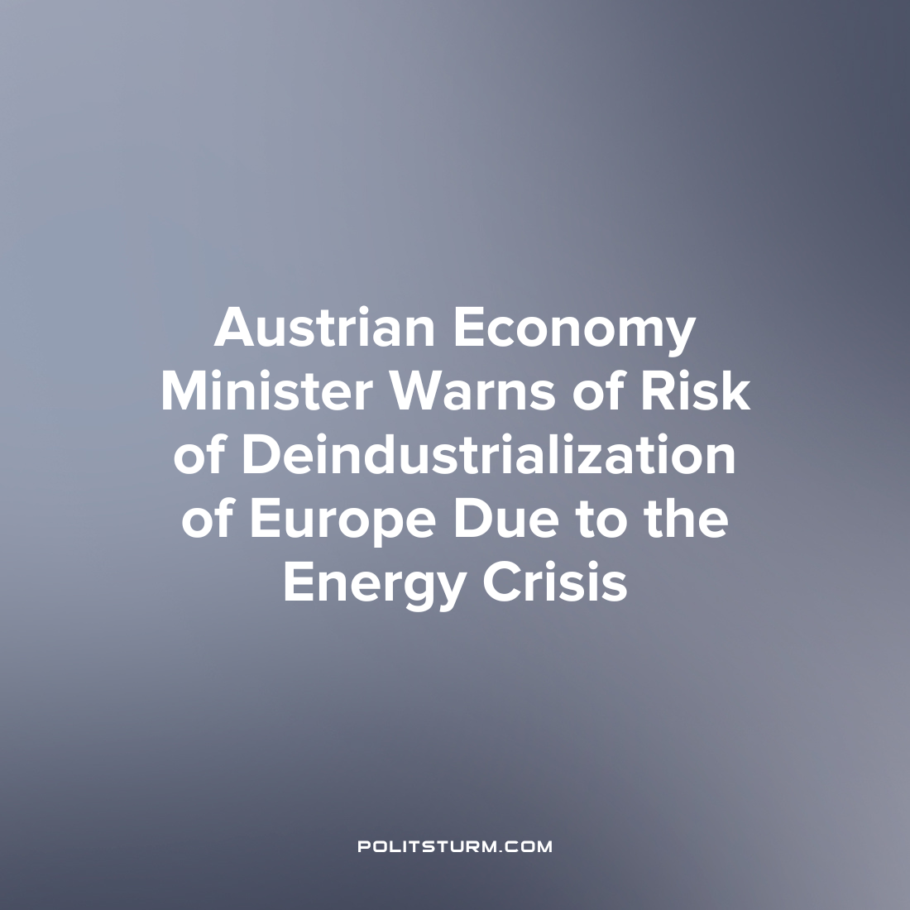

Original article
2023-01-09
1 min read

The energy crisis could lead to the deindustrialization of Europe, with all the ensuing consequences for the labor market and economic independence of the continent. This was stated by the Minister of Economics and Labor of Austria, Martin Kocher.
“In the case of energy-intensive companies, there is a risk of de-industrialization in Europe. If this gap in prices continues for a long time, then we will lose production,” Kocher warned.
The Minister explained that rising electricity prices may push entrepreneurs to transfer production to other parts of the world. This in turn will lead to a significant reduction in jobs in European countries. In parallel with this, there is a risk of increasing the strategic dependence of Europe on other countries, primarily on the United States.
To prevent such a situation, the Austrian Minister of Economics stressed the need to lower electricity prices, in particular through subsidies for the gas used to generate electricity. He also called for the development of alternative, renewable energy sources.
The current situation in Europe shows the inability of the bourgeois states to cope with the current energy crisis. Instead of developing industrial potential, Europe faces the threat of deindustrialization and a growing gap in living standards between socioeconomic classes.
The situation in Europe also shows that capitalism has long ceased to play a progressive role in historical development and is now a reactionary system that prevents the development of industry and the achievement of the well-being of society. Only the transition to the socialist system can free the working class from the oppression of the capitalists and unleash the industrial potential for long-term socio-economic development.
Source:
Handelsblatt – “Die Strompreise müssen sinken” Date: October 26 Gazeta.ru –“Austrian Minister of Economy admitted the risk of deindustrialization of Europe due to energy prices” Date: December 27

Original article

