Attacks on Neutral States Are Becoming Increasingly Normal
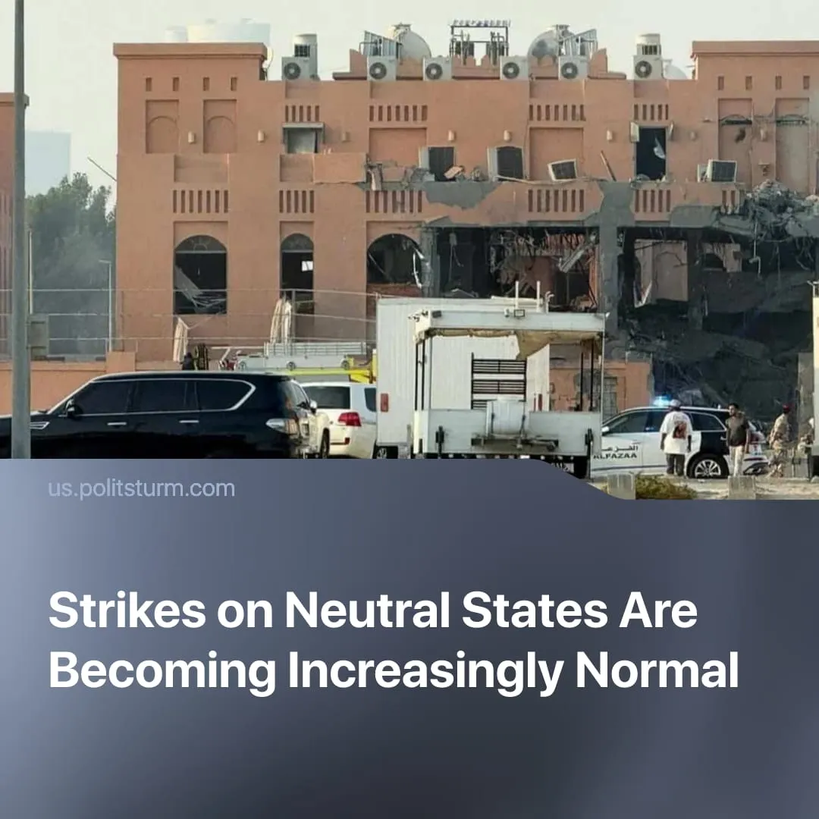

Original article
2025-09-24
1 min read

Israel bombed the territory of a US-allied state. In the past year alone, at least seven neutral or allied countries have been struck under the pretext of “harbouring enemies.”
Details. On September 9th, Israel launched a long-range airstrike on Qatar’s capital, Doha, aiming to eliminate top Hamas political leaders exiled there. Although Israeli missiles hit the Hamas office, killing six, the targeted senior officials survived the attack.
► The Qatari government denounced the Israeli “criminal assault” on its sovereignty, and convened an emergency summit of Arab and Islamic countries to formulate a response. The gathered governments only issued a rhetorical condemnation of the “cowardly and unlawful attack” and claimed to “stand firmly with Qatar”.
► The UN Security Council, notably with US support, also vaguely “expressed their condemnation of the recent strikes in Doha” and “underscored the importance of de-escalation” – but did not name Israel as the perpetrator. Although the USA criticised the attack as unhelpful, it staunchly reiterated its commitment to backing Israel.
► Neither the UN nor the Arab League proposed any material actions to stop Israel’s escalatory attacks in the region.
Context. Qatar, despite being a close American ally and host of the US military’s Middle East headquarters, was openly attacked by Israel without consequence. The normalisation of such attacks occurs as global conflicts have reached their highest frequency since WW2.
► Neutral or allied states are now frequently targeted under the pretext of “harbouring enemies,” a trend that has accelerated in the past few years. India’s Operation Sindoor attack this year was justified by alleged Pakistani support for insurgents in Kashmir.
► Similarly, since 2024, Iran has launched missile strikes against four neutral countries – Iraq, Syria, Pakistan and Qatar – claiming to target foreign entities, terrorists and spies within those countries’ borders.
► Despite the surrender of the PKK, Türkyie continued airstrikes and ground offensives in Iraq and Syria, which it frames as counter-terrorist operations against Kurdish militants.
► The USA recently deployed military forces in the Caribbean, bombing three Venezuelan boats alleged to be drug smugglers. Trump is reportedly considering airstrikes on Venezuela proper, under the pretext that Maduro’s government is harbouring “narco-terrorists.”

Original article

