AT&amp;T Workers Authorize Strike
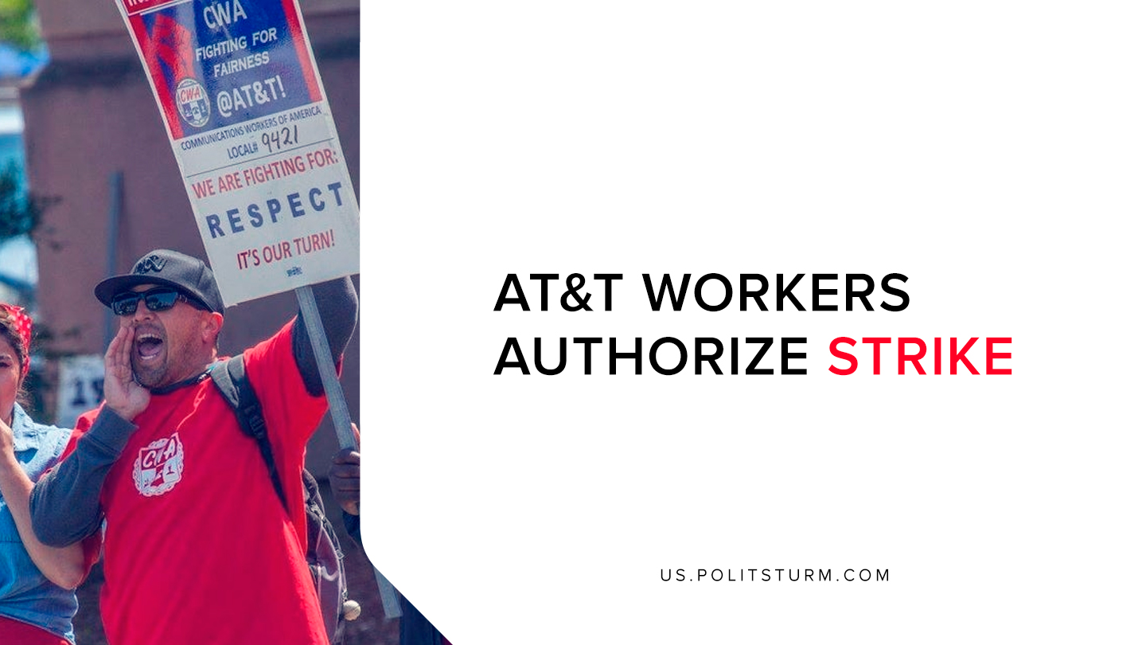

Original article
2019-07-26
1 min read

Members of the Communication Workers of America (CWA) voted to authorize a strike that is set to begin on August 4th, 2019. Workers and the union have been in ongoing contract negotiations with AT&T since June 24th, 2019.
The union has stated that AT&T has fallen short of its promises to create 7,000 new jobs since the Trump Tax Cuts have gone into effect as of January 1st, 2018. Instead, the company has eliminated 23,000 jobs since the tax cuts have gone into effect.
The current contract between the union and AT&T covers more than 22,000 workers in Alabama, Florida, Georgia, Kentucky, Louisiana, Mississippi, North Carolina, South Carolina, and Tennessee.
Mark Royse, AT&T’s vice president for labor relations, stated “As one of the largest employers in America, we’re proud of the number of quality middle class careers we’ve provided to our employees, with wages and benefits that are among the best in the country. We have a longstanding cooperative relationship with our unions, and we’re committed to working together to bargain fair contracts that will allow us to continue to provide those careers.”
Whereas the corporate spokesman for AT&T feels “proud” of the wages and benefits provided to the workers, the workers of the union beg to differ. The union has pointed out that AT&T has promised to create jobs for workers, and yet they have done quite the opposite.
While corporate executives and shareholders have benefited from the Trump tax cuts, AT&T workers have lost thousands of jobs. Workers are struggling valiantly to protect their livelihoods and obtain concessions from the capitalist class. However, the trade union struggle in-itself is insufficient to overcome the contradictions of capitalism. Only the establishment of the dictatorship of the proletariat, lead by the vanguard party of the working class, will be able to ultimately end capitalist exploitation.
Sources:
1, 2

Original article

