Atomic Heart: Alternative USSR, Real Propaganda
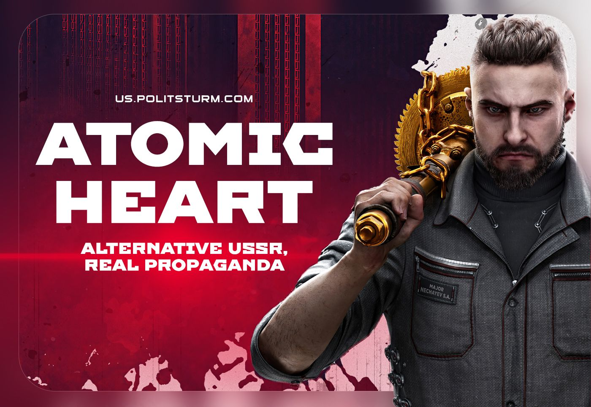

Original article
2023-03-12
26 min read

On February 21st, “Atomic Heart” was released – a video game by Mundfish, which takes place in the alternative USSR.
Throughout the more than five-year development period, the game caused a lot of excitement. Atomic Heart was positioned as the first AAA-project from a Russian studio in recent years. Discussion about the game constantly emphasized the use of elements of Soviet culture known to the people of the former USSR.
Atomic Heart tried to make an impression of a game that was supposed to present an image of the Soviet Union, different from the ideas prevailing in the gaming industry. Upon its release, the game received generally positive reviews, in which it was praised not least for its aesthetics, style, atmosphere and music.
What image of the Soviet Union and its citizens is presented in the game, and is it positive? Can the setting of the game be considered unique? Why did the game come out the way it did? We will discuss these and other issues in our article.

The Situation in the Gaming Industry
Before talking about the game itself, it's worth touching on the state of the gaming industry, which is directly related to the development of Atomic Heart.
In a capitalist society, almost everything is done for profit, and game development is a perfect confirmation of this statement. Game development requires the hired labor of game designers, artists, animators, programmers and other specialties, appropriate software and fine-tuned management within the team, which are impossible without significant funds.
Gaming industry is a place of big money. In the United States alone, in 2022, the video game market was estimated at $97.67 billion, which exceeds the amount of funds in the film industry by more than 3 times. The volume of the Russian video game market before February 24, 2022 was estimated at 177.4 billion rubles with a forecast of growth to 186.5 billion by 2025.
Error loading image
The directors of gaming companies are eagerly looking for investors willing to finance the development of their projects, and the latter, in turn, expect to receive this money back with profits. The gaming industry brings huge profits. In 2014, Microsoft acquired Mojang Studio – the creators of the legendary Minecraft game – for $2.5 billion, which was more than 20 times the annual income of the Swedish studio. Since then, according to rough estimates, the franchise has brought Microsoft more than $2.7 billion.
Error loading image
The desire for constant stable profit is clearly seen in the example of large franchises. Such well-known series of games as Call of Duty and Battlefield shooters, or FIFA and NBA sports simulators, are released every 2 or 3 years. The budgets for each game reach hundreds of millions of dollars, but at the same time conceptually these games practically do not differ from their predecessors, which initiated the series, and use the same set of key mechanics.
Since we are talking about multimillion–dollar revenues, any innovation or change in one of the parts of "success" casts doubt on the game as a whole: the audience may dislike the innovations, the ratings will be lower, and the number of copies sold will be less. Therefore, the constant "return to the roots" is not surprising: the development of remasters and remakes of the most popular games allows companies to re-profit from a successful concept.
Error loading image
Gradually, the growing conservatism of large franchises led to the formation of a spontaneous request among the gaming audience for a game project that would be made at a high level, but at the same time would offer a gaming experience, different from the standard setting of World War II or modern conflicts.
Atomic Heart was positioned as a project designed to fill this niche.

Soviet Era as a Game Element
‌The setting was supposed to be the cornerstone of the future success of the game: the Soviet era is another poorly developed niche of the gaming industry.
Since the games are made in a capitalist society, made by people brought up with a bourgeois ideology, and made mainly for profit, they also reproduce the cultural attitudes of the capitalist era, including anti-communism and anti-Soviet propaganda. This can be seen in the way the Soviet Union and the countries of socialism are traditionally portrayed.
The traditional portrayal of the Soviet Union and the countries of socialism in bourgeois society is filled with "cranberry" (klyukva in Russian) – anti-communist and anti-Soviet stereotypes about the USSR. Moreover, in the education and culture of Western countries they are enshrined in fact and continue to exist up until today.
Error loading image
The game industry is no exception. For decades it has been broadcasting the image of the Soviet Union as an evil empire and a totalitarian state, similar to Nazi Germany. There are many games in which representatives of the Soviet Union are the villains and the plot is built around the "Soviet invasion" (Freedom Fighters, the Red Alert series, World in Conflict, Wargame).
Error loading image
Where the Soviet Union is not the antagonist in the story, its image is presented as "ambiguous", or the USSR is portrayed as a "failed state”.
Most often, this view is given by games about the Second World War. The opening of the Soviet campaign from the Call of Duty 1 (which turns 20 this year) is widely known, where the defenders of Stalingrad are portrayed as cannon fodder, without any equipment and motivation. In the fifth part of the series, Soviet troops are depicted as savages, merciless to prisoners and treating war like a hunt, just like in the Company of Heroes 2. In Call of Duty: Black Ops, representatives of the Soviet command kill Red Army soldiers with chemical weapons, and the player is invited to make an attempt on Fidel Castro during the Caribbean crisis, albeit with an unfortunate outcome.
Error loading image
Games with a neutral-positive attitude toward the Soviet Union in the context of World War II are rare. These are mostly projects by studios from the former USSR countries (for example, the "Blitzkrieg" and "Men of War" strategy series), which cannot be compared to AAA projects like Call of Duty.
A common move is the complete absence of any motivation for the Soviet soldiers to fight. The player is simply offered to take control of one of the soldiers and complete in-game missions (as in Red Orchestra 2 and Enlisted). This phenomenon is perceived positively by the Russian-speaking audience ("at least it's not “a cranberry"), offering the player to figure out for himself what the character he controls is fighting.
Besides World War II, only Battlefield 1 allows the player to play as the Red Army during the Civil War in Russia and participate in the liberation of Tsaritsyn from the White Guards in one of the DLCs. As expected, the cutscene before the start of the game for the Bolsheviks depicts a Red Army soldier stating that the Civil War was a brutal fratricidal war and that Stalin, who commanded the troops in the region, was "disliked in the Kremlin”.
Error loading image
Recently, players have hardly been given a chance to play as Soviet soldiers in single-player games at all. In Call of Duty WW2, released in 2017, there was no Soviet campaign, despite claims of a "Crimea campaign" during development. In 2018, the producer of Battlefield 5 stated that adding the Red Army to the game was a problem because the USSR allegedly changed sides during World War II and was "not easy to place in the Allies and Axis confrontation". Apparently he was referring to the Molotov-Ribbentrop Pact, which is widely promoted by capitalists as the "Hitler-Stalin alliance”.
Released in 2021, Call of Duty Vanguard, seemingly offering to play as a Soviet female sniper in Stalingrad in the summer of 1942, contained many historical bloopers, which drew attention even before the release of the game.
The constant anti-Soviet propaganda, the lack of any coherent familiarity of Western developers with Soviet culture and games with corresponding themes, were expectedly causing disappointment among game audiences, especially in the former Soviet Union. A platform was created for a game that would, firstly, demonstrate a positive attitude toward the Soviet Union and, secondly, provide a realistic portrayal of Soviet society and its culture.

How Atomic Heart Depicts the USSR
Atomic Heart was positioned as such a project. "We don't mock the Soviet Union at all, nor do we make statements along the lines of 'It's good that it fell apart'... We admire the cultural and aesthetic legacy that we received. The heart of “Atomic Heart” is in the Kukryniksy and the masters of the Soviet poster. In sculptors like Vuchetich. In the Constructivism architects and the Stankovist painters”. - stated Robert Bagratuni (real name Maxim Zatsepin), the general director and also the main investor of the game. It was noted that the game takes place in the "alternative" USSR, so formally the developers left themselves space to maneuver.
The attempt to interpret popular images of Soviet culture, widely known in the former Soviet Union, but practically unknown to Western audiences, was one of the elements of the game's PR campaign. In many press materials, the developers showed robots, references to Soviet cartoons, famous objects from the USSR, and other elements. It gave the impression of a game with an unusual plot based around the "non-stereotypical Soviet Union" that the Russian-speaking audience had wanted for so long.
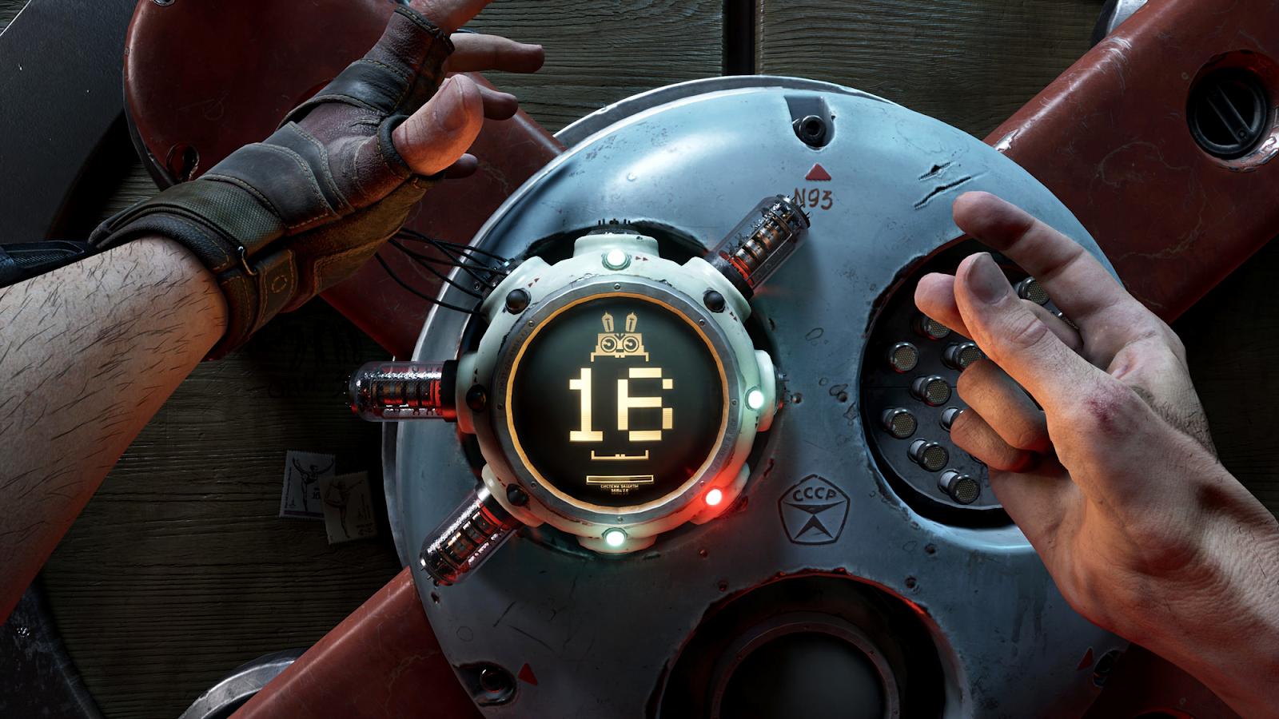
Soviet mark of quality and interface referring to the Hare robot from "Well, Just You Wait!" (A Soviet series of animated short cartoons produced by Soyuzmultfilm, well-known to the majority of the population of the former USSR countries – PS) in Atomic Heart.
The game's setting quickly became its key asset. This is eloquently evidenced not only by the pre-release materials, but also by the information leaked from the studio during the development of the game.
In January 2019, a scandal erupted over information from former and current developers about the state of affairs at Mundfish: violations of the Labor Code of the Russian Federation, constant unpaid overtime, boorish treatment of employees, high turnover, no development plan, numerous game concept changes.
According to one of the anonymous developers, Maxim Zatsepin put "a pretty picture" above everything else, because that's what would sell the game. Apart from the environment, Atomic Heart had nothing unusual to offer, which led to a restart of development of an almost finished product.
In 2018, the company released “Soviet Lunapark VR” project, created on the basis of Atomic Heart assets in order to obtain additional funding for development. On the basis of frames from this game and official materials on Atomic Heart, it was clear that the setting would be represented by a contrasting combination of images of Soviet culture in a sinister post-apocalyptic atmosphere. This technique is another variation on the portrayal of the remnants of Soviet culture in games, the most famous of which are the S.T.A.L.K.E.R. and Metro 2033 series.
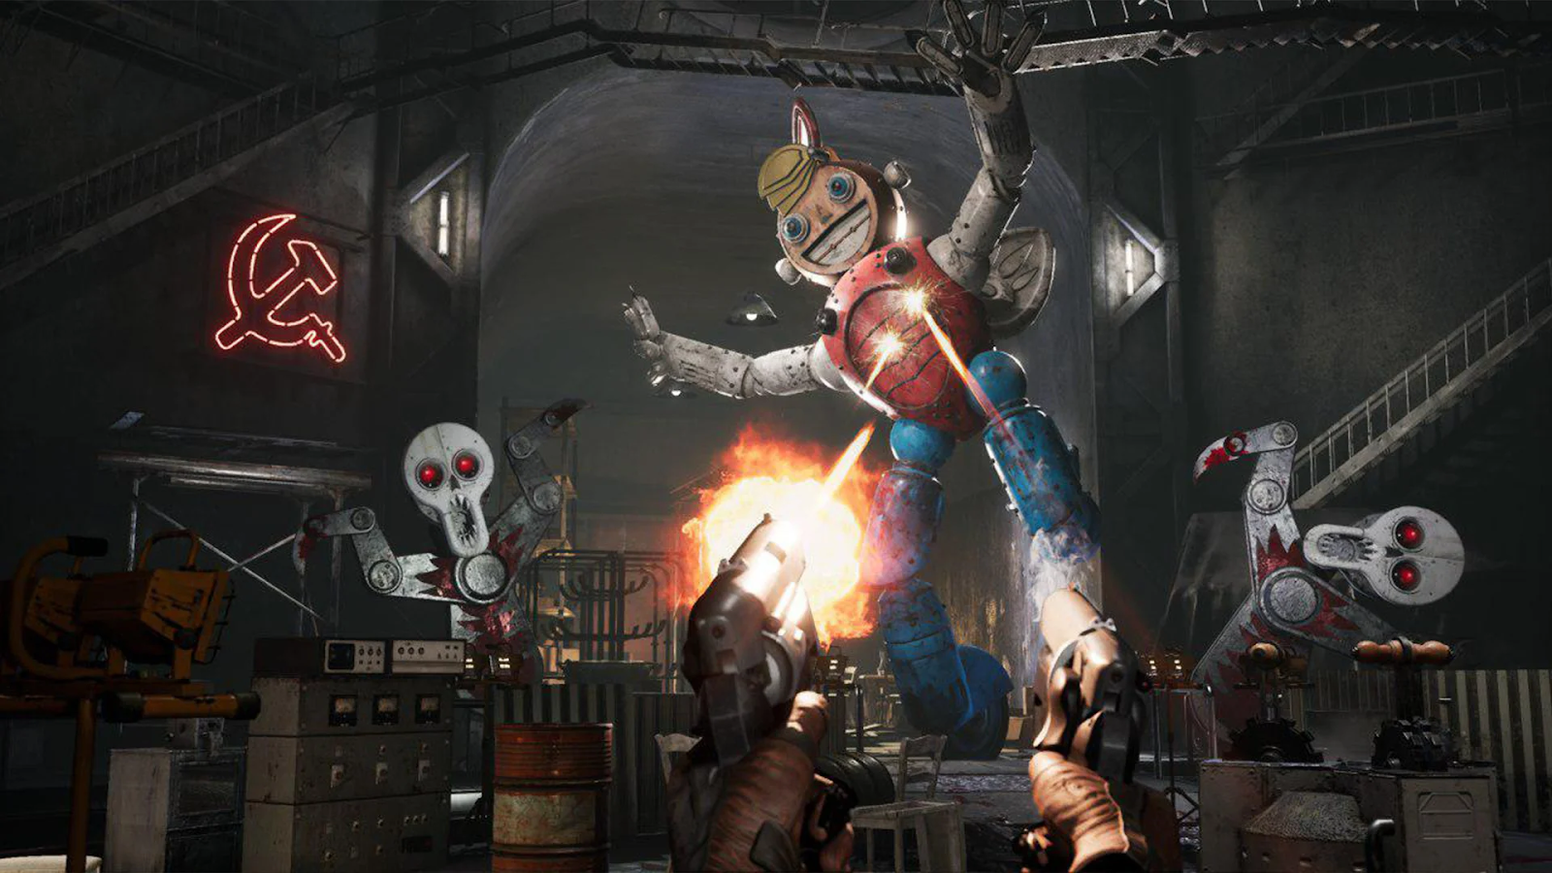
This was the atmosphere of the game on release. Frightening soulless robots with the appearance of Soviet toys, creating a "sinister valley" effect, a heavy industrial aesthetic juxtaposed with slender, almost cosmic forms in the architecture, battered and gutless factory workers, the emphatically sexy bodies of robot ballerinas, the occasional "russian Babushka" figure, the in-game animation about the pioneer and the capitalist in a pseudo-Soviet style – all this is meant to create an aesthetics of "an alternative retro-futuristic USSR", which, however, does not match the CEO's "no mockery of the Union" words at all.
What did we end up with? The "alternativeness" of the Soviet regime in game manifests itself mainly in the graphics. In the story, however, there are clear parallels with reality. Not Soviet reality, however, but the Western reality of anti-Soviet stereotypes, so when analyzing the various aspects of the game lore, we will refer to the real facts.

The Leadership of the "Alternative USSR"
The Soviet Union is portrayed in the game as a totalitarian state, as it is in other games where the "Soviet theme" is represented in one way or another. This is evident from the first dialogue of the game's incarnation of Molotov (named Yegor, as opposed to the real Vyacheslav Molotov – PS) with the main antagonist ─ the supposedly ideological communist, scientist Dmitry Sechenov. The academician says that his neuronet "Collective 2.0", was designed to unite people's minds into a single entity and allow them to control robots, and is aimed for the good of humanity and to prevent a new world war.

The scientist states: "...the time of the capitalist exploiters is coming to an end! Soon the working class in the West will throw off the yoke of the oppressors!
He is countered by the image of the "bureaucratic" Molotov. The latter is not interested in the threat of disrupting the launch of the neural network. The incident causes Molotov concern only in connection with the possible collapse of his plan to take over the world.
His “Atomic Heart” project plays an important role in the game's plot. The essence of the project is that the USSR secretly implements combat functions into its robots and sells them abroad, particularly to the United States, under the guise of civilian ones. After activating the “Collective 2.0”, it will be possible to order all robots in the United States, including those embedded in government agencies and defense facilities, to take over the country using radio commands.
Thus, according to the ‘villainous plan of the villainous Politburo’, the "red menace" will become a reality, communism will crush defenseless America and conquer the whole world.
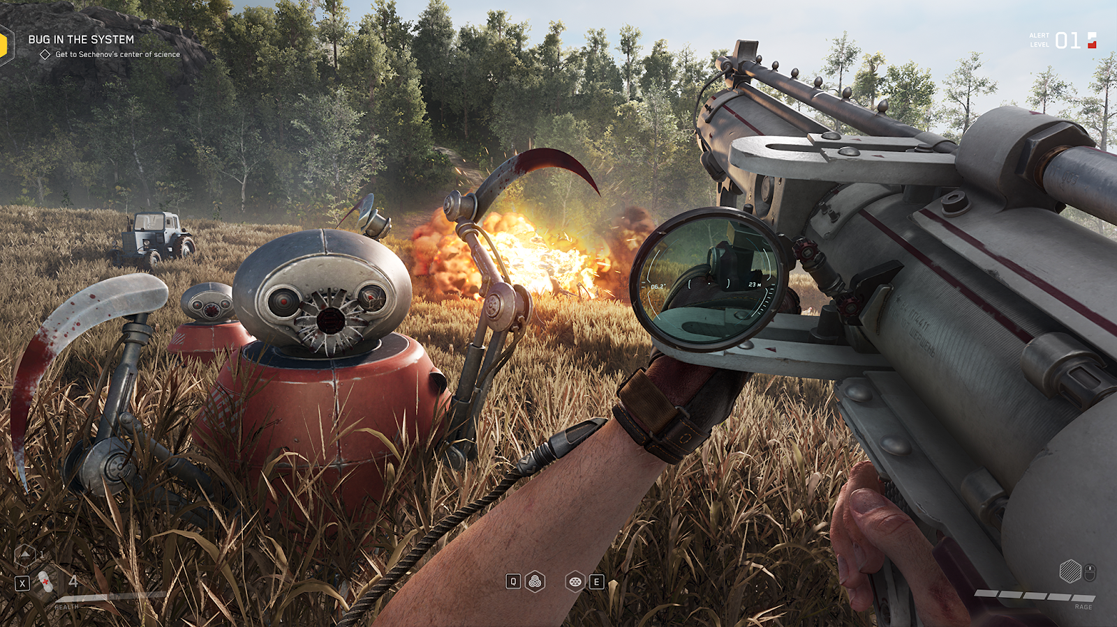
For the sake of this plan “Enterprise 3826” works. Soviet robots are supplied as humanitarian aid around the world precisely for the purpose of capturing it.
Finally, Atomic Heart tries to convince the player that the goal of the communist regime, at least in the "alternative USSR", is to take over the world, and that helping other nations (in this case, supplying robots) is only a cover for enslaving the masses.
In reality, the communists never set out to ‘conquer the world’. Revolutionary processes occur differently in different countries and cannot be imposed from the outside. The real Soviet leadership was well aware of this and fought relentlessly against the ultra-leftist line of "revolutionary war", which rather refers to the ideas of Trotsky, replicated in Western literature, by the way, in a positive way: "devoted prophet", "defender of democracy", "fighter against Stalinism", etc.
Even when the real USSR did have to initiate a military conflict, the objectives of the Soviet leadership were purely defensive in nature, as in the case of Finland or Poland.
Throughout the Cold War, the USSR took a defensive stance, guided by the concept of the peaceful coexistence of capitalism and socialism.
International aid provided by the USSR to many countries in Africa, America and Asia was designed to lead the peoples out of backwardness and capitalist oppression and to direct millions of people toward progress and the construction of socialism. One can recall the experience of Cuba, where advanced education and healthcare systems were created with the help of Soviet specialists.
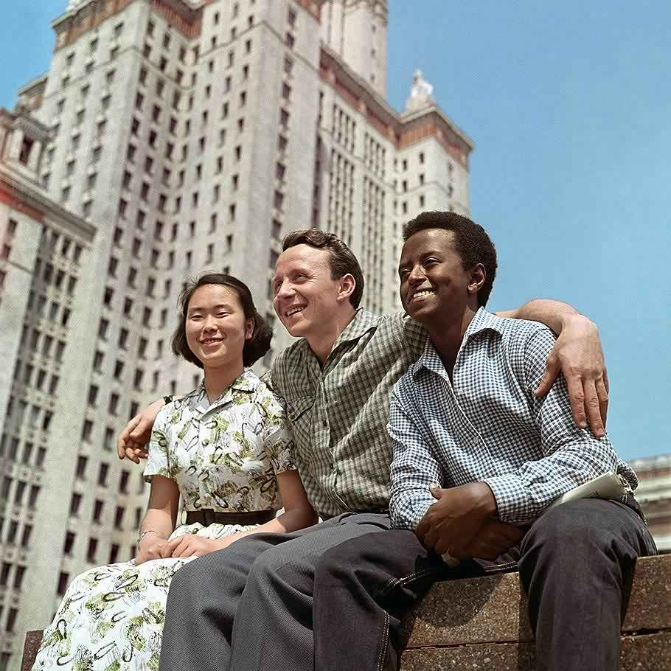
Moscow State University students, 1961. Modern right-wing propaganda would say it’s the “SJW cultural Marxist agenda”.
The image of ‘communist dictators’ with ideas of achieving personal domination of the world – isn’t it the classic bourgeois stereotype of "usurpation of power by immoral communists"? The negative image of the Communist Party is coupled with the considerable social inequality of the alternative USSR and the depravity of the "party elites’.
For example, “Enterprise 3826” is home to an “advanced theater”, where robot ballerinas (promoted as the most recognizable image of Atomic Heart) give performances. Upon entering it, the protagonist learns that only a select few can get a ticket to the local performances.
Turns out that under the guise of an “advanced theater” operates a brothel for the political elite of the country, supervised by the artistic director of the theater Lastochkin. The latter is aware of the dissatisfaction with this fact among the theater staff and fights it in every possible way. Thus, from one audio recording it becomes known about the arrest of a meeting of dissatisfied theater workers. This "cultural figure" takes advantage of the fact that "the topic of robosexuals is now at the peak of popularity among the Soviet elite", which is why he gets away with everything.
The country's party leadership doesn't care about ordinary workers as well. At the end of the game, an artificial intelligence, KhRAZ, informs the protagonist that Soviet supplies of robots to the United States are forcing American workers out of their factories and increasing unemployment, which is causing discontent among them. This policy inevitably leads to increased poverty among the American population and their disillusionment with the ideas of communism, for it is the Soviet robots that cause the unemployment of the American population. But the "totalitarian" CPSU clearly does not care.
Meanwhile, in reality, the image of a "workers' government that doesn't really care about the workers" was exploited by all the enemies of Soviet power, starting with the counterrevolutionaries.
Finishing the caricatural image of the Soviet Party leadership is the theme of the struggle for power over people. From conversations with the artificial intelligence KhRAZ, the protagonist learns that the Party leadership is planned to gain a privileged position in the "Collective 2.0". The lust for personal power attributed to communists and the Orwellian "some are more equal than others" are also the favorite propaganda labels of capitalists.
The game shows an absurd picture: an alternative USSR is making colossal steps in science and technology. At the same time, the country is ruled by a group of corrupt, idealess ‘apparatchiks’, striving only for world domination, the CPSU leadership is completely unfit and has no control over the situation in the country, as evidenced by the events in the plot. The construction of communism goes on not thanks to, but in spite of the Communist Party.
Such a state of affairs fundamentally contradicts historical facts. Industrialization, collectivization, the victory over fascism, the successes of socialist construction ─ all the achievements of socialism in the USSR are directly related to the ideological and organizational leadership of the Communist Party, the theory of Marxism-Leninism, and were carried out by the hard work of communists among the many millions of non-party masses in town and country, at the front and in the rear.
When opportunism prevailed in the CPSU and the work of Soviet democracy bodies became mainly a formality, we saw the opposite picture ─ careerism, the squalor of the party leadership, a throwback to capitalism and the collapse of socialism.
The same was true of Soviet democracy. The activities of various democratic bodies, trade unions, councils, and other public institutions involved tens of millions of people in the construction of socialism. This was reflected in the multitude of decisions of local bodies on various practical questions of the economy, initiatives to improve the life of the population and socialist production.
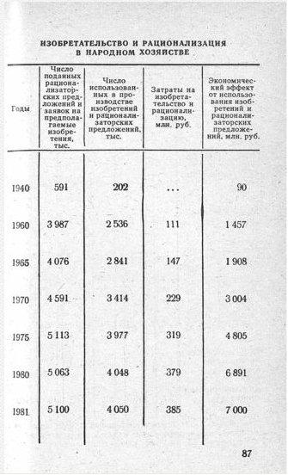
In 1981 Soviet workers made 3.1 million suggestions to simplify and cheapen the production. 4.050 million were used. Their cost was 385 million rubles, allowing to save 7 billion rubles.
Through specially formed demands to Soviet organs of various levels, Soviet citizens communicated their needs and requirements. At the grassroots level, it was the Soviet citizen who acted as the main initiator of the formulation and solution of economic tasks.
These facts in the world of the game are simply silent, because they do not fit into the image of the contradiction between high technology and the society of the "alternative USSR” painted by the developers.

A Human of the "Alternative USSR"
The human masses in the game act as the decorations, just as the houses, trees, and walls of underground laboratories.
Workers, with the exception of a select few scientific ‘heroes’, play no role in the narrative and do not move the plot. Despite society's approach to communism and the unprecedented growth of culture, in the course of the protagonist's conversations with KhRAZ, the player learns that not only foreigners but also Soviet citizens have not reached the level of consciousness necessary to launch the Collective 2.0 network.
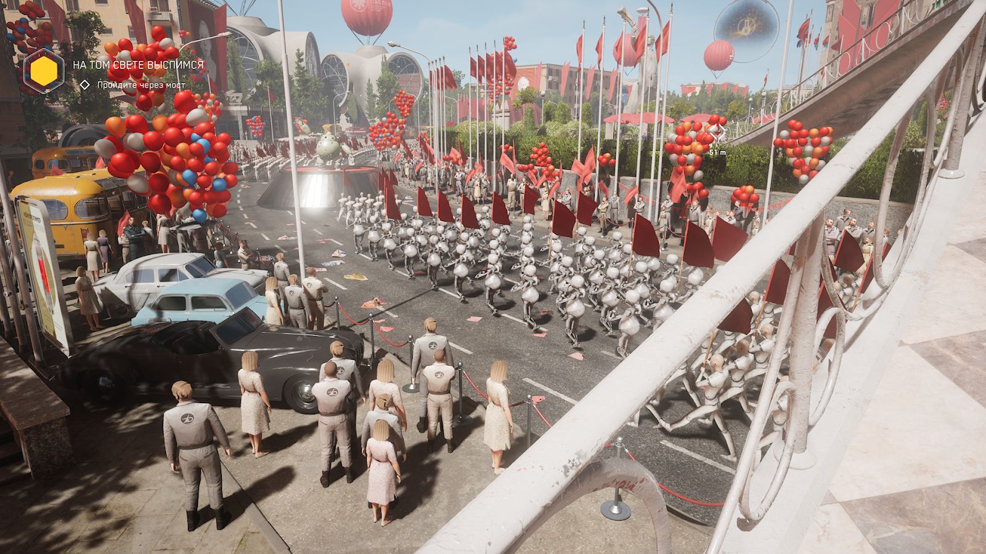
Even among the minor characters, we encounter not a single ideological communist. Moreover, most of the characters do not ask any questions about the obviously dangerous and inhumane content of the research being conducted. The theme of trust in the authorities and their representatives is tacitly forbidden. None of the employees of the theater talk about the need for any decisive measures to combat the depravity of the party leadership: everything is limited to a statement of fact and a hidden struggle with a bad art director.
The image of the ‘bad Soviet human’ manifests itself in the speech. Instead of a high level of culture, we hear constant profanity from minor characters, in particular a theater electrician in love with a robot and his colleagues.
The main character also constantly swears and boorishly insults other people throughout the game. At the beginning of the game he explicitly declares that he respects only Sechenov, and everyone else has to "earn" his respect.
During the game, this is explained by Major Nechaev's severe trauma and his mental instability. He has no doubts about the correctness of the Party's policy of taking over the world. The main character blindly believes in the correctness of his actions and in the good intentions of the main antagonist almost to the very end. Moreover, the Major only ‘sees the light’ thanks to the guidance of KhRAZ, who plays the role of the "voice of reason" almost to the very end of Atomic Heart, denouncing the local social order and the actors.
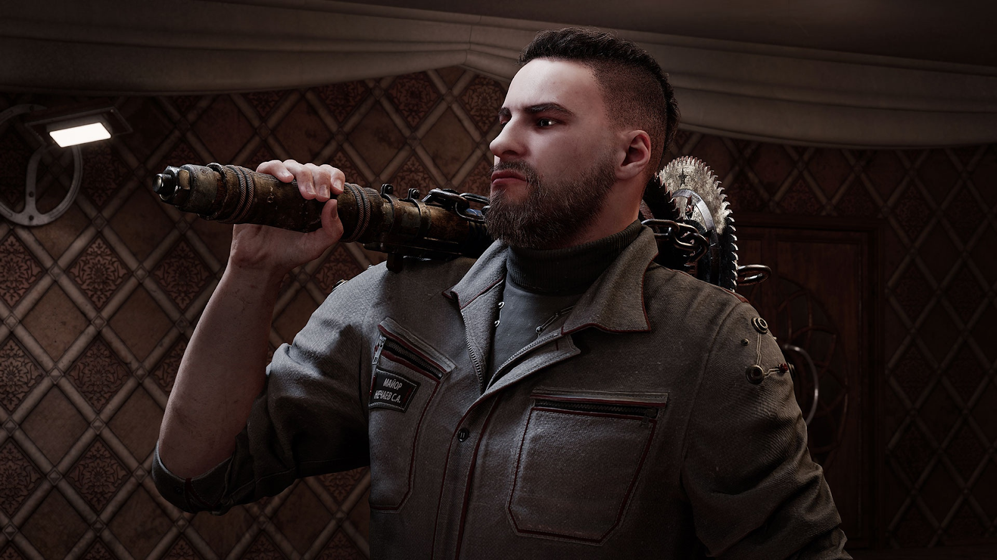
This blind faith of the military in the task assigned to them by the game's main antagonist is also explained in the story by the use of brainwashing. This plot element is a metaphor for all Soviet people: they were allegedly unable to think critically without help.
In spite of an unprecedented increase in culture and technological progress, the Soviet man is presented as an uncultured, gutless, and cowardly philistine who does not care what happens in his country. Throughout the game we are never shown how the workers of the Soviet Union participate in the construction of socialism.
Such a description of Soviet people is fundamentally untrue. The development of the USSR took place with the active participation of ordinary workers. It was they who carried out the policies of collectivization, industrialization, fought to preserve socialism during the Great Patriotic War and rebuilt the country after it.
In addition, throughout Soviet history, especially until the early 1960s, the vices in the governing bodies were exposed and punished. It is enough to remember the wide response and participation of the population in the party struggle of the late 20s and the political processes of the 30s.
Even in the twilight of socialism, when the moods of ideological baselessness and apathy were spreading throughout the USSR, they did not become dominant among all Soviet citizens. Workers still offered many ideas on how to improve production and life. They still showed labor heroism at socialist construction sites – suffice it to recall the story of the construction of the Baikal-Amur Mainline in the Soviet Far East.
In an attempt to denigrate the real image of the Soviet human, the authors of Atomic Heart showed their own attitude toward the working people as mere extras who have no effect on world events.
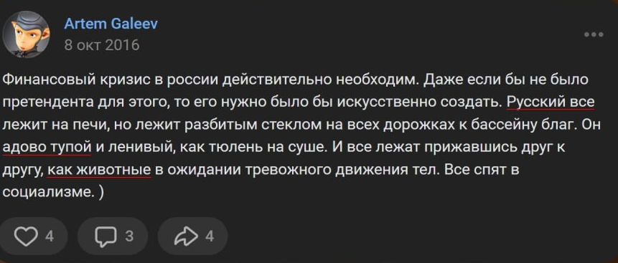
"Russia really needs a financial crisis. Even if there would be no pretendent for that, it should've been created artificially. Russian keeps sleeping on the furnace, but he sleeps as a broken glass on all the roads to a pool of goods. They are really stupid and lazy, as a seal on a coast. And they all sleep sticking to each other, as animals waiting for suspicious movements of their bodies. All sleep in socialism.)"
Shortly after the release of the game one eloquent fact appeared: the VKontakte profile of Artem Galeyev – one of the main developers of the game, responsible for the design and the concept of the project – contained a publication in which socialism was declared as the reason of “laziness” of the Russian people.
In presenting the people of the Socialist era as a gray mass, the developers have only reproduced the contemptuous attitude of the bourgeois intelligentsia toward the proletariat, which has no proper place in the world of contemporary art. Given the time frame of the game (1955), the authors of the game, consciously or not, try to convince the audience that this state of affairs was inherent in the Soviet Union far beyond the period of its decline and collapse.

Communists of the "Alternative USSR"
The story of the "Collective 2.0" project is central to the Atomic Heart narrative.
From the stories of the scientist who worked on the project, the protagonist learns its true purpose. The project will allow whoever possesses the “Alpha Connector” to control the will of robots and humans. Sechenov concealed the truth even from the Soviet government and revealed his plan only to a few of his closest associates.
The images of the party nomenclature and totalitarian society are reinforced by the mythology of ‘hiding the truth’. The activities of “Enterprise 3826” are for the most part top secret, as are the inhumane research conducted there and its victims. Likewise, the game "incident" itself is kept secret from the public and the world.
In Sechenov, the authors of the video game embodied their vision of a communist. The antagonist is a deeply sincere ideologue, and for the sake of human progress under his leadership he is ready to sacrifice everything and use any, even the most inhumane measures. It is noteworthy that even the organizer of the "incident", the scientist Petrov, as it turns out from the recording of his dialogue with the antagonist, sees nothing wrong with having a demigod over mankind, he only dislikes the fact that it will be Sechenov.
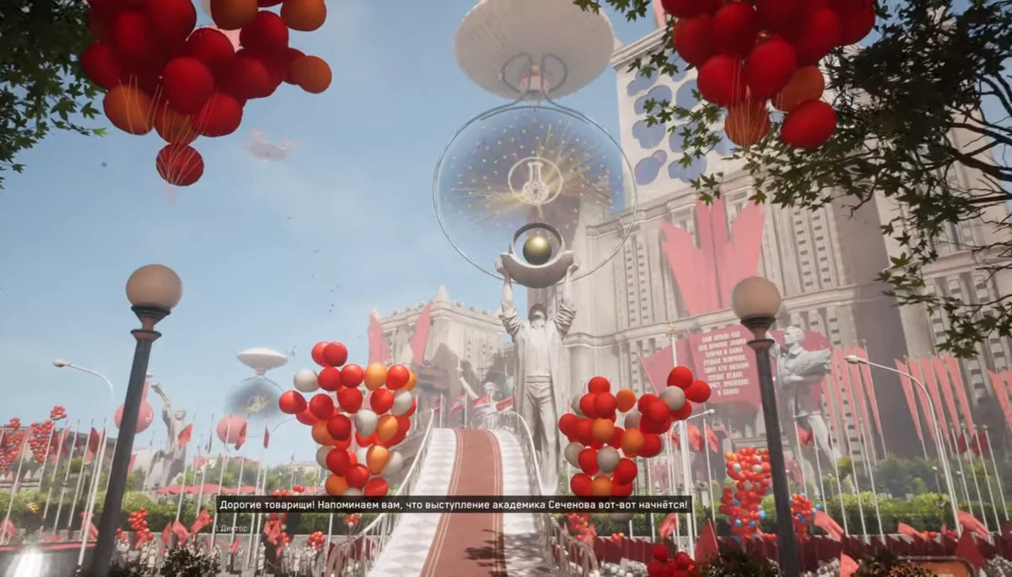
A further plot of the game reveals to the player the true plans of the country's leaders, Sechenov and KhRAZ, who turns out to be Sechenov's former colleague.
All of them are alien to the ideas of mutual aid, collectivism, and solidarity – essential elements of patriotism of the real Soviet citizen. Each side seeks to eliminate their rivals and use the robots to enslave the world for their own selfish purposes.
It turns out that Sechenov controlled the protagonist through an implant and brainwashing, while KhRAZ used the protagonist to eliminate Soviet leaders and other scientists.
The game has two endings, neither of which are good. In the first, Major Nechaev gets rid of KhRAZ, but allows Sechenov to continue his plan. In the second, KhRAZ kills Sechenov and neutralizes the protagonist in order to carry out his plan to destroy humanity by transforming it into a new life form.
In the end, the game presents Major Nechaev as a sick man, a blind slave to the system and a fool who was used by all sides.
The plot mirrors the Atomic Heart's view of the ideas of communism: the communists are supposedly ready to subjugate all of humanity to their will in order to realize their plans. However, what they do turns out to be their own undoing, endangering and destroying humanity. This is how the developers try to convince the audience of the danger of the ideas of communist development and the inevitability of their collapse.
However, upon closer examination of the game's vivid imagery and storyline, all attempts by the game's creators to expose communism prove untenable.
Real communists, unlike in the game, do not oppose the people. Moreover, it is the people who nominate the communists as spokesmen for their class interests. Communists know that the methods of achieving their goals must be consistent with their objectives.
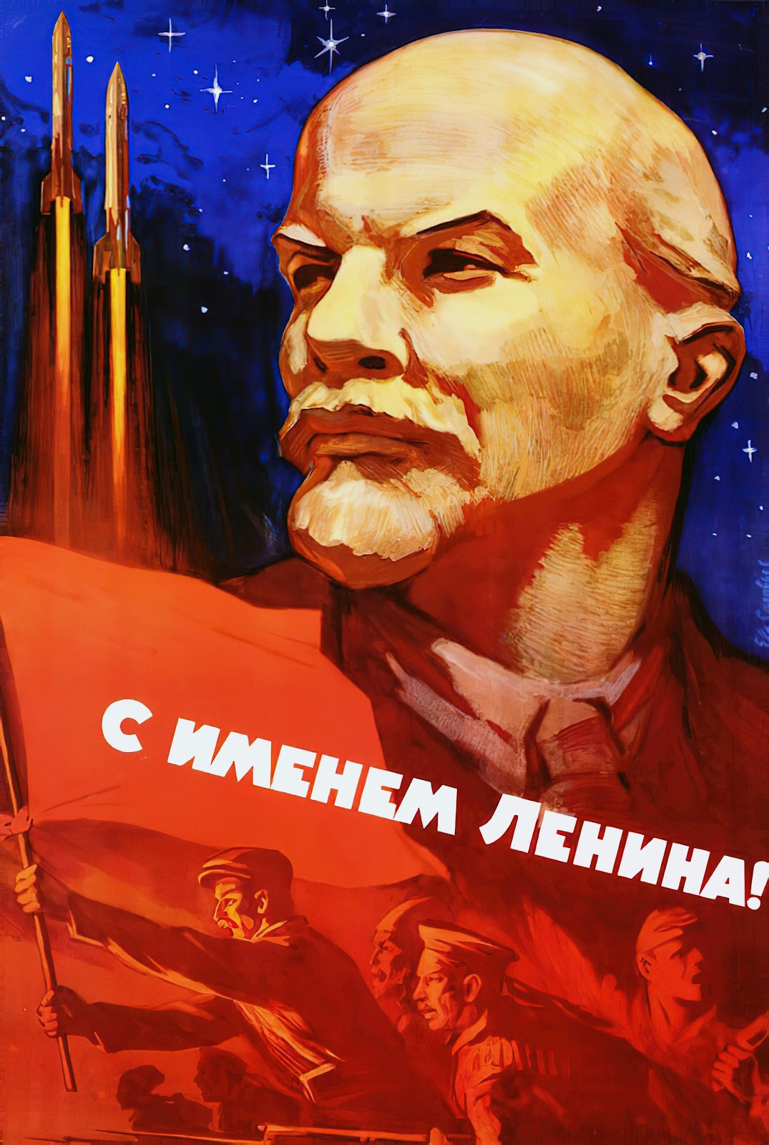
In the game, however, like in the Cold War pamphlets, the "communists" always resort to the most extreme methods. Even researching the breeding of plants suitable for other planets conducted in the Vavilov complex is carried out through poorly controlled experiments, creating extremely dangerous species. They spiral out of control when the complex is left unattended and turn their victims into a kind of zombie.
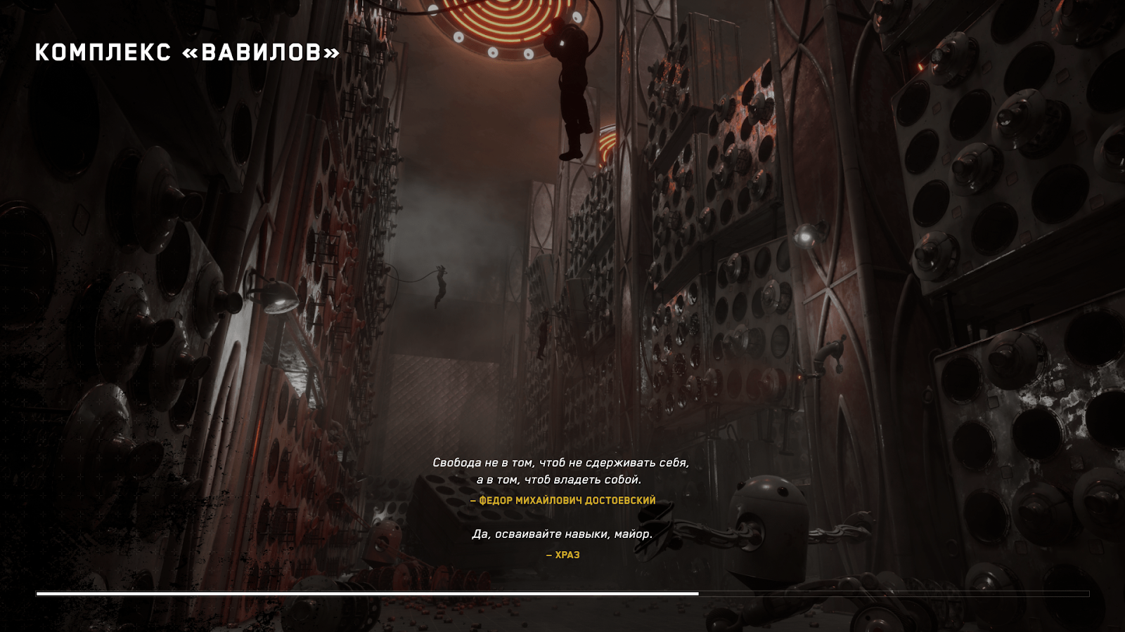
The idea of the mortal danger to which communists allegedly put humanity is a complete distortion of the real picture. It is not communism, but capitalism, as a socio-economic system which is incapable of solving the contradictions it has created, that puts people in danger of death.
Increasing economic crises leave billions of ordinary people impoverished. Increasing ecological problems and the inability to effectively combat mass epidemics kill millions. The deepening contradictions between the financial monopolies put humanity at risk of a world war.

“Soviet Bioshock”
As a result, the attempt of the authors of Atomic Heart to scare the masses with the horrors of communism looks ridiculous and hypocritical. One can look out of the window to see that the capitalist reality is scarier than the brightest anti-communist caricatures.
This becomes clearer if we compare Atomic Heart with projects with similar themes. During the development process, Mundfish was clearly inspired by elements of the Fallout and Bioshock universes. It has a claim to retrofuturism, robots and the aesthetics of industrial progress in common with the first, and the concept of the plot was taken from the second: "they wanted to build a utopia, but it turned out to be a disaster."
The fact of borrowing looks more obvious because both of these universes are an evil satire, but not on communism, but on various epochs of capitalism.
Fallout is known for the extensive use of American mass culture of the 1940s and 50s in the world that survived the nuclear war: jazz, retrofuturism aesthetics, corporate culture.
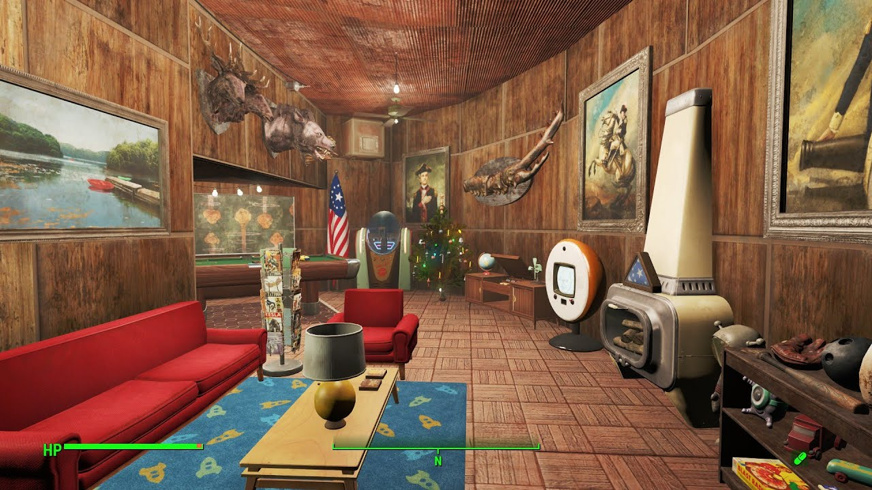
However, it is not limited to these elements. The pre-war USA in the world of Fallout is an imperialist state that carries out total surveillance of its citizens, inculcates chauvinism, racism and anti-communist hysteria, arranges wars for resources, conducts cruel experiments on people and covers the omnipotence of large monopolies. After the nuclear war, the remnants of the American government become obsessed with the idea of genocide of the surviving inhabitants and are the main antagonist of the second and third parts of the Fallout series. Unlike the fantasies of the "Soviet invasion", the mentioned elements of the gaming United States are present in the real United States not only of the Cold War, but also of modernity.
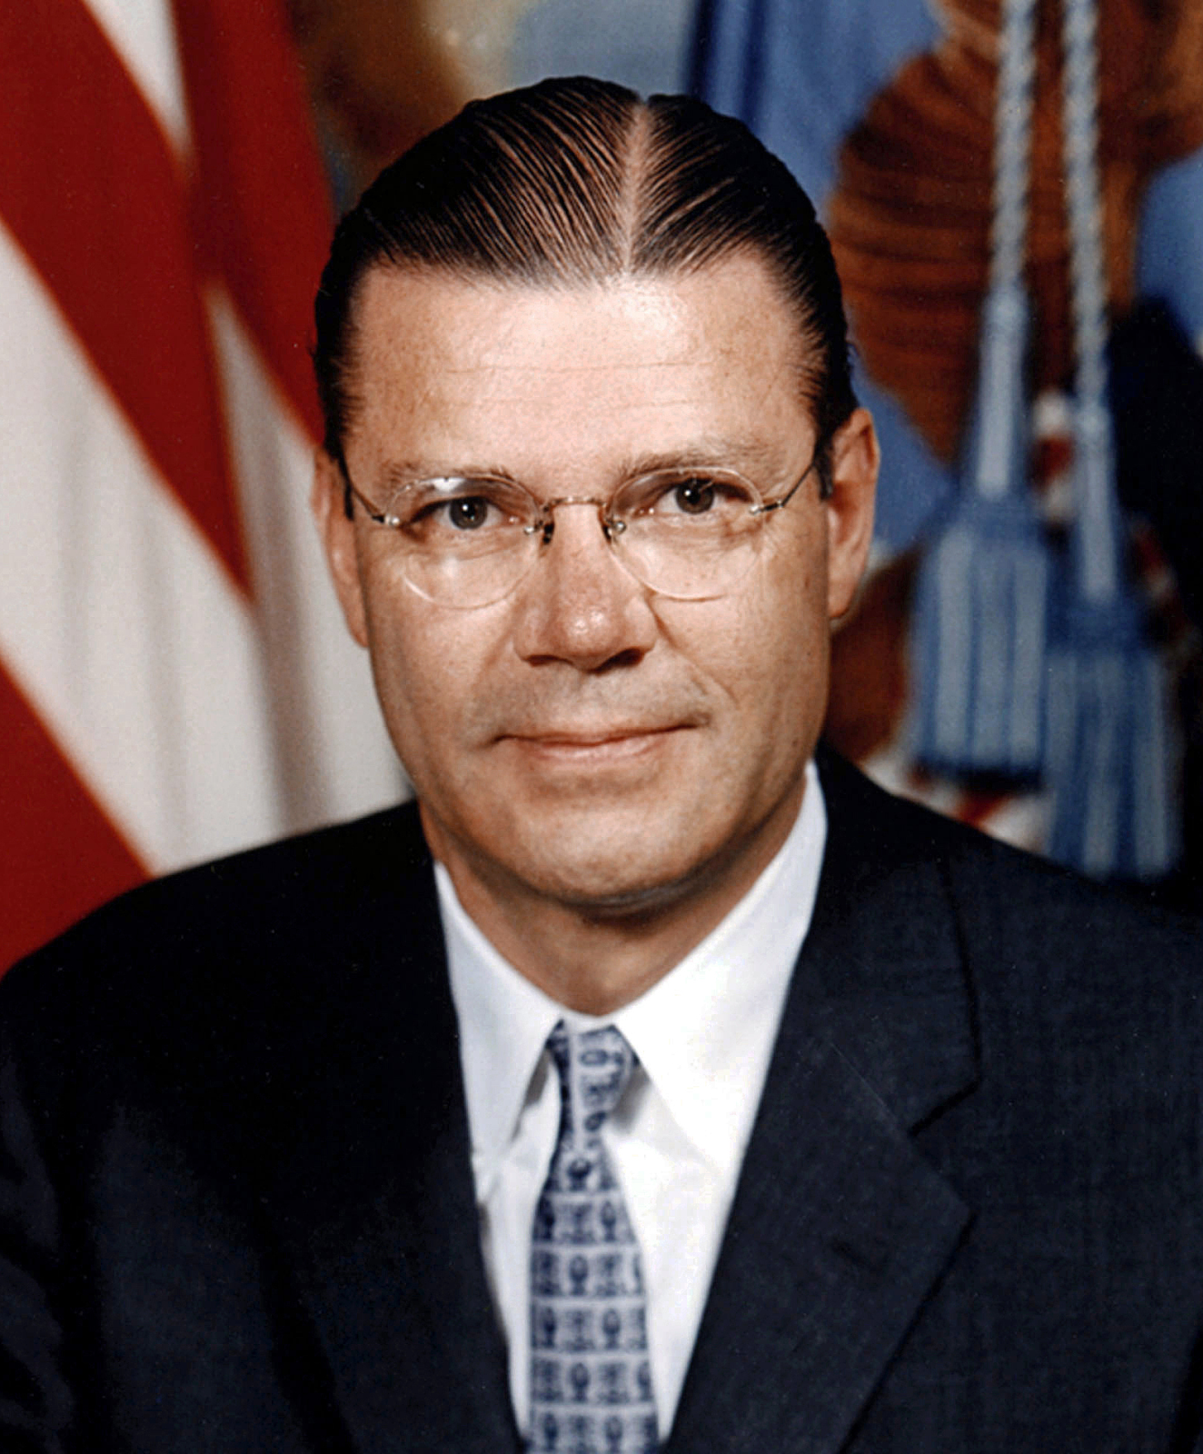
Robert McNamara – Secretary of Defense of the United States in 1961-1968. Under him, the "Project 100,000" was launched – a social experiment on recruiting the armed forces with conscripts with physical and mental disabilities in connection with the serious losses of the American army in the Vietnam War.
The first two parts of the Bioshock series ridicule the ideals of libertarianism: a desperate millionaire decides to build an underwater city where individualism is elevated to the rank of religion and all its citizens must live according to the capitalist ideal. However, in reality, the residents of the city become drug addicts and are ready to destroy everything around for the sake of a dose of the substance they need. At the same time, the imposition of corporate culture, selfishness and drug addiction, which are depicted in these games, exists in a real, not fictional, capitalist society.
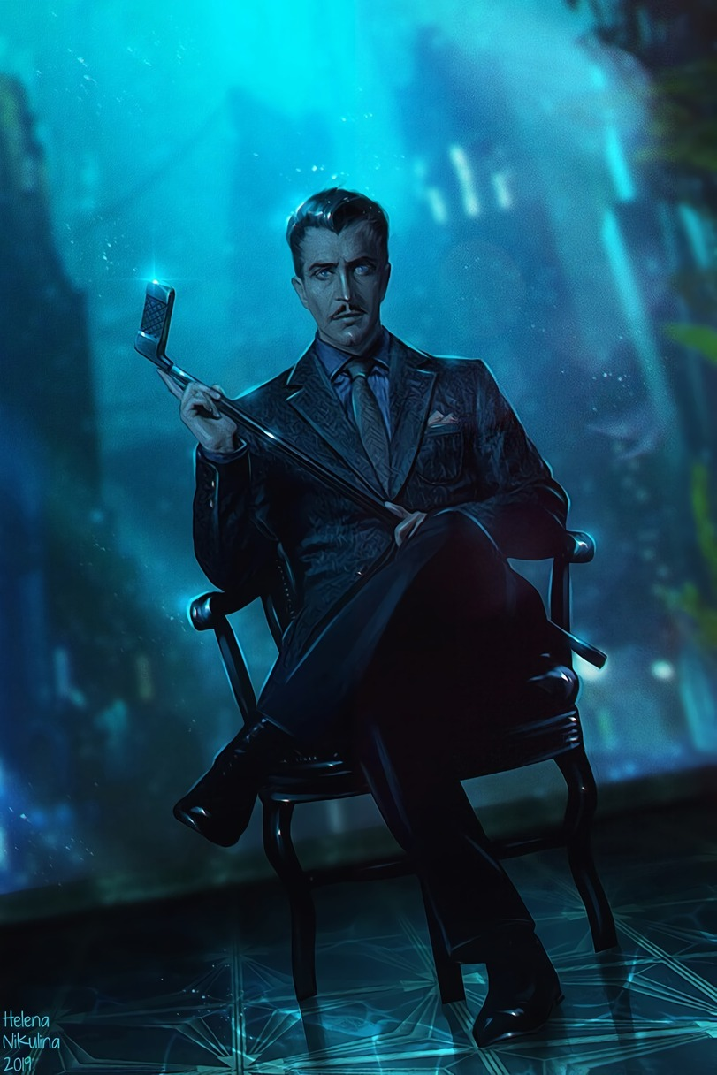
Andrew Ryan is one of the characters of Bioshock, a typical capitalist of the 30-50's, who decided to create his own capitalist utopia, which naturally turned into a nightmare.
The third part – Bioshock Infinite – depicts the fantastic flying city of Columbia, built by the United States at the dawn of the era of imperialism to promote the ideas of American exceptionalism. The city is a composite caricature of American society at the turn of the XIX-XX centuries: skyscrapers and star-spangled flags coexist with racism, enshrined at the legislative level and huge social inequality, workers suffer under the yoke of capital, and any attempts to organize them are brutally suppressed.
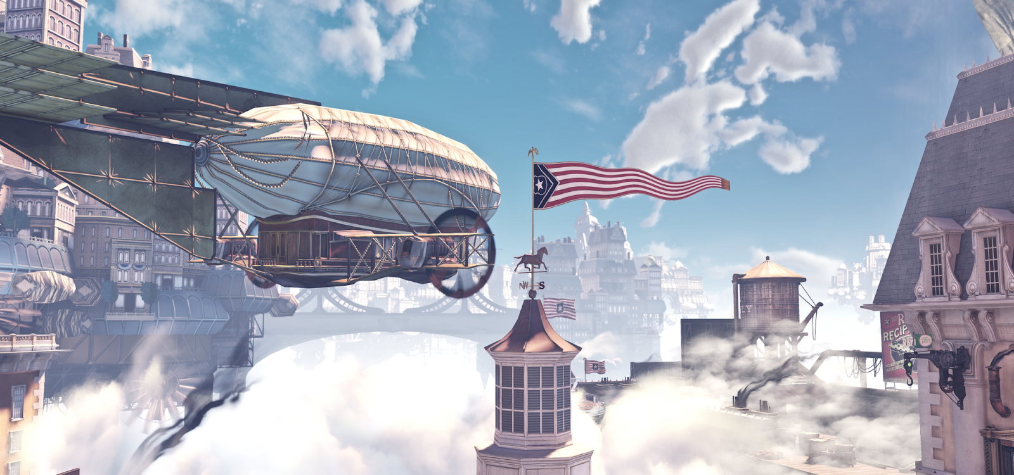
Against the background of these two elaborated and really relevant universes, Atomic Heart looks rather faded. The real source of inspiration, down to the plot and time period, is the lesser-known game You Are Empty, released in the mid-2000s.
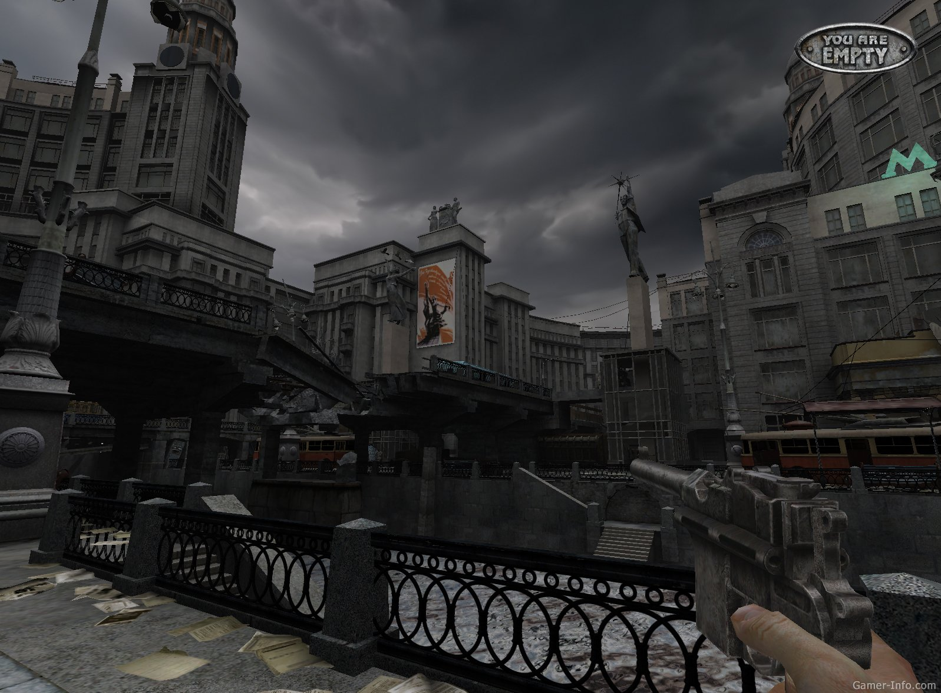
In this game, a certain Soviet scientist, like Sechenov in Atomic Heart, invented a machine for combining all consciousnesses into one, but after launching it turns people into monsters. The plot of Singularity released in 2010 is also suspiciously similar to Atomic Heart. American Marines sent to the area of an abandoned laboratory to study a radioactive release fall into the past, where reality changes, and a power-hungry scientist takes over the USSR and captures the world. An American soldier is called upon to prevent this and return to the "true" world, where the USSR was destroyed.
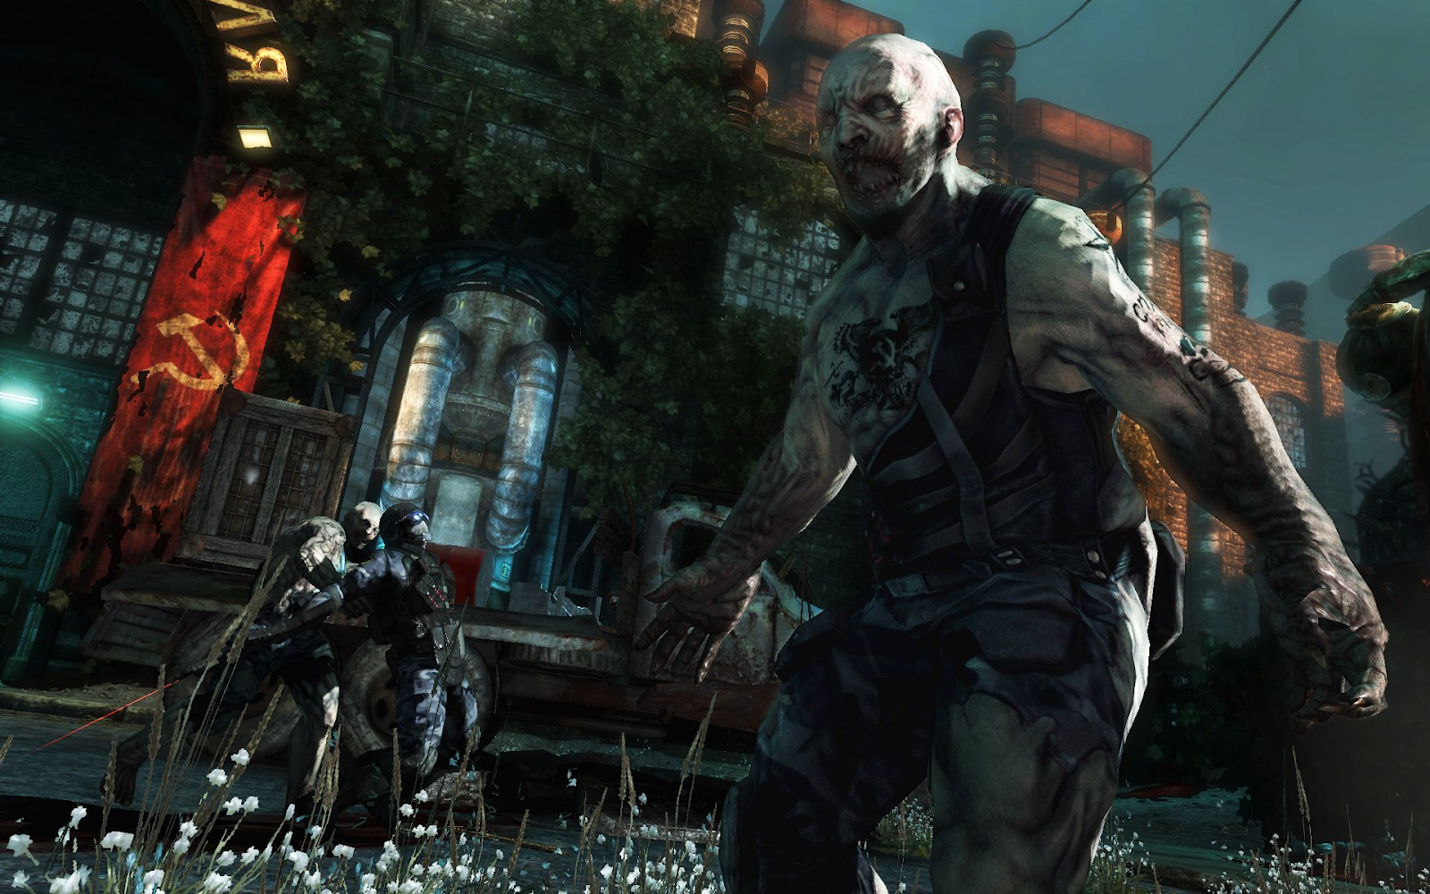
Ultimately, Atomic Heart's Soviet retrofuturism, unlike Fallout and Bioshock, has little in common with real Soviet culture. The concept of the plot, which looked relevant and topical in the setting of American imperialism or "victorious libertarianism", transferred to the USSR, turned into banal anti-Soviet propaganda.
Thus, Atomic Heart paints in front of us such a banal and worn-out picture of the "totalitarian USSR", which differs little from the anti-Sovietism of Western art, or from the same anti-Sovietism of the modern Russian Federation.

Eclecticism of the Game
We have already discussed how important the entourage of the game was for its promotion. But why did it happen that, despite the loud statements and expectations of the public, the most primitive stereotypes about the USSR turned out to be in the game? And why, judging by the reviews, does this moment go unnoticed?
The answer lies in a pragmatic calculation: by placing the setting at the center of the game, the developers sought to make a game that would appeal to the widest possible audience. This was possible only by inserting into it specific elements familiar to certain groups of potential buyers.
We mentioned the Russian-speaking audience above, but it was not a priority target. The CIS player does not like to buy expensive games (Pre-order version for CIS cost 2,500-3,600 rubles, or $35-50, while “world release” of the Standard edition cost $60). They are also familiar with torrents and can easily download "pirate" version of the game. And what were the other potential buyers?
Western gamers have not heard much about "Well, Just You Wait!" and Soviet toys, but they have been growing up with horror stories about the USSR. A totalitarian government? In the mind of the average Western player, "everyone knows" that the USSR had a totalitarian government. Many books have been written about it, "objective" bourgeois historians talk about it. The disenfranchised and battered Soviet citizens? But it is "obvious" that citizens in the USSR were powerless. The struggle for power? "It is a well-known fact" that the leaders of the Soviet Union fought each other for power. To a Western audience, which has been told since childhood about the "horrors of totalitarian communist regimes", there is nothing suspicious about this: to them, an objective view of the USSR is what anti-Soviet clichés are all about.
The whole "incident" around which the story revolves is an homage to the Chernobyl disaster, the truth of which was allegedly deliberately and maliciously suppressed. We have already covered this myth with the HBO series of the same name.
Finally, there is a group of specific fans of stereotypes about the USSR and Russia who like to see the Soviet Union portrayed "as in Red Alert". For them, the game has "Russian babushkas", "Russian women", and red flags everywhere.

The attempt to make a "Soviet Bioshock" or "Soviet pre-war era in Fallout" is also aimed at fans of these universes. Ability cartoons? The exact same ones were in Bioshock, and their hero is the Vault-Boy from Fallout, but "if only he had been in the USSR". Finally, hyper-sexualized robot ballerinas, all sorts of vulgar innuendos and foul words also have their purpose: to attract fans of such content, as well as a very specific group of right-wing gamers and "opinion leaders".
For these people – outraged by the realistic portrayal of women in games, the inclusion of ethnic and sexual minorities in the character pool, and who declare anyone who disagrees with them "SJWs", "leftists" and "cultural Marxists" – the game is presented as "anti-mainstream", challenging the big franchises and corporations.
It is also likely that various veiled nationalist jokes related to Ukraine were inserted into the game, and were presented as pure coincidences.
At one point in the game, photos of formally random Soviet cities, which turn out to be Donetsk, Zaporozhye, and Kremenchug, are hung on the board. In the game there are cans of pork sausage stuffing in blue and yellow colors. Yes, they existed in reality, but despite the abundance of examples of Soviet design, this particular one was taken by the developers.
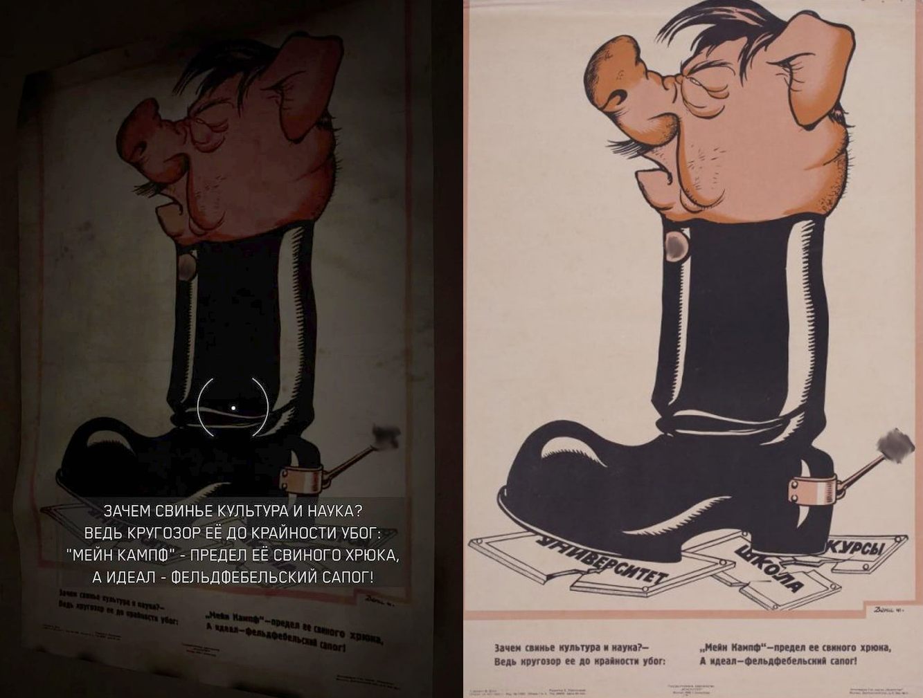
Victor Deni's caricature, again, featuring a pig, was taken from a number of Soviet posters from the time of World War II.
One could say that this is anti-fascist irony, but given how well such Easter eggs on current political topics lend themselves to the propaganda of Russian capitalists, the target audience for these "coincidences" appears to be the right-wing patriotic public in Russia.
Taken together, all of these points serve the purpose of reaching the widest possible audience and maximizing profits.

Could it Be Otherwise?
The answer lies in a pragmatic calculation: putting the setting at the forefront, the developers sought to make a game that would appeal to the widest possible audience. This could be done only by inserting specific elements familiar to certain groups of potential buyers into it.
We have already talked about the Russian-speaking audience above, but it was not a priority goal. A player from CIS countries does not like to buy expensive games (AH pre-order cost from 2500 to 3600 rubles) and is familiar with torrents. And what other potential buyers were there?
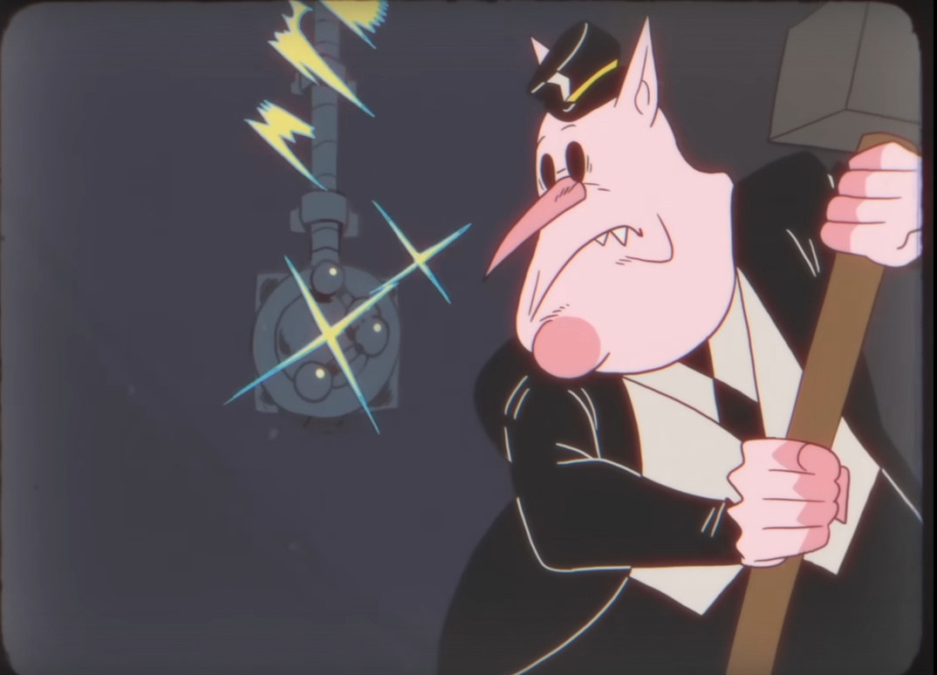
However, we should not be deceived by these trivia. Despite the abundance of all sorts of references to various things from the Soviet era, the game presents the Soviet Union as the capitalists want it to be: a "world evil" and a "red menace". AH in no way destroys this cozy world, but rather fills it with other colors.
Bourgeois society is dominated by bourgeois ideology. It permeates the vast majority of the "products" of imperialist culture, inevitably filling them with anti-communist and anti-Soviet motifs and a satire on the communist future that looks all the more ridiculous as it tries to portray as unrealizable those things that have already been realized in the past-a life without fear of tomorrow, a life without exploitation, without wars, without the oppression of capital.
Atomic Heart, contrary to the developers' claims, is an eclectic mix, designed to make a profit for the developer. The anti-Sovietism inherent in its plot is only superficially different from other similar products. It is adapted to modern graphics, provides various players with references to their preferred areas of interest, but in general, like other similar projects, contributes to the further consolidation of the image formed by the bourgeoisie of the USSR as a "failed state" and "evil empire" - the image one would expect from a product of the bourgeois era.

Original article

