Assassination of Hamas Leader in Iran
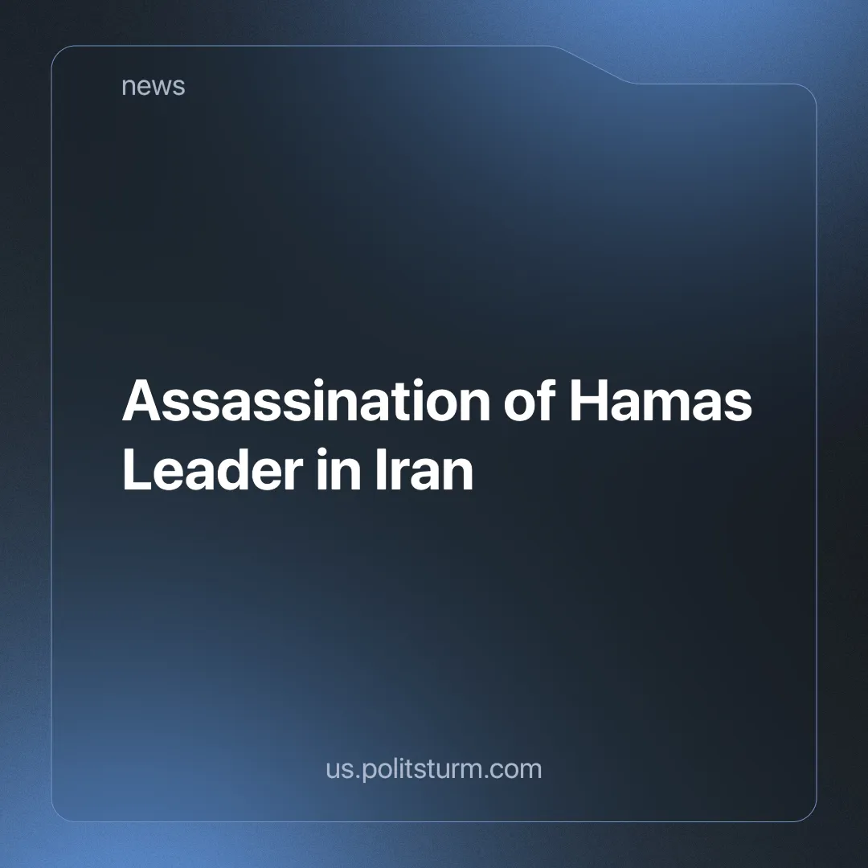

Original article
2024-08-02
2 min read

Ismail Haniyeh, a senior Hamas leader and negotiator in Gaza cease-fire talks, was assassinated on Wednesday in the Iranian capital Tehran. The details are unclear, Hamas officials [1] and the latest news from Iran [2] confirm that the method of assassination was a tactical missile or drone.
However, The New York Times states that a bomb was smuggled into the guesthouse where the visiting Haniyeh was staying [3]. Regardless of the particular circumstances, a top leader of the Hamas organization has been successfully removed from the equation as the death toll in Gaza approaches 39,500 [4].
Haniyeh was a key figure in the group's international diplomacy, and his assassination has prompted Hamas to abandon cease-fire and hostage-release negotiations. It "takes the battle to new dimensions and have major repercussions" said Hamas' armed wing [5].
"With this action, the criminal and terrorist Zionist regime has prepared the ground for severe punishment," declared Ali Khamenei [6]. A response that is a mere reiteration of previous plans in which the Islamic Republic vowed to avenge many key military figures assassinated by Israel over the years [7] [8] [9], but was limited to theatrical rocket attacks [10].
Iran's reluctance to retaliate in any meaningful way yet is a sign that, despite claims to the contrary, its foreign policy is guided by the logic of capital. As:
"war is the continuation, by forcible means, of the politics pursued by the ruling classes of the belligerent Powers long before the outbreak of war" [The Peace Programme, V.I. Lenin].
The Islamic Republic may or may not carry out its promises of revenge now, but regardless, it is only a question of when an imperialist war will break out in West Asia between Iranian and American capital.
In the case of an imperialist war, the bourgeoisie will try to deceive the working people with calls to defend the nation or with scaremongering. The working class should take matters into its own hands and organize as soon as it can on the Marxist-Leninist program, rightly seeing the capitalists as the real enemy, they should turn the imperialist war into a class war.
Links: 1 | 2 | 3 | 4 | 5 | 6 | 7 | 8 | 9 | 10

Original article

