Artsakh Has Fallen: Who is to Be Blamed?
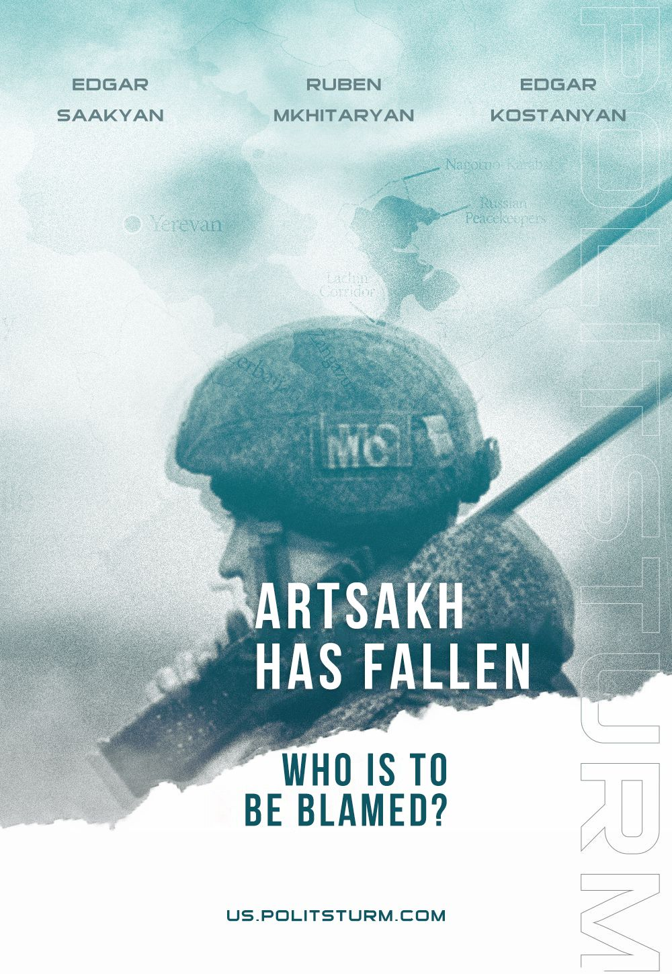

Original article
2023-09-23
17 min read

Preface: this article was published in May 2023 by our Armenian comrades. This material provides some historical context for the conflict and shows the interests of both Armenian and Azerbaijani capitalists in the region. This material was published in May 2023 – Politsturm International.
In May of this year, a checkpoint of the State Border Service of Azerbaijan was installed at the entrance to the Lachin corridor – the only route that was linking Armenia with Nagorno-Karabakh.
Baku stated that the checkpoint was being installed "in order to prevent the illegal transfer of manpower, ammunition, mines, as well as other military equipment from Armenia". In light of this recent news, the search to pin blame began again in Armenian society.
For some, it is tradition to blame the damned Bolsheviks for everything. However, these people forget that it was the hated Bolsheviks who were able to resolve the deadlocked conflict, the emergence of which Armenian and Azerbaijani nationalists played a big role in creating by deciding to proclaim the creation of independent antagonistic republics in 1918. We wrote about this in more detail in our article "The Nagorno-Karabakh Conflict: The Legacy of The Soviet Power?".
Some also blame the Russian Federation for everything.
The Russian Federation is indeed indirectly at fault since the incident in question occurred in the area of responsibility of Russian peacekeepers. But regarding this, it would be more fruitful to point out the impotence of the Russian leadership. It's likely most of the attention of the Russian authorities is tied up in their own situation in Ukraine, instead of Nagorno-Karabakh, and perhaps they have completely different interests in the region to those of the locals.
Relying on the help of Russia, France or the United States, and then blaming them for all the failures, is a flawed position. Our situation is not so different from that of a hundred years ago. Do we not realize that the imperialist powers have completely different interests that are separate and hostile to the interests of smaller dependent nations?
In general, the sentiment in Armenia is that “everyone is to blame, but us”. Some will object to this categorisation and say: that Prime Minister Nikol Pashinyan is to blame for everything. However, recognising the flaws of Armenia’s chosen nationalist course and the accusations against Nikol by his political opponents are not the same thing.
We do not deny the role of the individual in this whole story. However, those who point their fingers at Nikol, should not forget about those who were before him, and all those who supported the so-called velvet "revolution". Most importantly, if Armenian society soberly perceived its surrounding reality, and did not allow corruption to reach the monumental proportions that it has, then populists like Nikol would not have come to power.
We should not forget that arrogant sentiments have reigned in Armenian society for years. Most Armenians could not even imagine that Azerbaijan would be able to win a war against Armenia, because they were taught that Armenians are smarter, braver and better than Azerbaijanis. But even Sun Tzu, Clausewitz and other great military strategists taught that the underestimation of the enemy lies at the heart of any defeat.
Armenia has become a victim of its own national bravado. While Armenian society was engaged in sycophantic narcissism, the Aliyev regime modernized the Azeri army and purchased modern weapons.
And most importantly, nearly no one in Armenian society sees a direct causal link between the destruction of socialism in the former Soviet Union and the continuation of the Karabakh conflict.
The Armenian national bourgeoisie is constantly rushing in search of those to blame for its losses and failures during the competitive struggle between capitalist nation-states on the world stage.
In the late 1980s, Armenian liberals fought for bourgeois national independence and the return of the Armenian nation to the "motorway of civilization"; namely, for the restoration of capitalism. These Armenian singers for a happy future "like in Switzerland" forgot to add verses to their songs about the fundamentals of the future socio-economic structure they desired: exploitation, social stratification and cutthroat competition.
In fact, the ideologists of the Armenian national bourgeoisie did not lie about life "as in Switzerland" at that time. Those few whose interests were ultimately expressed by all sorts of "miatsums" (a popular Armenian word in the 90s meaning "reunification", specifically with Karabakh), "azatutsiuns" (Armenian word for "liberties") and the privatization/looting/destruction of state-owned Soviet enterprises accompanying the “national revival” do live like in Switzerland and even better. They have large accounts in ‘reliable’ Swiss banks, periodically go on vacation to Switzerland itself, have Swiss watches just as reliable as their Swiss bank accounts, and even some real estate in Switzerland itself - the then dream state of the Armenian national bourgeoisie from the early 1990s.
Dreams undoubtedly come true! At the end of the 1980s, the nascent post-Soviet national bourgeoisie promised its naive mass of future voters rivers of milk and honey. In Ukraine, it was expected that, having thrown off the ‘Sovok’ (a derogatory word, used by anti-communists as a nickname for “USSR”) from their shoulders, they would live like in France, or at least their romanticized picture of life there. In Azerbaijan, they dreamed of a life as sweet as sherbet, akin to life in the United Arab Emirates, which would be provided to the entire Azerbaijani nation by Baku’s oilfields.
In the ‘redeemed-by-God’ Russian Federation, they generally believed and still believe that the ballast weight of national "hanger-on republics" was finally thrown off their necks. That yesterday's "hangers-on" noisily and audaciously celebrate their liberation from "Soviet occupation and colonialism." For many former Soviet citizens, their "independence" days were held under the roar of artillery and explosions of bombs and shells. Deindustrialization, degradation of education, science, medicine and a general decline in the level of culture was what composed the celebratory “feast” served on their “festive” table.
Now, the long-rotten zombie of national chauvinism has risen from the grave and is wandering all over this vast territory of the former Soviet Union, rattling the chains of former solidarity. Apparently, the spectre of communism has left not only Europe but also the whole of Eurasia.
The most rabid former Soviet ‘pugs’ who barked so furiously at the ‘Sovok’ ended up exactly where they deserve: in the dustbin of history. The same place which the states of the phantom CIS have fallen, amongst mountains of junk, rust and garbage, under the gloomy skies of the darkest reaction. They swallow the stale air of the blackest obscurantism, not forgetting to continue with their most “important” work — unfounded criticism of the now dead ‘Sovok’ as the primary source of all the evils and troubles they now find themselves surrounded by.
Our opponents may again object: if Armenia found itself in such a dire situation because of the restoration of capitalism, then why did the destruction of socialism specifically in Azerbaijan eventually lead to the latter's victory in the Karabakh war?
We will answer this by pointing out the fact that this "victory" has not brought anything good for Azerbaijani workers and will not bring anything good. Only temporary euphoria and delusions of one's own greatness.
Firstly, under socialism, Armenians and Azerbaijanis lived peacefully in the Nagorno-Karabakh Autonomous Oblast (NKAO). Of course, there were all sorts of issues on a day-to-day basis, but there was peaceful coexistence between the two nations; there was friendship, interethnic marriages, etc. With the advent of capitalism, the newborn bourgeoisie of Azerbaijan could not resolve the Karabakh conflict, they could not find a way out of the current situation, and they did not want to make at least some compromises. Baku has decided to keep the Armenians of Nagorno-Karabakh under its jurisdiction.
We believe that the actions of the Azerbaijani leadership led to the death of a huge number of ordinary Azerbaijanis and the permanent displacement of many more. These people cannot be returned, but the conflict could have been avoided. The history of the early 1990s showed us this possibility, however, the chauvinist propaganda on both sides poisoned the well and killed even the notion of peace in the cradle.
An example of what could have been was the population exchange between the Azerbaijani village of Kyzyl-Shafag (Krasnaya Zarya), located in the wooded mountains of the Kalininsky district (now Lori) of the Armenian SSR and the Armenian village of Kerkenge, located near Baku, in the Shamakhi district of the Azerbaijani SSR — a unique example of the initiative of collective village communities — aimed at overcoming the conflict situation within the framework of the Armenian-Azerbaijani confrontation.
This is a politically harmful and inconvenient story for both Armenian and Azerbaijani nationalists today. The story of the workers of two villages who managed to organize themselves, enter into a dialogue with each other as reasonable people and independently, together, find a bloodless way out of the crisis situation of a carefully inflamed war that was not provoked or caused by them and is not in their interests.
Secondly, what the nationalists do not realise is that the euphoria passes quickly. A sense of your own greatness can only last so long while social contradictions, exploitation, the dictatorship of capital, social stratification, and the dead and crippled in this war remain.

Azerbaijani workers have received a false sense of restoring “historical justice”, and the ruling class in Azerbaijan will have the opportunity to exploit the resources of the captured regions and sell them to Turkey. Some Azeris die in order to seize lands inhabited mainly by Armenians, while others — the ruling class — are able to enrich themselves by exploiting the resources of the region and unblocking transport and communication lines between Azerbaijan and Turkey.

Some get coffins and injuries, while others make a profit. And of course, this “victory”, which was achieved with the direct support of Turkish imperialism, will end up turning Azerbaijan into a raw material appendage for Turkish capital.

So in this situation, for Azerbaijani workers, the victory is Pyrrhic.

Thirdly, the Azeri victory rings hollow, due to the continued existence of Artsakh and the 120 thousand Armenians who do not want to become citizens of Azerbaijan or leave their lands. That is to say that the inter-ethnic contradictions have not gone away. There still are and will be revanchist sentiments in Armenian society. It is not possible to completely destroy Artsakh or especially the Republic of Armenia itself, at least with the current geopolitical situation in the region. Simply because other regional imperialists (Russia and Iran) are not interested in this outcome.

We believe that this is not the end of the war. Relatively speaking, 30 years ago, Armenia won, while now Azerbaijan is the victor. We don't know what will happen next, the situation can change in a diametrically opposite direction. Even 5 years ago, no one could have imagined that Baku would decide to start a war. We cannot be sure exactly how the balance of power between the imperialists in the region is changing.

Thus, as long as representatives of capital are in power in the republics of Transcaucasia, this war will go on indefinitely, or until one of the parties is completely destroyed. That is to say that Azerbaijani and Armenian workers face the prospect of being killed in future wars. In this war, workers and their children will die for the economic ambitions of the ruling class, but not the children of the Azerbaijani or Armenian bourgeoisie.

In the post-Soviet space, to varying degrees all workers have lost far more than they have gained from the restoration of capitalism in each country (i.e. in some places “only” social stratification and deindustrialization, while others have wars between former fraternal republics).

Let's return to the world of competition in the world of generalised commodity production and capital accumulation. The ideologists of capital convince us from year to year that the struggle of each against all and the desire to dominate at any cost is inherent in human nature. They conclude that therefore in the competitive struggle – be it for a place under the sun, or for the rate of profit in the capitalist market – the fittest and strongest survive. However, why do they refuse to accept this “immutable truth” in relation to their failures and miscalculations?
If a once-efficient bank, which self-confidently privatized profits during good years, fails, then why do its owners immediately run with an outstretched hand to the state? Why do they nationalize their losses and completely forget their instructions to the dispossessed about the evils of limiting and controlling private business by the state in the interests of the working majority?
The same thing happens at a higher level of competition — national competition, expressed in a direct clash of states. The bourgeoisie, which has failed, immediately absolves itself of responsibility and shifts the blame to a convenient scapegoat.
However, in the specific case of the Armenian bourgeoisie, all its problems were and are systemic in nature, the root of their troubles lies in the form of productive and social relations that are predominant in Armenian society. They promote the private interests of a few, who incessantly enrich themselves through the exploitation of labor; the appropriation of the fruits of social labor, coupled with unscrupulous speculation and parasitism with rent.
Having won the battle in the competition for living space and resources in 1994, the Armenian bourgeoisie failed or did not want to develop its success and invest enough resources and capital in the qualitative strengthening of Artsakh as a springboard for further promotion of its bourgeois national interests. That is, of course, if the unrecognized republic was actually considered by them as such, and not a political and ideological springboard for the further career growth and enrichment of a few businessmen-politicians from Karabakh and "mainland" Armenia.
Today, in the permanent competitive war between national states, the fight has remained in favour of the Azerbaijani bourgeoisie, who are feverishly strengthening their positions on the ground, occupying all possible tidbits. After all, the struggle over Nagorno—Karabakh is primarily over natural resources, minerals, pastures, mines, and quarries for the extraction of decorative stones - everything that can bring profit and temporarily satisfy the insatiable greed of capitalist locusts.
Unfortunately, we do not have the full picture of the development of capitalism in Armenia and, in particular, its links with the resource and agricultural base in Artsakh. We do not know how the chains of export and sale of tangible profit-making resources from Artsakh, for example, gold, were built, who participated in it and how, etc.
What is the share of Armenian capitalists who suffered losses after losing territories in Karabakh in 2020, how strong is their influence on the current ruling government in Armenia? To what extent are some of the largest Armenian oligarchs tied to Karabakh, including those who sponsor and support the ruling party of "the People's Prime Minister" Pashinyan? What per cent of the profits does restoring the "territorial integrity of Azerbaijan" promise them in exchange for lifting the blockade from Armenia by Turkey and "lasting peace with Azerbaijan"?
The Armenian bourgeoisie, being unable to defend its positions or rely on Russia, is trying to find a compromise with the Turkish and Azerbaijani capitalists, but this is impossible. In the conditions of the crisis of capitalism, while the markets shrink, someone has to make room. Baku looks with lust at the Armenian province of Syunik, but of course, because it has the world's largest reserves of molybdenum and enriched mining metals! They also look towards the "Zangezur corridor", which will allow Turkish capitalists to successfully promote their influence over the entire Transcaucasia giving them a foothold there, as well as access to the Caspian Sea and Central Asia.
But such a scenario would meet resistance from Iran, as it is important for Iran to maintain its borders with Armenia in the north in order to diversify its transport communications. Iran itself offers military cooperation to Armenia, but Yerevan pushes them away, worried about sanctions that may be imposed on Armenia by Western countries for such cooperation.
Pashinyan's personal whims also play a role here. For him, it is important to maintain the reputation of a "democrat" in the West and to be in the top rankings of Economic Freedom of the World, as well as to be among the laureates of other liberal ‘awards’.
Behind the ideological and national screens they put up, it is important for us to expose the real class interest of the Armenian bourgeoisie. At the same time, it is obvious that this bourgeoisie is not a monolith and there are splits with it - reflecting the competitive nature of capital. The splits manifest themself at the external political and ideological level, including for example the confrontation of the Armenian businessmen that support Pashinyan and his ruling party with another organisation – the Armenian Apostolic Church.
In any case, the class interest of the disunited and disorganized working majority of Armenia remains subordinate to the bourgeois national interests of Armenian businessmen. The Armenian capitalists’ biggest worry currently due to the conflict is the reduction in the quantity of such an important commodity as labor, which, in fact, is what brings them profit.
The mass of working people in all this history are the ones who bear all the hardships of the crises, the horrors of war, the lawlessness of market anarchy and the falsity of bourgeois parliamentary cretinism.
Of course, so far the national bourgeoisie is firmly sitting on the neck of the working people. The carrot hung out by political entrepreneurs in front of the noses of voters for many of the latter still has a rather juicy and attractive appearance.
Therefore, the chaotic Brownian movement of the working people in the wake of bourgeois parties and impudent populists will continue. We do not know how long before the bourgeois parties and their ideologists will discredit themselves in the eyes of the working majority. And in general, will they leave anything at the end of their activities that is worth restoration and subject to further development?
But whatever the case, the way out of nationalist squabbling and competitive denial of the right to life and self-determination of other peoples for the workers of all current states, lies only through awareness of their own, and therefore all of mankind’s, collective interest and the international struggle for liberation and social transformation.

Original article

