Around 160,000 Telecommunications and Postal Workers to Strike in Great Britain
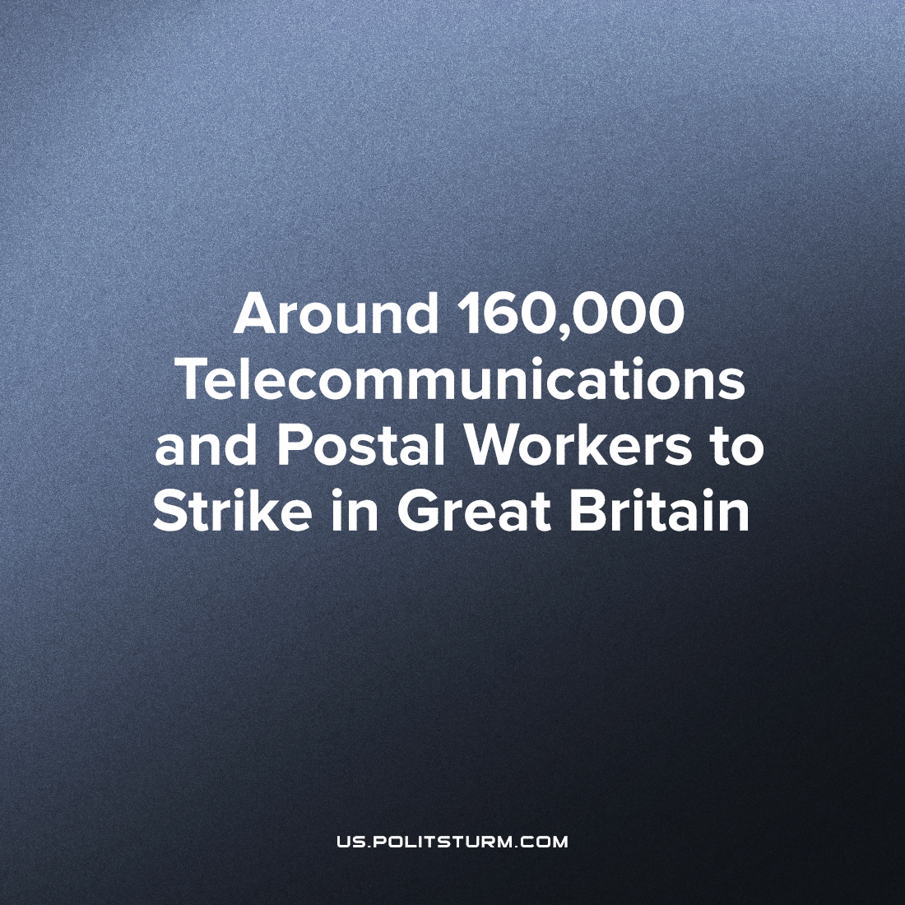

Original article
2022-08-16
4 min read

At the end of the month, around 160,000 telecommunications and postal workers are to go on a strike organised by the Communication Workers Union (CWU). Who are these workers and why are they striking?
Around 40,000 British Telecom (BT) workers have already, for the first time in 35 years, held a strike over the 29th of July and the 1st of August and with a mandate of almost 96%. The workers’ demands were not met, and they are going to strike again on the 30th and 31st of August. This industrial dispute is about pay – and was spurred in response to the offer of a fixed £1,500 pay rise (equivalent to an average increase of about 5%), which, after considering inflation (which is approaching 10%, and could reach 13% by the end of the year), is in real terms a big pay cut. Impoverishment amongst BT workers has already reached such a point where the company has organised workplace food banks (pictured below) for its own employees, many of whom are otherwise unable to purchase even staple foods. This abhorrent practice is an attempt to normalise in-work poverty and encourage the workers to share the burden of deprivation amongst each other, allowing the capitalists to steal a larger chunk of the workers’ surplus value.

Error loading image
Meanwhile, BT announced an annual profit of £1.3 billion, £700 million of which was paid to shareholders. The CEO of this formerly state-owned but now privatised telecommunications service provider has gifted himself an annual pay of £3.5 million (a 32% increase), and the CFO has taken a salary of £2.2 million. The General Secretary of the CWU has declared, “BT Group workers are saying: enough is enough. We are not going to stop until we win”.
Approximately 115,000 Postmen and Postwomen and 2,000 Post Office workers are to join the BT workers on strike. The postal delivery workers are to strike on the 26th and 31st of August, as well as the 8th and 9th of September, after rejecting a 2% pay rise (which similarly, in real terms and factoring in the inflation of nearly 10% is a big pay cut) and having achieved a yes vote of 98% in the ballot. While the office workers are to strike on the 26th, 27th and 30th of August, also in response to pay cut in real terms. The postal delivery workers work for Royal Mail, a recently privatised enterprise, that has reported a yearly profit of £758 million, while the Post Office employs the office workers, a state-owned company, which made an annual profit of £39 million, last year. Both enterprises want their workers to accept a large pay cut (during an ongoing cost-of-living crisis), with no remuneration whatsoever for their increased workload over the past couple of years, due to the pandemic. The bourgeois media, in an act of class solidarity with their postal counterparts, is demonising the workers’ attempt to resist their immiseration, bemoaning the inconvenience caused and the monetary loss caused by the strike. Following the strike announcement, Sky News, the Evening Standard, the Guardian, the Daily Mail, the Telegraph, Reuters and many more have all released stories about how Royal Mail is losing £1 million per day, and therefore cannot afford the demands of the workers, despite the company has made more than £2 million per day last year. Either this is a barefaced lie or the company’s CEO has just been awarded a “short-term bonus” of £140,000 (part of his total annual pay of £753,000) for reducing the company’s daily profits by more than £3 million. The right to “freedom of the press”, remains, just like all other capitalist “freedoms”, a “freedom” for the owning classes.
Similarly, the British state has once again demonstrated itself not to be an “apolitical institution”, nor a “fair arbiter of interests” within society but has revealed its class essence as the fighting arm of the dictatorship of capital. In the wake of the wave of strikes this summer, and the renaissance of the labour movement in Britain the government has passed a law forcing agency workers to act as strike-breakers, which is not only gross infringement on the fundamental democratic right to strike, but an extremely reckless move that will greatly worsen industrial disputes. Also, for example, in the case of the ongoing rail strikes, allowing specialist, safety-critical roles to be temporarily filled by agency workers who aren’t fully trained for a said position is putting both the workers and the public at large in danger. This kind of law is unheard of in Western Europe, yet it follows the British tradition of having the most restrictive anti-trade union laws in the region – like stifling mail-in restrictions on balloting (the union must maintain a contemporary address for every member) as well as a withdrawal of legal protection for the workers should the strike take on a political character to name a couple.
Many trade unions have recently disaffiliated with the British “Labour” party, mainly due to the new leadership headed by Keir Starmer, who are openly betraying the interests of labour. However, the CWU is still affiliated with the “Labour” party, and the leadership of the CWU is thoroughly imbued with social-democratic delusions. Capitalism cannot be reformed away, and as their own experience screams out to them – nationalisations and state-owned enterprises (which Starmer’s labour party isn’t even in favour of) under capitalism are no better at defending the interests of their workers. The workers of the state-owned Post Office and Network rail are just as prone to immiseration and deteriorating work conditions as the privatised BT and Royal Mail, resulting in all of them going on strike this summer. The only permanent solution to immiseration is socialism – the destruction of the capitalist state, and the institution of private property that it protects leading to the emancipation of human labour from its status as a commodity. It is only through the study of Marxism-Leninism; can the current relations of production can be demystified and the path to socialism be laid bare.
Sources:
https://www.cwu.org/news/bt-group-members-set-to-strike-on-29-july-1-august/
https://www.reuters.com/world/uk/bt-group-openreach-workers-announce-further-strike-action-2022-08-12/
https://www.bigissue.com/news/employment/bt-food-bank-community-pantry-own-staff/
https://www.cwu.org/news/royal-mail-strike-mobilising-our-divisions-across-the-uk/
https://www.cwu.org/news/cwu-to-royal-mail-you-can-afford-it-so-pay-up/
https://www.cwu.org/news/post-office-strike-three-new-days-of-action-announced-for-august/
https://www.mirror.co.uk/money/royal-mail-boss-handed-140000-27264328
https://www.gov.uk/government/news/new-law-in-place-to-allow-businesses-to-hire-agency-workers-to-plug-staffing-gaps-caused-by-strike-action

Original article

