Army’s Top General Fired Immediately After Trump Victory Claims
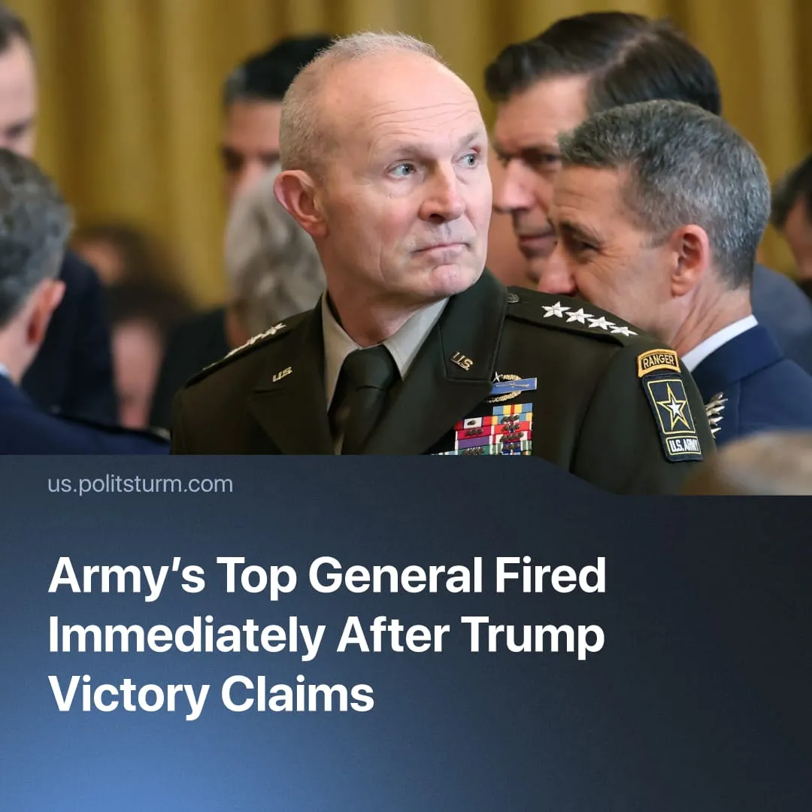

Original article
2026-04-06
1 min read

The Pentagon fired the US Army’s Chief of Staff, its most senior officer. This happened immediately after Trump declared "victory" in the conflict with Iran.
Details. Following the first month of the US–Iran conflict, Defence Secretary Pete Hegseth removed the Army Chief of Staff, Randy George, and two other senior generals.
► On 2 April, Hegseth requested the retirement of Army Chief of Staff Randy George, a four-star general and the highest-ranking officer in the US Army, removing him effective immediately despite more than a year remaining in his term, with no official reason provided.
► General Christopher LaNeve has taken over as Army Chief of Staff. Unlike Randy George, who was confirmed under the Biden administration, LaNeve is a Trump appointee, promoted to vice-chief of staff in February 2026. Hegseth described him as “a generational leader” who would “help ensure the Army revives the warrior ethos, rebuilds for the modern battlefield, and deters our enemies around the world.”
Context. Over the first month of the conflict, Trump has declared victory in some form at least 12 times.
► Just one day before the high-profile firing, Trump delivered a prime-time address declaring, “our armed forces have delivered swift, decisive victories on the battlefield,” and that the US was “on track to complete all of America’s military objectives very shortly.” Despite these claims, he simultaneously extended the conflict’s one-month deadline by another two to three weeks.
► Recent polls show Donald Trump’s approval has dropped to 36 % amid the Iran conflict. A majority of Americans disapprove of the war, oppose large-scale ground troop deployment, and expect the conflict to be prolonged, while confidence in the administration’s planning remains low.
For a deeper analysis of the US-Iran conflict, see the Marxist position on this subject: The Middle East: Architecture of War.

Original article

