Are Big Corporations Marxist? "Corporate Communism" and Monopolies Explained
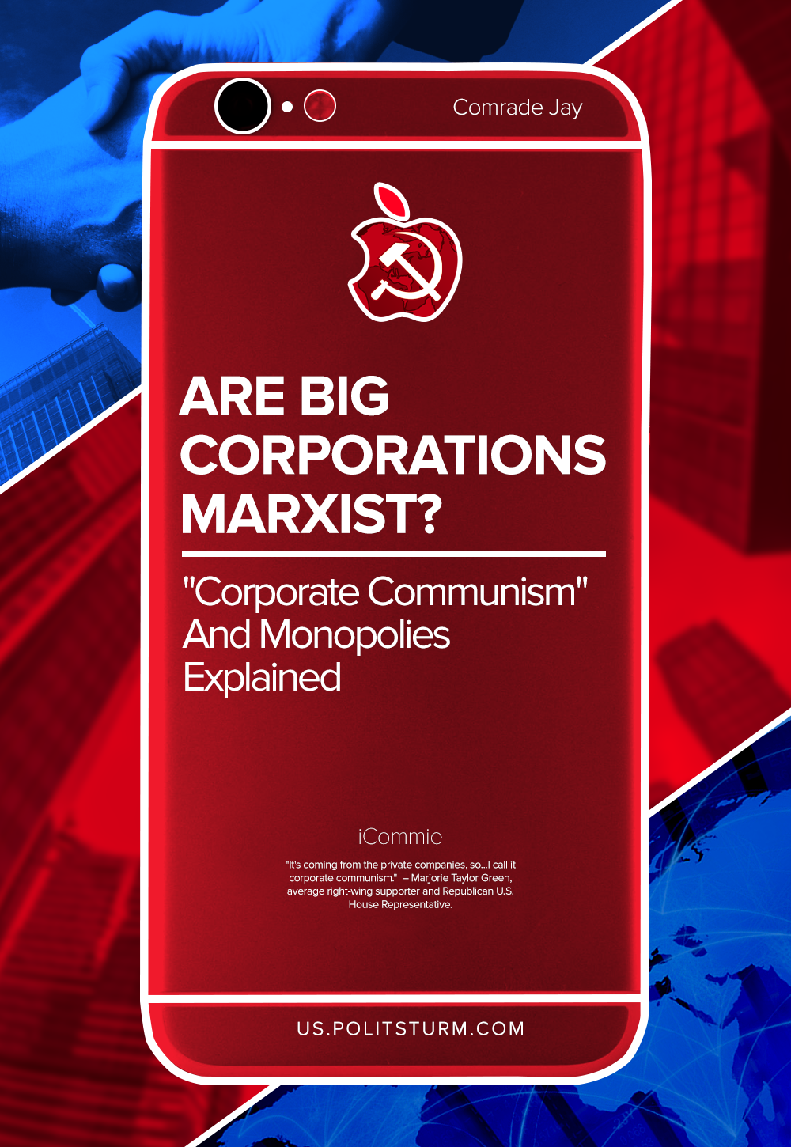

Original article
2021-09-16
11 min read

Are big corporations actually Marxist? A lot of American right-wing supporters actively promote the idea of “corporate communism”. For example, several months ago, Republican U.S. House Representative Marjorie Taylor Green was joined by others in the American reactionary media and government calling various corporations “communist” for taking actions against the decision of the state of Georgia for changes made in the voting laws of the state.
The accusations of “corporate communism” were directed primarily at major league baseball for moving the annual All-Star baseball game out of Atlanta in response to this legislation.
Rep. Marjorie Taylor Greene: “I call it corporate communism. These are private corporations who thrive on capitalism… But yet they are adapting these communist policies, just like the Democrats are.” pic.twitter.com/Bw2A0fow2C
— The Hill (@thehill) March 30, 2021
“It’s coming from the private companies, so…I call it corporate communism.” – Green stated.¹
The idea that capitalist monopolistic formations have somehow evolved into all-powerful communist formations isn’t new. As far back as 2009 Democrat journalist and author Dylan Ratigan coined the phrase “Corporate Communism” as a means of describing the malignancies and antagonisms of capitalist monopolies and cartels.²
Building upon his idea, he subsequently published the book Greedy Bastards in 2012 in which he, like others, builds his arguments on the false a priori ideological deduction that the forces of Soviet socialism and that of Capitalist corporate monopolism are identical.
Copying and pasting hackneyed U.S. Red Scare Cold War ideology reveals the inability of these people to accurately compare and contrast capitalism and communism by way of an objective scientific historical analysis.
So, are monopolies really communist? Let’s take a look.

Corporations and The Formation of Monopolies
Corporations in particular and monopolies in general are modern large capitalist enterprises created specifically by the development of the world capitalism. They have control over industries, markets and the national economy based on a great concentration of production and capital in order to establish monopolistic prices and extract monopolistic profits. Dominance in the national economy is the basis of the influence that monopolies have on all spheres of life in modern countries.
The formation and growth of monopolies are historically inextricably linked with the development of free competition capitalism into monopoly capitalism. This process started in the second half of the XIX century. In his penultimate work “Das Kapital”, Karl Marx articulated this capitalist economic principle this way:
“The battle of competition is fought by cheapening of commodities. The cheapness of commodities depends…on the productiveness of labor, and this again on the scale of production. Therefore, the larger capitals beat the smaller.” Further, the credit system which “begins as a modest helper of accumulation” soon “becomes a new and formidable weapon in the competitive struggle, and finally it transforms itself into an immense social mechanism for the centralization of capitals.”³
The United States were one of the first countries to have monopolies established. Corporations were created in the United States in the last period of the XIX century (1860s – 1890s) and early years of the XX century. However, they didn’t appear from nowhere. Most of the big companies we know today, from “Ford”, “Standard Oil” and “U.S. Steel” to “Google”, “Apple” and “Microsoft” started as small enterprises. The last ones especially like to point to the fact that the creators of these monopolies started with making stuff in the backyards of their houses.
Error loading image
There were lots of such small “Co.” and “Ltd.” organizations. But the ones we all know today were not just smart, but also lucky, dexterous and unprincipled enough to become the first in the market competition and conquer their place under the sun.
“Free competition is the basic feature of capitalism, and of commodity production generally; monopoly is the exact opposite of free competition, but we have seen the latter being transformed into monopoly before our eyes, creating large-scale industry and forcing out small industry, replacing large-scale by still larger-scale industry, and carrying concentration of production and capital to the point where out of it has grown and is growing monopoly… This transformation of competition into monopoly is one of the most important — if not the most important — phenomena of modern capitalist economy.” – stated Lenin in his famous work “Imperialism, the Highest Stage of Capitalism.”⁴
Capitalist enterprises and economies require stable and predictable labor, social, and economic conditions, or guarantees, to survive. This is precisely why capital requires the force of governments to ensure this stability. Nevertheless, putting aside state power for the protection of dictatorship of capital and private property, a primary means through which corporate capitalist formations survive and dominate the socio-economic conditions is through creating monopolies.
Monopolies permit the dominant capitalist economic forces to succeed through acquiring weaker or vulnerable competitors in any given economic segment in order to expand production and market share as well as through cutting production costs by the use of new forms of production technology. Most critically, of course, corporations seek stable rates of profits by reducing the labor costs of manufacturing.
This battle keeps going on in the modern world. Monopolies, i.e. big capitalists suppress smaller ones and compete with other corporations. Moreover – they actively participate in the political life of the modern states through bribes, state apparatus or open “lobbying” system, like in the United States.
Error loading image
So, monopolies develop out of the competitive and predatory nature of capitalism. Subsequently, they become dominant economic forces that can exert pressure and influence upon governments and society itself. Monopoly capitalism becomes imperialist in the sense that they drive political policies for its own interest and are able to engage the power of the governments for protection, social and economic stability, survival, and enlarging their dominion.
One might ask – are monopolies inevitable? The development of the capitalist mode of production and exchange has clearly demonstrated that this is, indeed, the case. As monopolistic conglomerations consolidate their economic position, large scale enterprises, be they industrial, retail, or finance, force out or subsume smaller enterprises. As these monopolies consolidate, their influence over all economic and political life increases even to the point of the merging, intermingling, and support of national governments for the purposes of economic control and protection. Practically speaking, the fusion of monopolistic capital and the organ of a government becomes a form of state monopoly capitalism.

The Roots of the “Corporate Communism” Idea
Because corporations, by way of monopolies, have assumed authoritarian proportions of economic, political, and social control, the feelings of victimization of the petty bourgeoisie (small capitalists) and the working class intensify. The political and economic disempowerment, alienation, and loss of social status turn them against corporations.
But how does it end with anti-communism? They see corporate influence and authority, but lack of the workers’ political power, domination of the petty-bourgeois theories throughout the history of the United States and massive anti-communist propaganda that has been formulated and perpetuated through the American educational system and propaganda organs of the government and media for the last 70 years lead to the strange yet expected outcome – the communism being blamed for the problems of capitalism.
Error loading image
However, any centralized control that capitalist corporate and finance monopolies may exert upon the consumers and the workers have nothing to do with providing goods and services for the benefit of everyone in society but has everything to do with increasing the rates of profit for a relatively small capitalist class.

Monopolies as the Basis for Socialism
We could see that monopolies emerge under capitalism and operate according to the rules of the market, i.e. the rules of capitalism. Big corporations are a true symbol of one of the contradictions of the modern world – contradiction between the social nature of production and the private nature of appropriation.
It may sound funny, but there is some truth in rightists’ lies: corporations do prepare basis for socialism by uniting workers in one industrial complex and by making technological progress. Lenin clearly pointed on that “paradox”, which turns out to be a logical conclusion:
“…what is the state? It is an organization of the ruling class…if a huge capitalist undertaking becomes a monopoly, it means that it serves the whole nation. If it has become a state monopoly, it means that the state directs the whole undertaking.
In whose interest? Either in the interest of the landowners and capitalists, in which case we have not a revolutionary-democratic, but a reactionary-bureaucratic state, an imperialist republic. Or in the interest of revolutionary democracy — and then it is a step towards socialism.
For socialism is merely the next step forward from state-capitalist monopoly. Or, in other words, socialism is merely state-capitalist monopoly which is made to serve the interests of the whole people and has to that extent ceased to be capitalist monopoly.”⁵
However, it doesn’t mean that monopolies can evolve into socialism themselves. Joseph Stalin wrote:
“The domination of finance capital in the advanced capitalist countries…the export of capital to the sources of raw materials…the omnipotence of a financial oligarchy, which is the result of the domination of finance capital-all this reveals the grossly parasitic character of monopolistic capitalism, makes the yoke of the capitalist trusts and syndicates a hundred times more burdensome, intensifies the indignation of the working class with the foundations of capitalism, and brings the masses to the proletarian revolution as their only salvation.”⁶
This salvific struggle for freedom and liberation, however, can only be effective if the workers are organized as militant, disciplined, and ideologically educated revolutionary class, if they have a vanguard – truly Communist party.

Conclusion
Are big corporations Marxist? No, they aren’t, as they are a result of the development of the small enterprises, they developed under capitalism and operate under capitalism. The development of capitalist economies has greatly intensified the contradiction between the tendency towards planning, which is the internal organization of the activities of a large industrial association, and the anarchy of the capitalist economy. As monopolies grow, it deepens, giving rise to new systems of economic regulation in the form of intersectoral monopoly unions, state regulation and programming.
However, under capitalism this contradiction can never be resolved. Though monopolies prepare the ground for socialism, it cannot, and it will not, simply occur or evolve organically. It is necessary for the working class, the truly revolutionary class, to learn and organize in the party to seize the means of production and liberate itself from the contradictions and parasitic metastasis of capitalism.
SOURCES
¹ https://www.newsweek.com/marjorie-taylor-greene-says-fighting-corporate-communism-brings-gop-factions-together-1580902
² https://www.businessinsider.com/corporate-communism-is-killing-us-2009-10
³ Karl Marx “Capital” Chapter 25, Section 2.
⁴ https://www.marxists.org/archive/lenin/works/1916/imp-hsc/ch07.htm
⁵ https://www.marxists.org/archive/lenin/works/1917/ichtci/11.htm#v25zz99h-360
⁶ Joseph Stalin “Foundations of Leninism” Chapter 3.
ADDITIONAL RESOURCES
https://www.salon.com/2012/07/17/the_new_totalitarianism_how_american_corporations_have_made_america_like_the_soviet_union_salpart/

Original article

