Applebee's and Taco Bell Franchise Executive Claims Capitalists Will Benefit From Higher Gas Prices
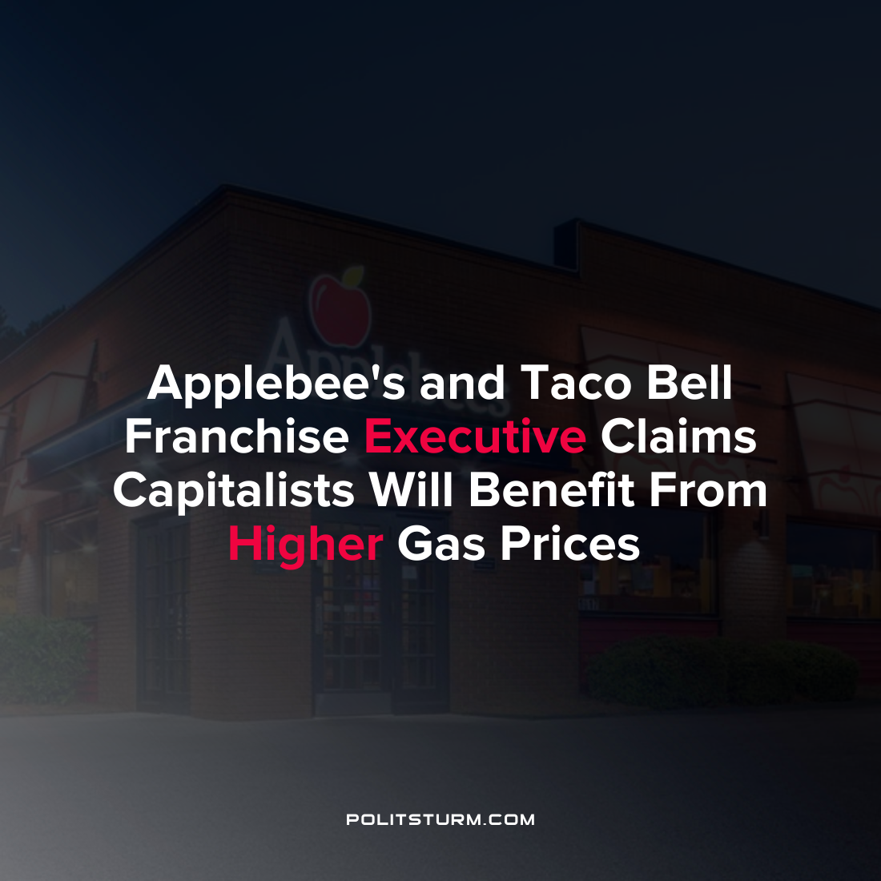

Original article
2022-03-25
1 min read

One of the executives of American Franchise Capital which owns 67 Taco Bell and 50 Applebee’s restaurants had an email leaked which expressed their opinion on rising gas prices and its effects. Namely, the executive saw the rising prices as an opportunity for the capitalists to offer lower wages and exploit a larger quantity of laborers.
“Most of our employee base and potential employee base live paycheck to paycheck. Any increase in gas prices cuts into their disposable income. As inflation continues to climb and gas prices continue to go up, that means more hours employees will need to work to maintain their current level of living…This benefits us as prices rise, people who were relying on unemployment money, simply will have less money to spend. It will force people back into the workforce.”
This view expresses that inflation presents an opportunity for the capitalists to exploit workers competing against each other in the labor market, driving down wages and bolstering corporate profits. The executive was elated that current conditions would drive more workers “into the hiring pool”, which means drawing them out of the army of the unemployed into the labor market and putting downward pressure on wages. The capitalist class knows that the conditions that are unfavorable for the working class create opportunities for them to exploit and profit at their expense.

Error loading image
Error loading image
Source: https://twitter.com/MorePerfectUS/status/1507417295739629571/photo/1
Source: 1

Original article

