Apple is Changing Indian Labor Law
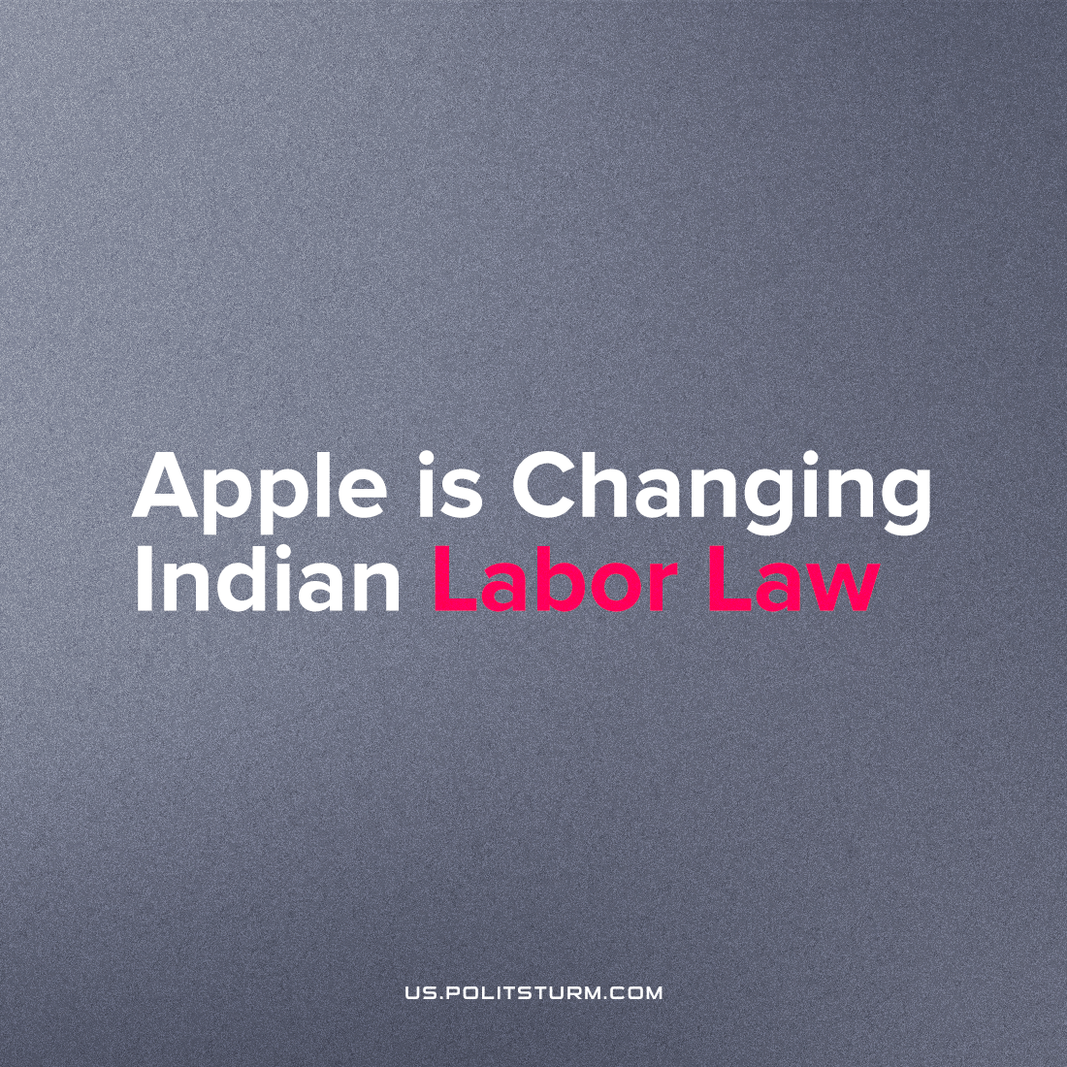

Original article
2023-03-28
1 min read

Bloomberg reports Apple is about to change Indian labor law. The reform plan includes, among other things, an increase in the length of the working day. [1] It is legitimate for the tech giant to want to use as much cheap labor as possible. But should Indian workers assume their government will not bend to the will of foreign company? Unfortunately not, seems like Indian government supports idea of slave exploitation of their citizens. For Indian capitalists It’s profitable as well. Such decisions can help to intensify industry and increase profits.
Quite often bourgeois economists claim actions of monopolies are tightly controlled by states. However, this news demonstrates just how wrong this statement is. American capital in the form of Apple literally dictates its will to Indian state and government by lobbying profitable laws.

What is the reason?
Imperialist conflicts and competition exacerbate the contradictions of capitalist society. China claims to be world greatest economy leader for western businessmen it is no more a place for a profitable apply of capital, it is a great competitor. This forces monopolists like Apple to move production to other countries. More than that, imperialistic competition can even cause war conflict, this is why disagreements lead to military tensions.
In the end, only ordinary people will suffer from such decisions. Indian workers will now be forced to work 12 hours a day. Also, India plans to use female labor, which is also very profitable for Apple, because female workers are paid much less.
“In electronics manufacturing, thanks to the hygienic environment and the roles in the units, women are a natural fit. Women have superior manual dexterity, which is necessary for high-precision electronics assembly.”
If we turn to history, we will see that the methods of capitalism used to intensify the exploitation of workers in the 19th century are not so different from those of the 21st century. Capitalism brings ruin, exorbitant, grueling labor to the working class. Only labor creates the rich. That is the reason labor is to be increasingly appropriated by capitalists – the wealth of the capitalists is the poverty of the proletariat.
Source: 1

Original article

