Apple and Google Fined for Breech of Anti-Trust Laws


Original article
2024-03-16
2 min read

On April 4, the European Union Commission confirmed the imposition of a record $1.95 billion (€1.8 billion) fine on Apple for violating antitrust laws and abusing its dominant position in the market for music streaming services and apps. This development was just the first chord in a massive symphony, as the US Department of Justice is also preparing a lawsuit against the company. The investigation ranges from the integration of the iPhone and Apple Watch to the digital payment system and the use of green text bubbles to differentiate between Android and iMessage messages[1] [2].
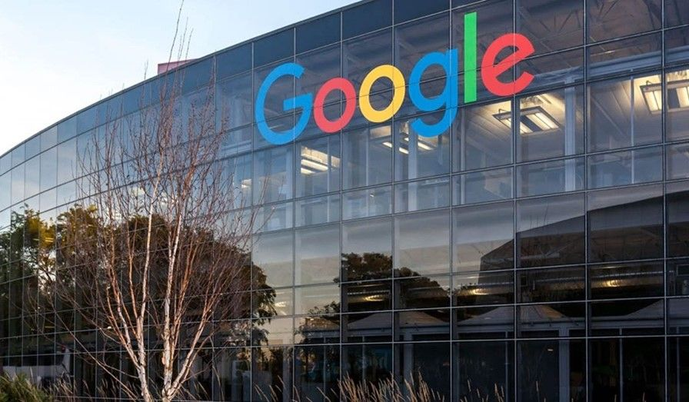
The Googleplex, the headquarters of Google and its parent company, Alphabet Inc.
The growing wave of antitrust actions also includes cases against Google in the areas of digital advertising and unfair use of its price comparison service for its own advantage over European competitors, with a $2.7 billion (€2.42 billion) fine confirmed on January 11[3]. In addition, lawsuits against Amazon, accused of using anti-competitive strategies to maintain its monopoly power, are part of the current political landscape. Both companies are also affected by the European Digital Marketplaces Act, which tightens the requirements for major players in advertising technology. As of March 7, Apple, Alphabet (Google), Meta, Amazon, Microsoft and ByteDance - the six companies that were designated by the Commission in September 2023 - are required to fully comply with all requirements under the Digital Markets Regulation. In fact, the Digital Markets Act (DMA) — approved by the European Parliament on July 5, 2022, along with the Digital Services Act (DSA) — "aimed at increasing competition in digital markets" has come into force[4].
Although bourgeois experts say that Apple and other techno-giants will be forced to adapt their business practices, which may entail long-term changes in the economic landscape, we see that in practice such fines have limited impact. Economic resetting is inevitable, but it will primarily result in increased monopolization of markets and the suppression of small companies by larger ones that have already taken their "place in the sun." These costs will inevitably be covered by wage cuts or mass layoffs, which are traditional methods of intensifying labor exploitation.
From a political point of view, such fines are merely cosmetic measures designed to divert attention from the fundamental problem of the monopolization of all markets. The state is an instrument of violence in the hands of the ruling class to protect its interests. Even with huge fines, capitalist monopolies will continue to exert influence and profit by reducing workers' wages and expanding markets. In this context, capitalism continues to demonstrate not only the relevance but also the scientificity of Marxist theory, which proves the inevitability of monopolization within the capitalist system. Thus, we point out that current anti-monopoly efforts represent only a superficial solution, fail to overcome the basic contradictions of capitalism or play their role in maintaining monopolistic policies. The only way to eliminate capitalist monopolies is the transition to socialism.
Sources:
[1] morningstar.com - “EU's record Apple antitrust fine is just the start of a Big Tech regulatory crackdown this year” dated March 9, 2024”;
[2] eunews.it - “Multa Ue da 1,8 miliardi a Apple per abuso di posizione dominante nel mercato dello streaming musicale” dated March 4, 2024;
[3] edition.cnn.com - “EU court should uphold Google’s $2.7 billion antitrust fine, top adviser says” dated January 11, 2024;
[4] italian.tech - “Rivoluzione Apple: su iPhone si potranno installare app da altri Store digitali” dated January 25, 2024

Original article

