Anti-Labor Scalia Confirmed as Secretary of Labor
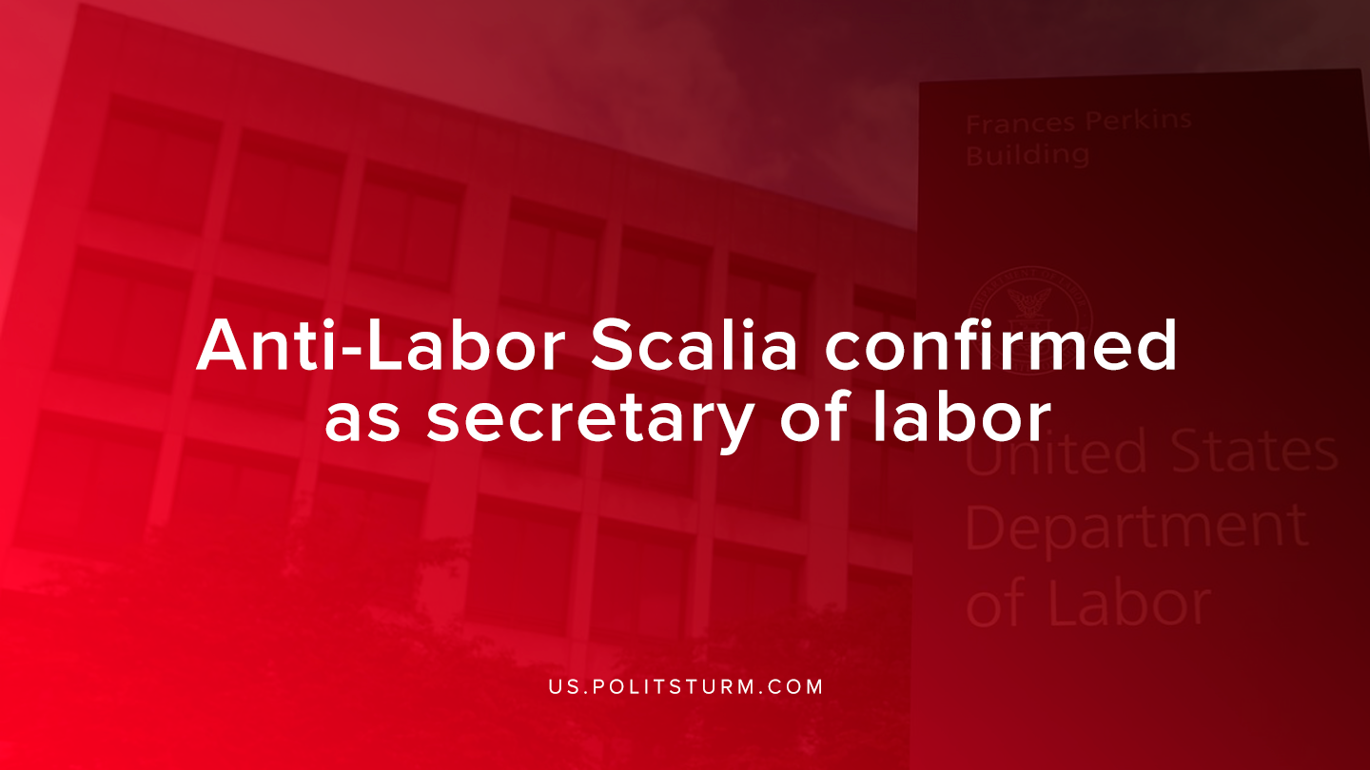

Original article
2019-10-16
1 min read

Eugene Scalia has been confirmed as the secretary of the U.S Labor Department. Scalia was nominated to this position back in August,2019 by Donald Trump. Scalia is a lawyer who has worked at several positions within the federal government and is the son of the late Supreme Court Justice Anton Scalia.
While in private practice, Scalia represented employers against employees in several key decisions. For example, in Retail Industry Leaders Ass’n v. Fielder , Scalia challenged a law that required increased expenditures on employee health care.
Scalia also touted his success in loosening regulations in the finance sector by challenging SEC regulations regarding mutual funds and fixed indexed annuities.
Scalia is a contributor to the ‘Federalist Society’ which is an organization of conservatives and libertarians focused on influencing public policy by promoting “individual liberty, traditional values, and the rule of law”.
Scalia has spent his legal career defending corporations and business interests as a lawyer for the Retail Industry Leaders Association. Scalia is now responsible for recommending new labor-related legislation, enforcing current legislation, enforcing workplace safety, among other responsibilities.
Scalia is undoubtedly a representative for capital and yet he is being appointed to the Secretary of Labor. This is yet another example of the United States demonstrating that the state exists as a dictatorship of the bourgeoisie and represents their class interests. The “individual liberty” that the conservatives support is the freedom to exploit, the values of liberalism, and the rule of the capitalist class.
Sources: 1, 2 ,3, 4, 5

Original article

