The September Anti-Fascist Uprising in Bulgaria, 1923
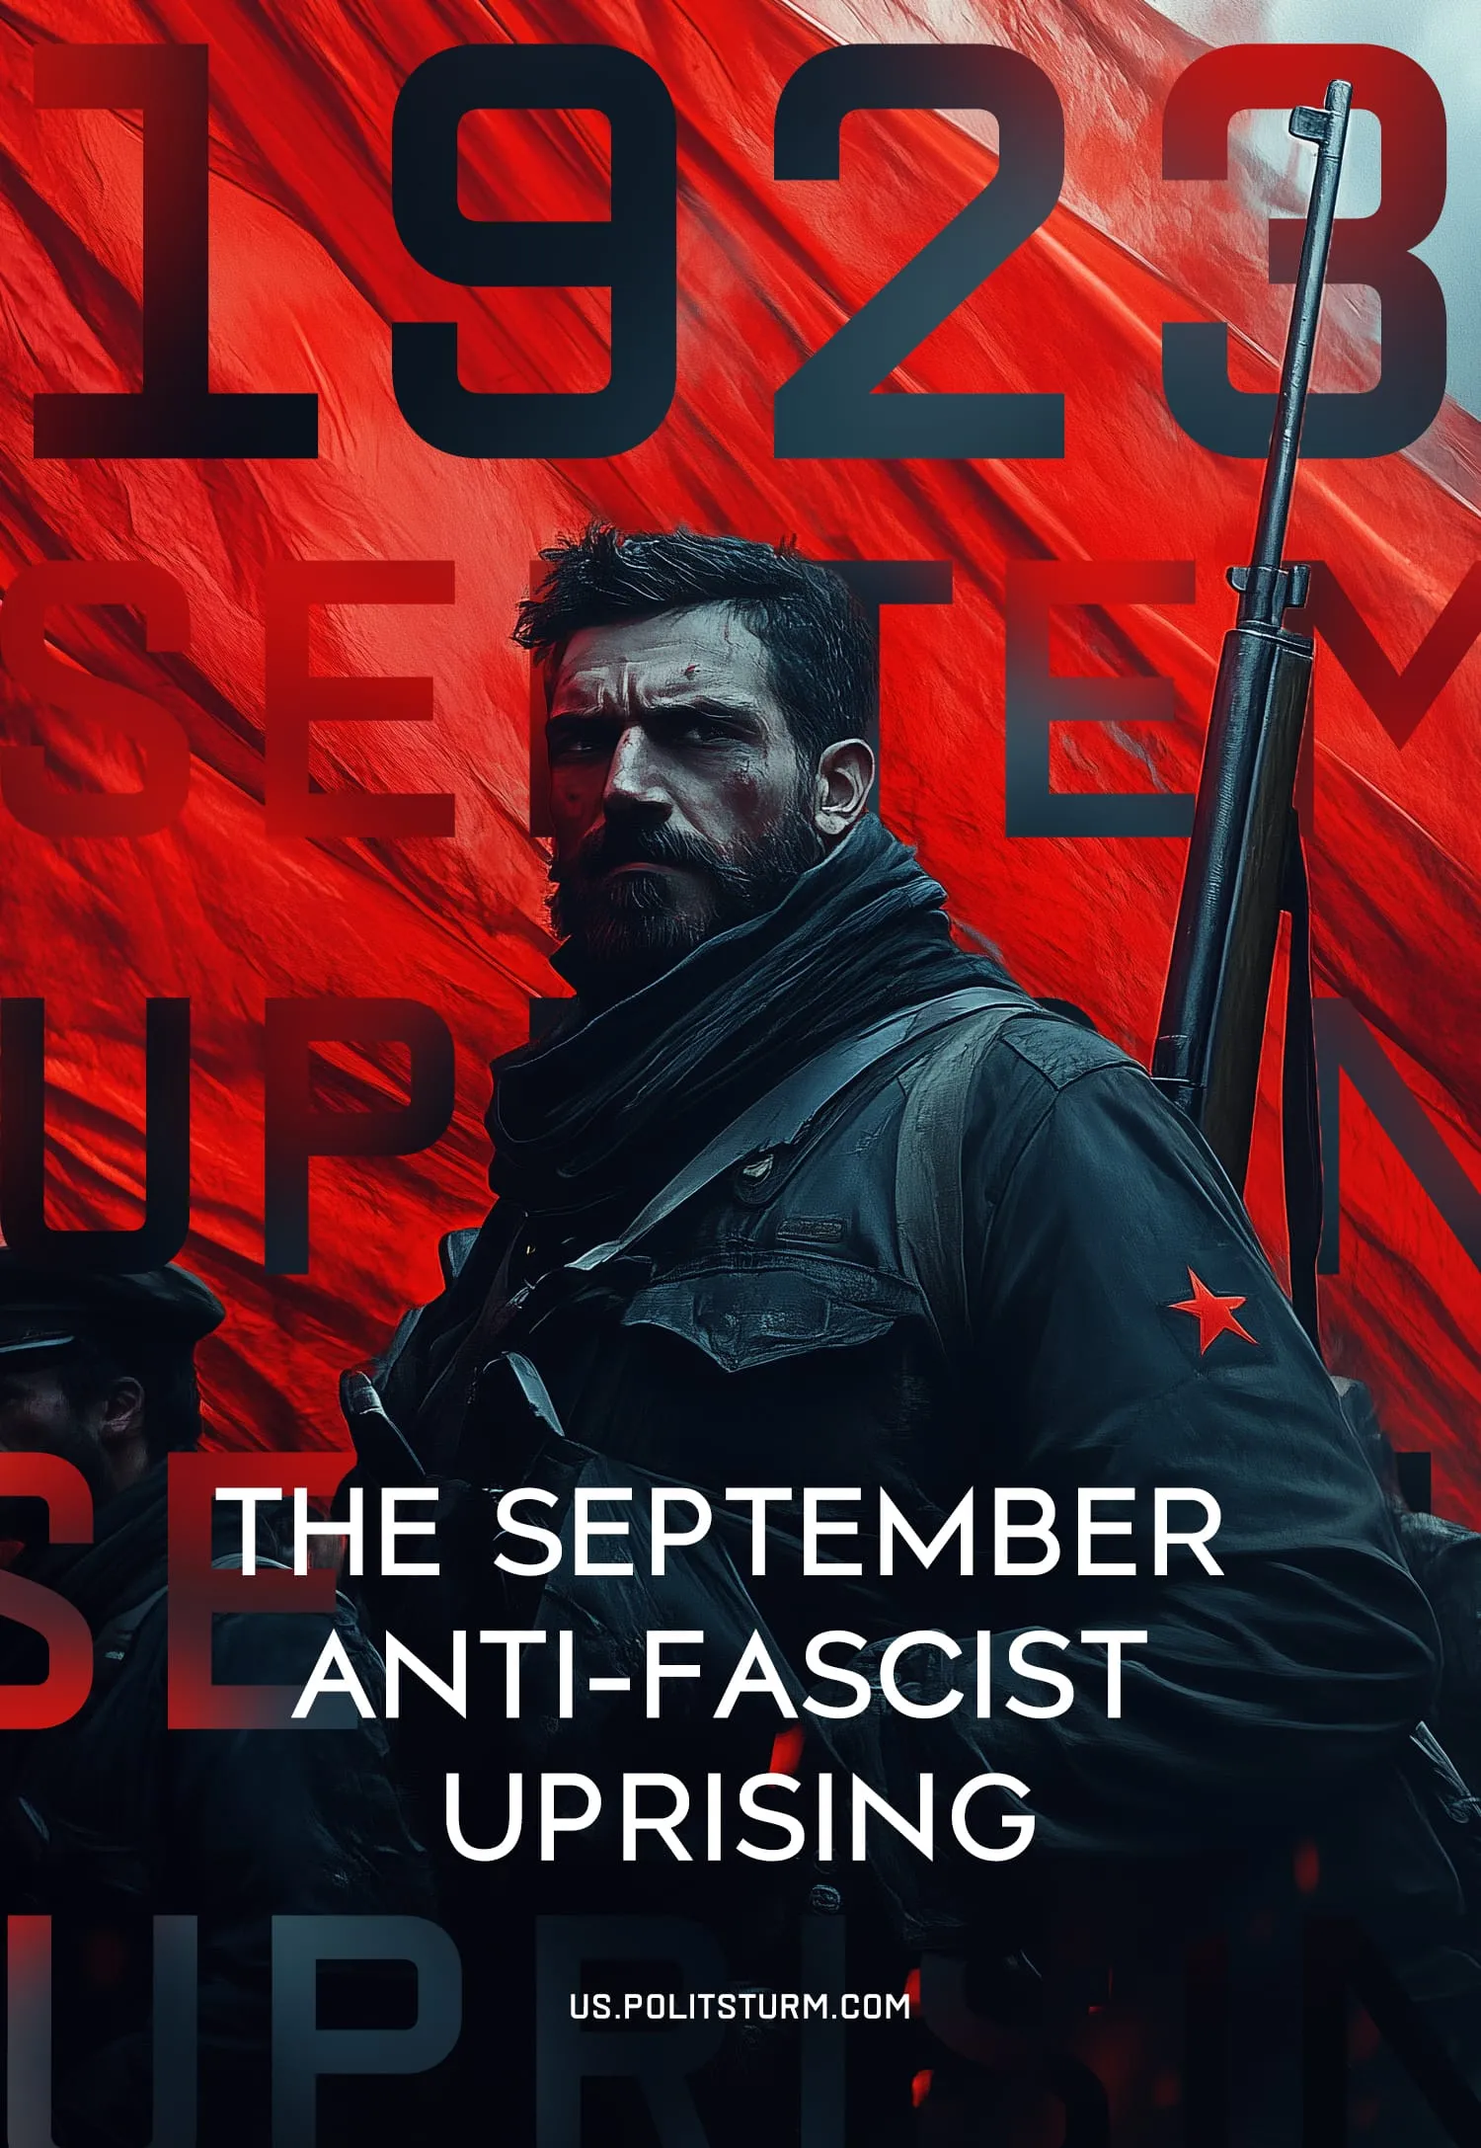

Original article
2024-10-26
68 min read

1923 marked the first conflict on the Balkan peninsula between the workers and the emerging European fascism. The uprising was a response to the terrorist dictatorship of military circles that came to power in a well-prepared coup in the summer of that year.
This event had a significant impact on the development of the Bulgarian communist and European revolutionary movement, served as a lesson for Marxist parties and once again demonstrated the true class position of the bourgeoisie. Georgi Dimitrov later said that without the 1923 September Uprising, "neither the creation of the powerful Eastern Front nor the historic victory of September 9, 1944 (where the fascist government was overthrown) would have been possible".
The lessons of the September Uprising, together with the examination of the mistakes made by the Bulgarian Communist Party in the preparation and execution of the uprising, as well as the study of the roots of these mistakes, provide an important case study for present-day communists.

1. The National liberation movement and the establishment of capitalism in Bulgaria
In Bulgaria, which had been under Turkish feudal rule for several centuries, the national movement emerged in the 1870s. During this period, the Bulgarian bourgeoisie began to fight for the freedom of the national language, culture, and political autonomy which would allow it to step into new capitalist relations within a unified national market.
As early as 1833, there were several big peasant uprisings against the Turkish feudal lords, their cruelty and unbearable taxes, but the national character of this bourgeois-democratic movement developed much later.
In its struggle for the national market in the 1870s, the Bulgarian bourgeoisie rallied the support of the peasantry, the most numerous class. One of the key slogans was the demand for an independent church, which for the Turkish authorities signaled the desire for recognition of Bulgarian nationality and administrative autonomy.
At the same time, Turkish rule in the Balkans weakened due to internal issues, resulting in the Turkish government's ineffectiveness and economic powerlessness in the face of Western European capital. By carving out its niche in Bulgarian markets, European capital intensified competition with local Bulgarian producers, worsening the conditions of local peasants and craftsmen.
The Russian victory in the Russo-Turkish War of 1877–1878 played a significant role in the bourgeois-democratic revolution in Bulgaria. The Treaty of San Stefano led to the creation of a large Bulgarian national state.
The class reorganization of Bulgarian society, typical of bourgeois-democratic revolutions, occurred after Turkish feudal landlords and some peasants fled the advancing Russian army. Bulgarian peasants took over the abandoned lands and estates, thereby becoming a class of small landowners free from Turkish feudal dependency. However, the abolition of the old property relations inevitably led to the emergence of new contradictions.
With the spread and expansion of capitalist relations to Bulgarian villages, the peasantry began to differentiate rapidly. By 1908, 4.4% of the largest landowners with plots over 20 hectares owned 26.4% of the country's total land area, while the poorest 56.7% of all landowners owned only 16.7% of the land [1]. In addition, the confiscation of cattle by the Turks upon their departure led to the emergence of a class of kulaks — cattle owners who leased their working cattle to poor peasants.
Another aspect of capitalist development in predominantly agrarian Bulgaria was the rapid growth of peasant debts. The entire pre-war history of the country was marked by a steady increase in peasant poverty, aggravated by multiple severe crop failures. In 1923, despite relatively favorable conditions for the peasants, their debts from promissory notes, mortgages, and pledges exceeded 1 billion levs [1]. For comparison, the total value of the country's national property before the war was 10 billion levs. Pauperized peasants could not find work in the emerging industry and swelled the ranks of impoverished "hired hands with a plot".
Economically underdeveloped, with a large proportion of small peasant farms and no mass proletariat, Bulgaria entered the era of imperialism.

2. Bulgaria in the era of imperialism
During the period of Turkish hegemony, Western European capital was granted access to Bulgarian markets. Despite Turkey's dependence on European countries, which extended to Bulgaria, it was not possible to stop the development and deepening of capitalist relations.
By the 1890s, after liberation, Bulgaria had accumulated the capital necessary to organize large-scale industry. The bourgeoisie demanded more protectionism from the government and got it in the form of tariffs on foreign goods ranging from 25% to 100% of their value. At that time, the country's industry was focused on the processing of agricultural products and the production of textiles.
The economically underdeveloped Bulgaria needed foreign loans to build up its industry, and it got them. Along with the loans, it also became dependent on the German, French, and Austrian banking capital, which tried to drain all the natural wealth of the country and stifle the development of any industry that was unprofitable for them.
At the same time, the first manufacturing proletariat, composed mainly of bankrupt craftsmen and landless peasants, began to emerge. The labor movement began to form its first organizations. The first underground printing press published the works of Marx, Chernyshevsky, and Herzen.
Nikolai Chernyshevsky was a Russian materialist philosopher, writer, and revolutionary democrat. His influential novel "What Is to Be Done?" became a blueprint for revolutionary thinking in Russia, inspiring later socialist movements, including Lenin's. Alexander Herzen was a Russian philosopher and socialist known as the father of Russian socialism. He played a crucial role in developing socialist thought in the 19th century and founded The Bell, a newspaper that advocated for social reforms and greater freedoms in Russia.
Revolutionary elements began to struggle against opportunism and tried to "seize" the periodical press. In 1891 the founding congress of the Bulgarian Social Democratic Party was held.
The economic situation in Bulgaria led the government to develop only those industries that were not in conflict with the monopolies of the West. At the beginning of the 20th century, the processing of agricultural products accounted for 42.3% of production, while heavy industry accounted for only 8.4%. The share of small-scale handicraft products in the Bulgarian industry reached 75%. The dependence on foreign capital was reflected in their high loan interest rates thereby the need to share profits with it.
The imperialist war of 1914–1918 significantly worsened the situation of the working class: tax rates for the population rose, inflation hit 500-1200%, causing large-scale famine, and the workday length was extended under the guise of supporting the war effort.
By 1918, discontent with the war and revolutionary unrest in the army had grown. After the defeat at Dobro Pole in September, the Bulgarian army, exhausted by three years of war, abandoned its positions and turned back home. The anger of the masses and the military was directed against Ferdinand's government. In the town of Radomir, where many military units had gathered, an uprising began. The soldiers proclaimed a republic and marched towards Sofia.
Although the Radomir Uprising was crushed by German battalions because it failed to find support in the country, it was exactly this uprising that forced the leaders of the Entente to sign an armistice to ease the revolutionary situation in the Balkans. In 1918, Bulgaria, which had fought on the side of Germany in World War I, was occupied by the Entente countries, which temporarily stabilized the fragile position of the monarchy.
The Entente occupation, the collapse of industry, the impoverishment of the peasantry, and the aftermath of the war crippled the Bulgarian economy. The recent uprising, severe urban unemployment, falling wages, bourgeois speculation, and, on top of that, the huge reparations the country had to pay under the Treaty of Neuilly, all contributed to a new revolutionary crisis.

3. The Growing Revolution. Coming to power of the Agrarian Union.
The situation in Bulgaria became more and more revolutionary. Strikes on an unprecedented scale often led to clashes with police and military forces. Meetings and rallies became common. Peasants who had returned from the war overthrew the old local authorities and refused to pay taxes. The revolutionary press began to grow. The bourgeois parties, completely discredited by the war (and their support for it), tried to appease the masses by forcing the abdication of Emperor Ferdinand. Petty bourgeois parties, including the "broad" social-democrats and the agrarian union, were also brought into the government.
The Bulgarian Agrarian Union was formed in 1899 in response to the discontent of the peasant masses due to poverty and worsening economic conditions. By the beginning of the war, it had become a significant political force. This organization brought together different groups of peasants who were dissatisfied with the actions of the government during the Balkan Wars of 1912–1913. The agrarian crisis and the growth of the peasant movement after World War I gave the Agrarians a solid base and a dominant position in the new government. In contrast to the Communist Party, which also had significant influence among the working class but advocated for a Marxist-oriented revolution, the Agrarians represented the peasantry and aimed for reforms within a rural, agrarian context.
Although the wealthy peasants that could afford to exploit labor themselves (kulaks) played a leading role in the union, the majority of the party was composed of poor and middle-strata peasants seeking to free themselves from exploitation by big capital. 51% were poor peasants (with plots of less than 5 hectares), 32% were middle-class peasants (with plots of 5-10 hectares), and 14% were kulaks (with plots of 10-20 hectares).
The class composition of the union was reflected in its contradictory program and ideology. The ideologist and head of the union, Alexander Stamboliysky, put forward the main task of protecting the interests of the village against both the bourgeoisie and the urban proletariat [1]. His views on the opposition between the working class and the peasantry were based on a complete misunderstanding of the principles of class struggle. Stamboliyski believed that capitalism should be opposed by a system of cooperatives without abolishing private property. In his view, power should belong to the "labor class," — primarily the peasantry.
Thus, the leadership of the reformist Agrarian Union promoted the interests of the kulaks. However, it always had to take into account the interests of the middle and poor peasantry as well.
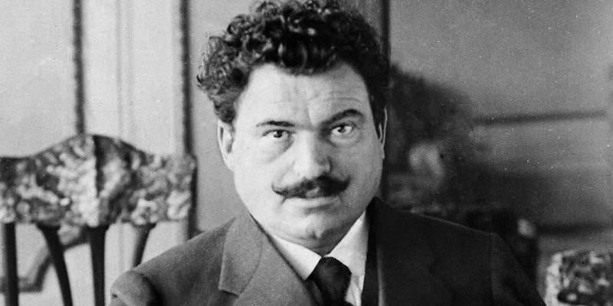
Aleksandar Stamboliyski
In the parliamentary elections of August 1919, the Agrarians won 30% of the vote and became the most influential party in the government. Their participation in the suppression of the national railway workers' strike at the end of 1919 was a guarantee of their loyalty in the eyes of the Bulgarian capitalists and the Entente. On the one hand, the union sought allies for reform, while on the other a fear of the growing labor movement and the influence of the Communist Party led the union to align itself with the bourgeois parties. This coalition took the form of the National Assembly in October 1919.
Once the strike movement of the late 1919 and early 1920 was crushed, the Agrarian Union decided that there was no longer any need for traditionally bourgeois parties. To avoid discrediting itself in the eyes of the peasantry and to push through reforms, the National Assembly was dissolved on February 20, 1920, on the initiative of the Agrarian Union. In the early elections of March 1920, the Union won 40% of the vote.
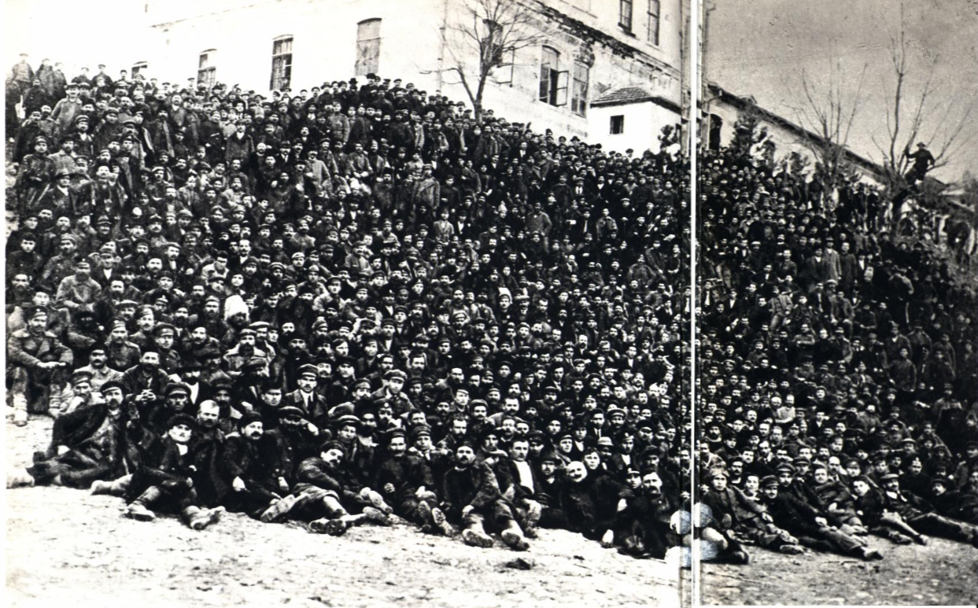
Striking railway workers at Gorna Oryahovitsa station, imprisoned in the barracks of the town of Tarnovo. 1919
Through the law of obligatory voting, which was used to intimidate the population, and the dissolution of municipalities where the Communists had won a majority, the Agrarian Union secured an absolute majority in the new National Assembly. On May 21st, 1920, an all-Agrarian single-party government was formed [2]. The Union now had the opportunity to implement its program.
The landowners took full advantage of this. Initially, Stamboliyski and his union enjoyed the loyalty of the bourgeois parties. But things did not go as planned. The union's policies severely affected the interests of the bourgeoisie. In 1920–1921, they passed a law on land ownership that confiscated surplus land above a certain limit. They also enforced universal compulsory labor service and a state monopoly on the bread trade. Military profits and large private homes were also confiscated. Although most of the measures were not fully implemented, the actions of the Agrarian Union had a significant impact on the capitalists’ interests.

4. The Bulgarian Communist Party
During the rise of the revolutionary movement in 1903, the Social Democratic party split into a left-wing representing the revolutionary tendency - the "narrow socialists" (Tesnyaki) — and a right-wing — the opportunist "broad socialists". The Tesnyaki fought against the apparent opportunism of the "broad socialists", while at the same time making a number of significant mistakes of their own. In 1905, the party expelled a group of "anarcho-liberals," and in 1908 the "progressive" group, which adhered to the principles of broad socialism, was also expelled.
The Tesnyaki achieved a lot in leading the workers' movement, spearheading the massive strike movement of 1905–1906 and putting the principle of party leadership over trade unions into practice.
During the imperialist war, the Tesnyaki remained committed to the principles of internationalism and fought decisively against social chauvinism in the press, at anti-war rallies and meetings. They exposed the predatory nature of the war from the parliamentary tribune, fought against war loans, and opposed the policy of civil peace, for which they were repressed by Ferdinand's government. The ideological link between the Tesnyaki and the Bolsheviks was manifested in their support for Lenin's line and their break with the opportunist social-chauvinist parties of the Second International.
For all its merits, it was not a Bolshevik party. Beginning in 1905, the party organ "Novoye Vremya" (“New Time”) served as a platform for criticism of Lenin and the Bolsheviks. On issues related to the 1905 Russian Revolution, they sided with the Mensheviks. The Tesnyaki accused Lenin of misunderstanding the driving forces of the bourgeois revolution and characterized the Bolsheviks as Jacobin, bureaucratic ultra-centralists. The Bolsheviks' preparation for armed rebellion was seen as a Blanquist tactic. The rebellion in their eyes could only be spontaneous, and the systematic work of organizing it was seen as pointless.
Party leader Blagoev repeatedly declared that their centralism had nothing to do with the "Blanquist-Bonapartist" centralism of Lenin. The idea of transforming a mass strike into a rebellion was interpreted by the Tesnyaki in a centrist, vacillating spirit - as a way to push through particularly drastic reforms without going beyond the bounds of bourgeois legality in the most democratic countries. A mass strike was seen as something separate from a revolution, and there was no talk of transforming it into an armed rebellion.
At the beginning of the imperialist war, the Tesnyaki were in confusion. They thought that the only force capable of stopping the war was the German Social Democracy, which had voted for war loans. General mobilization and the slogan "the fatherland is in danger" supposedly paralyzed the revolution in Germany. In their view, the vote for war credits was something close to a violation of Social Democratic morality [1].
Centrism also manifested itself at the Zimmerwald conference. They called for a fight for peace. Their delegation did not join Lenin's group and continued to advocate for the restoration of the Second International, with an agreement between various centrist groups.
Anti-war efforts failed as repression intensified: the party was unable to launch broad underground activities. It was not until the end of the war that it was able to resume normal work within the boundaries of democratic concessions. In 1917, the Tesnyaki finally raised the slogan of turning the imperialist war into a civil war.
The Tesnyaki party was not a party of the proletarian revolution. Its centrism and misunderstanding of Bolshevik tactics were due in part to the backwardness of the Bulgarian workers' movement – the country's proletariat was small and scattered among many enterprises. The numerous and influential petty-bourgeois intelligentsia became a conduit for opportunism within the party.
The Tesnyaki rejoiced at the February Revolution in Russia but again took a semi-menshevik position. In their view, the February Revolution should begin a long period of bourgeois democracy that would prepare Russia for a socialist revolution.
Although the Tesnyaki supported the victory of the proletariat in the October Socialist Revolution, they did not fully embrace Bolshevik views and felt that the proletariat shouldn't have seized power so soon. They argued that the productive forces in Russia were not yet developed enough to sustain the immediate building of socialism and so supported a protracted period of bourgeois democracy to lay the foundation for socialism, even though welcomed the revolution itself. This semi-Menshevik stance, influenced by Plekhanov's teachings, distanced them from the Bolshevik approach to socialist construction.
The Radomir Uprising of 1918 in Bulgaria came and passed without the Tesnyaki’s involvement.
The Tesnyaki had revolutionary achievements. In 1918, they won a general amnesty for political prisoners. Despite its mistakes, its influence and authority among the working class grew steadily. By March 1919 the party had more than 20,000 members, and by the time of the September Uprising it had more than 40,000. In class composition, however, the party was still 80% peasant [3].
On May 25-27, 1919, the First Constituent Congress of the Bulgarian Communist Party was held in Sofia. All the main points of the program corresponded to the experience of the Russian Communist Party (Bolsheviks). In June 1919, the BKP was one of the first parties to join the Third International, where it became known as one of the largest communist parties in Europe. The party actively opposed Stamboliyski's policies and exposed his demagogy. It also exposed the activities of the White émigré reaction and opposed aid to Denikin and Wrangel. In 1921 the BKP organized aid for the starving in Soviet Russia; in 1922 it succeeded in disarming Wrangel's forces in Bulgaria.
But despite the gradual bolshevization of the party, it remained stuck in its old "tesnyak" positions for a long time. During the process of joining the Comintern, the party developed an opportunist theory of the "three-quarters". The essence of this theory was that since Bulgaria was practically a colonial country, the success of the revolution there depended three-quarters on the revolutions in the big capitalist countries. This theory was supported by the BKP leadership and led to a policy of refusing to prepare for revolution and waiting for a pan-European revolution. This policy manifested itself in the dominance of parliamentary forms of struggle within the BKP.
Work with the peasantry was limited to efforts among farm laborers. The BKP made no attempt to expand its activities within the Agrarian Union or to organize a left-wing faction to represent the interests of the poorest peasants. The BKP did not differentiate the Agrarian Union from the bourgeois parties, viewing the 120,000 small and middle-income peasants in the union as a passive voting mass.
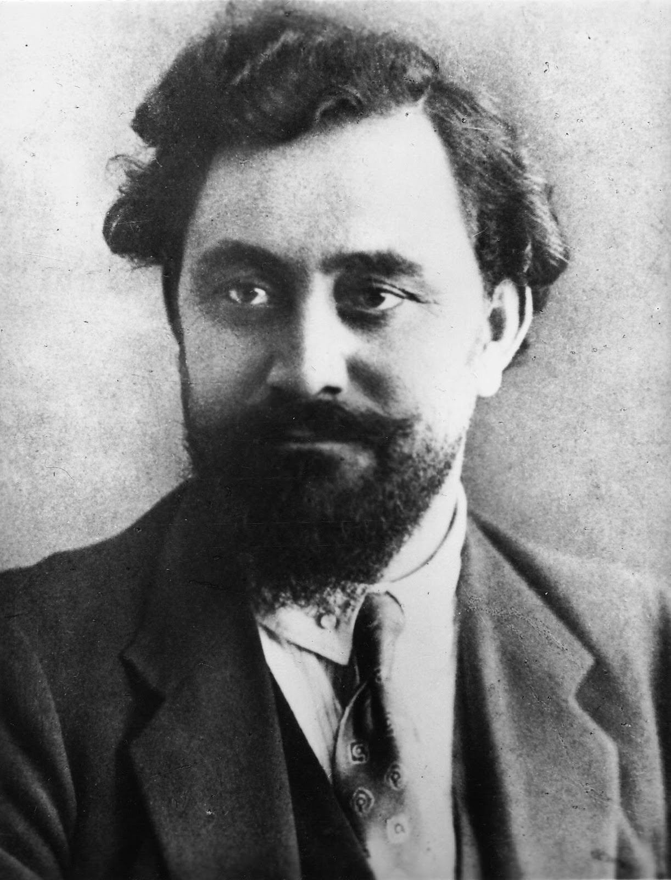
Georgi Dimitrov
The party reconsidered its attitude toward the peasantry only after the brutal suppression of the nationwide political strike organized by Vasil Kolarov and Georgi Dimitrov on July 27, 1919, throughout Bulgaria, followed by arrests, repression, and the closure of the party newspaper, "Rabotnicheski Vestnik". The party needed to connect with the peasant masses, who remained under the influence of the kulak-led Agrarian Union, but the moment was lost.
The party's "tesnyak" past and the mistakes it had made would have a fateful impact on its future struggles.

5. The strengthening of the reaction
The Bulgarian bourgeois parties were defeated in the parliamentary and local elections. They began to consolidate their forces between 1920 and 1922. Fragments of the bourgeois Liberal, Popular, Democratic, and Radical parties formed a "Constitutional" bloc in late 1921. The goal of this bloc was to remove the BZNS (Bulgarian Agrarian National Union, romanized: Bŭlgarski zemedelski naroden sŭyuz, BZNS) from power and crush the revolutionary movement.
In the meantime, fascist fighting organizations were formed by them to prepare for an armed seizure of power. The main support organization of the fascist reactionary bourgeoisie was the "People's Conspiracy," which was organized in the spring of 1922 with funds from the bankers. The fear of the communist movement and the general offensive of capital in Europe made a clash between the bloc and the peasant government inevitable.
The central idea of this group was to create a strong, supra-party, "classless" state. The multi-party system would be replaced by a monopoly party "above all". This was the headquarters of the Bulgarian reaction, led by A. Grekov, A. Tsankov and H. Kaporov.
Such a party was necessary for the Bulgarian capitalists and their political elite. First, the reaction lacked a mass base, which it sought to obtain by including other right-wing parties in the government coalition. Secondly, it was much easier to turn the parliament into an obedient mechanism of the new regime while maintaining the democratic facade.
Later, on August 10, 1923, the People's Conspiracy joined the "Democratic Conspiracy", which was created by the persuasion of A. Tsankov. The latter consisted of the same reactionary right-wing parties, but in a purely decorative role [3].
The bourgeois parties in Bulgaria had no solid social support. They relied mainly on the reactionary officers, whose aspirations and pride were hurt after the defeat in the imperialist war. The central organization of the militarists was the "Military League", founded in 1919, with its imitation of Italian fascism, characteristic of many future fascist groups [4].
Bulgarian fascism developed under the economic and ideological influence of Italy and at the same time became hostile both to bourgeois democracy in the person of the BZNS and to the communist movement under the leadership of the BKP. The fascists made demagogic calls for the modernization of the national economy while promoting revanchist ideas about the creation of a "Greater Bulgaria" [5].
Another important force in the reactionary camp was Wrangel's white emigrants, who settled in Bulgaria after the defeat of the Red Army in the Crimea. About 30,000 emigrants moved to the Balkans. 6,000 of them retained their combat organization and were stationed in 11 strategically important settlements. These units could be mobilized at any time to suppress protests [6].
The Entente had plans to transfer Wrangel's remnants from Bulgaria to Ukraine, which was then the base of the White counterrevolution, to continue the fight against the USSR. The Bulgarian army actively recruited technical specialists for the navy and aviation. Emigrant workers went to factories to produce ammunition [7].
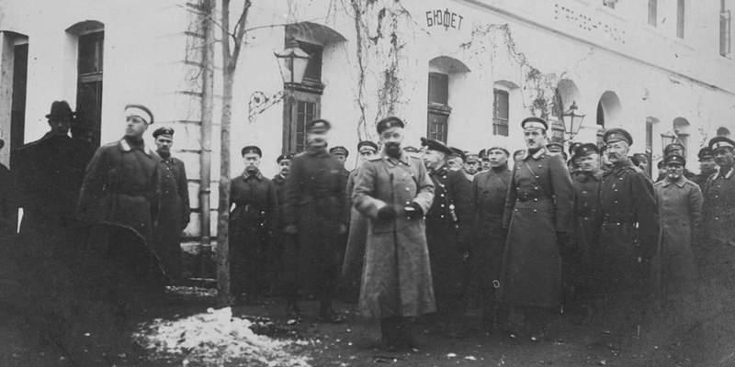
White Guards in Bulgaria
During this period, the conflict between the Union government and Macedonian nationalist organizations fighting for autonomy in neighboring Yugoslavia intensified. It was a significant political and military force, numbering over 8,000 partisans. It was a disciplined organization with extensive experience in underground work. According to the Treaty of Niš between Bulgaria and Yugoslavia, the latter's troops could pursue Macedonian partisans on Bulgarian territory.
The BKP failed to take the correct position on the Macedonian question. Instead of recognizing Macedonia's right to self-determination and thereby gaining the support of the Macedonian units, the BKP refused to make any statements on the matter. The Communist Party believed that the slogan of a Balkan federation in itself would resolve all national tensions. The road proceeding from the right to self-determination enables the possibility of a Balkan federation, not the other way around.
As a result of this mistake, reactionary circles were able to sway a significant portion of the semi-conscious Macedonian armed bands (often called 'cheti') [8] to join the struggle in Bulgaria against the Serbianization policies of Yugoslavia. These fighters, originally from Macedonia, became tools in the hands of the Bulgarian chauvinist big bourgeoisie and Italian imperialists. However, there was a left wing within these groups, with which the Comintern and Soviet Russia maintained contact.
Another point of support for the reaction was the Internal Macedonian Revolutionary Organization (VMRO), created with the help of Bulgarian nationalists. This militant nationalist group was used to overthrow the Stamboliyski government, which was pursuing a policy of rapprochement with Yugoslavia.
Following the example of the Italian fascists, fascist youth organizations were created [9]. Without sparing money, the reactionaries launched the newspaper "Slovo" — an informal organ of the "People's Conspiracy". A joint-stock company was established with money from bankers and monopolists.
In addition, realizing the growing political tension, the police and military also went over to the side of reaction. The right wing of the Agrarian Union, whose members held the most important ministerial portfolios in the period between 1920 and 1922, also gravitated toward the reactionary bloc.
Allied reparations commissions also acted on behalf of the Entente in Bulgaria. The most influential Inter-Allied Commission, consisting of representatives of France, Italy, and England, established control over the National Bank in 1922. Bulgaria was not able to pay reparations.
Later, this commission was given the right to examine and approve the state budget before it was reviewed by the National Assembly. Numerous control commissions further intensified the exploitation of the Bulgarian working class; they were able to interfere in the economic and political life of the country. In 1922, one such Inter-Allied Commission issued an ultimatum to the Stamboliyski government demanding the establishment of effective control over the Bulgarian economy, granting the Allies practical authority over economic matters [10].
Within the framework of the agreement between the Bulgarian big bourgeoisie, the officers' unions, the Macedonian VMRO units, and Wrangel's white émigrés, with the support of the Inter-Allied Commission, pressure was exerted on the government of the Agrarian Union and a plan for an armed coup was jointly developed for the spring of 1922. The preparations were accompanied by provocations. In 1921, members of the Bloc attacked a communist demonstration. In May of the same year, the People's House, a cultural and community center in Sofia, was burned down.
After ideological preparation, a "national" rally of all bourgeois parties was held in Tarnovo on September 17, 1922. The rally was supposed to be a signal for action. However, the government of the peasants was able to take countermeasures: a congress of sugar beet growers taking place nearby broke up the rally. At this critical moment, the BKP pursued a policy of "struggle" against both the Bloc — the urban bourgeoisie — and the Agrarian Union — the peasantry (led by the kulaks) [16,17,18]. The opportunism of this main line of the Communist Party, according to which the Bloc and the union are equal enemies of the proletariat, presented the fight against fascist reaction, embodied in the Bloc, as unnecessary. Stamboliyski's struggle with the Bloc was interpreted as a struggle of the urban and rural bourgeoisie that did not concern the proletariat. In an agrarian peasant country, the conscious refusal to reach out to and ally with the peasantry (especially the poor and middle peasantry misled by the kulaks) isolated the BKP and the working class.
Moreover, it remained a formal, verbal measure of its willingness to oppose the Bloc and to accept the directives of the Comintern. The BKP did not create militant organizations around the party; there were no organs of proletarian self-defense. The BKP's organizational system, inherited from the Tesnyaki, was ideologically and practically unsuited to militant action. The Tarnovo rally took place without the participation of the BKP. The shallow protests of the Communist Party did not go beyond the pages of the newspapers. The appeals of the BKP did not contain any practical instructions. In this context, even the Agrarian Union was a more militant organization.
The activities of the BKP were limited to token measures. The Communist Party, with the help of the "Union of Return to the Homeland," attempted to conduct educational work and agitation among the Wrangelites to oppose the ultimatum of the Inter-Allied Commission. The BKP, which had received secret documents from sympathetic military officers about the impending coup, began a campaign to expose the fascists' intentions [11]. Realizing that things were moving toward the overthrow of the power of the Agrarian Party, Stamboliyski began a rapprochement with the Communist Party. In mid-April 1922, the BKP adopted a resolution on technical cooperation with the Union against the Bloc coup attempts. On May 16, 1922, in its manifesto, the BKP called on all the working people of Bulgaria to unite in the struggle against reaction [12].
However, fearing the strengthening of the Communist Party and the proletariat, Stamboliyski's government did not dare to fully support the workers, did not purge the country of obvious reactionaries, and refused to arm the proletariat. It's these half-measures that reflected the class composition of the Union.
At the same time, the pressure from the Entente increased: an immediate acceptance of the ultimatum was demanded. The leaders of the Constitutional Bloc announced the mobilization of their forces. In August 1922, provocations against the BKP became more frequent, and militant fascist detachments began to form.
In response, communists began to gather in district centers. Attempts were made to arm workers and organize pickets at party clubs. However, the BKP was unable to apply the tactics of a united worker-peasant front. Having decided on a military-technical alliance with the Union, the BKP rejected the possibility of a political agreement with it [12].
On November 19, 1922, with the joint activities of the BKP and the BZNS, a referendum was held on the need for a trial of the arrested ministers - members of the Constitutional Bloc. 651 thousand votes were cast for the trial, 251 thousand against [13]. The victory in the referendum contributed to a certain rapprochement between the BKP and the peasantry.

6. The Rightwards Turn of the BZNS Government
After winning the referendum, the Stamboliyski government concluded that the threat of a fascist coup had diminished. Fearing the strengthening of the BKP's position, it launched a full-scale attack on the communists using the police and penal apparatus. Repression was particularly severe during the April 1923 elections. The Communist Party, on the other hand, merely issued declarations against the Union's terror instead of continuing the struggle against the conspirators. With all its influence, the BKP did not take any measures other than legal methods to resist the repressions.
In May and June 1923, the situation in the country grew tense once more. In the spring elections, the peasants garnered just over half of the votes, while the Communist Party received a quarter. Having received the majority of votes in the parliament, Stamboliyski felt confident in his political dominance [14]. The fascists, fearing that the Union government would introduce new reforms that infringed upon their profits under pressure from the peasantry, sought to establish their dictatorship as swiftly as possible. The conspirators established contact with the monarch who still "reigned but did not rule" — Boris III and secured covert support from the palace.
The Bulgarian fascist leaders received backing from capitalists in England and Italy. Britain, after the French occupation of the Ruhr, aimed to weaken French influence in the Balkans. Mussolini, in turn, sought claims to the Yugoslav territories in the Adriatic. The pro-French and pro-Yugoslav orientation of the Agrarian Union prompted England and Italy to support the conspirators.
Despite the warning of the ambassador in Paris, M. Savov, about the impending fascist coup and the attempt on Stamboliyski's life, the Peasant Party did not take any decisive measures against the reactionary groups. It continued to persecute the BKP [15]. At the next elections to the People's Assembly on April 22, 1923, the reactionary camp suffered a defeat, receiving 33% fewer votes than in the previous elections. The bulk of the peasantry voted for the Agrarian Union out of inertia, living under illusions about the possibility of further reforms.

7. The fascist coup d'état of June 9th, 1923.
The timing of the fascist coup was very favorable. The peasantry was busy working in the fields and the loyal units were on the Yugoslav border, where provocations by Macedonian detachments were becoming more frequent.
On the night between the 8th and 9th of June 1923, mobilized officers and their units, Macedonian terrorists, and members of the army of Wrangel arrested government ministers and peasant leaders in the capital and other major cities. The conspirators met no resistance from the police or the government. Monopoly capital, such as Bulgaria's tobacco cartel, helped organize the coup.
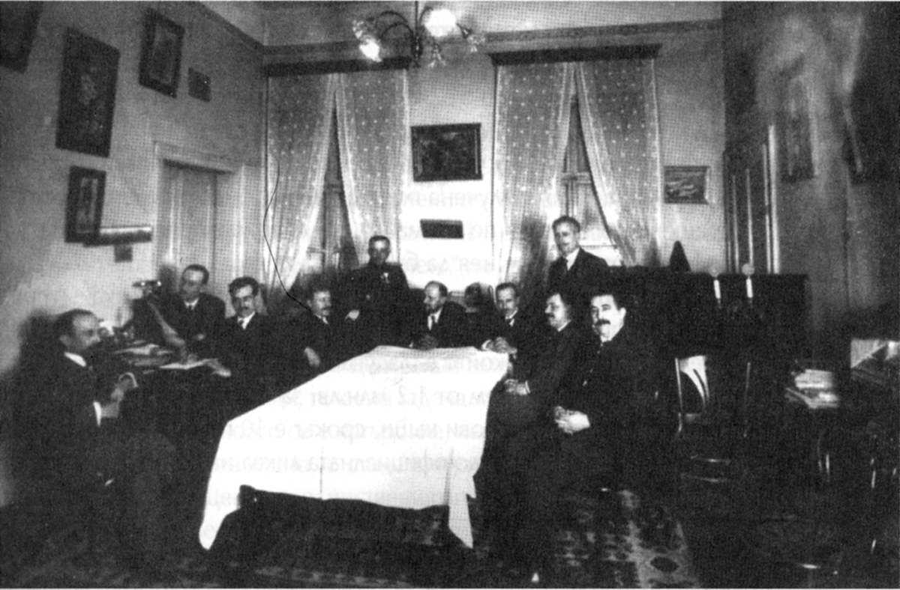
The leaders of the June 9th coup in the house of General Ivan Rusev. From left to right: Dimo Kazasov, Kimon Georgiev, Nikola Rachev, Yanaki Mollov, Ivan Valkov, Alexander Tsankov, Hristo Kalfov, Ivan Rusev, Petar Todorov, Tsvetko Boboshevski
On June 9th, after receiving assurances of support from the French ambassador, Tsar Boris, a mere figurehead at this point, appointed one of the main ideological leaders of the coup, Professor Alexander Tsankov, as head of the new coalition government, which was ostensibly democratic [16][19].
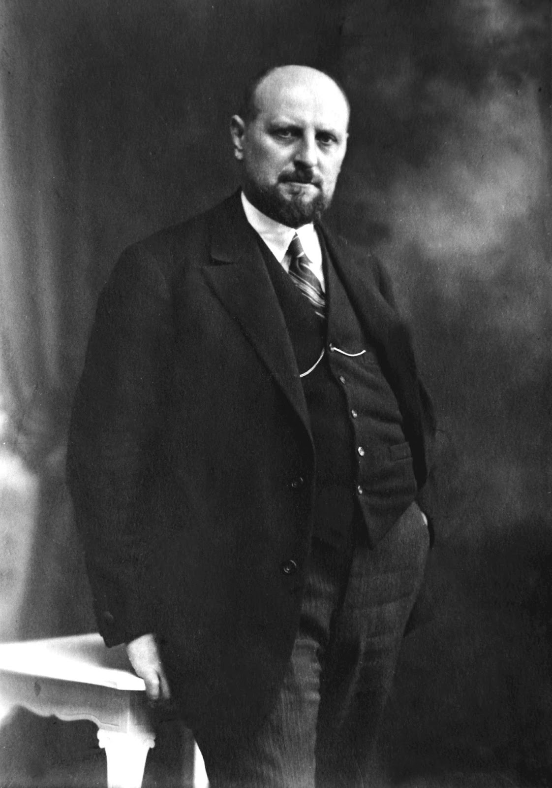
Alexander Tsankov
However, the fascists' performance was not perfect. The Bloc's forces were weak and could only suppress scattered spontaneous resistance. The fascist detachments were few in number. Despite the participation of officers, the main body of soldiers was unenthusiastic about the coup. The workers clearly remembered the machinations of the bourgeois parties and saw the fascist nature of the coup. Spontaneous peasant uprisings broke out in Plovdiv, Pleven, Shumen, Vrachan and other districts. Stamboliyski, with a large detachment of peasants, tried to resist the fascists.
By the evening of June 9th, the most important points were in the hands of the fascists: railroads, post office, telegraph and police stations. The leadership of the Agrarian Union was defeated. Stamboliyski was assassinated and beheaded by the “Military League” during the coup. The Internal Macedonian Revolutionary Organization (IMRO), whose leaders had personal contacts with the coup organizers and reactionary officers, played an important role in the formation of the new government. Only some local organizations of farmers continued to resist in the province.
A revolutionary situation had developed in the country. It was clear that the only force capable of stopping fascism was the 40,000-strong Communist Party. The intervention of the Bulgarian Communist Party, together with the Union and the peasantry, was absolutely necessary: the peasantry itself was rising up, while it’s kulak leadership was disorganized, and its policies debunked in the eyes of the peasantry. In these conditions, the leadership of the movement would inevitably fall into the hands of the BKP. Opportunities for the formation of a workers' and peasants' organization opened up.
In the district of Plevenna, for example, peasant detachments of several thousand people under the leadership of Minister of Agriculture Obov acted together with the BKP. The fascists were defeated and their weapons fell into the hands of the rebels.
How did the BKP act? Certainly not like the Bolshevik party. It did not change its old attitude of neutrality in the struggle between the two “bourgeoisies”.
This is how the central committee of the BKP assessed the situation in the “Workers' Herald” on the 10th of June:
“The new government established by a military coup is the replacement of one military-police dictatorship — of the rural bourgeoisie — by another military-police dictatorship — of the urban bourgeoisie.” [1]
In a further proclamation on June 11th, the Central Committee declared the following:
“The armed struggle between the supporters of the overthrown government and the new government is not over. The CP and the hundreds of thousands of workers and peasants united under its banner are not taking part in this armed struggle. We do not know how this struggle will develop.” [1]
The Central Committee then began sending couriers to local organizations with instructions to refrain from the fight. The new government even ordered that these couriers not be stopped, and later the Minister of the Interior summoned a member of the Central Committee, Lukanov, and told him that the Plevna organization should lay down its arms. The demand was accepted.
In the town of Grabovo, the local peasant organization itself proposed to the BKP to stand together against the fascists, which was rejected by the local communists, who followed the demand of the Central Committee. The neutrality of the BKP had a terrible effect on the workers and gave the fascists time to regroup their forces and consolidate themselves in the institutions of power. The Central Committee of the BKP from the beginning of 1923 was headed by H. Kabakchiev. He would later say that the fascist coup of June 9th came as a complete surprise [1].
This terry-cloth opportunism, bordering on counter-revolution, continued until the Executive Committee of the Comintern began to send telegrams to the Central Committee through the Soviet Embassy in Vienna with the following message:
“We are alarmed by reports that you are slowing down the struggle of the Plevna against the new government. Is this true? It seems to us that the situation demands that we find a way of acting together, even with Stamboliyski himself. Otherwise the government, once strengthened, will crush the Communist Party. Think seriously about the situation. Remember the tactics of the Bolsheviks at the time of the Kornilov mutiny and act without hesitation” [1].
On the first day of the coup, the Executive Committee of the Communist International (known by its acronym ECCI) issued an appeal to the workers and peasants of Bulgaria:
“If the Stamboliisky government persecuted the workers, the Tsankov government will not: the government of bureaucrats and generals will exterminate the workers. Whoever mistakenly thought that the struggle of the victorious White Guard clique against Stamboliisky was nothing but the struggle of two bourgeois cliques, towards which the working class could observe neutrality, will realize his mistake in the lesson of the bloody persecutions that will fall upon the workers' organizations. The putschist government is our enemy. It must be smashed. Unite for the struggle against the creators of the White Guard coup, unite not only with the broad peasant masses but also with the surviving leaders of the peasant parties”. [1].
In response, the Central Committee of the BKP began a polemic with the ECCI in the pages of the “Communist International”. At that time, arrests of communists began, and the party organizations in Tarnovo, Grabovo, and Pleven were smashed. Demonstrations and meetings were broken up and censorship was in full swing.
During the days of the coup, the BKP declared itself the defender of the (liberal) constitution. In its printed material, it called for immediate elections and the establishment of a parliamentary regime. The height of opportunism was the statement of the Central Committee that the Polish party organization and the proletariat in Poland had not taken up arms against the fascist coup, but against the advancing detachments of the landlords.
This behavior of the Central Committee could not be tolerated by the local organizations, which spontaneously began to establish links with the surviving members of the Union. This escalated to the point where the actions of the Central Committee aroused irreconcilable opposition in the largest party organization in Sofia.
Vasil Kolarov, General Secretary of the ECCI since 1922 and foreign representative of the BKP, who arrived after his arrest on July 10th, confirmed that the Comintern Executive Committee and other parties had condemned the June tactics of the BKP.
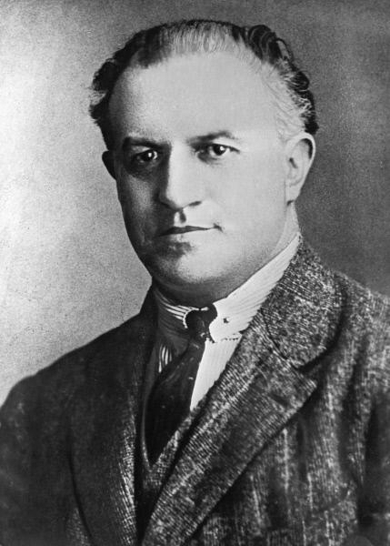
Vasil Kolarov
In June, Georgi Dimitrov also took a position of “neutrality”. Kolarov described the situation after the 9th of June as a complete “political and moral discord between the workers and the landlord government”. In general, he understood the BKP Central Committee's decisions on non-intervention, its fears of defeat, intervention, and, above all, the losses of the revolutionary movement, but he did not draw any final conclusions.
After the criticism of the ECCI, a break in the policy of the Central Committee and the Bolshevization of the party began. On the 5th and 6th of August 1923, the BKP decided to change its tactics of “neutrality”’ and began preparations for an armed uprising... Although the favorable moment was lost and the fascists had already consolidated themselves in the government institutions and the army, the uprising was by no means hopeless.

8. The September Uprising
From the beginning of the preparations, attempts were made to establish links with the peasantry; all mass workers' organizations were called upon to participate: trade unions, splinter groups of the Bulgarian Agrarian National Union (BZNS), the craftsmen's union, etc. [20]
Only the peasant landowners responded to the call of the BKP, which developed a left-wing in its organizations, the “united front” faction, which advocated a common cause with the workers. With the central organization of the BZNS defeated the individual peasant organizations looked to the leadership of the BKP for guidance and support. The party began to organize a united front [21].
Communists from local organizations helped to rebuild the scattered centers of the BZNS, supporting and defending the arrested peasants [22]. Georgi Dimitrov also called for a united front in the Workers' Bulletin. Initially, the uprising was planned for October-November 1923.
It was obvious that the new government would not allow time for full preparation for the uprising. In the Communist Party, the criticism of the previous opportunist policy was never carried out; the old Central Committee [23] organized the uprising, which slowed down the preparations and the setting of the date.
The slander against the Plevenna organization was never exposed and the authority of the Central Committee over the local organizations was lost. This played an important role later when the local communists took up the struggle without waiting for an order from the Central Committee. No general strike was prepared, no railway strike was prepared, no telegraph strike was organized. The BKP had no experience in underground work.
The removal of the BKP from its alliance with the peasant union also deprived it of its military equipment, which was in the hands of the “Orange Guard”, the Union's military organization. Only rifles and revolvers already in possession were prepared. Assembly of combat units was not completed — only in the Vrachanski district, the situation was more or less satisfactory.
One of the greatest failings of the BKP was that it did not carry out any work in the barracks, despite the existence of soldiers sympathetic to the Communist Party and even some Communist cells in the army [24]. The BKP issued no advice or practical guidance for such soldiers. This explains why not a single military unit sided with the rebels during the uprising.
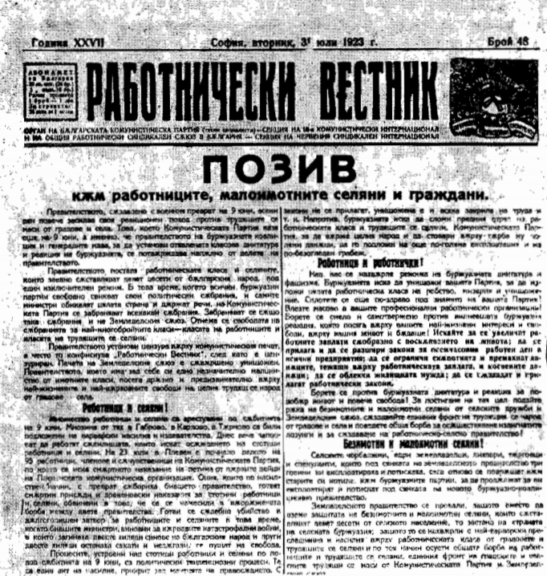
The call of the BKP to form a united front with the peasantry
Wanting to defeat the Communist Party, the bourgeoisie struck a blow of its own in response to the uprising allegedly planned and approved for 17th of September. On September 12th, more than 2,000 communists were arrested, the party press and BKP clubs were closed down and the premises of the Central Committee of the party were sealed. Communist propaganda was banned throughout the country. In addition, some of the leading members of the Agrarian Union defected to the fascists.
Bulgaria had the following peculiarities. Only food and tobacco production was more or less developed in the country, so there were only a few large labor centers — the capital Sofia and the city of Plovdiv. The proletariat, including the railway and agricultural workers, numbered about 500,000 (out of a total population of around 5 million). Bulgaria had a dense network of railways, the control of which was of strategic importance. At the same time, the country is split by a mountain range, through which there were only four passes with roads. The BKP had to take all this into account in its preparations.
The leaders of the revolutionary wing of the BKP, Dimitrov and Kolarov, on 17th of September, after fierce arguments, obtained approval for an armed uprising on September 22nd and 23rd [26]. The center of the uprising was to be the Vrachan district. By that time, spontaneous protests had already begun in several regions. Thus, the announcement of the time of the uprising, to which Marxist theorists attach exceptional importance, came when the spontaneous uprisings had already become a fact. There was no general unified plan or leadership, each region acted independently.

8.1 Central Bulgaria
The most revolutionary district, Starozagorski, was the first to take up the struggle on the 19th of September, fearing that the uprising would be disrupted or abandoned. Here the local communists were able to create a real fighting organization, uniting the BKP, Komsomol members, united-front peasants, and non-party workers. Although the arrests of September 12th deprived Starozagoro of its entire district leadership, a new revolutionary committee was formed. The uprising in this district began prematurely because there was no real central committee leadership of these districts: the local party committee, without waiting for a signal from the center, set the general uprising for September 19th.
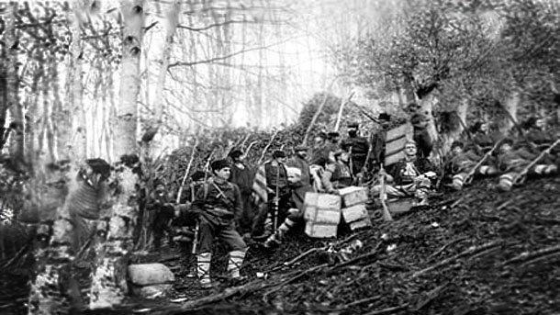
Rebels from the city of Myglizh, Starozagorski Krai
On the night of September 20th, detachments of workers and peasants seized power in the villages of the Starozagorski district and continued their offensive against the cities of Stara and Nova Zagora, Kazanlak, and Chirpan. The attack on Stara Zagora was carried out by four detachments, each of which had to occupy a strategic point at the signal of a small group attacking the city prison with grenades.
Coordination between the units was poor: while some units attacked the main points - the gendarmerie and infantry barracks - others were inactive at the railway station and the telegraph office. The plan for the takeover of the barracks did not take into account the need for a surprise - the grenade attack started 400 meters away and only served to alert the gendarmes and infantry. Despite the selfless sacrifice during the capture of the ground floor of the gendarmerie barracks, no success was achieved and no further action was taken.
In Kazanlak and Chirpan Ocolya, at the instigation of the Chirpan committee of the BKP, instead of marching simultaneously with the Stara Zagora detachments, the insurgents first began to liberate small villages and managed to capture many of them (Shipka, Yenina, Myglizh, Sheynovo, etc.).
Workers' and peasants' power was established in all the occupied villages (Golyamo-Dryanovo, Himitli, Rozovets, etc.) [27]. In the Chirpan Okolya (county), more than 4,000 people took up the armed struggle. There the villages of Dylboki, Zmeevo, Strelts, etc. were occupied by fighting.
Only a day later, on the morning of September 20th, the insurgents began to gather in small, scattered detachments at Chirpani. At 15:00 two companies of fascists and artillery from the defeated Stara Zagora arrived there. Even the large, well-armed Medovsky detachment of the insurgents could not change the situation and, on September 23rd, it was forced to retreat.
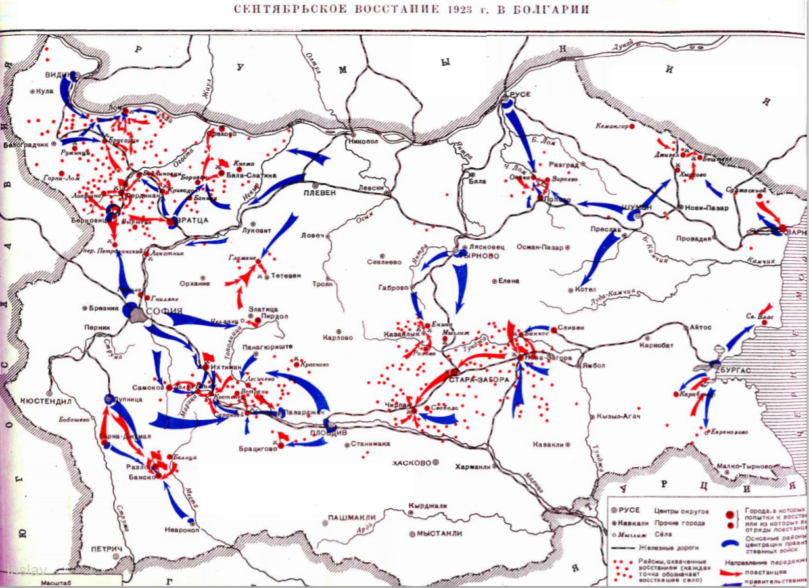
On September 21st, an uprising broke out in the eastern and southern parts of Kazanlak. A large rebel detachment of 1,500 relatively well-armed men took up a waiting position there. The fascists, who had received reinforcements from Tarnovo, attacked the rebels and defeated the detachment.
In Nova Zagora, the BKP committee correctly combined the intervention of the city organization with the help of the surrounding districts. In a sudden attack, a detachment of only 100 men seized the whole of Nova Zagora, where the garrison consisted of 300 gendarmes and Wrangel's men. The rebels seized the police station and the prison, from which they released their leaders. 300 rifles and several machine guns were captured.
Only the barracks resisted, and the rebels were in no hurry to take it. There was also no communication with Stara Zagora, where the battle was taking place. It was not until the morning of September 20th that the storming of the barracks began. By then the fascist infantry came from Sliven and the cavalry from Yambol. The Semptevrians were defeated. They retreated to the mountains and scattered.
The lack of centralized leadership and the fragmentation of individual units after fierce fighting led to the retreat of the insurgents. Poor leadership during the fighting led to the diversion of large numbers of troops to secondary tasks. In the town of Stara Zagora, during the siege of the gendarmerie barracks, the leaders of the detachment, Doncho Pehlivanov and Asen Vilchev, were killed, after which all leadership disappeared and the insurgents were defeated and returned to their homes.
On the 19th and 20th of September, earlier than planned, widespread fighting broke out in the Plovdiv district. Plovdiv was an important industrial center with numerous workers' organizations, which could have decided the outcome of the uprising in the district and given an advantage to the whole of central Bulgaria. The Plovdiv committee of the party was among those who supported the struggle against the decisions of the ECCI in the summer of 1923. Up to the moment of the uprising, the policy of “not provoking” the fascist police was followed, and workers' meetings and demonstrations were avoided.
The result was not the preparation of an uprising of the proletariat, but the preparation of a conspiratorial coup. At the time of the arrests on September 12th, the party workers were not informed of the possible raids; the newly organized military committee was unaware of the situation, as all decisions were discussed behind the scenes by the leaders of the previous committee.
Following the outbreak of the uprising in Stara Zagora, a meeting of the regional/county committees of the Plovdiv district called for immediate action. On September 20th, a spontaneous uprising broke out in the district. Villages in the valleys of the Topolnitsa, Kalaglare, and Abdulare rivers were taken. Forty villages were liberated in the struggle.
On September 23rd, the workers and peasants took the town of Bratsigovo in the Plovdiv district. From there the uprising spread to the neighboring districts of Peshter and Plovdiv. Fierce battles were fought in the area of Gramada. They ended with the retreat of the peasants after the government troops were reinforced with artillery [29].
The situation was extremely favorable for the uprising here: fighting in Stara Zagora, victory in Nova Zagora, mobilization of the fascists had failed and no one showed up at the checkpoints; most of the garrison was diverted. But the committee waited for the 22nd of September…
The next day the situation changed dramatically. Following the news of the suppression of the uprising in Stara and Nova Zagora, a state of siege was imposed on the city and the party organization was smashed. Only one out of 17 couriers managed to leave the city to communicate with other districts. On the 22nd of September, the terror intensified, and the complete uprising in Plovdiv never took place. The rebellious districts were defeated.
By the time of the general uprising — the 22nd and 23rd of September — the rebels in the most militant districts of central Bulgaria had been dispersed and the rebellion was already suppressed. The districts of Plovdiv and Starozagoro were of strategic importance. The former was an industrial district, the latter a typical peasant district — they formed the center of the country with important railway junctions.
A victory in these districts would have divided the government's troops, isolating them from each other in different parts of the country. However, since the performance of the rebels was scattered and the railroad was not paralyzed, the government could move reinforcements quickly by rail from district to district.

8.2 Northwestern Bulgaria
The uprising scheduled for September 22nd and 23rd never spread to the whole country. In the capital, with the assistance of traitors, the police arrested the entire Sofia Revolutionary Committee, except for two who had escaped and one who had committed suicide. Lukanov, the same author of the letter to the Plovdiv rebels instructing them to lay down their arms at the demand of the fascists, remained at the head of the capital's party organization. On September 21st, the day the terror intensified, he and his supporters gave orders canceling the uprising in the capital.
The news that everything was calm in the capital, the telegraph was working, and the railways were functioning, played a demoralizing role. Due to the fact that numerous forces of fascists and Wrangel were present in Sofia, the uprising in the city was supposed to delay and tie down the military units of the government. Inaction in Sofia led to the striking force of the uprising, the Vratsa district, being left to fight on their own.
Kolarov and Dimitrov were in the Vratsa district at that time to organize the uprising. The doubting party members remaining in the capital only sent out a directive to postpone it.
Thus, the uprising failed in several places, for example, in Somokovo, where the rebels had already taken up their initial positions [28]. In the Sofia region, the Kumarish district joined the fight. The peasants of the Gnilyane village, armed with pitchforks and axes, seized power and proclaimed a workers' and peasants' republic ("Gnilyane Republic"), but were defeated by well-armed and numerous fascists on September 24th.
The Ihtiman-Dolnobansky district of the Sofia region was also engulfed in rebellion. The workers and peasants were able to seize all the villages of the district, the Ihtiman city, and the Kostenets-Banya station. Fierce battles for the station lasted for 3 days, until September 24th. Fascist reinforcements drove the rebels into the mountains, where they continued the fight until October.
The party’s choice of the primary uprising location also raises questions. The Vratsa region is located in the northwestern part of Bulgaria; it is not a geographical, industrial, or strategic center. The district is separated from the capital by a mountain pass with two passages - one railway and one highway. Having occupied them, it was easy for the fascists to isolate the center of the uprising from the capital and the entire periphery of the region. The Central Committee chose it since the best-trained combat squads were located there, that is, it was a choice of convenience.
The uprising in the Vratsa region was the largest and best organized. The main military revolutionary committee, headed by Dimitrov, Kolarov, and Genov operated here. Gavril Genov headed the Vratcha region organization, which had 4 thousand members, 2 thousand Komsomol members, as well as large forces of farmers. In addition, it began preparing for the uprising immediately after the events of June 9th, exerting a strong influence on the Central Committee during the polemics with the ECCI.
The uprising in this district was scheduled for September 22nd. According to the plan, during the uprising, individual units were to be pulled together in the Vratsa city for a further march on Sofia city. The day before, on September 22nd, the local committee suddenly postponed the uprising until units from other districts arrived. Having received reinforcements, the local government units destroyed the party organization. The city remained in the hands of the fascists.
However, the uprising began anyway. Combat units were able to occupy most of the villages of the Ferdinand, Berkovskaya, Beloslatinskaya, and Vratsa outskirts. On the night of September 22nd, the Ferdinand city was captured. The city became the center of the uprising. The Region and Main Revolutionary Committees, as well as the headquarters of the uprising, were located here.
By 10 a.m. on September 23rd, the entire Ferdinand county had rebelled. The neighboring Lomian county had also rebelled, although fighting was still going on in the Lom City. There were battles in the easternmost region of the district, Orekhovsky, from where the Revolutionary Committee had no information. However, the district center, Vratsa, was never taken. At 11 o'clock, Georgi Dimitrov's Lopushansky detachment defeated the government detachment with artillery that had entered Ferdinand.
Gavril Genov and Hristo Mikhailov proved themselves to be experienced leaders. On this day, the fascist detachments were routed near the villages of Gorni-Lom and Ruzhintsy in the Vidin district [31].
By the evening of September 23rd, the Revolutionary Committee took control of the actions of all the rebels in the Vratsa district. Rear work and distribution of ammunition were organized, all banks and enterprises were taken under control, and extensive propaganda work was launched.
It was decided to send one small detachment with a field gun to occupy the Berkovitsa city, the rest of the forces were to attack Vratsa. On September 24, workers and peasants under the leadership of Hristo Mikhailov took the Berkovitsa city and Chiprovtsi, as well as some villages on the border with Yugoslavia. Georgi Moskov and his detachment captured the Lom city and besieged the cavalry barracks and its fascist garrison [30]. Even though the chairman of the revolutionary committee subsequently fled, the siege of the barracks continued until September 26th. However, the pursuit of the enemy was not organized, and neither was the capture of the Petrohan pass with the highway to Sofia city. From there, an attack on the rebel’s exposed rear was possible.
In the Orekhov district, the uprising began from September 22nd to 23rd. Too much time was spent establishing local power; the Orekhov city was not taken before the night of September 24th. Afterwards, the Orekhovsky detachment went out to intercept the fascist formation advancing deep into the Vratsa district, but it was defeated. On September 26th, during the retreat, they united with the Knezh detachment, and, having made their way to the north, both detachments crossed the Yugoslav border. On September 24th, positions were taken for the main attack on Vratsa. A cover force was sent to the Boychinovtsi station, but the government units drove the rebels out the very same evening. Thus, the fascists broke into the center of the rebellious region and threatened the focus of the uprising. The Revolutionary Committee decided to eliminate the breakthrough.
During the night, a battle for the station began, which lasted until the evening of September 25th. An open attack over a long distance led to heavy losses, and the desertion of the detachment commander. After the Revolutionary Committee took control of the detachment, the offensive became more organized. By nightfall, the fascists were scattered, with some of the officers being taken prisoner.
On September 26th, government units began an offensive from the Petrohan pass, defeated a detachment of rebels and recaptured the Berkovitsa station. The road to Ferdinand and Boychinovtsi was open. At 4 o'clock, it became known that the main forces of the Revolutionary Committee had been routed near Krivodol.
On the morning of September 27th, it was decided to give a decisive battle near Boychinovtsi station with their main forces (800 men with 3 artillery guns and 10 machine guns). For this purpose, a small cover detachment was left in Ferdinand. By 3 o'clock, this garrison was defeated, and the city was taken by the fascists. Having learned of this, some of the Revolutionary Committee units went home, while others crossed the Yugoslav border. Between September 28th and 29th, the last detachments of the rebels fighting in the northern direction were scattered. After the Entente's approval, Tsankov's government additionally mobilized reserve officers and non-commissioned officers [32]. It also used those in the labor service, arming them and sending them to suppress the uprising. “Civil Committees” and “Spitzkommandos” [27] were organized drawing from representatives of the bourgeoisie and lumpen elements.
At this critical moment, the "broad-left" socialists played their role. They supported the fascist government. They ensured the smooth operation of the railways and communications. The "broad-left" harshly suppressed the anti-government struggle of their rank-and-file members [27]. Some of them themselves participated in the suppression of the uprising as part of the "socialist detachments" [16]. The defeated rebel detachments offered only partial resistance during the retreat. Those of the rebels who did not go to the mountains and were not captured crossed the border, and became political emigrants for a long time. Most of them found refuge in the Soviet Union.
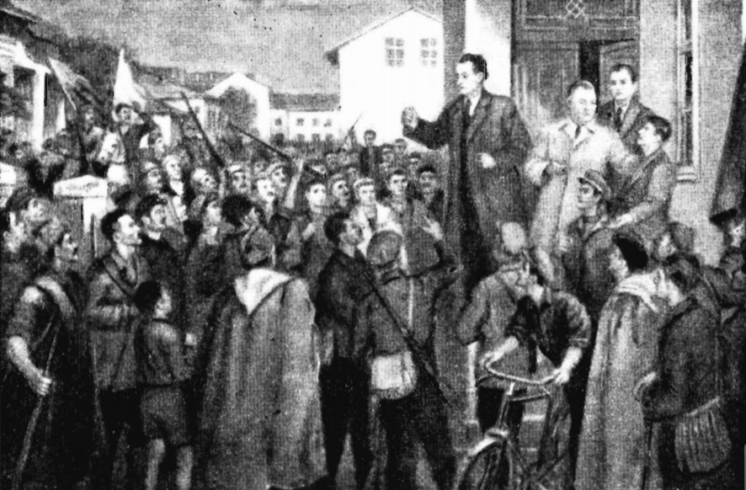
G. Dimitrov, V. Kolarov and G. Genov in Mikhailovgrad. Painting by M. Georgiev.
After the suppression of the uprising, executions and mass beatings took place throughout Bulgaria for several weeks, during which about 20 thousand people died and tens of thousands were arrested [33]. This massacre brought “world fame” to Tsankov’s government. Even based on these figures, we can say that the uprising was of a massive popular nature.
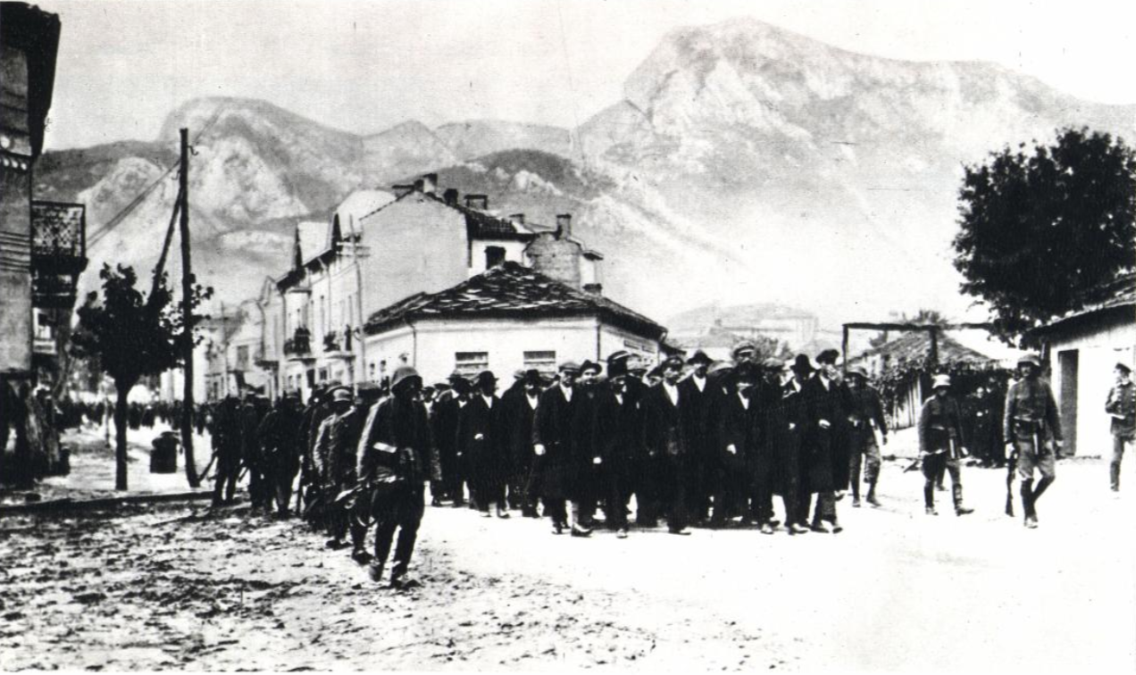
Captured rebels in the Vratsa city
In the Chirpan region, about 30 rebels were killed, and one of them, Mikhailov, unable to withstand the torture, jumped out of the second-floor window. In the Samokov region, 20 arrested people were taken out of prison and killed by the decision of the city committee headed by the regiment commander.
In Kyustendil, on September 27th, the editor and lawyer of the city branch of the Agricultural Union were executed, and along with them, 10 participants in the uprising were shot against the barracks wall while trying to surrender. In the city of Vratsa, even though its residents did not participate in the uprising, 280 houses were burned out of fear that they would fall into the hands of the rebels.
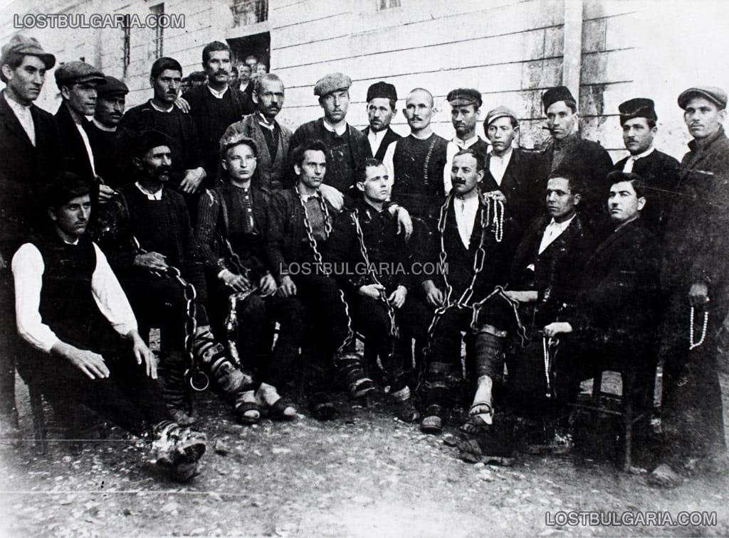
Condemned to death rebels from Berkovitsa and the Karamusal village
In the Lomsk region, about 7 or 8 thousand people took part in the uprising, and 3 thousand were sent to prisons and barracks after their arrest. Others were put on barges and sent down the Danube, where field courts were held. These courts sentenced 30 to 40 people to death every day.
The residents of the Medkovets village were gathered in the schoolyard, where 80 arrested peasants were brought. After the prisoners were shot to music and cries of "Hurray, long live the Tsar!", the villagers were forced to dance in a circle around the dead and thank the officers, the "saviors of the fatherland". In the Lomsk region, about 400 rebels were killed, although no more than 18 fell in battle [28].
This is a small part of the massacres and repressions that were carried out by the reactionary fascist government throughout Bulgaria. They often took place without trial or investigation.
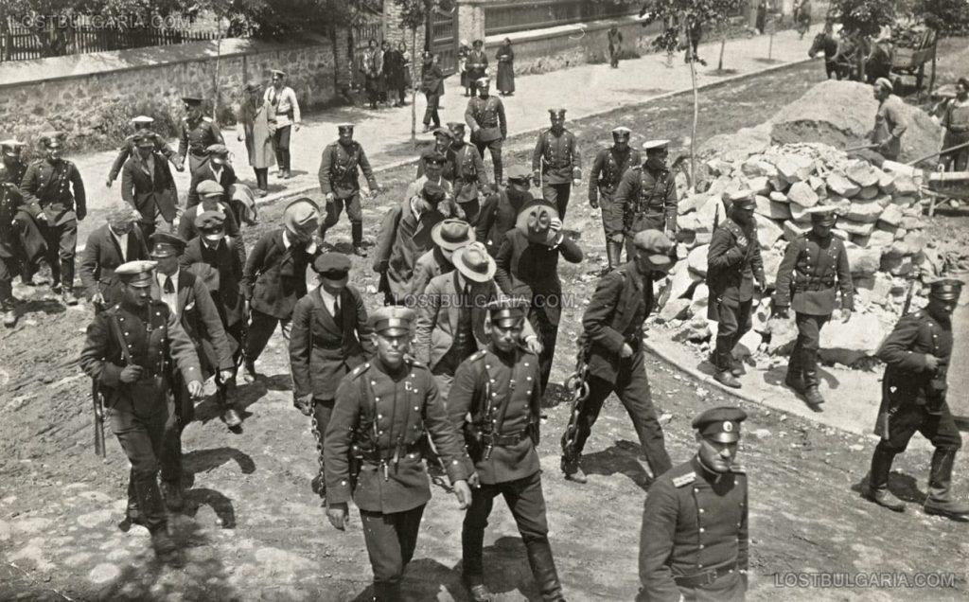
Student activists of the uprising are taken to court

9. Causes of defeat and its significance
The September uprising was completely suppressed by October 1923. The reasons for the failure cannot be reduced to any one exhaustive cause. It was a whole series of mistakes made by the BKP during the preparation and the uprising itself.
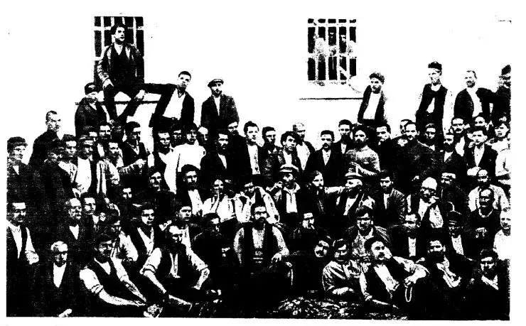
A group of imprisoned participants of the uprising in the Starozagorski district. 1923.
The BKP was a serious political force in Bulgaria, had impressive social support and skills in working with the masses, and its influence at the time of the uprising was great. However, it had theoretical and organizational errors, which resulted in weak and ineffectual tactics of the uprising. These errors became apparent when it was no longer possible to turn the tide of events.
Firstly, alienation from the peasantry, expressed in a long, fickle struggle against the Agricultural Union and weak efforts among other layers of peasants. This did not allow the creation of a truly strong united front of the proletariat and the peasantry, did not allow for explanatory work within the largest class in a purely agrarian country, and did not allow them to demonstrate to the peasantry the class nature of the fascist coup.
Secondly, a weak and indecisive struggle against opportunism in its ranks. Vacillating and hesitant party members remained in important posts in the management of railways and communications. At the most critical moment of the uprising, they did not stop or try to interrupt the movement of government reinforcements. In a number of cases, they openly hindered the uprisings, thereby helping the fascists.
The predominance of parliamentary methods of struggle in the BKP deprived it of the experience of illegal, underground work, which was so crucial during the uprising.
Opportunism in the BKP led to the fact that without instructions from the Comintern, the party was unable to understand the essence of the coup of June 9th. For two months, it continued to view the struggle of the Agricultural Union with the Constitutional Bloc as a struggle of the rural and urban bourgeoisie, and not as a predominantly petty-bourgeois peasant party against a bloc of reactionary parties of the big bourgeoisie, connected with European finance capital.
Thirdly, political work in the army was not organized, and propaganda and agitation among soldiers were almost completely absent. As a result, almost no one in the military supported the uprising. This preserved such a powerful organized force of the fascist government.
Another series of reasons can be found in the tactics used during the preparation and the uprising itself.
- Preparation for the uprising was carried out extremely poorly and in a limited time;
- The principle of surprise was not observed. Poor conspiracy led to the fact that even the central authorities in some cases knew about the next steps of the rebels;
- Poor organization and coordination of the uprising, the lack of reliable communication channels, and a single center for managing the entire uprising. Hence the impossibility of consolidating successes and continuing the fight after failures;
- The uprising was not launched simultaneously in all key centers of the country. Most villages and towns rose to fight separately and not as a united front. Detachments of rebels did not know about each other, spontaneously captured settlements and stopped there. Following this they were defeated separately by regular army troops;
- Concentration of forces at strategically important nodes was observed only by government troops.
- The center of the uprising was chosen incorrectly;
- Poor armament of the rebels. There are known cases when the power of peasants and workers in the villages was established only with pitchforks and axes in their hands;
- Underestimation of the guerrilla method of warfare. With small numbers and poor equipment, this could have become an effective way to fight the reactionary troops. Some small detachments successfully resisted in the mountains until the beginning of October.
Despite the failure, the September Uprising of 1923 has enormous historical significance for the international revolutionary movement. The blood spilt by the brave "Septemvrians" was not in vain, but gave a powerful start to the revolutionary alliance and unification of the Bulgarian proletariat with the peasantry. This helped the Bolshevization of the Bulgarian Communist Party and the awareness of their class interests by the workers of Bulgaria.
"The September uprising created a bloody and unbridgeable gap between the masses of the people and the fascist bourgeoisie. As a result, fascism never managed during the succeeding years to stabilize its positions and to form a broad social basis. The selfless struggle and the consistent worship and tireless work for the establishment of a united anti-fascist front brought it much closer to the masses, strengthened its ties with them and created the prerequisites for its emergence as the true leader of the working people of town and countryside in the struggle for democracy and socialism". — Georgi Dimitrov [34]
The September Uprising was a mass uprising of the proletariat and peasantry who fought for the power of the Soviets. This heroic struggle opened a century-long history of resistance to fascist reaction throughout the world.
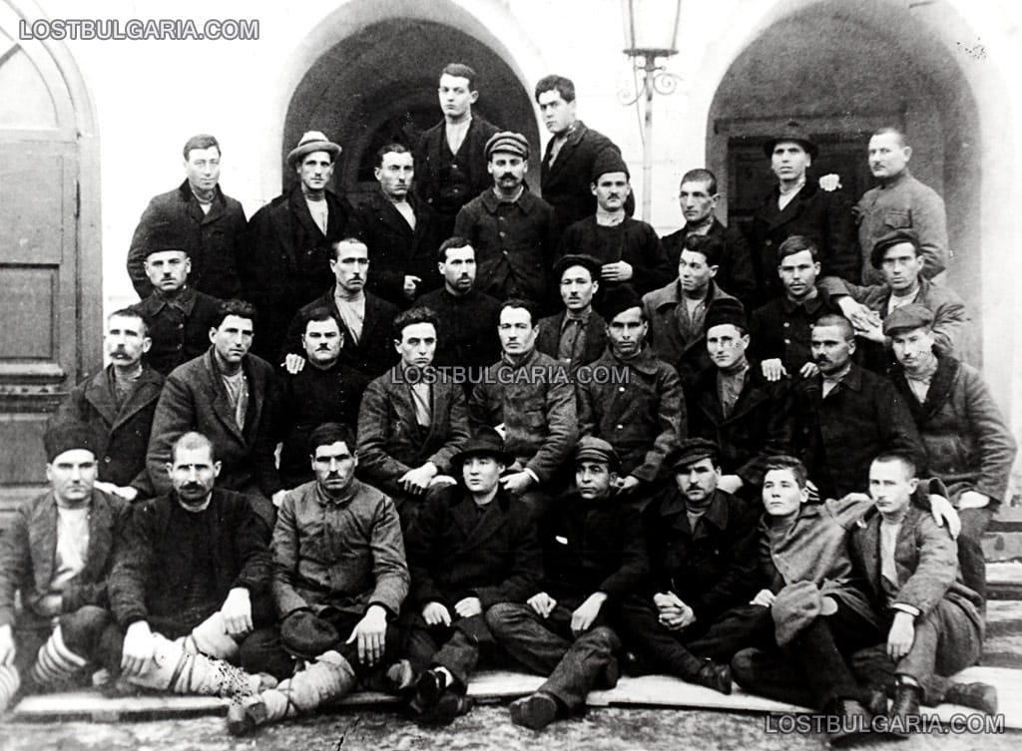
Participants of the September Uprising from Stara Zagora who emigrated to the USSR
Sources:
1. Bazhenov L. The September Uprising in Bulgaria. Marxist Historian, No. 4-5, 1932, pp. 253–292
2. История Болгарии. В двух томах. Том. 2. М.: Издательство АН СССР, 1955. С. 63. (The History of Bulgaria. In Two Volumes. Vol. 2. Moscow: Publishing House of the Academy of Sciences of the USSR, 1955, p. 63.)
3. Valeva E.L. (ed.) Bulgaria in the 20th century: Essays on political history. Moscow: Nauka, 2003. 463 p.
4. Poppetrov N. Fascism in Bulgaria—specific features // Bereginya. 777. Sova. 2015. No. 3 (26).
5. Grishina R.P. The emergence of fascism in Bulgaria. 1919-1925. Sofia: Publishing House of the Bulgarian Academy of Sciences, 1976. - 345 p.
6. Penkovsky D. D. Participation of White émigrés in military formations and combat operations in various countries of the world // Knowledge. Understanding. Skill. - 2014. - No. 2. - P. 149-157.
7. Radkov A. V. Socio-economic and political adaptation of Russian military emigration in the 1920s // News of the Laboratory of Ancient Technologies. - 2014. - No. 3 (12). - P. 61-67.
8. Kyosev Dino G. History of the Macedonian-national-revolutionary movement. Sofia: Publishing House on the National Society on the Fatherland Front, 1954. pp. 496–499.
9. “Rabotnicheski Messenger.” August 31, 1922 // “Rabotnicheski Herald”. Select articles and materials. T. 2 (1904–1923). Sofia. 1953, 711 p.
10. The Bulgarian Communist Party in resolutions and decisions at the congress, conference and plenum of the Central Committee. T. 2, 1919–1923. Sofia, 1957, pp. 174–175, 178–180.
11. Kolarov V. P. Bulgaria after the imperialist war: Verbatim of lectures of Comrade Kolarov, V. P. read on November 17 and 20, 1936. Moscow, 1937. Page 23.
12. Bulgarian Communist Party in resolutions and decisions at the congress, conference and plenum of the Central Committee. Vol. 2, 1919–1923. Sofia, 1957, p. 159.
13. "Rabotnicheski Vestnik". January 24, 1923 // "Rabotnicheski Vestnik". Selected Articles and Materials. Vol. 2 (1904-1923). Sofia. 1953, 711 p.
14. Minaev L. M. The Struggle for a Workers' and Peasants' Union in Bulgaria. Questions of History, No. 9, November 1983, pp. 68-83.
15. Kosev D. The September Uprising of 1923. Sofia. Published by the Bulgarian Academy of Sciences. 1954. 356 p.
16. Tsonev, G. The September Uprising in Bulgaria in 1923 / G. Tsonev, A. Vladimirov; Ed. and with a foreword by G. Valetsky. Moscow; Leningrad: OGIZ: SOTSEKGIZ, 1934 (Typo-lithography named after Vorovsky). P. 74.
17. Bulgarian Communist Party in resolutions and decisions at the congress, conference and plenum at the Central Committee. T. 2, 1919–1923. Sofia, 1957, p. 259.
18. “Rabotnicheski Herald”, June 9, 1923 // “Rabotnicheski Herald”. Select articles and materials. T. 2 (1904–1923). Sofia. 1953, 711 p.
19. Tsankov A. Bulgaria in turbulent times: Spomeni. Sofia: Seer, Cop. 1998. P. 182.
20. "Rabotnicheski Vestnik". July 31, 1923 // "Rabotnicheski Vestnik". Selected Articles and Materials. Vol. 2 (1904-1923). Sofia. 1953, 711 p.
21. Kabakchiev H. The Communist Party of Bulgaria in the First Period of Its Development and the Comintern. Class Struggle, No. 3, March 1934, pp. 71-81.
22. "The 25th Anniversary of the September Uprising: Collection". Sofia. 1948, pp. 141-143, 165-166.
23. Tsonev, G. The September Uprising in Bulgaria in 1923 / G. Tsonev, A. Vladimirov; Ed. and with a preface by G. Valetsky. Moscow; Leningrad: OGIZ: SOTSEKGIZ, 1934 (Vorovsky Typography and Lithography). P. 93.
24. Tsonev, G. The September Uprising in Bulgaria in 1923 / G. Tsonev, A. Vladimirov; Ed. and with a foreword by G. Valetsky. Moscow; Leningrad: OGIZ: SOTSEKGIZ, 1934 (Vorovsky Typography and Lithography). P. 55.
25. Tsonev, G. The September Uprising in Bulgaria in 1923 / G. Tsonev, A. Vladimirov; Ed. and with a foreword by G. Valetsky. Moscow; Leningrad: OGIZ: SOTSEKGIZ, 1934 (Vorovsky Typography and Lithography). P. 105.
26. Bulgarian Communist Party in resolutions and decisions at the congress, conference and plenum at the Central Committee. T. 2, 1919–1923. Sofia, 1957, pp. 353–354.
27. “The 25th Anniversary of the Septemvrian Rising: Collection.” Sofia. 1948, p. 192.
28. Kolarov V. September uprising in Bulgaria in 1923. M.: Publishing house I.K. MOPR, 1924. 65 p.
29. “The 25th Anniversary of the Septemvrian Rising: Collection.” Sofia. 1948, pp. 208–211.
30. Gramchev A. Bringing km of history to the BKP VV Vrakansko. Sofia: BKP, 1955. P. 172.
31. Tikhomirov N. Lessons of the Bulgarian uprising (September 1923). Moscow:. Gosvoenizdat, 1924. pp. 22–24.
32. Ibid. P. 26.
33. Materials on the history of the Bulgarian Communist Party (1895–1925). Sofia, 1963. P. 217.
34. Dimitrov G. Report at the VII World Congress of the Communist International; Political Report of the Central Committee BRP(k) to the 5th Party Congress. Moscow: Gospolitizdat, 1958. P. 131.
Further reading:
Extended Plenum of the Executive Committee of the Communist International, June 12-23, 1923.
"The September Uprising in Bulgaria in 1923 in Light of New Documents". Modern and Contemporary History. Issue 5, 1996.
V.A. Kruglov. "The Activities of Comintern Organizations in the 1920s". Scientific News.
M.A. Birman. The Formation and Development of the Bulgarian Proletariat, 1878-1923.
A.L. Evdokimovich. "The Policy of the Comintern in Bulgaria and the Macedonian National Revolutionary Organizations, 1920-1925".
Report of the representative of the BCP (t.s.) in the Executive Committee of the Comintern S. Sapunov on the September anti-fascist uprising in Bulgaria. October 7, 1923 // Izvestiya TsIK, 1923, October 7.
Tsonev. From the article "The Revolutionary Struggle in Bulgaria in 1923 and Its Lessons".
Intelligence report on the reasons for the defeat of the September uprising in Bulgaria // Certified copy. AVP RF. F. 04. Op. 7. Folder
64. D. 886(7). L. 20-21.— M., 1931.
Resolution of the Central Committee of the BCP (commonwealth) on a general armed uprising. September 20, 1923 // CPA, f. 3, op. 1, a. e. 11, l. 1. Copy. BCP in resolutions and decisions, v. 2, p. 331.
Presentation of the report of the Secretary of the Central Committee of the BCP N. Isakov at a meeting of the Presidium of the ECCI on the situation in the BCP and Bulgaria after the September Uprising of 1923 // Copy. RGASPI. F. 495. Op. 2. D. 27. L. 54-57.
A report from the village of Kilifarevo in the Tarnovo District in the newspaper Rabotnicheski Vestnik about the reprisals of the government authorities against the villagers after the coup d'etat of June 9, 1923. June 18, 1923 // Rabotnicheski Vestnik, 1923, June 25.
A report from the local committee of the BCP (t.s.) of Pleven in the newspaper Rabotnicheski Vestnik about the ban by the government authorities on the activities of communists in the city. July 14, 1923 // Rabotnicheski Vestnik, 1923, July 14.
A letter from V. Kolarov to the Executive Committee of the Communist International on his first impressions of the situation in Bulgaria after the coup d'etat of June 9, 1923 // Autograph. RGASPI. F. 495. Op. 19. D. 477. L. 1-7 ob.
Photo album “Georgy Dimitrov. 1882–1949." Ed. BСP. Sofia, 1970.

Original article

