Anti-Communist Intellectuals Linked to Epstein’s Elite Circle
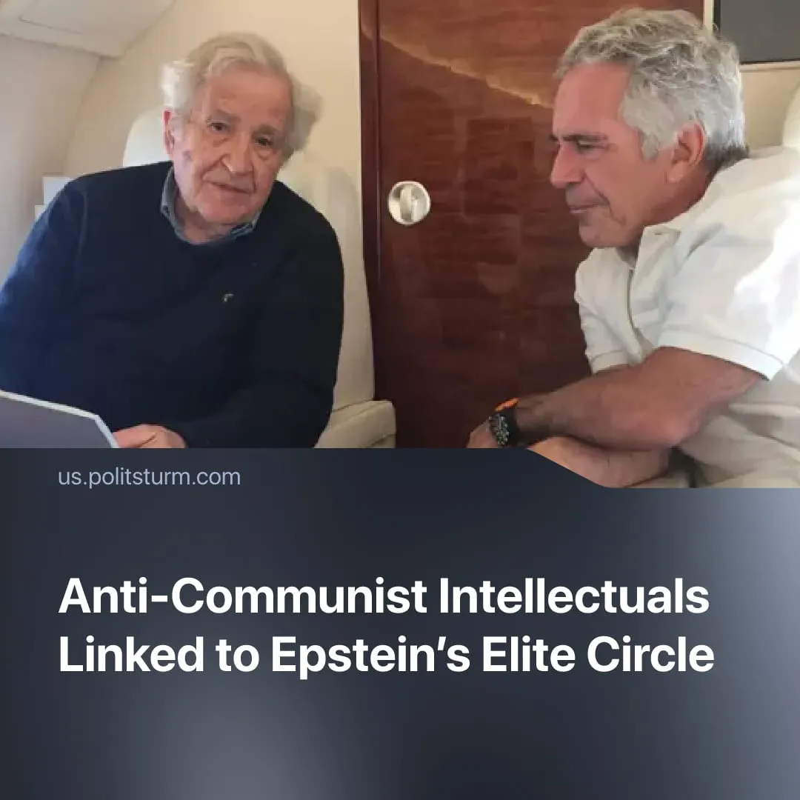

Original article
2026-02-11
1 min read

Noam Chomsky and Simon Montefiore's connections to Epstein and his accomplice were uncovered in newly released files on his case.
Details. Noam Chomsky is directly named in released emails and financial records. Documents confirm repeated meetings with Epstein after his 2008 conviction for soliciting a minor, along with extensive correspondence. In one instance, Chomsky stated he was “really fantasizing about the Caribbean island.”
► The files show that in February 2019, Epstein received advice from Chomsky on handling negative media coverage, including a message suggesting he ignore the “horrible way” he was being treated in the press and public.
► Files show Chomsky maintained connections with elite political figures, including Steve Bannon, Trump’s far-right White House strategist. In an introductory email, he told Bannon he was “quite disappointed to have missed you the other night… Lots to talk about.”
► Simon Sebag Montefiore does not appear in Epstein’s direct correspondence but is documented in exchanges with Ghislaine Maxwell, Epstein’s trafficking accomplice, concerning his work on Stalin.
Context. Chomsky, a “libertarian” socialist, anarchist, and linguist, became widely known for books critiquing “power” and the media’s role in supporting aggressive US foreign policy, including "Who Rules the World" and "Manufacturing Consent".
► Despite his “radical” image, Chomsky has denounced socialist projects that have uplifted the lives of millions of workers. He regards the October Revolution as a “coup” orchestrated through Lenin’s “opportunistic vanguardism” that later sought to destroy “workers' control.”
► Simon Sebag Montefiore built his reputation through elite-funded, anti-communist “pop history” works such as "Stalin: The Court of the Red Tsar" and "Young Stalin". These rely on selective sources and speculative narratives, privileging personalised intrigue over serious historical analysis. Ironically, Montefiore is the primary proponent of Stalin’s alleged relationship with a 13-year-old, though no archival evidence has been presented to support this.
► A $10 million film adaptation of Young Stalin is now in production, co-written by Montefiore, further commercialising his sensationalised pop-history.

Original article

