Amtrak Set To Furlough 2,000 Workers
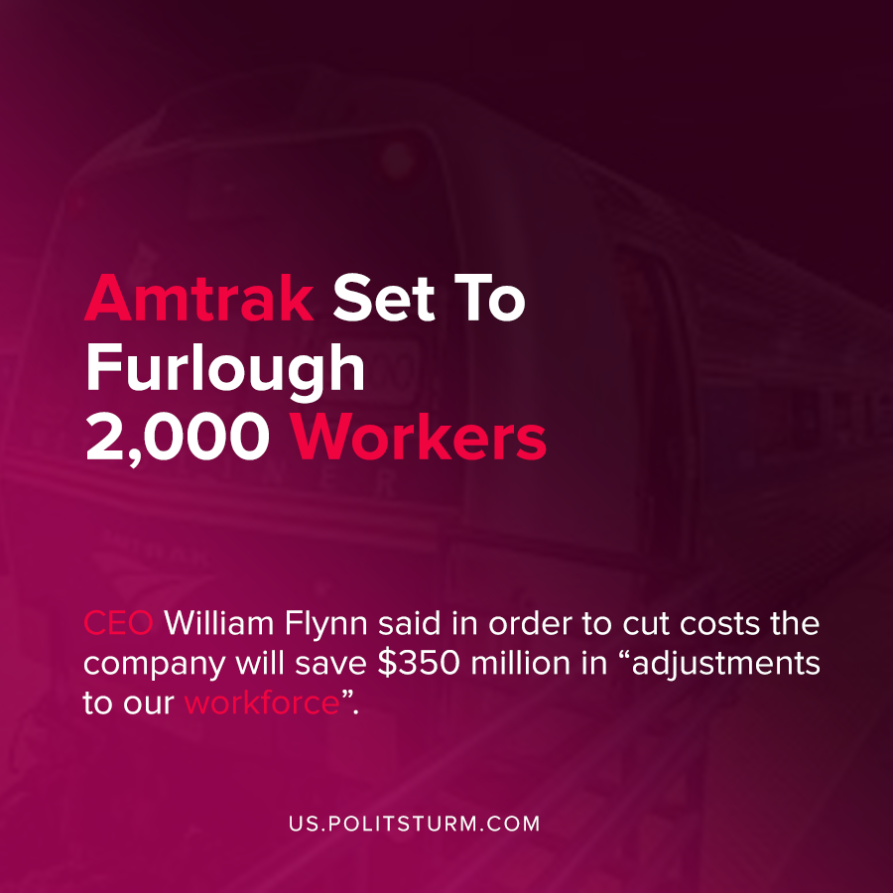

Original article
2020-09-04
1 min read

During the latest crisis of overproduction and the associated coronavirus pandemic, the travel industry experienced decreased effective demand. Amtrak submitted a letter to Congress back in May that requested $1.475 billion in additional funding in order to maintain minimum service levels.As part of the CARES Act, employers who received federal funds are required to have workers employed until at least October 1st, 2020. As effective demand has reduced expected ridership by 50% and with the continued pandemic in the United States, Amtrak is furloughing approximately 2,000 of its employees.
In a letter to Congress, CEO William Flynn outlined his plan to deal with the decrease in demand.
Amtrak is preparing to take significant steps to help offset the impacts of these revenue losses
by reducing operating costs by approximately $500 million in FY 2021… $350 million will be from adjustments to our workforce.”
Under the capitalist economic system, the priority of executives is the maximization of profits. In order to reduce expenditures, workers lose their livelihoods and the ability to support themselves and their families.
A socialist economic system, by contrast, would not be subject to the need to produce profits for the small group of private owners the capitalists.
Sources: 1 , 2 , 3

Original article

