Amnesty International Has Published A Report On Ukrainian War Crimes
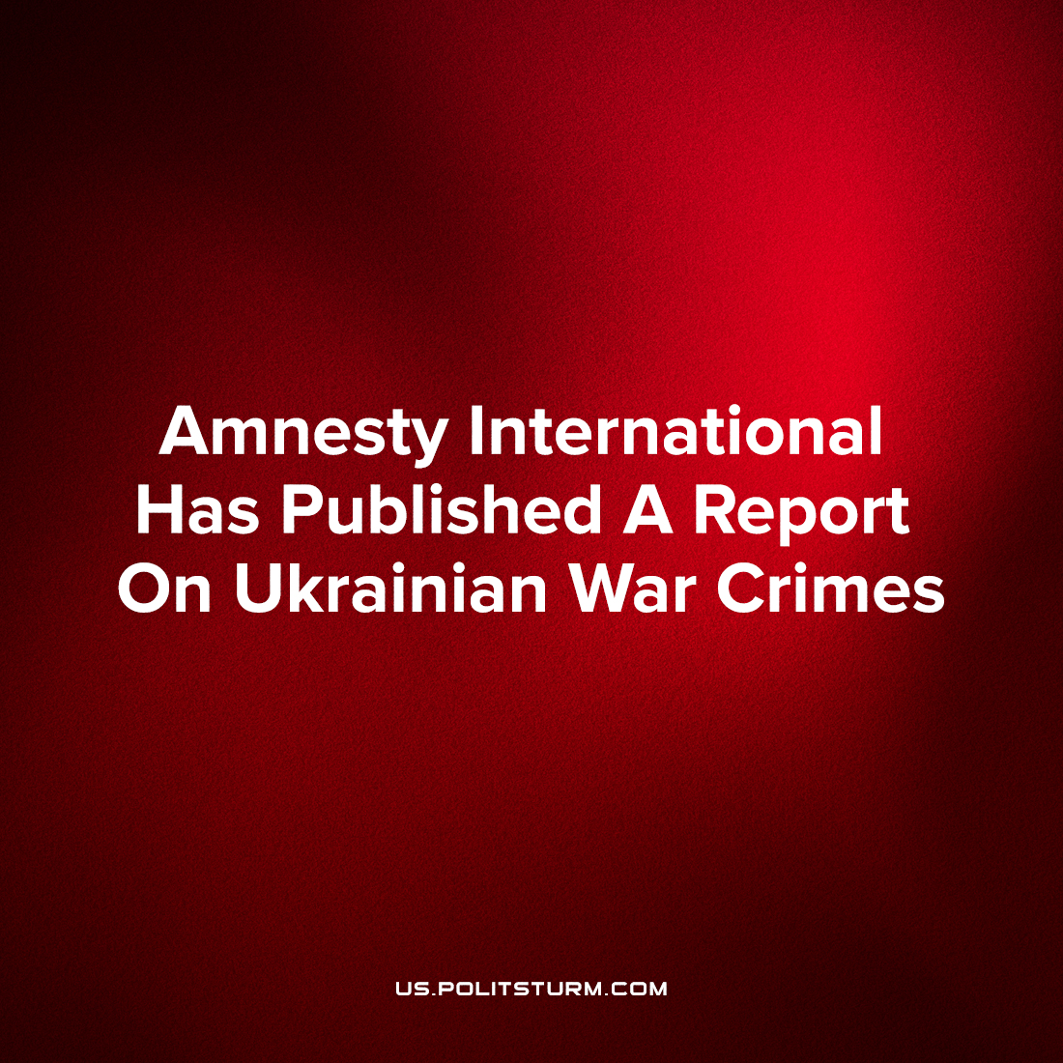

Original article
2022-08-11
3 min read

A recent report by Amnesty International has said:

“Ukrainian forces have put civilians in harm’s way by establishing bases and operating weapons systems in populated residential areas, including in schools and hospitals, as they repelled the Russian invasion that began in February”
“Such tactics violate international humanitarian law and endanger civilians, as they turn civilian objects into military targets. The ensuing Russian strikes in populated areas have killed civilians and destroyed civilian infrastructure.”
Reads a publication dated August 4, 2022, on the website of one of the most authoritative international human rights organizations.
It is stated that between April and July, A.I.’s employees spent several weeks of research on Russian strikes in the Kharkiv, Donetsk, Lugansk and Mykolaiv regions, according to which it revealed that the APU fired from settlements, and were also based in residential buildings in 19 cities and villages of the regions. The Crisis Evidence Lab analyzed satellite imagery to confirm some of these incidents.
Amnesty International records the placement of military bases in five hospitals, numerous cases of the use by Ukrainian troops of schools located in densely populated residential areas, the use of sleeping areas as bridgeheads, including camouflaging of armoured vehicles at the expense of trees in yards, deployment of artillery pieces within city limits, arrangement of a base on the territory of the university in Bakhmut (Artyomovsk) and other direct violations of humanitarian law through the exploitation of civilian infrastructure for defensive purposes.
The reaction of Ukrainian senior officials was not long in coming:

“Any attempt to question the right of Ukrainians to resist genocide, to defend their families and homes, their lives and the lives of their children, to oppose Russia’s actions as a terrorist state is a perversion, no matter what legal constructions mask it,” – said Defense Minister Oleksiy Reznikov.

“This behavior of Amnesty International is not about seeking and bringing the truth to the world. It is about creating a false balance between the perpetrator and the victim. Between a country that destroys thousands of civilians and a desperately defending the country, saving its people, saving the continent from this invasion,” — Minister of Foreign Affairs Dmitry Kuleba.

“There are certain rules that the aggressor does not comply with. Demonstratively. At the same time, the victim of aggression is required to strictly comply with all letters without regard to the context. Which in practice means suicide,” – Advisor to the Minister of Defense Alexei Kopytko.

“The aggression against our state is unprovoked, invasive and openly terrorist. And if someone makes a report in which the victim and the aggressor are allegedly the same in something, if some data about the victim is analyzed, and what the aggressor was doing at that time is ignored, this cannot be tolerated…”, – President Vladimir Zelensky.
August 6th, in the Ukrainian President’s daily address to the people, he again accused Russian forces of striking the Zaporizhzhia nuclear power plant and mentioned that:

“…for some reason there is no report or even a simple notification from Amnesty International about it”.
Considering the similar case which we reported on previously, when the UN pointed to the responsibility of Ukraine for the death of 56 people in a nursing home in Staraya Krasnyanka, Luhansk region, we emphasized that the capitalist government has a dire need to maintain superiority in the information struggle over the hearts and minds of millions of people inside the country and abroad, ensuring the flow of foreign military and humanitarian aid.
Thus, the capitalist government of Ukraine does not even try to deny its own war crimes, openly justifying them instead. However, as Agnes Calamar, Secretary General of Amnesty International correctly noted: “Being in a defensive position does not exempt the Ukrainian military from respecting international humanitarian law”.
On August 7th, Amnesty International apologized for causing “distress and anger”, but the agency didn’t retract its findings. In the example of Ukraine, we see once again that under capitalism the government is not interested in bringing truth to people, but tries to justify the predatory interests of capital and hide the crimes committed to satisfying them. Only the power of the proletariat, the class genuinely interested in uncovering objective truth, is capable of putting an end to the stream of lies which protect the exploiters for whom the preservation of profits is more precious than human life.

Original article

