Americans Struggle to Pay Bills During Crisis
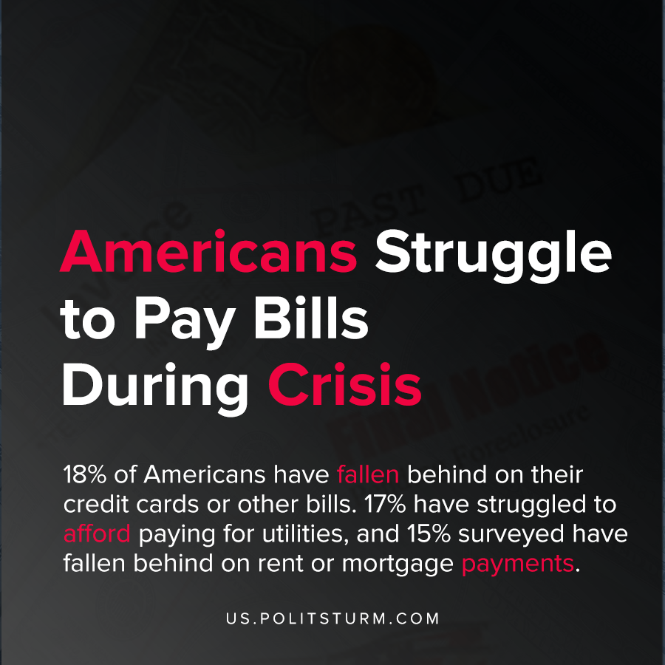

Original article
2020-12-30
1 min read

Large numbers of Americans have struggled paying bills during the pandemic, according to a survey by the Kaiser Foundation. 18% of Americans have fallen behind on their credit cards or other bills. 17% have struggled to afford paying for utilities, and 15% surveyed have fallen behind on rent or mortgage payments.
A large percentage of the Americans surveyed have either lost income personally during the pandemic or their spouse has lost income.
Over a quarter of Americans (26%) say they or a member of their household have either skipped meals since February or have relied on charity or government programs for meals. Many have also reduced the size of meals because there was not enough money to afford food.
During crises, the burden falls upon the workers who lose their jobs and suffer from all their associated negative consequences. The absurdity of the capitalist system is the overproduction of commodities coupled with the poverty and destitution that afflicts countless workers.
A socialist system, by contrast, would not suffer from periodic crises of overproduction nor the burdens of usurious financial capital and landlords.
Source: 1

Original article

