American Universities Out of Reach For Many
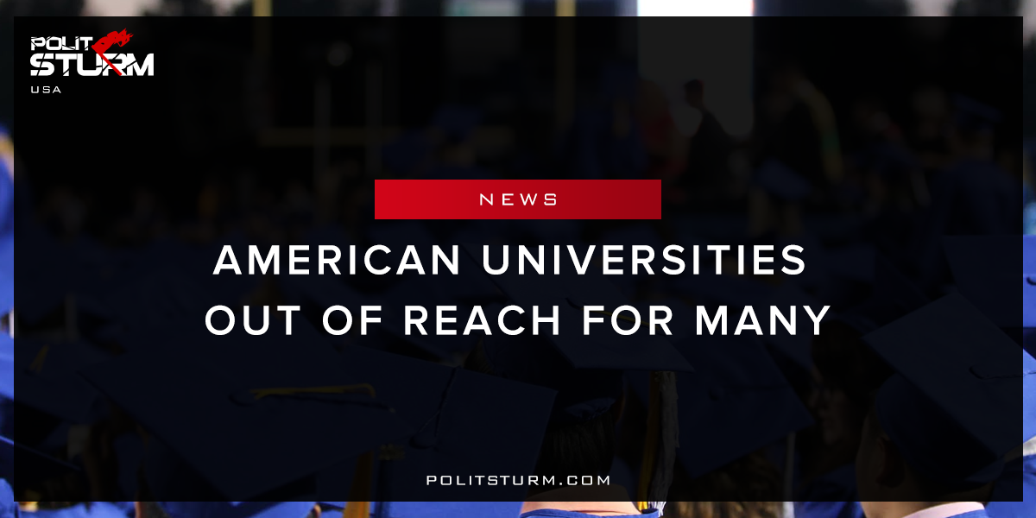

Original article
2018-03-03
1 min read

If you went to a private four-year college 30 years ago, you would’ve paid $15,160 per year, according to the College Board.
Today, your tuition fee would be more than twice that amount at $34,740. That number might seem high, but it actually pales in comparison to what some universities are charging.
According toThe Chronicle of Higher Education and U.S. News and World Report, the most expensive colleges in the U.S. cost between $50,000 and $60,000 per year.
Politsturm: The elite universities in the United States are so expensive that they almost exceed the annual median income for a family. The cost of private, four-year colleges has skyrocketed which ensures only the wealthiest Americans can afford sending their children to these prestigious universities without incurring massive student debt. In the capitalist economic system education is a commodity like any other. As a result the wealthy oligarchs are able to afford the best quality education for their families. Rather than providing education to all people, universities charge outrageous tuition and fees .
Higher education is structured in such an absurd way due to the logic of the capitalist economic system. For-profit universities are able to educate the children of the wealthy ensuring great prospects for these individuals. The mass of working people have less favorable options. Student debts have created a generation of workers who will be paying interest for decades. To the oligarchy The American education system, like many other aspects of the American economy, emphasizes and exacerbates the gap between the oligarchs and the working class.
Sources: 1, 2

Original article

