American Homeless Population Grows
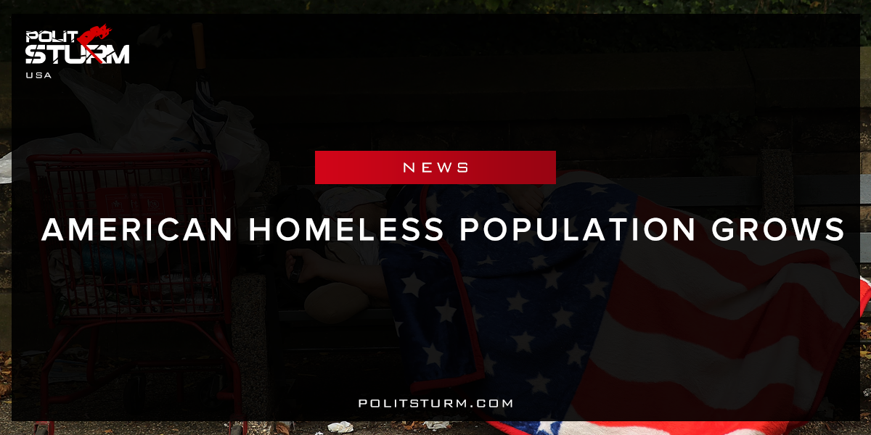

Original article
2017-12-07
2 min read

America’s homeless population has risen this year for the first time since 2010. The increase is reportedly due to a surge in the number of people in West Coast cities who cannot afford the rising cost of housing.
The study by the US Department of Housing and Urban Development revealed nearly 554,000 homeless people across the US during local tallies conducted in January – up nearly one percent from 2016, AP reported.
Of that total, around 193,000 people had no access to nightly shelter and were forced to live all over, including cars, tents, streets. The unsheltered figure rose by over nine percent compared to two years ago.
Increases are said to be higher in several West Coast cities, where at least 10 local governments have declare states of emergency since 2015 due to a homelessness boom. One of the worst consequences of the West Coast homeless explosion is a deadly hepatitis A outbreak that prompted the California governor to declare a state of emergency in mid-October.
Politsturm: The recent increase in the homeless population reflects the increasingly precarious situation faced by many Americans. Under capitalism residential real estate is a commodity like any other. The Case-Shiller U.S National Home Price Index shows that real estate prices have increased 6.25% on average over the last five years. Homes are becoming more expensive and unaffordable for the working class. Rent has also increased dramatically, forcing many people onto the streets as they have no other alternative.
These facts display the absurdity of American capitalism. Housing is not allocated or distributed according to any rational plan or methodology. Real estate is not allocated to provide shelter to the population as one would expect in a humane, rational society. Housing is rather a commodity that is used by the rich for the purposes of speculation and accumulation. Capitalists and landlords are able to exploit the working class by “flipping” properties and charging egregious rents. Does the working class need people who reap profits off by speculating on real estate or charging these rents? What about the hundreds of thousands of our own citizens who have become entirely dispossessed by these exploiters? The fact of the matter is that on the other side of the tragedy of the American homeless population is the class of capitalists and landlords who profit off this arrangement.
Sources: 1, 2

Original article

