American Franchise Capital Executive on Inflation
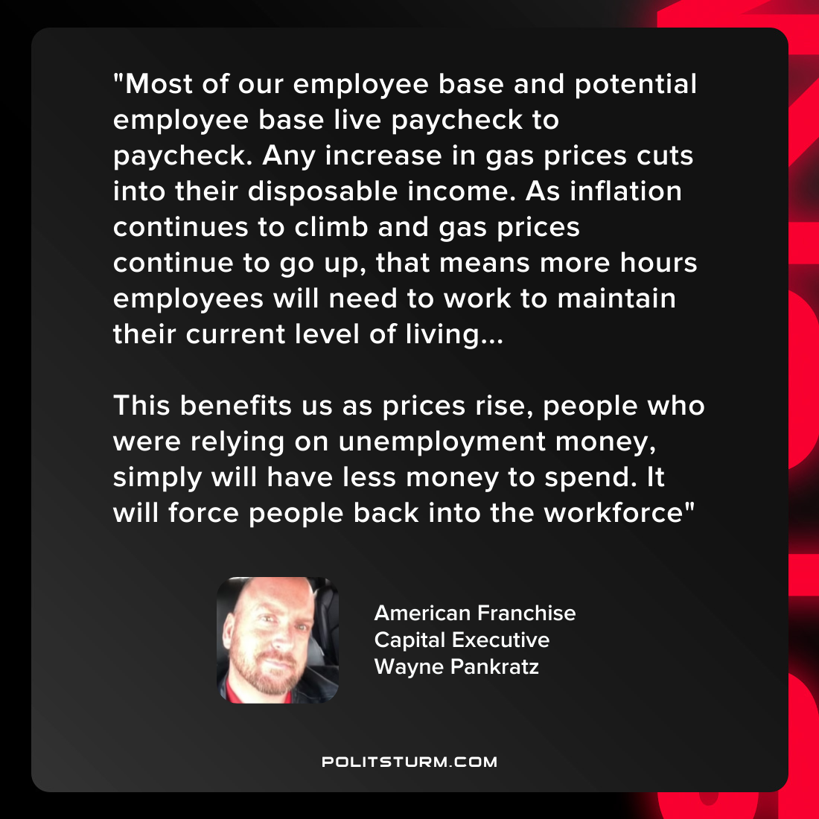

Original article
2022-03-25
1 min read

“Most of our employee base and potential employee base live paycheck to paycheck. Any increase in gas prices cuts into their disposable income. As inflation continues to climb and gas prices continue to go up, that means more hours employees will need to work to maintain their current level of living…
This benefits us as prices rise, people who were relying on unemployment money, simply will have less money to spend. It will force people back into the workforce”
~American Franchise Capital Executive, Wayne Pankratz

Original article

