American Airlines To Furlough 17,500 Workers
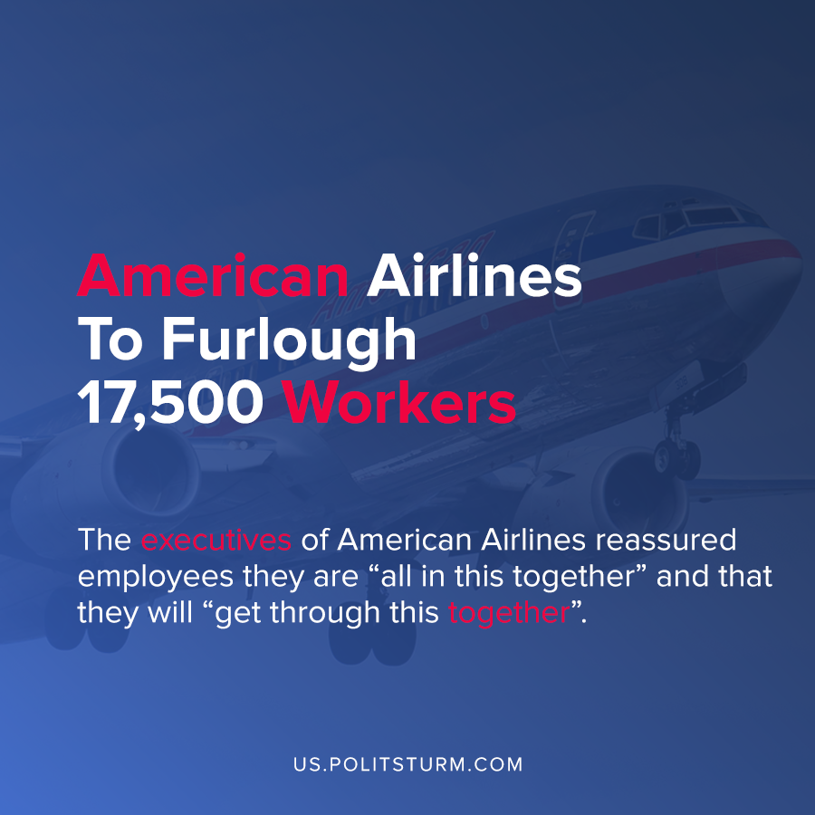

Original article
2020-08-26
1 min read

In a corporate filing with the Securities and Exchange Commission (SEC), American Airlines announced that it will furlough approximately 17,500 of its U.S.-based employees starting on October 1, 2020.
In the filings, the cause of the layoffs was expressed as the termination of the Payroll Support Program (PSP), which was a provision of the CARES Act. This legislative act provided funds that were used to pay workers salaries.
Facing a sharp decline in demand and the likelihood that the Payroll Support Program will not be extended, the company will be dramatically reducing its workforce. According to the filing, there will be 40,000 fewer American Airlines employees than there were prior to the pandemic and overproduction crisis.
The corporate executives of American Airlines reassured employees that they are “all in this together” and that they will “get through this together”.
Despite the rhetoric of the capitalist class, the workers at American Airlines are suffering the brunt of the negative consequences of the crisis. 8,100 flight attendants, 1,600 pilots, 2,275 fleet service workers, and many other workers are losing their livelihoods.
The capitalist economic system is subject to periodic crises that lead to mass unemployment of the working class. Perversely, the increase in the labor supply creates a mass army of the unemployed who struggle to survive. Only the replacement of the capitalist economic system with a planned, socialist economic system will end the needless suffering of the working class which occurs as a result of unemployment.
Source: 1

Original article

