“America First” Fails to Convince Americans
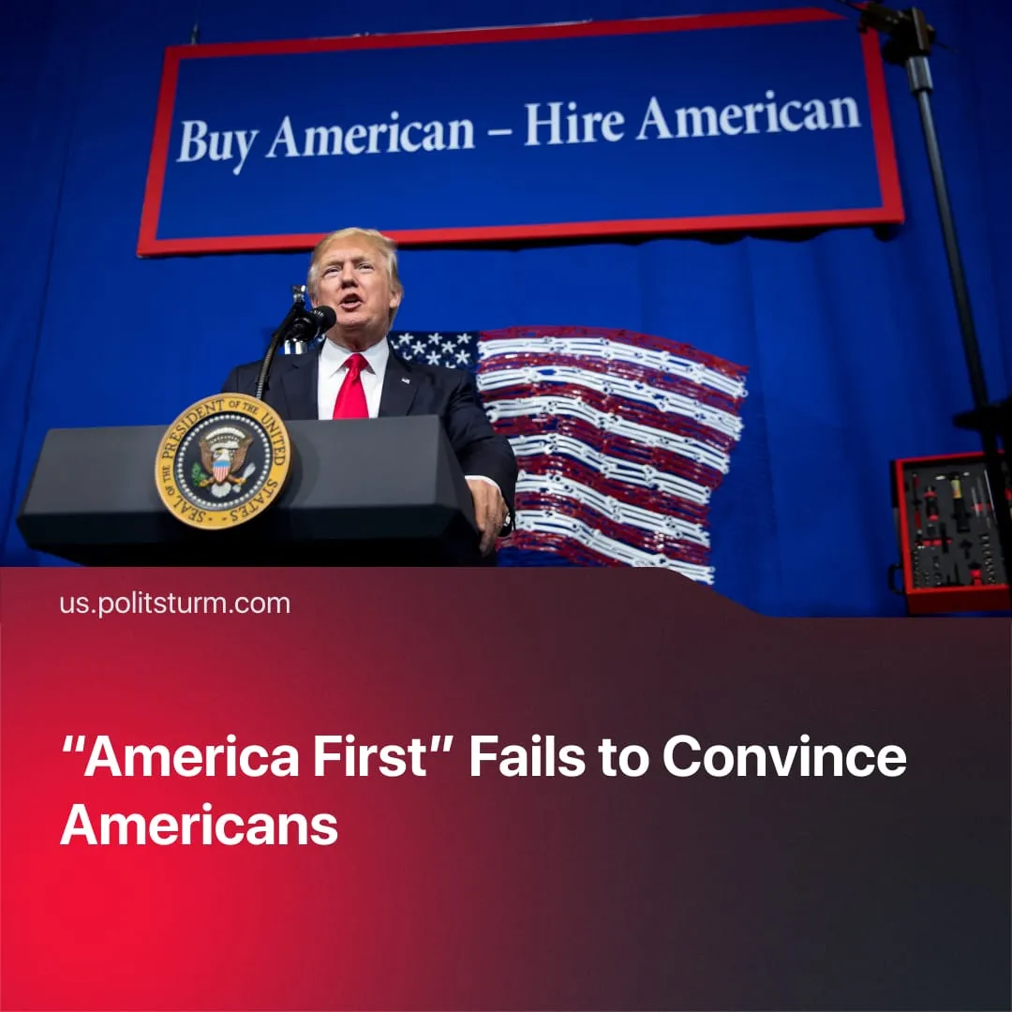

Original article
2025-11-10
1 min read

Trump's "America First" policies have failed to win the trust of Americans.
Details. Trump’s disapproval rating has risen to 58%, with growing media reports showing public dissatisfaction toward his “America First” policies outlined in the Republican Party program.
► 54% of adults disapprove of Trump’s handling of the economy, and over half of 18–64-year-olds believe the American economy is in a recession. Whilst 60% of Americans currently think that the economy is the top national concern.
► 53% disapprove of Trump’s immigration policy, while only 8% see immigration as the nation’s most important issue.
► A 61% majority of Americans disapprove of the Trump administration’s tariff increases. Among people aged 18-29, this goes up to 72%.
► 52% of adults disapprove of US foreign policy under Trump’s rule. Notably, statements about taking over Greenland and Gaza.
Context. Trump’s “America First” program was presented as a patriotic defence of the US worker – promising to rebuild industry, protect jobs, and end foreign “exploitation.” In practice, these policies have failed to halt the rapid decline in Americans’ living standards – the bottom 60% of US households no longer earn enough to cover basic needs as wages stagnate and prices rise.
► The policies have relied on chauvinistic and patriotic imagery – rallies, speeches, and media messaging frame tariffs, deportations, and military posturing as defending American sovereignty and restoring the nation’s “golden age.”
► In reality, these policies have served both ideological and material goals of US imperialism – enriching corporations through tax cuts and deregulation, expanding the military, suppressing domestic unrest, and using rhetoric to divide the working class, build support for imperial ambitions, and prepare the population for confrontation with rival imperialist China.

Original article

