Amazon Workers Sue Over Working Conditions
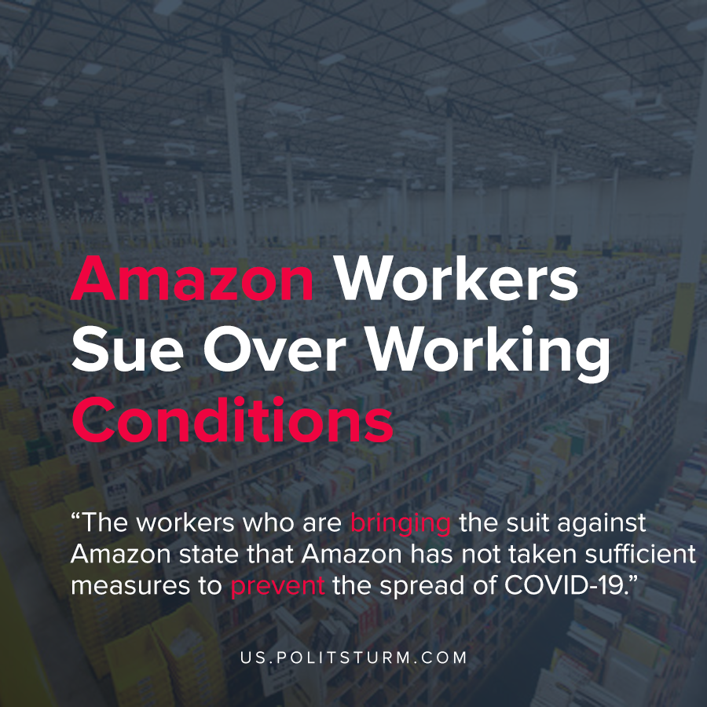

Original article
2020-06-08
1 min read

Three Amazon workers at the JFK8 Fulfillment Center in Staten Island, New York and members of their households are filing a suit against Amazon for being put at serious risk for COVID-19 exposure.The workers are suing to force Amazon to change their workplace and leave policy to stop putting workers, their families, and the community at risk of COVID-19 exposure.
The Amazon JFK8 facility is 855,000 square feet in size, employs over 5,000 workers, and services New York City, which is Amazon’s single largest market. The workers who are bringing the suit against Amazon state that Amazon has not taken sufficient measures to prevent the spread of COVID-19.
Workers state that Amazon discourages workers from taking sanitary measures that would prevent the spread of the virus, even if it means being away from their work station for very limited amounts of time. Also, the workers state that Amazon did not sufficiently sanitize high-touch surfaces, provide quarantine benefits in a timely manner, nor implement sufficient contact tracing for infected employees.
“Workers at Amazon’s JFK8 facility are asking a court to enforce public health guidance at our workplace because we’ve seen how the company’s current leave and break policies and failure to do thorough contact tracing of ill workers’ interactions have put all of us at risk,”, said the plaintiff Derrick Palmer.
While Amazon has profited during the coronavirus pandemic, the workers have been exposed to the virus and have suffered as a result. The capitalist economic system prioritizes the production of surplus value, and its appropriation to the owners of the means of production. The health and safety of the workers are not a primary concern under capitalism. Only a socialist, planned economy would be able to protect the interests of the workers, rather than a small group of oligarchs.
Source: 1

Original article

