Amazon Warehouse Workers Fight to Form Union
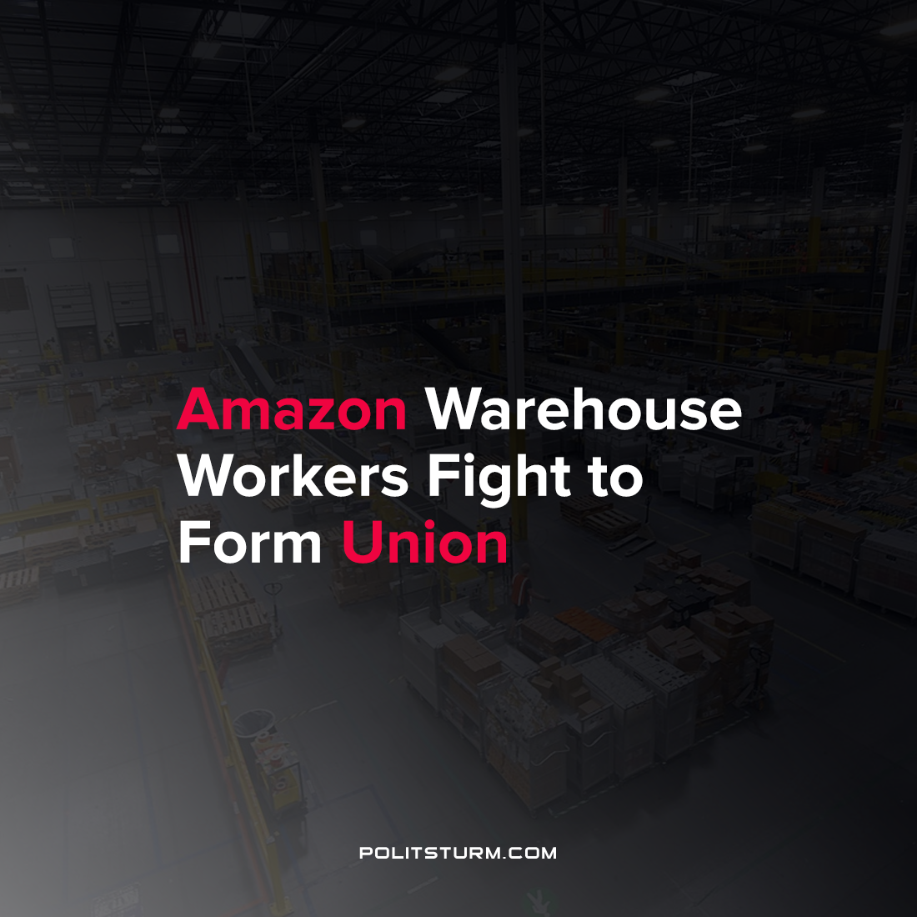

Original article
2021-10-23
1 min read

Amazon workers at the Staten Island, New York Fulfillment Center are preparing to file for a union election with the National Labor Relations Board. As previously reported, workers at this location have already brought a lawsuit against Amazon with respect to working conditions and hazards, which was subsequently dismissed. Now, workers are preparing to unionize at this location.
Amazon has taken actions to dissuade unionization by reportedly confiscating pro-union literature and distributing anti-union flyers. The company has also slandered an organizer who was fired from the location due to his unionization effort. A leaked memo described organizer and former warehouse employee Christian Smalls as “not smart or articulate”.
Amazon has publicly come out against the unionization efforts of its workers.
“Every day we empower people to find ways to improve their jobs, and when they do that we want to make those changes—quickly. That type of continuous improvement is harder to do quickly and nimbly with unions in the middle.”, said Amazon spokesperson Kelly Nantel.
The workers are standing in opposition to Amazon and are forming unions to improve the material conditions of their lives. The workers will need to continue their struggles within the workplace and forming a political organization capable of ending capitalist exploitation entirely.
Source: 1 2 3

Original article

