Amazon Pushes Workers to Graveyard Megacycle Shifts
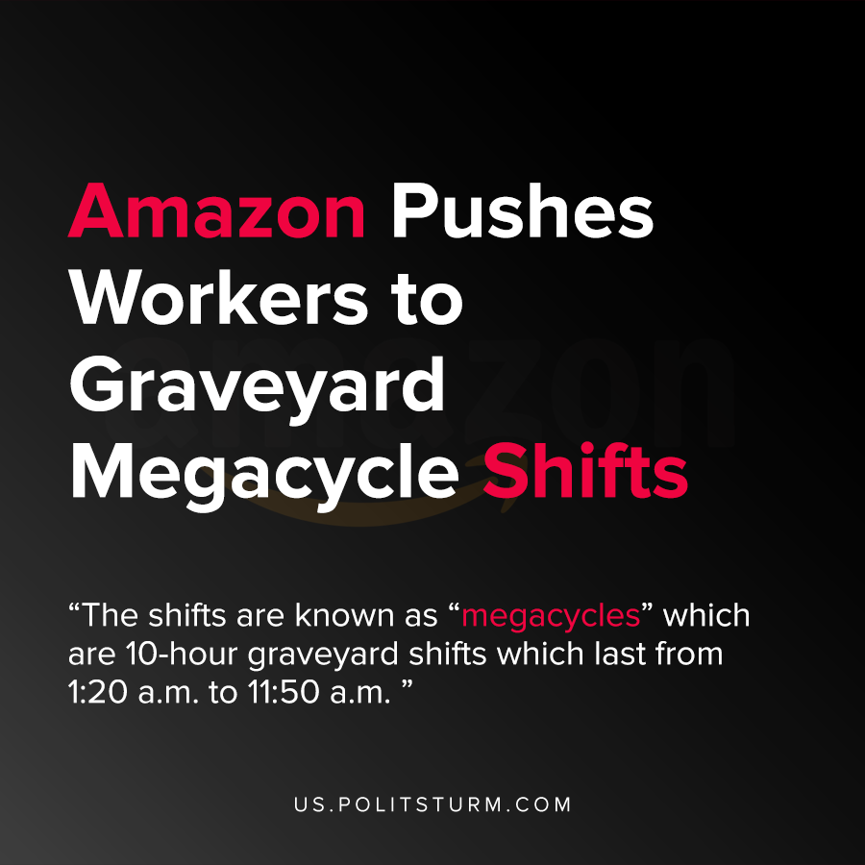

Original article
2021-02-13
1 min read

According to Motherboard, Amazon is forcing warehouse workers to either work 10-hour graveyard shifts or lose their jobs. The shifts are known as “megacycle” shifts which are characterized by the extended length of the shift which lasts from 1:20 a.m. to 11:50 a.m.
The Amazonians United organization responded saying the changes are unacceptable for the workers, for example, parents and caretakers. There are also obvious health and safety concerns associated with the lengthened workday.

“Can you imagine working 1am-noon, 4 days a week? What time will we sleep and live life?! How do we adjust during our weekends? This change will be nationwide at Delivery Stations—Amazon is setting an example for how other companies can exploit workers with this inhumane shift”
Amazon is concerned with profit and returns for shareholders, and having longer shifts with fewer workers benefits the capitalists bottom line.
Until the workers unite and consciously move to an economic system that serves the workers, socialism, the bourgeois will continue their exploitation of the workers. The capitalist economic system is predicated upon the exploitation of the workers which thereby enriches the owners of capital. The “choice” given to workers was to unconditionally accept the worsening conditions or lose their livelihood. In light of this fact, workers must defend their rights and struggle against the capitalists to obtain better working conditions.
Source: 1 , 2 , 3

Original article

