Amazon Pushes For In-Person Union Vote Despite COVID
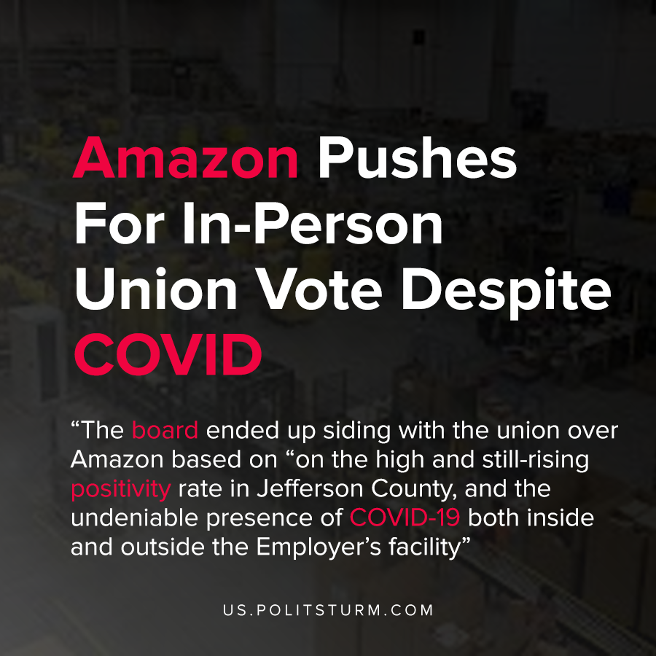

Original article
2021-01-26
1 min read

As we have previously written about, workers at the Amazon warehouse in Bessemer, Alabama were petitioning to unionize pursuant to the National Labor Relation Act.
The workers were struggling for better working conditions at Amazon, formal grievance procedures, and the removal of “at-will” employment status. The latter allows capitalist enterprises to fire workers without due cause.
In a teleconference discussing the upcoming vote, the union and Amazon expressed different views on how the vote should be conducted. The petitioner, the Retail, Wholesale, and Department Store Union, expressed that it would be reasonable during a pandemic to allow for mail-in ballots due to the inherent health risks associated with conducting an in-person vote.
Amazon, by contrast, stated that mail-in-ballots would create undue administrative burden and that an in-person vote could be safely conducted. Amazon also contended that the spread of the coronavirus in the county the vote would be conducted in is “irrelevant”.
The board ended up siding with the union over Amazon based on “on the high and still-rising positivity rate in Jefferson County, and the undeniable presence of COVID-19 both inside and outside the Employer’s facility”.
While the union was able to secure mail-in ballots during a pandemic, Amazon’s actions reveal the true class interests. In pushing for in-person voting during unsafe conditions, Amazon hoped to suppress the vote and undermine the worker’s ability to collectively bargain. Marxist-Leninist theory shows that the capitalist’s drive for profit is the motivating force behind their actions, which must be exposed and countered through the dictatorship of the proletariat.
Source: 1 , 2

Original article

