Amazon Hires Cops to Suppress Unionization
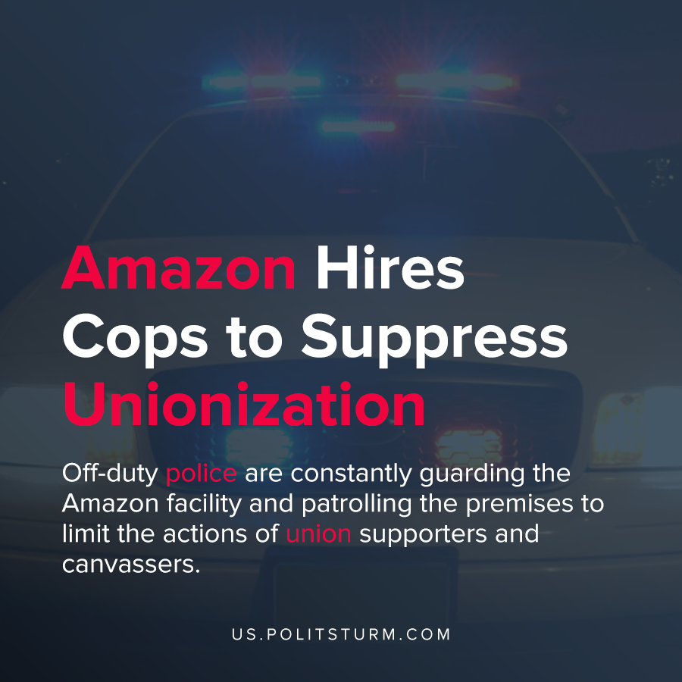

Original article
2021-03-31
1 min read

According to a recent report by Truthout, Amazon is employing off-duty police to intimidate workers and union officials ahead of a historic union vote. Workers at the Bessemer, Alabama warehouse are voting for unionization and if successful they would be the first Amazon workers to unionize.
Off-duty police are constantly guarding the Amazon facility and patrolling the premises to limit the actions of union supporters and canvassers.
In addition to employing police to harass and intimidate workers, Amazon has taken other measures to prevent unionization. Disgruntled workers were given financial incentives to quit, anti-union meetings were conducted, and mailboxes to collect union votes were placed on company property.
The police are playing their historic role of protecting the interests of the oligarchs and the dictatorship of capital. The unionization of workers and the improvement of working conditions threatens the rule of capital, and the capitalists will use any means necessary to continue their class domination.
Source: 1

Original article

