Alt-Right "Proud Boys" Outnumbered at “Demand Free Speech” Rally
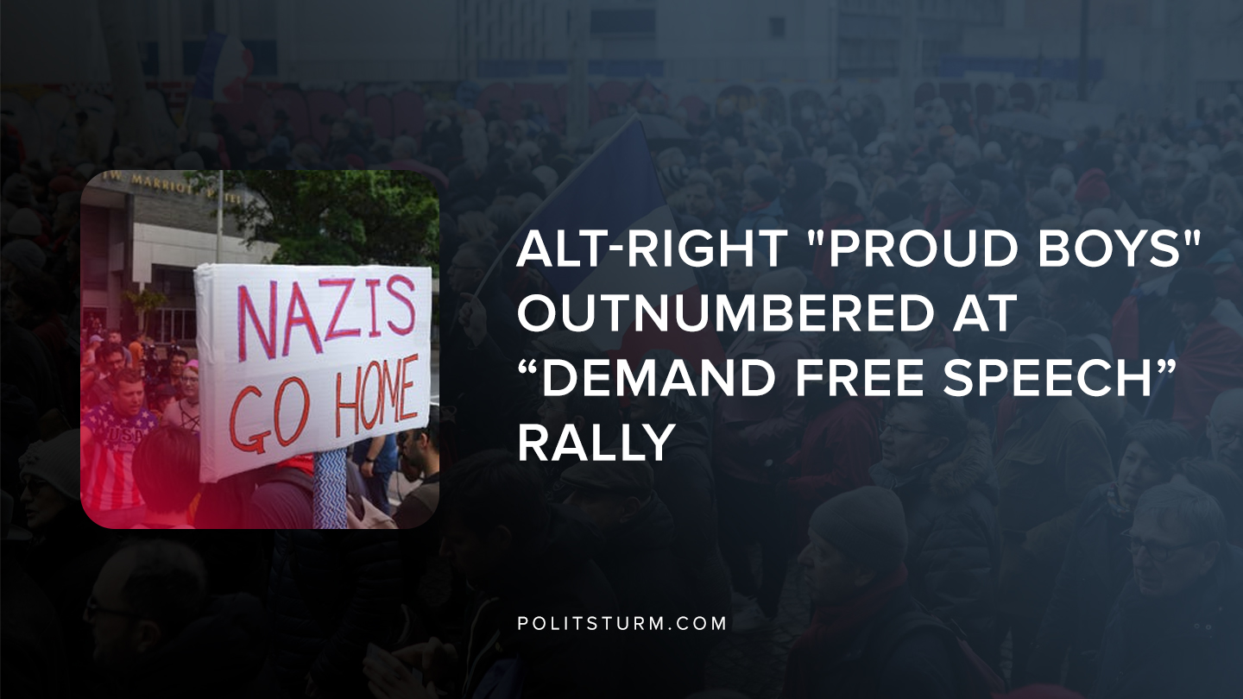

Original article
2019-07-07
1 min read

A demonstration was held on July 6th, 2019 in Washington D.C at Freedom Plaza and Pershing Park to protest an alleged “anti-conservative” bias in the media. The group is a self-proclaimed “chauvinist” organization with ties to the white nationalist movement in the United States.
The purpose of the rally was the limitation of conservative “freedom of speech” on social media platforms, such as Facebook and Twitter.
The conservative rally was counter-protested by the “All Out DC” rally which organized a large crowd in opposition. Counter-protesters outnumbered the Proud Boys by 2-1, amongst which approximately 50 where anti-fascists.
The Proud Boys event received limited attention, and no arrests were made as there were only minor skirmishes between the two groups.
The alt-right and their associated organizations reflect the reactionary, nationalist worldview that proclaims the superiority of “Western Civilization”. These groups serve the interests of the capitalist class, as they utilize the mass discontent at the failing capitalist system in a way that serves the interests of the capitalist class.
Racism, nationalism, chauvinism, and other forms of reactionary views are useful to the capitalist class to the extent that the working class can be fragmented, and political power can remain consolidated in the hands of the oligarchic capitalist class.

https://www.usatoday.com/story/news/nation/2019/07/06/white-nationalist-linked-proud-boys-outnumbered-counter-protesters/1661585001/

Original article

