Alec Baldwin: Negligent Homicide by Capitalism
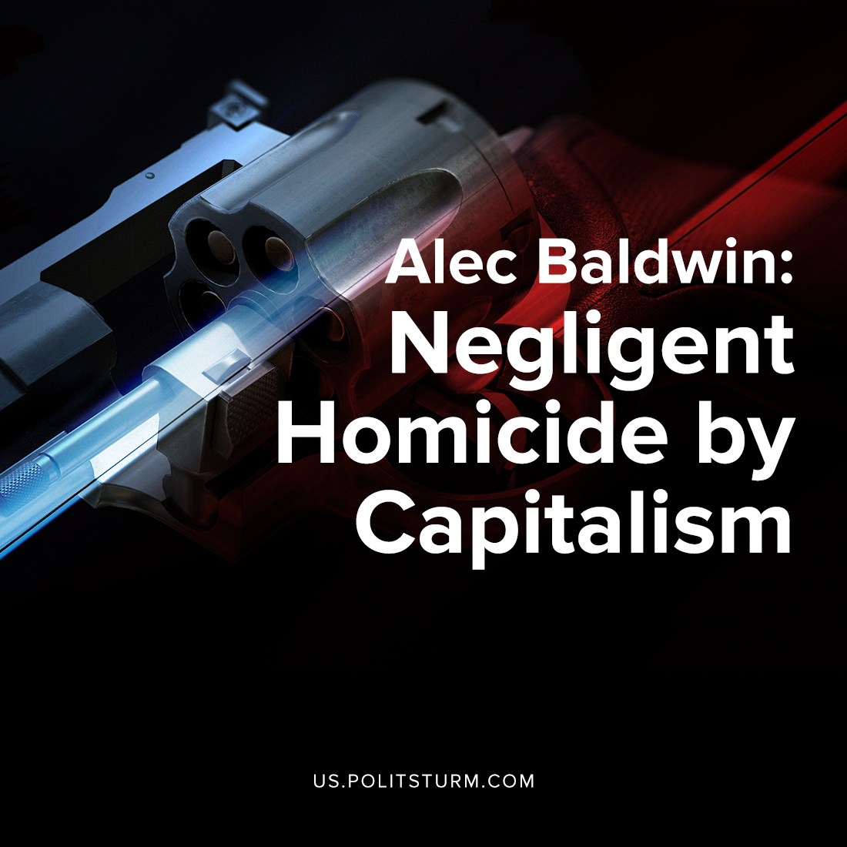

Original article
2021-11-13
5 min read

On October 21st, during the filming for his new film Rust, American actor Alec Baldwin aimed and fired a handgun loaded with live ammunition, killing the director of production and cinematographer Halyna Hutchins, and injuring the film’s director.
Guilt was cast in every direction, with four of the film’s crew listed in a Court warrant, one of whose defense lawyers is baselessly alleging a conspiracy of sabotage by striking workers. But the apparent conspiracy is an open one; in which powerful, propertied interests operate a dangerous and repressive environment in the media industry, through their practices of nepotism, abuse and ultimately their fundamental drive for increasing profitability. Let’s take a look.
While Baldwin holds credit as the movie’s producer and the hand on the smoking gun, it is likely he will skirt under the court’s net for legal negligence in this case. He had been handed the firearm for a scene rehearsal by the film’s assistant director Dave Halls – himself fired from another movie in 2019 for a different on-set shooting injury.

Halls hadn’t checked the weapon, but anyways informed Baldwin that it would be safe to handle. The assistant director would later say that it was “not his responsibility” to check the gun’s ammunition – a responsibility commonly assigned to his position on other movies, say retired professionals.
Taking the gun from a props cart, he chose instead to place his faith in the production’s 24 year-old armorer Hannah Gutierrez Reed who had prepared it – further pushing responsibility onto props master Sarah Zachry, who had transported the revolver in question from a gun-safe in a truck, and is the fourth relevant individual identified by police. Both claim that, at the time of the shooting, they had no idea that earlier in the day the revolver was used by unspecified crew members to shoot bottles in the desert with live ammunition.
An armorer was hired by a film studio to oversee the safe handling and use of firearms and ammunition for the production. In her own words, Gutierrez-Reed described receiving no formal training in this field and basically learning everything on the fly. Her career really began years before she was born, when her father became an armorer on some major Hollywood films.
Like the film’s assistant director Halls, armorer Gutierrez-Reed has a record of lax production safety in her very short career. In her sole other credit as armorer, she reportedly carried loaded handguns under her armpits, and fired a gun next to the ear of actor Nicolas Cage – generally exhibiting a lack of the most basic gun safety practices.
Perhaps the most bitter context for the death of Halyna Hutchins is the fact that mere hours before the incident, a number of the production’s camera crew struck against negligent conditions of workplace safety. Before six IATSE workers had left the set that day for their strike, they saw that they had been replaced with non-union staff in order to continue work.
Error loading image
Instead of halting production due to the lack of qualified staff, as often happens in media strikes at a high cost to the studio, the production executives wasted no time at all in employing grossly unqualified scabs.
The lawyer for Gutierrez-Reed has made an allegation of sabotage directly implicating these very same workers who struck against the dangerous workplace environment (which the defense lawyers have also indicated in their clients defense); saying of the imagined saboteur:
“…wanted to do something to cause a safety incident on set…
…to prove a point, to say that they’re disgruntled”
The timing of this argument was certainly no happy accident for the industry, given the overall strike actions which were being executed by IATSE union members across the industry as negotiations soured over their most recent contract. The smear campaign against completely innocent crew members men and other crew, who it seems would have had no access to the firearm, intends to recast the labor movement as the villain of this story. However, the real culprit is being indicated from all sides to be the kind of dangerous, corrupt studio workplace which has increasingly become the norm in the film industry.
In fact, it is only now that renewed activity by the labor unions is building up a levee against the overflowing tide of capitalist profiteering. This strike wave by IATSE workers stretched to over 69,000 workers, and has since been resolved with the industry.The tragic death of Halyna Hutchins is another unfortunate example of capitalists putting the desire for maximum profits above all else, including the safety of the workers. While the defense attorney of the accused may point to the striking workers as a scapegoat, this could not be further from the truth. The lax safety standards and scabbing of striking workers are related to the bottom line of the film production company, i.e. profitability. Adequate and reasonable measures to protect workers are not taken to the extent that they are not compatible with maximum profitability. Such tragic events are therefore bound to recur as long as the capitalist system continues to exist.
Sources: 1, 2, 3, 4

Original article

