Alabama Hyundai Subsidiary Accused of Employing Child Labor in Plants
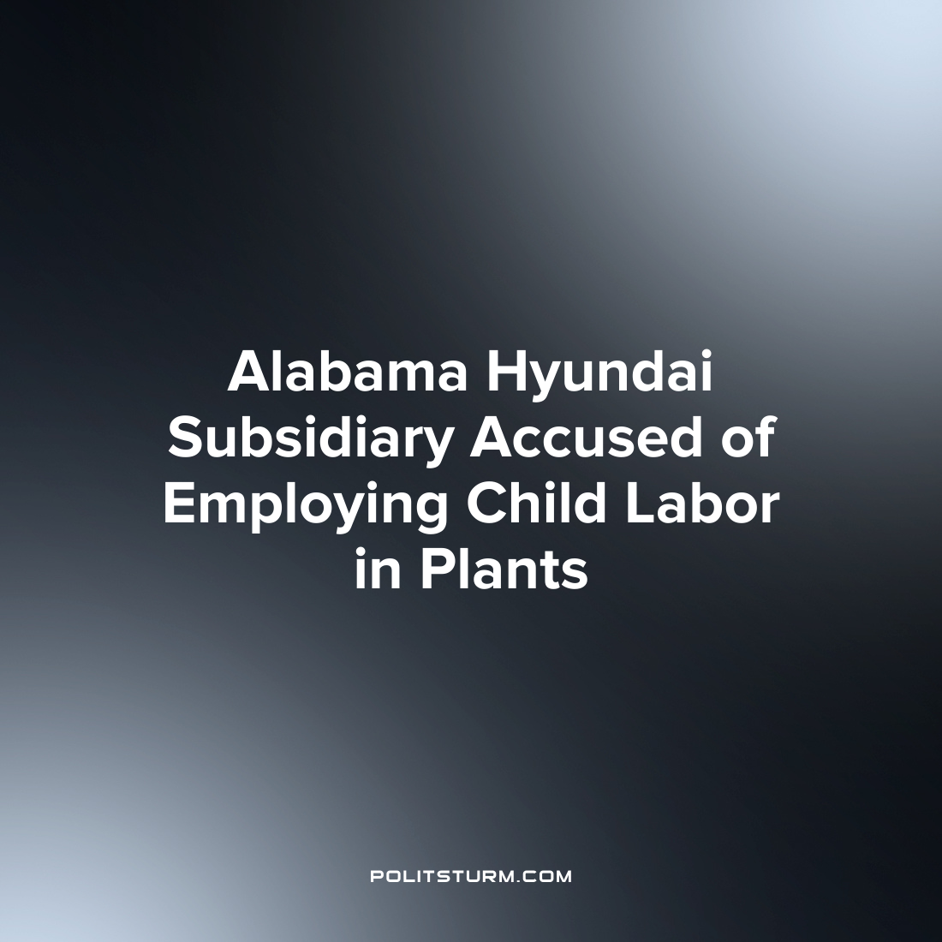

Original article
2022-07-22
1 min read

According to a report by Reuters, a Hyundai Motor Corporation subsidiary in Alabama is accused of utilizing child labor in their plant. SMART Alabama LLC. operates a metal stamping plant which manufactures parts for the company’s nearby assembly line in Montgomery, Alabama. The report goes on to state that workers as young as 12 years old have worked at the plant.
The company has a documented history of violations of occupational safety for its workers by the Occupational Safety and Health Administration. Alabama and federal laws prohibit those under the age of 18 from working at metal pressing and stamping operations due to the inherent risks involved in this type of work.
A former worker at the plant attested that there were approximately 50 underage workers working at the plant across all shifts. Another worker said that they worked alongside approximately a dozen minors during their shift.
Capitalism has a long history of exploiting child labor in order to bolster the profits of the oligarchs. In this instance SMART Alabama LLC is accused of exploiting migrant child labor in an effort to maximize profits despite the clear exploitation and danger this poses to children. As long as the capitalist system continues to exist, the capitalists will continue to use all available means to exploit the working class for their own private profits, regardless of the social consequences of their actions.
Source: 1 2

Original article

