Airline Industry Faces Critical Failure in Pandemic Aftermath
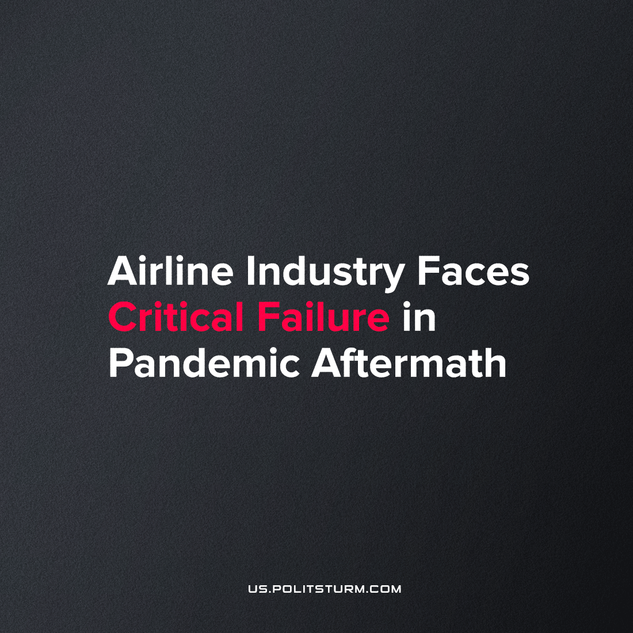

Original article
2022-07-05
2 min read

Hours-long queues, cancelled flights, and hundreds of stacked bags: this is the reality of summer vacation for European travelers in 2022. During the past two years, crisis loomed over the airline industry and has finally dropped. Airport administrations are forced to impose limitations on the daily number of flights, and airline companies convulsively slash their flight schedules.
Transavia cancelled 240 flights in July and August passing Amsterdam’s Schiphol Airport.
Corendon Airlines and Air Malta relocated 150 flights and approximately 300 more to Rotterdam and other smaller airports respectively.
British KLM cancelled all flights from Europe to Amsterdam.
Belgian Brussels Airlines, a subsidiary of Lufthansa, cancels almost 700 flights.
In the U.S., Airlines of America give an estimated number of 15 percent of planned flights that have been cut from the summer schedule.
Why can’t these companies deal with the growing demand?
All this is an echo of the staff shortage which began in 2020. Trying to enshrine their profitability and survive the Covid crisis, airline companies looked to reduce payroll expenses by offered early retirement to their employees, together with unpaid leave packages. In July of 2020, Bloomberg stated that the number of airline workers around the world who have been fired or may lose their job is around 400.000. Now, these people are replaced by new staff who need to be trained again. This issue surfaced already in 2021 but didn’t lead to such serious consequences as we are seeing now. As the number of air travelers comes back to a pre-pandemic level, the atrophied industry can’t meet even this demand, which should not have been unanticipated.
How can the market resolve the crisis?
As usual, cutting flights at the expense of workers isn’t the only issue. Apart from decreasing flight numbers and the exclusion of some small cities from air service, fare costs rise. Based on data from Hopper, average U.S. domestic airfares reached $400 at the end of May, starting at $250 in the beginning of the year. And although airline workers held a series of successful strikes in France, Great Britain and Germany, these cannot change the general trend of the market. Their victory, certainly deserving wide applause and requiring the continuation of their struggle, will fall on the shoulders of the purchasers or in other words, the regular working person.
The bourgeoisie, as usual, tries to explain their actions by pointing fingers at a number of external factors, such as unexpected growth of demand, restrictions put in place by airport administrations, strikes, and the “unavoidable” loss of their employees during the pandemic market downturn. However, the origin of this crisis is systematic and lies in the lack of planning. Permanent competition between the different market players forces them to adjust to daily economic instability. As a result, the race of here and now profit-making only finishes with a consequent series of crises, each as bad as the one before. Capitalism has once again proved its inability to meet the needs of people. The daily growing demand of humanity requires precise assessment and rational utilization of the resources needed for the fabrication of goods and further equal distribution of products. All this requires centralized planning, implementation of which is impossible without the socialization of the means of production and their further subordination to the interests of the proletarian majority.
Sources: 1, 2, 3

Original article

