African Americans Suffered 1.63 Million Excess Deaths Between 1999 and 2020
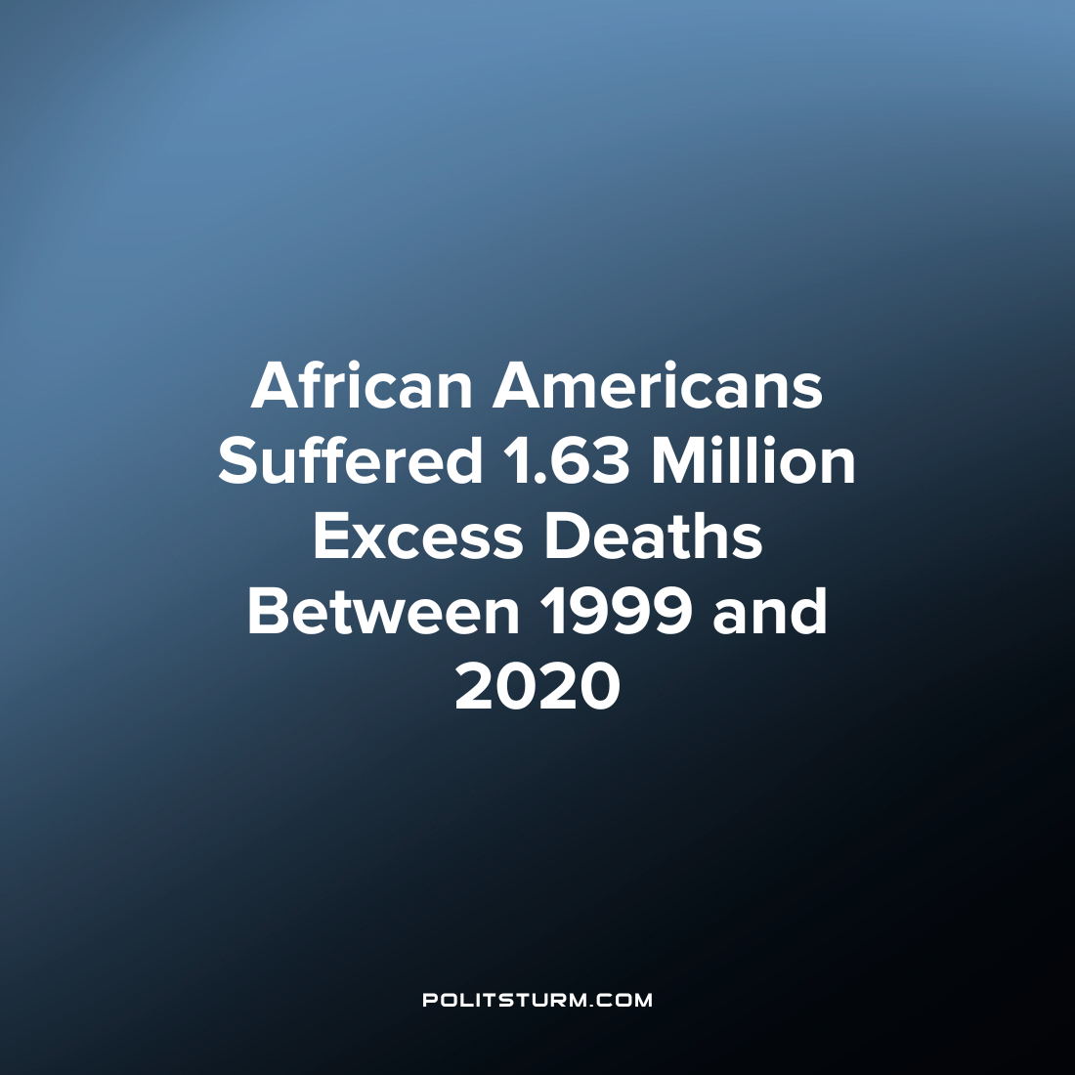

Original article
2023-05-23
1 min read

A new study by the Yale University School of Medicine shows a stark difference in expected health outcomes on the basis of race. The study found that African Americans had 1.63 million excess deaths between 1999 and 2020 compared to white Americans, representing more than 80 million years' worth of potential life lost. In order to analyze the trends of excess mortality, researchers took data from death certificates and examined the age-adjusted mortality rates of African Americans. The researchers found that there has been little to no improvement in the unequal outcomes of the U.S. healthcare system as it pertains to the higher age-adjusted mortality rates of African Americans.
“So far, our efforts to address health equity have failed to produce sustainable improvements in the lives and years lost by Black Americans because of disparities in death rates across the spectrum of age”, said Harlan M. Krumholz, MD, the senior author of the study.
Despite the passage of time, there has been little to no improvement in the excess mortality of African Americans. The capitalist system which inserts the profit motive into the provision of healthcare has a history of racist outcomes or so-called “inequities” which has caused incalculable damage and needless suffering. As long as the capitalist system continues to exist, the oligarchs will continue to profit off a medical system which is wholly inadequate and furthermore has discriminatory outcomes on the basis of race. As long as the capitalist system continues to exist, racial discrimination and unequal health outcomes will be an unfortunate reality that must be grappled with.
Source: 1

Original article

