US leaders believe AfD Label Is a ‘New Berlin Wall’
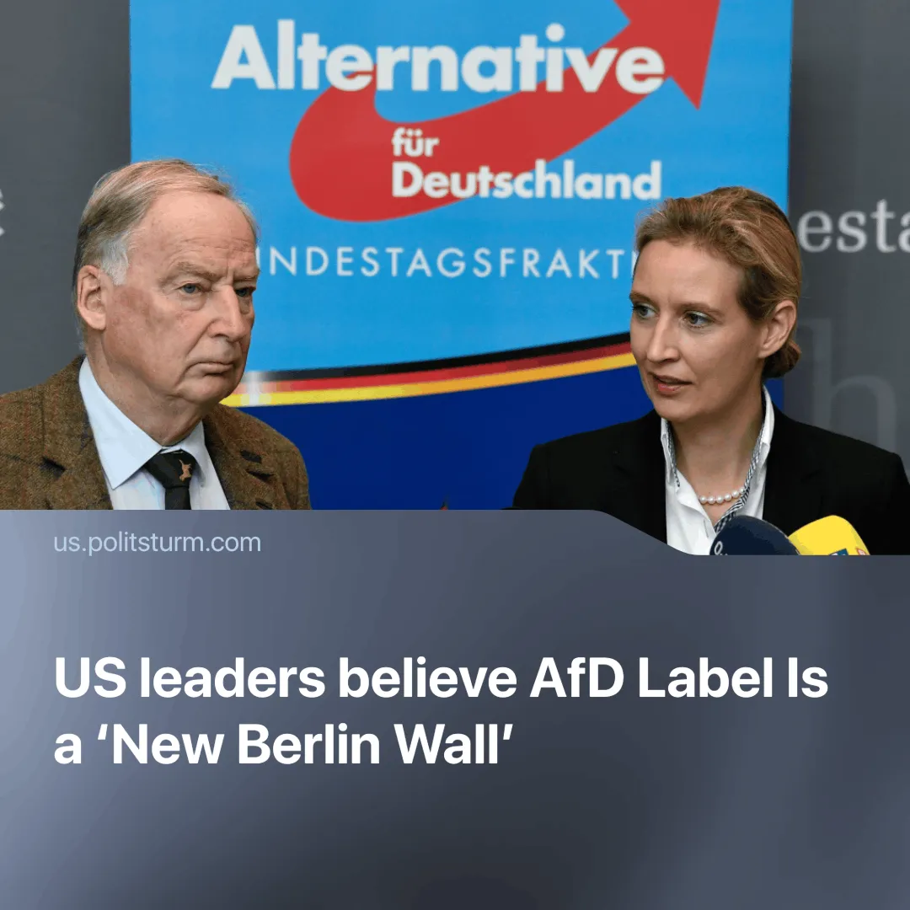

Original article
2025-05-06
1 min read

With the AfD now polling as Germany’s second-most popular party, the state has officially designated it a “proven extremist” organisation — potentially marking the first formal step toward banning a major electoral force whose politics clash with EU priorities.
► On May 2, Germany’s domestic intelligence agency, the Federal Office for the Protection of the Constitution (BfV), officially designated the AfD as a “proven right-wing extremist” organisation, opening the door for expanded surveillance and a potential legal ban.
Details. The agency cited the AfD’s promotion of an “ethnicity- and ancestry-based understanding of the people” that is “incompatible with the free democratic order.” One example of this ideological stance is shown by AfD leader Björn Höcke’s 2017 speech, in which he described the Holocaust memorial in Berlin as a “monument of shame” and called for a “180-degree turnaround” in Germany’s remembrance culture.
► The designation allows the state to deploy informants, tap communications, and potentially pursue a formal party ban.
► Chancellor Olaf Scholz responded cautiously, stating that calls to ban the AfD should not be rushed. He urged that “everything needs to be weighed carefully” and warned against acting with “haste,” despite the party’s extremist designation.
► U.S. leadership has expressed strong disapproval. Secretary of State Marco Rubio criticised the move as “tyranny in disguise,” defending the AfD’s stance on immigration. Vice President J.D. Vance declared that the Berlin Wall was being rebuilt.
Context. The AfD has consistently criticised the European Union, advocated for Germany’s exit from the bloc, and supported closer ties with the United States, as shown by the reaction of US officials.

Original article

